Oracle Database 19c: Tuning

# Table of Contents

Practices for Lesson 1: Course Introduction 5

Practices for Lesson 1 6

Practices for Lesson 2: Introduction to SQL Tuning 7

Practices for Lesson 2: Overview 8

Practice 2-1: Using SQL Developer 9

Practices for Lesson 3: Using Application Tracing Tools 21

Practices for Lesson 3: Overview 22

Practice 3-1: Tracing Applications 23

Practices for Lesson 4: Optimizer Fundamentals 59

Practices for Lesson 4: Overview 60

Practice 4-1: Understanding Optimizer Decisions (Optional) 61

Practices for Lesson 5: Generating and Displaying Execution Plans 101

Practices for Lesson 5: Overview 102

Practice 5-1: Extracting an Execution Plan by Using SQL Developer 103

Practice 5-2: Extracting Execution Plans 108

Practices for Lesson 6: Interpreting Execution Plans and Enhancements 123

Practices for Lesson 6: Overview 124

Practice 6-1: Using Dynamic Plans 125

Practices for Lesson 7: Optimizer: Table and Index Access Paths 131

Practices for Lesson 7: Overview 132

Practice 7-1: Using Different Access Paths 133

Practices for Lesson 8: Optimizer: Join Operators 175

Practices for Lesson 8: Overview 176

Practice 8: Using Join Paths 177

Practices for Lesson 9: Other Optimizer Operators 189

Practices for Lesson 9: Overview 190

Practice 9-1: Using the Result Cache 191

Practice 9-2: Using Other Access Paths (Optional) 210

Practices for Lesson 10: Introduction to Optimizer Statistics Concepts 231

Practices for Lesson 10: Overview 232

Practice 10-1: Index Clustering Factor 233

Practice 10-2: Creating Expression Statistics 242

Practice 10-3: Enabling Automatic Statistics Gathering (Optional) 247

Practice 10-4: Using System Statistics (Optional) 269

Practices for Lesson 11: Using Bind Variables 279

Practices for Lesson 11: Overview 280

Practice 11-1: Using Adaptive Cursor Sharing 281

Practice 11-2: Using CURSOR_SHARING (Optional) 300

Practices for Lesson 12: SQL Plan Management 309

Practices for Lesson 12: Overview 310

Practice 12-1: Using SQL Plan Management (SPM) 311

Workshop 1 347

Workshop 1: Overview 348

Workshop 1: Enhancing the Performance of a SQL Query Statement 349

Workshop 2 357

Workshop 2: Overview 358

Workshop 2: Reviewing the Execution Steps of the SQL Statement 359

Workshop 3 365

Workshop 3: Overview 366

Workshop 3: Learn to Tune Sort Operation Using an Index in the ORDER BY Clauses 367

Workshop 4 379

Workshop 4: Overview 380

Workshop 4: Identifying and Tuning a Poorly Written SQL Statement 381

Workshop 5 387

Workshop 5: Overview 388

Workshop 5: Effects of Changing the Column Order in a Composite Index 389

Workshop 6 403

Workshop 6: Overview 404

Workshop-6: Using Information in the 10053 File to Tune a SQL Statement 405

Workshop 7 409

Workshop 7: Overview 410

Workshop 7: Understanding the Optimizer’s Decision 411

Workshop 8 417

Workshop 8: Overview 418

Workshop 8: Tuning Strategy 419

Workshop 9 435

Workshop 9: Overview 436

Workshop 9: Using SQL Plan Baseline to Manage a Better Execution Plan 437

# Practices for Lesson 1: Course Introduction

## Practices for Lesson 1

There are no practices for lesson 1.

# Practices for Lesson 2: Introduction to SQL Tuning

## Practices for Lesson 2: Overview

### Overview

This practice covers using SQL Developer.

## Practice 2-1: Using SQL Developer

### Overview

In this practice, you get acquainted with SQL Developer functions.

### Tasks

1. Start Database. To start up a database from the command line, use SQL*Plus to connect to Oracle with administrator privileges and then issue the STARTUP command.
   1. Open terminal from the desktop and switch to oracle user:

su - oracle

* 1. Enter sqlplus / as sysdba
  2. Start the database using the command startup. Enter startup
  3. Enter following commands to open the current PDB

Alter pluggable database all open;

* 1. Exit SQL*Plus command-line. Enter EXIT.
  2. Start the listener service by typing the following command:

lsnrctl START

1. Start Oracle SQL Developer.

Double-click the Oracle SQL Developer icon on your desktop.

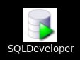

1. Create a database connection to the SH schema by using the following information:

|  |  |
| --- | --- |
| a. Connection Name | sh_connection |
| b. Username | sh |
| c. Password | sh |
| d. Hostname | localhost |
| e. Port | 1521 |
| f. Service name | orclpdb |

Right-click the Connections icon on the Connections tabbed page, and then select

**New Connection** from the shortcut menu. The **New / Select Database Connection Window** appears. Use the preceding information to create the new database connection.

**Note:** To display the properties of the newly created connection, right-click the connection name, and then select Properties from the shortcut menu. Enter the username, password, host name, and service name with the appropriate information, as provided in the table. Select the “**Save Password**” check box.

The following is a sample of the newly created database connection for the SH schema using a local connection:

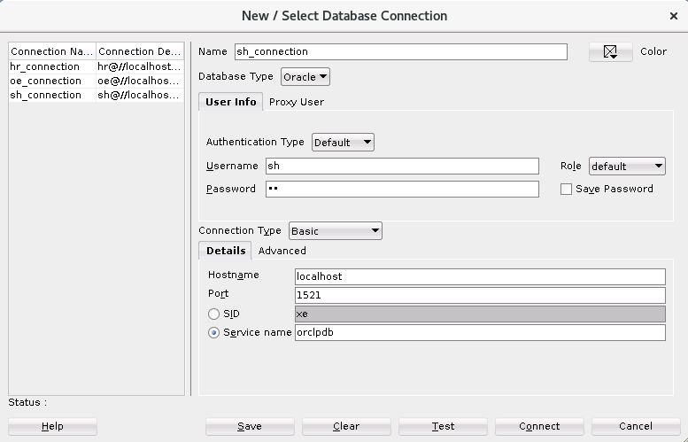

1. Test the new connection. If the Status is Success, save the connection and then connect to the database by using this new connection.



1. Create a new database connection named hr_connection.
2. Right-click sh_connection in the Object Navigation tree, and select the Properties menu option.
3. Enter hr_connection as the connection name and hr as the username and password, select Save Password, and then click Test to test the new connection.
4. 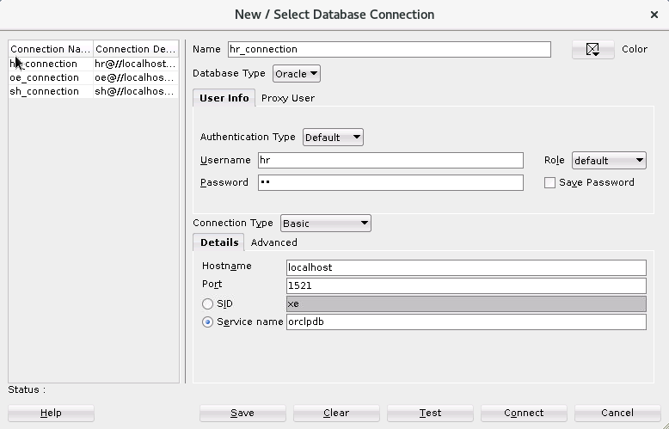Click Connect to connect to the database.
5. Repeat steps 2 and 3 to create and test a new database connection named

oe_connection. Enter oe as the database connection username and password.

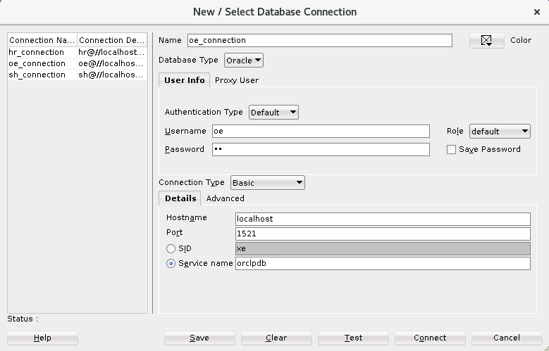

1. 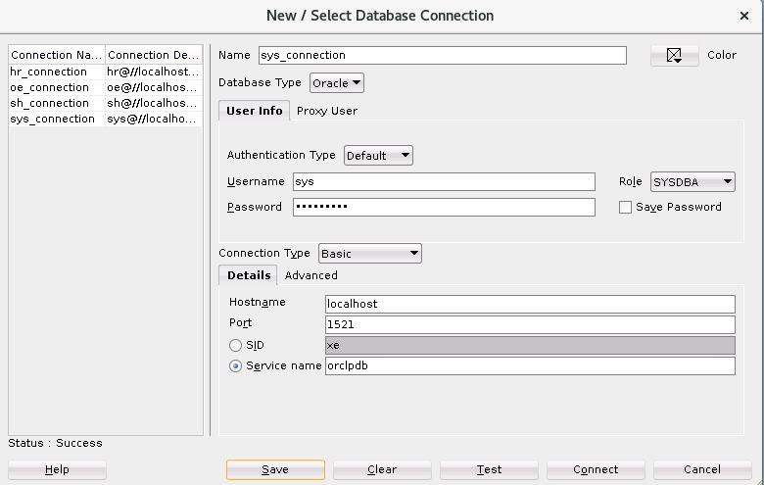Repeat steps 2 and 3 to create and test a new database connection named sys_connection. Enter sys in the Username field and fenago in the Password field. From the Role drop-down menu, select SYSDBA as the role.

#### Browsing the HR, SH, and OE Schema Tables

1. Browse the structure of the EMPLOYEES table in the HR schema.
2. Expand the hr_connection connection by clicking the plus sign.
3. Expand Tables by clicking the plus sign.
4. Display the structure of the EMPLOYEES table. Click the EMPLOYEES table. The Columns tab displays the columns in the EMPLOYEES table as follows:

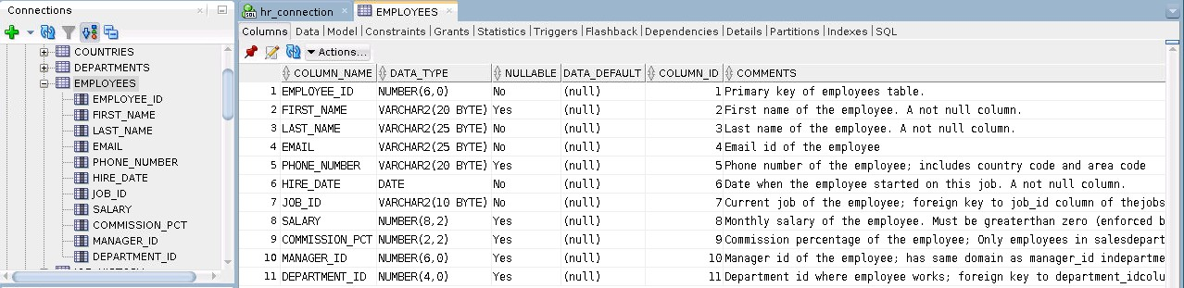

1. Browse the EMPLOYEES table and display its data.

a. To display the employee data, click the Data tab. The EMPLOYEES table data is displayed as follows:

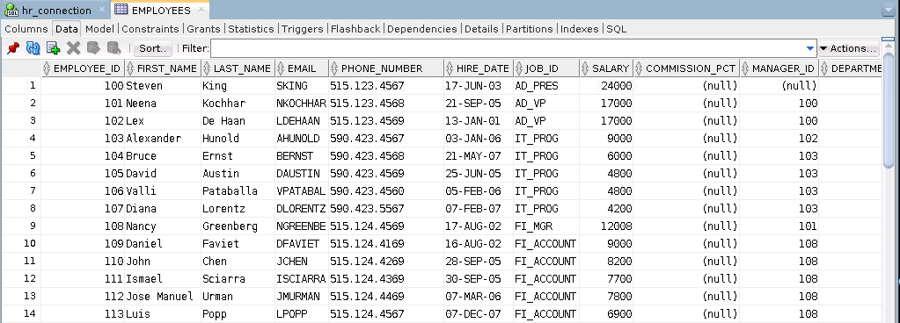

1. Use the SQL Worksheet to select the last names and salaries of all employees whose annual salary is greater than $10,000. Use both the Execute Statement (F9) and the Run Script (F5) icons to execute the SELECT statement. Review the results of both methods of executing the SELECT statements on the appropriate tabs.
2. Display the SQL Worksheet by using any of the following two methods: Select Tools > SQL Worksheet, or click the Open SQL Worksheet icon. The Select Connection window appears. Select hr_connection. Enter the following statement in the SQL Worksheet:

SELECT *

FROM employees

WHERE SALARY > 10000;

1. Execute by pressing Ctrl + Enter or by clicking the Run Statement icon .

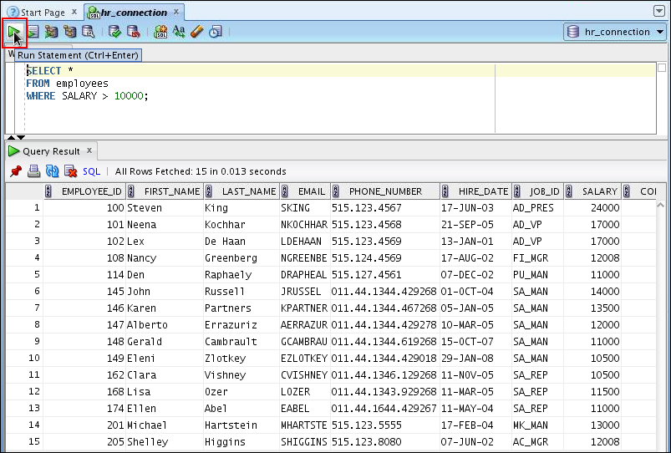

1. Execute by pressing the F5 key or by clicking the Execute Script icon .

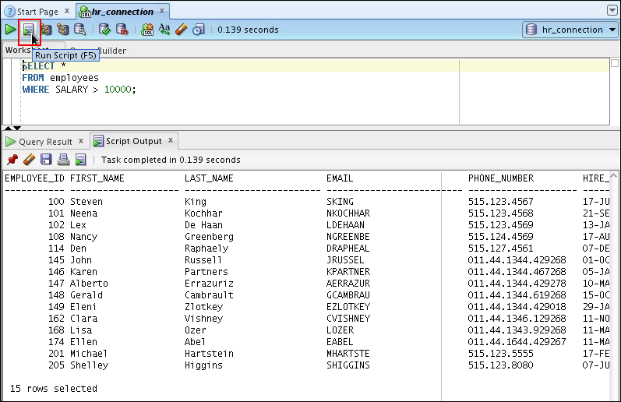

1. In the same SQL Worksheet, create and execute a simple anonymous block that outputs “Hello World.”
2. 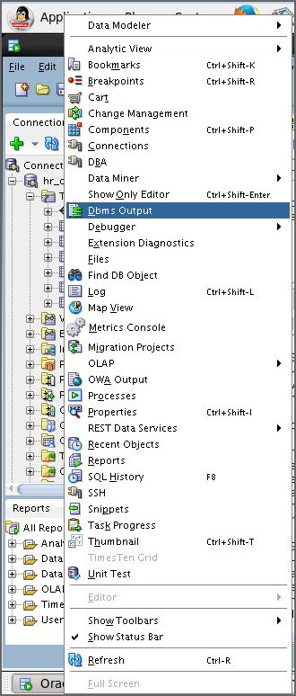Enable SET SERVEROUTPUT ON to display the output of the DBMS_OUTPUT package statements. Select **View > Dbms Output.**
3. Click the green plus sign, as shown below, to enable DBMS_OUTPUT.

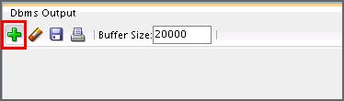

1. 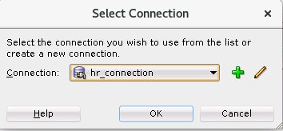In the dialog box that appears, select hr_connection and click OK.
2. 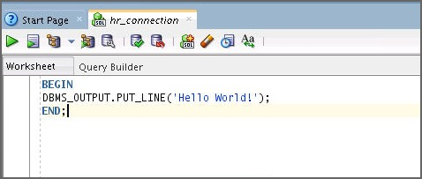Use the SQL Worksheet area to enter the code for your anonymous block.

BEGIN

DBMS_OUTPUT.PUT_LINE('Hello World!');

END;

1. Click the Execute icon (Ctrl + Enter) to run the anonymous block.

The Script Output tab displays the output of the anonymous block as follows:

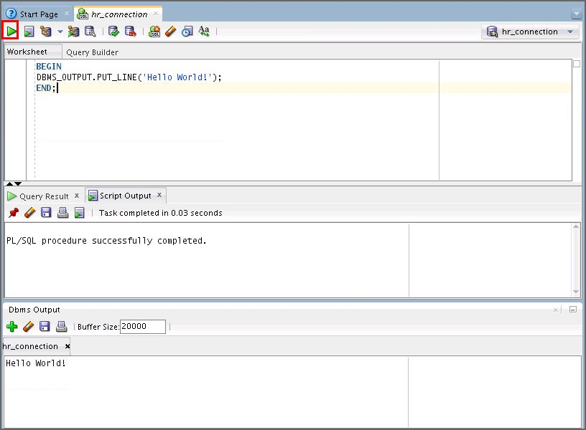

# Practices for Lesson 3: Using Application Tracing Tools

## Practices for Lesson 3: Overview

### Overview

This practice covers the following topics:

* Creating a service
* Tracing your application by using services
* Interpreting trace information by using trcsess and TKPROF

## Practice 3-1: Tracing Applications

### Lab Solution

### Copy lab files in /home/oracle directory using following commands: (Run as root)

### ln -s /headless/Desktop/oracle19c-labs/tuning/labs/ /home/oracle/

### chmod -R 777 /headless/Desktop/oracle19c-labs/tuning/labs

### Overview

In this practice, you define a service and use it to generate traces. You then interpret the generated trace files. You can find all needed script files for this practice in your /home/oracle/labs/solutions/Application_Tracing directory.

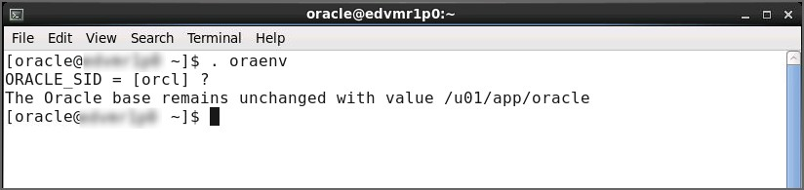**Note:** Before executing the scripts, set your environment by using the following code:

### Tasks

1. Your environment should be initialized with the at_setup.sql script as shown below.

set echo on

drop user trace cascade;

create user trace identified by trace default tablespace users temporary tablespace temp;

grant connect, resource, dba to trace;

alter session set container = orclpdb;

drop tablespace tracetbs including contents and datafiles; drop tablespace tracetbs3 including contents and datafiles;

create tablespace tracetbs

datafile '/u01/app/oracle/oradata/orcl/tracetbs.dbf' size 100m extent management local uniform size 40k;

create tablespace tracetbs3

datafile '/u01/app/oracle/oradata/orcl/tracetbs3.dbf' size 100m extent management local uniform size 10m;

connect trace/trace@orclpdb

drop table sales purge;

create table sales as select * from sh.sales;

drop table sales2 purge;

create table sales2 tablespace tracetbs as select * from sh.sales where 1=2;

drop table sales3 purge;

create table sales3 tablespace tracetbs3 as select * from sh.sales where 1=2;

exit;

Execute the at_setup.sql, to prepare for this lab activity

* 1. Open terminal
  2. Navigate to Application_Tracing folder usning the command cd

/home/oracle/labs/solutions/Application_Tracing

* 1. Connect to your database instance as the SYS

sqlplus / as sysdba

* 1. Execute the at_setup.sql script as follows

SQL> @at_setup.sql

1. You now execute seven workload scripts that are traced. All workload scripts run under the ORCLPDB service. Your goal is to analyze the generated trace files to interpret what happens in the seven cases. From your terminal session, execute the run_tracep0.sh script.

$ cd /home/oracle/labs/solutions/Application_Tracing

$ **./run_tracep0.sh**

…

Connected to:…

SQL>

SQL> connect trace/trace@orclpdb Connected.

SQL>

SQL> alter session set tracefile_identifier='mytraceP0';

Session altered.

SQL>

SQL> set termout off SQL>

SQL> exit;

...

$

1. Enable tracing for ORCLPDB service.

oracle@edvmr1p0 Application_Tracing]$ **sqlplus / as sysdba**

SQL*Plus: Release 19.0.0.0.0 - Production on Wed Jun 3 07:17:15 2020

Version 19.3.0.0.0

Copyright (c) 1982, 2019, Oracle. All rights reserved.

Connected to:

Oracle Database 19c Enterprise Edition Release 19.0.0.0.0 - Production

Version 19.3.0.0.0

SQL> **select name from v$active_services;**

NAME

orclXDB orcl

SYS$BACKGROUND SYS$USERS

orclpdb

SQL> **exec dbms_monitor.serv_mod_act_trace_enable(service_name=>'orclpdb');**

PL/SQL procedure successfully completed. SQL> **exit**

1. When tracing for ORCLPDB is enabled and run_tracep0.sh has finished, execute the run_tracep1.sh script from your terminal session.

$ **./run_tracep1.sh**

…

SQL>

SQL> connect trace/trace@orclpdb Connected.

SQL>

SQL> alter session set workarea_size_policy=manual;

Session altered.

SQL>

SQL> alter session set sort_area_size=50000;

Session altered.

SQL>

SQL> alter session set hash_area_size=5000;

Session altered.

SQL> SQL>

SQL> alter session set tracefile_identifier='mytraceP1';

Session altered.

SQL> EXEC DBMS_MONITOR.session_trace_enable; PL/SQL procedure successfully completed.

SQL> SQL>

SQL> set timing on SQL>

SQL> select /*+ ORDERED USE_HASH(s2) */ count(*) from sales s1, sales s2 where s1.cust_id=s2.cust_id;

COUNT(*)

172878975

Elapsed: 00:00:44.35 SQL>

SQL> SQL>

SQL> connect trace/trace@orclpdb Connected.

SQL>

SQL> alter session set tracefile_identifier='mytraceS1'; Session altered.

Elapsed: 00:00:00.00

SQL> EXEC DBMS_MONITOR.session_trace_enable; PL/SQL procedure successfully completed.

Elapsed: 00:00:00.01

SQL>

SQL> set timing on SQL>

SQL> select /*+ ORDERED USE_HASH(s2) S1 */ count(*) from sales s1, sales s2 where s1.cust_id=s2.cust_id;

COUNT(*) 172878975

Elapsed: 00:00:13.72 SQL>

SQL> exit;

…

$

1. Execute the run_tracep2.sh script from your terminal session. Observe the output.

$ **./run_tracep2.sh**

…

SQL> alter session set container = orclpdb; Session altered.

SQL>

SQL> connect trace/trace@orclpdb Connected.

SQL>

SQL> alter session set tracefile_identifier='mytraceP2';

Session altered.

SQL> EXEC DBMS_MONITOR.session_trace_enable; PL/SQL procedure successfully completed.

SQL>

SQL> set timing on SQL>

SQL> declare

1. c number := dbms_sql.open_cursor;
2. oname varchar2(50);
3. ignore integer;
4. begin
5. for i in 1 .. 5000 loop
6. dbms_sql.parse(c,'select object_name from dba_objects where object_id = '||i , dbms_sql.native); -- use literal
7. dbms_sql.define_column(c, 1, oname, 50);
8. ignore := dbms_sql.execute(c);
9. if dbms_sql.fetch_rows(c)>0 then
10. dbms_sql.column_value(c, 1, oname);
11. end if;
12. end loop;
13. dbms_sql.close_cursor(c);
14. end;

16 /

PL/SQL procedure successfully completed.

Elapsed: 00:02:24.36 SQL>

SQL> SQL>

SQL> connect trace/trace@orclpdb Connected.

SQL>

SQL> alter session set tracefile_identifier='mytraceS2'; Session altered.

Elapsed: 00:00:00.00 SQL>

SQL> declare

1. c number := dbms_sql.open_cursor;
2. oname varchar2(50);
3. ignore integer;
4. begin
5. dbms_sql.parse(c,'select object_name from dba_objects where object_id = :y' , dbms_sql.native); -- use bind var
6. for i in 1 .. 5000 loop
7. dbms_sql.bind_variable(c,':y',i);
8. dbms_sql.define_column(c, 1, oname, 50);
9. ignore := dbms_sql.execute(c);
10. if dbms_sql.fetch_rows(c)>0 then
11. dbms_sql.column_value(c, 1, oname);
12. end if;
13. end loop;
14. dbms_sql.close_cursor(c);
15. end;

17 /

PL/SQL procedure successfully completed. Elapsed: 00:00:00.86

SQL>

SQL> exit; Disconnected …

$

1. Execute the run_tracep3.sh script from your terminal session. Observe the output.

$ **./run_tracep3.sh**

…

SQL>

SQL> connect trace/trace@orclpdb Connected.

SQL>

SQL> alter session set tracefile_identifier='mytraceP3';

Session altered.

SQL> EXEC DBMS_MONITOR.session_trace_enable; PL/SQL procedure successfully completed.

SQL>

SQL> update sales set amount_sold=20000 where prod_id=13 and cust_id=987;

2 rows updated.

SQL>

SQL> commit;

Commit complete.

SQL> SQL>

SQL> connect trace/trace@orclpdb Connected.

SQL>

SQL> create index sales_prod_cust_indx on sales(prod_id,cust_id);

Index created.

SQL>

SQL> connect trace/trace@orclpdb Connected.

SQL>

SQL> alter session set tracefile_identifier='mytraceS3';

Session altered.

SQL> EXEC DBMS_MONITOR.session_trace_enable; PL/SQL procedure successfully completed.

SQL>

SQL> update sales set amount_sold=30000 where prod_id=13 and cust_id=987;

2 rows updated.

SQL>

SQL> commit;

Commit complete.

SQL>

SQL> connect trace/trace Connected.

SQL>

SQL> drop index sales_prod_cust_indx; Index dropped.

SQL> SQL>

SQL> exit;

Disconnected …

$

1. Execute the run_tracep4.sh script from your terminal session. Observe the output.

$ **./run_tracep4.sh**

…

SQL>

SQL> connect trace/trace@orclpdb Connected.

SQL>

SQL> alter session set tracefile_identifier='mytraceP4';

Session altered.

SQL> EXEC DBMS_MONITOR.session_trace_enable; PL/SQL procedure successfully completed.

SQL>

SQL> set timing on

SQL>

SQL> DECLARE

1. TYPE SalesCurTyp IS REF CURSOR;
2. v_sales_cursor SalesCurTyp;
3. sales_record sh.sales%ROWTYPE;
4. v_stmt_str VARCHAR2(200);
5. BEGIN
6. -- Dynamic SQL statement with placeholder:
7. v_stmt_str := 'select * from sh.sales where amount_sold>0'; 9
8. -- Open cursor and specify bind argument in USING clause:
9. OPEN v_sales_cursor FOR v_stmt_str; 12
10. -- Fetch rows from result set one at a time:
11. LOOP
12. FETCH v_sales_cursor INTO sales_record;
13. EXIT WHEN v_sales_cursor%NOTFOUND;
14. END LOOP; 18
15. -- Close cursor:
16. CLOSE v_sales_cursor;
17. END;

22 /

PL/SQL procedure successfully completed.

Elapsed: 00:00:21.27 SQL>

SQL>

SQL> connect trace/trace@orclpdb Connected.

SQL>

SQL> alter session set tracefile_identifier='mytraceS4';

Session altered.

Elapsed: 00:00:00.01

SQL> EXEC DBMS_MONITOR.session_trace_enable; PL/SQL procedure successfully completed.

Elapsed: 00:00:00.01

SQL>

SQL> set timing on SQL>

SQL> DECLARE

* 1. TYPE SalesCurTyp IS REF CURSOR;
  2. TYPE SalesList IS TABLE OF sh.sales%ROWTYPE;

|  |  |  |
| --- | --- | --- |
| 11 | -- Open cursor: |  |
| 12 | OPEN v_sales_cursor FOR v_stmt_str; |  |
| 13 |  |  |
| 14 | -- Fetch rows from result set one at a time: |  |
| 15 | LOOP |  |
| 16 | FETCH v_sales_cursor BULK COLLECT INTO Sales_List | LIMIT |

1. Execute the run_tracep5.sh script from your terminal session. Observe the output.

$ **./run_tracep5.sh**

…

SQL>

SQL> connect trace/trace@orclpdb Connected.

SQL>

SQL> alter session set tracefile_identifier='mytraceP5';

Session altered.

SQL>

4

5

6

7

8

9

v_sales_cursor sales_List v_stmt_str

BEGIN

SalesCurTyp; SalesList;

VARCHAR2(200);

-- Dynamic SQL statement with placeholder:

v_stmt_str := 'select /* S4 */ * from sh.sales where

amount_sold>0';

10

10000;

17

18

19

20

21

EXIT WHEN v_sales_cursor%NOTFOUND;

END LOOP;

-- Close cursor:

CLOSE v_sales_cursor;

22 END;

23 /

PL/SQL procedure successfully completed. Elapsed: 00:00:00.87

SQL> SQL>

SQL> exit; Disconnected …

$

SQL> EXEX DBMS_MONITOR.session_trace_enable; PL/SQL procedure successfully completed.

SQL> delete from sales2;

0 rows deleted;

SQL>

SQL> insert into sales2 select * from sh.sales union all select * from sales;

1837686 rows created. SQL> commit;

Commit complete.

SQL> SQL>

SQL> connect trace/trace@orclpdb Connected.

SQL>

SQL> alter session set tracefile_identifier='mytraceS5';

Session altered.

SQL> EXEX DBMS_MONITOR.session_trace_enable; PL/SQL procedure successfully completed.

SQL>

SQL> insert into sales3 select * from sh.sales union all select * from sales;

1837686 rows created. SQL> commit;

Commit complete.

SQL>

SQL> exit;

Disconnected …

$

1. Execute the run_tracep6.sh script from your terminal session. Observe the output. Wait until you see the message run_tracep6 finished before proceeding to the next step.

$ **./run_tracep6.sh**

… SQL>

SQL> connect trace/trace@orclpdb Connected.

SQL>

SQL> alter session set tracefile_identifier='mytraceP6';

Session altered.

SQL> EXEX DBMS_MONITOR.session_trace_enable; PL/SQL procedure successfully completed.

SQL>

SQL> exec dbms_lock.sleep(30); Connected.

SQL> update sales set amount_sold=amount_sold+1; 918843 rows updated.

SQL>

SQL> exec dbms_lock.sleep(60);

SQL> exit;

Disconnected from Oracle Database 12c Enterprise Edition Release

12.2.0.1.0 - 64bit Production [oracle@EDT3R13P1 Application_Tracing]$ PL/SQL procedure successfully completed.

SQL>

SQL> rollback; Rollback complete.

SQL>

SQL> -- Run_tracep6 Finished SQL> exit;

Disconnected …

$

**Note:** run_tracep6.sh takes a while to execute completely. Wait for some time to finish execution and then continue.

1. Execute the run_tracep7.sh script from your terminal session. Observe the output.

$ **./run_tracep7.sh**

… SQL>

SQL> connect trace/trace@orclpdb Connected.

SQL> drop index SALES_CUST_INDX; Index dropped.

SQL> alter session set tracefile_identifier='mytraceP7';

Session altered.

SQL> EXEC dbms_monitor.session_trace_enable; PL/SQL procedure successfully completed.

SQL>

SQL> declare

1. c number := dbms_sql.open_cursor;
2. custid number;
3. amount number;
4. ignore integer;
5. begin
6. dbms_sql.parse(c,'select cust_id, sum(amount_sold) from sales where cust_id=2 group by cust_id order by cust_id' , dbms_sql.native);

-- use bind var

1. dbms_sql.define_column(c, 1, custid);
2. dbms_sql.define_column(c, 2, amount);
3. ignore := dbms_sql.execute(c);
4. if dbms_sql.fetch_rows(c)>0 then
5. dbms_sql.column_value(c, 1, custid);
6. dbms_sql.column_value(c, 2, amount);
7. end if;
8. end;

16 /

PL/SQL procedure successfully completed.

SQL>

SQL> connect trace/trace@orclpdb Connected.

SQL>

SQL> create index sales_cust_indx on sales(cust_id);

Index created.

SQL>

SQL> exit;

Disconnected …

$

1. Disable tracing for your database.

[oracle@edvmr1p0 Application_Tracing]$ **sqlplus / as sysdba**

SQL*Plus: Release 19.0.0.0.0 - Production on Wed Jun 3 07:38:33 2020

Version 19.3.0.0.0

Copyright (c) 1982, 2019, Oracle. All rights reserved. Connected to:

Oracle Database 19c Enterprise Edition Release 19.0.0.0.0 - Production

Version 19.3.0.0.0

SQL> **exec dbms_monitor.serv_mod_act_trace_disable(service_name=>'orclpdb');**

PL/SQL procedure successfully completed. SQL> **exit**

1. Try to find out all the trace files that were generated to handle the previous seven cases.

**Note:** Your output may differ based on your environment.

$ **./show_mytraces.sh** orcl_ora_19313_mytraceP1.trc orcl _ora_19313_mytraceP1.trm orcl _ora_19355_mytraceS1.trc orcl _ora_19355_mytraceS1.trm orcl _ora_19382_mytraceP2.trc orcl _ora_19382_mytraceP2.trm orcl _ora_19467_mytraceS2.trc orcl _ora_19467_mytraceS2.trm orcl _ora_19474_mytraceP3.trc orcl _ora_19474_mytraceP3.trm orcl _ora_19503_mytraceS3.trc orcl _ora_19503_mytraceS3.trm orcl _ora_19534_mytraceP4.trm orcl _ora_19549_mytraceS4.trc

orcl _ora_19549_mytraceS4.trm

orcl _ora_19558_mytraceP5.trc orcl _ora_19558_mytraceP5.trm orcl _ora_19568_mytraceS5.trc orcl _ora_19568_mytraceS5.trm orcl _ora_19583_mytraceP6.trc orcl _ora_19583_mytraceP6.trm orcl _ora_19634_mytraceP7.trc orcl _ora_19634_mytraceP7.trm

$

1. After you identify the location of those trace files, merge their content into one file called mytrace.trc located in your $HOME/labs/solutions/Application_Tracing directory.

$ **./merge_traces.sh**

$

1. Use tkprof over the mytrace.trc file to generate a compiled trace output called myreport.txt located in your $HOME/labs/solutions/Application_Tracing directory.

$ **./tkprof_traces.sh**

TKPROF: Release 19.0.0.0- Development on Wed Jun 3 02:00:00 2018

Copyright (c) 1982, 2019, Oracle and/or its affiliates. All rights reserved.

$

1. In addition, run TKPROF over the trace file that was generated for case 7 (step 12) with the

EXPLAIN option set to your TRACE account.

$ **tkprof /u01/app/oracle/diag/rdbms/orcl/orcl/trace/*mytraceP7.trc myreport2.txt explain=trace/trace@orclpdb**

TKPROF: Release 19.0.0.0.0- Development on Wed Jan 3 02:00:48 2018

Copyright (c) 1982, 2019, Oracle and/or its affiliates. All rights reserved.

$

1. After this is done, interpret the trace generated for case 1 (step 6). Case 1 appears near the beginning of the myreport.txt file.

**Suggestion:** Use a text editor or pager that has a search capability. vscode, vi, and less

are available in the class machines. vscode provides a GUI.

**Hint:** Search for the first occurrence of the string ‘ORDERED USE_HASH(s2)’ and examine the trace. Then find the second occurance and compare the trace to the first occurance. What do you observe, and what are your conclusions?

* 1. Case 1 illustrates the consequences of using manually sized SQL area parameters, such as HASH_AREA_SIZE. The first statement was executed by using a very small HASH_AREA_SIZE value. The immediate consequence was the number of temporary segments needed to execute the statement. Later, the same statement was executed, but this time by using the default SQL area parameters, which were sized automatically by the system to handle the needs. You can see a high disk value as well as a high number of waits for temporary segments for the first execution, compared to the second one. Compare the statistics direct path read temp and direct path write temp in the two statement traces. These indicate activity from SQL work areas to temporary segments.
  2. **Note:** The actual statistics will vary from the example shown.

SQL ID: 5h4bydz30hwf7 Plan Hash: 2354142265

select /*+ ORDERED USE_HASH(s2) */ count(*) from

sales s1, sales s2 where s1.cust_id=s2.cust_id

|  |  |  |  |  |  |  |  |  |  |  |  |  |  |  |
| --- | --- | --- | --- | --- | --- | --- | --- | --- | --- | --- | --- | --- | --- | --- |
| call |  | count |  | cpu |  | elapsed |  | disk |  | query |  | current |  | rows |
| Parse |  | 1 |  | 0.00 |  | 0.00 |  | 0 |  | 0 |  | 0 |  | 0 |
| Execute |  | 1 |  | 0.00 |  | 0.00 |  | 0 |  | 0 |  | 0 |  | 0 |
| Fetch |  | 2 |  | 105.91 |  | 118.33 |  | 806501 |  | 8874 |  | 0 |  | 1 |
| total |  | 4 |  | 105.92 |  | 118.34 |  | 806501 |  | 8874 |  | 0 |  | 1 |

Misses in library cache during parse: 1 Optimizer mode: ALL_ROWS

Parsing user id: 95

Rows Row Source Operation

1 SORT AGGREGATE (cr=8874 pr=806501 pw=2524 time=0 us)

172878975 HASH JOIN (cr=8874 pr=806501 pw=2524 time=244058880 us cost=463845 size=1196022750 card=119602275)

918843 TABLE ACCESS FULL SALES (cr=4437 pr=4434 pw=0 time=770629

us cost=1230 size=4594215 card=918843)

918843 TABLE ACCESS FULL SALES (cr=4437 pr=4433 pw=0 time=775236

us cost=1230 size=4594215 card=918843)

Elapsed times include waiting on following events:

Event waited on Times Max. Wait Total Waited

Waited SQL*Net message to client 2 0.00 0.00

Disk file operations I/O 2 0.00 0.00

db file sequential read 1 0.01 0.01

direct path read 88 0.08 1.16

direct path write temp 2524 0.02 0.77

direct path read temp 797634 0.14 8.46

SQL*Net message from client 2 0.00 0.00

*****************************************************************

…

SQL ID: 3a5334n3vuu8y Plan Hash: 2354142265

select /*+ ORDERED USE_HASH(s2) S1 */ count(*) from

sales s1, sales s2 where s1.cust_id=s2.cust_id

|  |  |  |  |  |  |  |  |  |  |  |  |  |  |  |
| --- | --- | --- | --- | --- | --- | --- | --- | --- | --- | --- | --- | --- | --- | --- |
| call |  | count |  | cpu |  | elapsed |  | disk |  | query |  | current |  | rows |
| Parse |  | 1 |  | 0.00 |  | 0.00 |  | 0 |  | 0 |  | 0 |  | 0 |
| Execute |  | 1 |  | 0.00 |  | 0.00 |  | 0 |  | 0 |  | 0 |  | 0 |
| Fetch |  | 2 |  | 61.66 |  | 67.70 |  | 8866 |  | 8874 |  | 0 |  | 1 |
| total |  | 4 |  | 61.66 |  | 67.71 |  | 8866 |  | 8874 |  | 0 |  | 1 |

Misses in library cache during parse: 1 Optimizer mode: ALL_ROWS

Parsing user id: 95

Rows Row Source Operation

1 SORT AGGREGATE (cr=8882 pr=2 pw=0 time=0 us)

172878975 HASH JOIN (cr=8882 pr=2 pw=0 time=188874752 us cost=4314 size=1196022750 card=119602275)

918843 TABLE ACCESS FULL SALES (cr=4441 pr=2 pw=0 time=791235 us

cost=1230 size=4594215 card=918843)

918843 TABLE ACCESS FULL SALES (cr=4441 pr=0 pw=0 time=938296 us

cost=1230 size=4594215 card=918843)

Elapsed times include waiting on following events:

Event waited on Times Max. Wait Total Waited

Waited SQL*Net message to client 2 0.00 0.00

SQL*Net message from client 2 0.00 0.00

*************************************************************

1. Interpret the trace generated for case 2 (step 7). In this trace, the first statement of interest has the string “use literal.”

**Note:** This trace is very long. What do you observe, and what are your conclusions?

* 1. For this case, an almost identical statement was run 5000 times, but each time a different literal was used to execute the query. This caused the system to parse almost the same statement 5000 times, which is extremely inefficient, although the time precision is too low to give accurate information about the parse time of each statement. But the elapsed time and the CPU for the PL/SQL block include the time that these 5000 statements took to execute.

**Note:** Confirm that these 5000 executions are at “recursive depth: 1”.

The actual statistics you see will vary from the example shown. The first two recursive SQL statements are shown and then the last statement where object_id = 5000 is shown.

…

declare

c number := dbms_sql.open_cursor; oname varchar2(50);

ignore integer; begin

for i in 1 .. 5000 loop

dbms_sql.parse(c,'select object_name from dba_objects where object_id = '||i , dbms_sql.native); -- **use literal**

dbms_sql.define_column(c, 1, oname, 50); ignore := dbms_sql.execute(c);

if dbms_sql.fetch_rows(c)>0 then dbms_sql.column_value(c, 1, oname);

end if; end loop;

dbms_sql.close_cursor(c);

end;

Optimizer mode: ALL_ROWS Parsing user id: 95

Elapsed times include waiting on following events:

|  |  |  |  |  |  |  |
| --- | --- | --- | --- | --- | --- | --- |
| call count cpu elapsed | disk | query |  | current |  | rows |
| Parse 1 0.00 0.00 | 0 | 0 |  | 0 |  | 0 |
| Execute 1 4.27 5.77 | 0 | 0 |  | 0 |  | 1 |
| Fetch 0 0.00 0.00 | 0 | 0 |  | 0 |  | 0 |
| total 2 **4.27 5.77** | 0 | 0 |  | 0 |  | 1 |
| Misses in library cache during | parse: 0 |  |  |  |  |  |

Event waited on Times Max. Wait Total Waited

Waited SQL*Net message to client 1 0.00 0.00

SQL*Net message from clien 1 0.00 0.00

**********************************************************************

SQL ID: 04qmn5w5qg1j3 Plan Hash: 2729849777 select object_name from

dba_objects where object_id = 1

|  |  |  |  |  |  |  |
| --- | --- | --- | --- | --- | --- | --- |
| call count cpu elapsed | disk | query |  | current |  | rows |
| Parse 1 0.02 0.03 | 0 | 0 |  | 0 |  | 0 |
| Execute 1 0.00 0.00 | 0 | 0 |  | 0 |  | 0 |
| Fetch 1 0.00 0.00 | 1 | 3 |  | 0 |  | 0 |
| total 3 0.02 0.03 | 1 | 3 |  | 0 |  | 0 |
| Misses in library cache during | parse: 1 |  |  |  |  |  |

Optimizer mode: ALL_ROWS

Parsing user id: 95 (**recursive depth: 1**)

Rows Row Source Operation

0 VIEW DBA_OBJECTS (cr=3 pr=1 pw=0 time=0 us cost=5 size=158 card=2)

0 UNION-ALL (cr=3 pr=1 pw=0 time=0 us)

0 FILTER (cr=3 pr=1 pw=0 time=0 us)

0 NESTED LOOPS (cr=3 pr=1 pw=0 time=0 us cost=5 size=108 card=1)

0 NESTED LOOPS (cr=3 pr=1 pw=0 time=0 us cost=4 size=104 card=1)

1. TABLE ACCESS BY INDEX ROWID OBJ$ (cr=3 pr=1 pw=0 time=0 us cost=3 size=82 card=1)
2. INDEX RANGE SCAN I_OBJ1 (cr=2 pr=0 pw=0 time=0 us cost=2 size=0 card=1)(object id 36)

0 INDEX RANGE SCAN I_USER2 (cr=0 pr=0 pw=0 time=0 us cost=1 size=22 card=1)(object id 47)

0 INDEX RANGE SCAN I_USER2 (cr=0 pr=0 pw=0 time=0 us cost=1 size=4 card=1)(object id 47)

0 TABLE ACCESS BY INDEX ROWID IND$ (cr=0 pr=0 pw=0 time=0 us cost=2 size=8 card=1)

0 INDEX UNIQUE SCAN I_IND1 (cr=0 pr=0 pw=0 time=0 us cost=1 size=0 card=1)(object id 41)

0 NESTED LOOPS (cr=0 pr=0 pw=0 time=0 us cost=2 size=29 card=1)

0 INDEX FULL SCAN I_USER2 (cr=0 pr=0 pw=0 time=0 us cost=1 size=20 card=1)(object id 47)

0 INDEX RANGE SCAN I_OBJ4 (cr=0 pr=0 pw=0 time=0 us cost=1 size=9 card=1)(object id 39)

0 FILTER (cr=0 pr=0 pw=0 time=0 us)

0 NESTED LOOPS (cr=0 pr=0 pw=0 time=0 us cost=1 size=83 card=1)

0 INDEX FULL SCAN I_LINK1 (cr=0 pr=0 pw=0 time=0 us cost=0 size=79 card=1)(object id 137)

1. INDEX RANGE SCAN I_USER2 (cr=0 pr=0 pw=0 time=0 us cost=1 size=4 card=1)(object id 47)

Elapsed times include waiting on following events:

Event waited Times Max. Wait Total Waited

Waited db file sequential read 1 0.00 0.00

**********************************************************************

SQL ID: 28m8r9uth07db Plan Hash: 2729849777 select object_name from

dba_objects where object_id = 2

|  |  |  |  |  |  |  |
| --- | --- | --- | --- | --- | --- | --- |
| call count cpu elapsed | disk | query |  | current |  | rows |
| Parse 1 0.01 0.02 | 0 | 0 |  | 0 |  | 0 |
| Execute 1 0.00 0.00 | 0 | 0 |  | 0 |  | 0 |
| Fetch 1 0.00 0.00 | 0 | 5 |  | 0 |  | 1 |
| total 3 0.01 0.02 | 0 | 5 |  | 0 |  | 1 |
| Misses in library cache during | parse: 1 |  |  |  |  |  |

Optimizer mode: ALL_ROWS

Parsing user id: 95 (recursive depth: 1)

Rows Row Source Operation

1. VIEW DBA_OBJECTS (cr=5 pr=0 pw=0 time=0 us cost=5 size=158 card=2)

1 UNION-ALL (cr=5 pr=0 pw=0 time=0 us)

1 FILTER (cr=5 pr=0 pw=0 time=0 us)

1 NESTED LOOPS (cr=5 pr=0 pw=0 time=0 us cost=5 size=108 card=1)

1 NESTED LOOPS (cr=4 pr=0 pw=0 time=0 us cost=4 size=104 card=1)

1 TABLE ACCESS BY INDEX ROWID OBJ$ (cr=3 pr=0 pw=0 time=0 us cost=3 size=82 card=1)

1 INDEX RANGE SCAN I_OBJ1 (cr=2 pr=0 pw=0 time=0 us cost=2 size=0 card=1)(object id 36)

1 INDEX RANGE SCAN I_USER2 (cr=1 pr=0 pw=0 time=0 us cost=1 size=22 card=1)(object id 47)

1 INDEX RANGE SCAN I_USER2 (cr=1 pr=0 pw=0 time=0 us cost=1 size=4 card=1)(object id 47)

0 TABLE ACCESS BY INDEX ROWID IND$ (cr=0 pr=0 pw=0 time=0 us cost=2 size=8 card=1)

0 INDEX UNIQUE SCAN I_IND1 (cr=0 pr=0 pw=0 time=0 us cost=1 size=0 card=1)(object id 41)

0 NESTED LOOPS (cr=0 pr=0 pw=0 time=0 us cost=2 size=29 card=1)

0 INDEX FULL SCAN I_USER2 (cr=0 pr=0 pw=0 time=0 us cost=1 size=20 card=1)(object id 47)

0 INDEX RANGE SCAN I_OBJ4 (cr=0 pr=0 pw=0 time=0 us cost=1 size=9 card=1)(object id 39)

0 FILTER (cr=0 pr=0 pw=0 time=0 us)

0 NESTED LOOPS (cr=0 pr=0 pw=0 time=0 us cost=1 size=83 card=1)

0 INDEX FULL SCAN I_LINK1 (cr=0 pr=0 pw=0 time=0 us cost=0 size=79 card=1)(object id 137)

1. INDEX RANGE SCAN I_USER2 (cr=0 pr=0 pw=0 time=0 us cost=1 size=4 card=1)(object id 47)

**********************************************************************

...

SQL ID: 2d2078j2pucd5 Plan Hash: 2729849777 select object_name from

dba_objects where object_id = 5000

|  |  |  |  |  |  |  |
| --- | --- | --- | --- | --- | --- | --- |
| call count cpu elapsed | disk | query |  | current |  | rows |
| Parse 1 0.01 0.01 | 0 | 0 |  | 0 |  | 0 |
| Execute 1 0.00 0.00 | 0 | 0 |  | 0 |  | 0 |
| Fetch 1 0.00 0.00 | 0 | 5 |  | 0 |  | 1 |
| total 3 0.01 0.01 | 0 | 5 |  | 0 |  | 1 |
| Misses in library cache during | parse: 1 |  |  |  |  |  |

Optimizer mode: ALL_ROWS

Parsing user id: 95 (recursive depth: 1)

Rows Row Source Operation

1. VIEW DBA_OBJECTS (cr=5 pr=0 pw=0 time=0 us cost=5 size=158 card=2)

1 UNION-ALL (cr=5 pr=0 pw=0 time=0 us)

1 FILTER (cr=5 pr=0 pw=0 time=0 us)

1 NESTED LOOPS (cr=5 pr=0 pw=0 time=0 us cost=5 size=108 card=1)

1 NESTED LOOPS (cr=4 pr=0 pw=0 time=0 us cost=4 size=104 card=1)

1 TABLE ACCESS BY INDEX ROWID OBJ$ (cr=3 pr=0 pw=0 time=0 us cost=3 size=82 card=1)

1 INDEX RANGE SCAN I_OBJ1 (cr=2 pr=0 pw=0 time=0 us cost=2 size=0 card=1)(object id 36)

1 INDEX RANGE SCAN I_USER2 (cr=1 pr=0 pw=0 time=0 us cost=1 size=22 card=1)(object id 47)

1 INDEX RANGE SCAN I_USER2 (cr=1 pr=0 pw=0 time=0 us cost=1 size=4 card=1)(object id 47)

0 TABLE ACCESS BY INDEX ROWID IND$ (cr=0 pr=0 pw=0 time=0 us cost=2 size=8 card=1)

0 INDEX UNIQUE SCAN I_IND1 (cr=0 pr=0 pw=0 time=0 us cost=1 size=0 card=1)(object id 41)

0 NESTED LOOPS (cr=0 pr=0 pw=0 time=0 us cost=2 size=29 card=1)

0 INDEX FULL SCAN I_USER2 (cr=0 pr=0 pw=0 time=0 us cost=1 size=20 card=1)(object id 47)

0 INDEX RANGE SCAN I_OBJ4 (cr=0 pr=0 pw=0 time=0 us cost=1 size=9 card=1)(object id 39)

0 FILTER (cr=0 pr=0 pw=0 time=0 us)

0 NESTED LOOPS (cr=0 pr=0 pw=0 time=0 us cost=1 size=83 card=1)

0 INDEX FULL SCAN I_LINK1 (cr=0 pr=0 pw=0 time=0 us cost=0 size=79 card=1)(object id 137)

0 INDEX RANGE SCAN I_USER2 (cr=0 pr=0 pw=0 time=0 us cost=1 size=4 card=1)(object id 47)

**********************************************************************

* 1. Another statement was also executed 5000 times but, this time, using a bind variable. The statement of interest has the string “use bind var.” The statement was parsed only once, and executed 5000 times. This behavior is much more efficient than the previous one.

**Note:** The CPU and elapsed columns for the PL/SQL block include the time spent on all the SQL statements executed inside the block.

…

**********************************************************************

declare

c number := dbms_sql.open_cursor; oname varchar2(50);

ignore integer; begin

dbms_sql.parse(c,'select object_name from dba_objects where object_id = :y' , dbms_sql.native); -- **use bind var**

for i in 1 .. 5000 loop dbms_sql.bind_variable(c,':y',i); dbms_sql.define_column(c, 1, oname, 50); ignore := dbms_sql.execute(c);

if dbms_sql.fetch_rows(c)>0 then dbms_sql.column_value(c, 1, oname);

end if; end loop;

dbms_sql.close_cursor(c); end;

|  |  |  |  |  |  |  |
| --- | --- | --- | --- | --- | --- | --- |
| call count cpu elapsed | disk | query |  | current |  | rows |
| Parse 1 0.01 0.01 | 0 | 0 |  | 0 |  | 0 |
| Execute 1 0.55 0.55 | 0 | 0 |  | 0 |  | 1 |
| Fetch 0 0.00 0.00 | 0 | 0 |  | 0 |  | 0 |
| total 2 **0.56 0.56** | 0 | 0 |  | 0 |  | 1 |
| Misses in library cache during | parse: 1 |  |  |  |  |  |

Optimizer mode: ALL_ROWS Parsing user id: 95

Elapsed times include waiting on following events:

Event waited on Times Max. Wait Total Waited

Waited SQL*Net message to client 1 0.00 0.00

SQL*Net message from client 1 0.00 0.00

**********************************************************************

SQL ID: 25t3qdy59b8tk Plan Hash: 2729849777 select object_name from

dba_objects where object_id = :y

call count cpu elapsed disk query current rows

|  |  |  |
| --- | --- | --- |
| Parse 1 0.00 0.00 0 0 | 0 | 0 |
| Execute 5000 0.23 0.22 0 0 | 0 | 0 |
| Fetch 5000 0.27 0.29 0 26810 | 0 | 4931 |
| total 10001 0.50 0.51 0 26810 | 0 | 4931 |
| Misses in library cache during parse: 1 |  |  |
| Misses in library cache during execute: 1 |  |  |
| Optimizer mode: ALL_ROWS |  |  |
| Parsing user id: 95 (**recursive depth: 1**) |  |  |
| Rows Row Source Operation |  |  |
| 0 VIEW DBA_OBJECTS (cr=3 pr=0 pw=0 time=0 card=2) | us cost=5 | size=158 |
| 0 UNION-ALL (cr=3 pr=0 pw=0 time=0 us) |  |  |
| 0 FILTER (cr=3 pr=0 pw=0 time=0 us) |  |  |

0 NESTED LOOPS (cr=3 pr=0 pw=0 time=0 us cost=5 size=108 card=1)

0 NESTED LOOPS (cr=3 pr=0 pw=0 time=0 us cost=4 size=104 card=1)

1. TABLE ACCESS BY INDEX ROWID OBJ$ (cr=3 pr=0 pw=0 time=0 us cost=3 size=82 card=1)
2. INDEX RANGE SCAN I_OBJ1 (cr=2 pr=0 pw=0 time=0 us cost=2 size=0 card=1)(object id 36)

0 INDEX RANGE SCAN I_USER2 (cr=0 pr=0 pw=0 time=0 us cost=1 size=22 card=1)(object id 47)

0 INDEX RANGE SCAN I_USER2 (cr=0 pr=0 pw=0 time=0 us cost=1 size=4 card=1)(object id 47)

0 TABLE ACCESS BY INDEX ROWID IND$ (cr=0 pr=0 pw=0 time=0 us cost=2 size=8 card=1)

0 INDEX UNIQUE SCAN I_IND1 (cr=0 pr=0 pw=0 time=0 us cost=1 size=0 card=1)(object id 41)

0 NESTED LOOPS (cr=0 pr=0 pw=0 time=0 us cost=2 size=29 card=1)

0 INDEX FULL SCAN I_USER2 (cr=0 pr=0 pw=0 time=0 us cost=1 size=20 card=1)(object id 47)

0 INDEX RANGE SCAN I_OBJ4 (cr=0 pr=0 pw=0 time=0 us cost=1 size=9 card=1)(object id 39)

0 FILTER (cr=0 pr=0 pw=0 time=0 us)

0 NESTED LOOPS (cr=0 pr=0 pw=0 time=0 us cost=1 size=83 card=1)

0 INDEX FULL SCAN I_LINK1 (cr=0 pr=0 pw=0 time=0 us cost=0 size=79 card=1)(object id 137)

0 INDEX RANGE SCAN I_USER2 (cr=0 pr=0 pw=0 time=0 us cost=1 size=4 card=1)(object id 47)

**********************************************************************

1. Interpret the trace generated for case 3 (step 8). This trace starts at the string “update sales set amount_sold=20000”. What do you observe, and what are your conclusions?
   1. If you look closely at this case, you see that you access the complete table to update only two rows. This is very inefficient. The alternative case is much better because it uses an index to speed up the retrieval of the rows that need to be updated.

SQL ID: 8mt8gqs6btkb6 Plan Hash: 3654535892

update sales set amount_sold=20000 where

prod_id=13 and cust_id=987

|  |  |  |  |  |  |  |
| --- | --- | --- | --- | --- | --- | --- |
| call count cpu elapsed | disk | query |  | current |  | rows |
| Parse 1 0.00 0.00 | 0 | 1 |  | 0 |  | 0 |
| Execute 1 0.09 0.10 | 228 | 4441 |  | 3 |  | 2 |
| Fetch 0 0.00 0.00 | 0 | 0 |  | 0 |  | 0 |
| total 2 0.10 0.11 | 228 | 4442 |  | 3 |  | 2 |
| Misses in library cache during | parse: 1 |  |  |  |  |  |

Optimizer mode: ALL_ROWS Parsing user id: 95

Rows Row Source Operation

0 UPDATE SALES (cr=4441 pr=228 pw=0 time=0 us)

2 TABLE ACCESS FULL SALES (cr=4441 pr=228 pw=0 time=19 us cost=1231 size=3549 card=91)

Elapsed times include waiting on following events:

Event waited on Times Max. Wait Total Waited

Waited db file scattered read 20 0.00 0.00

db file sequential read 184 0.00 0.00

SQL*Net message to client 1 0.00 0.00

SQL*Net message from client 1 0.00 0.00

**********************************************************************

…

SQL ID: c9ffzgn5fv6gk Plan Hash: 1889391443

update sales set amount_sold=30000 where

|  |  |  |  |  |  |  |
| --- | --- | --- | --- | --- | --- | --- |
| call count cpu elapsed | disk | query |  | current |  | rows |
| Parse 1 0.00 0.00 | 0 | 2 |  | 0 |  | 0 |
| Execute 1 0.00 0.00 | 0 | 3 |  | 3 |  | 2 |
| Fetch 0 0.00 0.00 | 0 | 0 |  | 0 |  | 0 |
| total 2 0.00 0.00 | 0 | 5 |  | 3 |  | 2 |
| Misses in library cache during | parse: 1 |  |  |  |  |  |

1. Interpret the trace generated for case 4 (step 9). This trace can be found below the string ‘sh.sales where amount_sold>0’. What do you observe, and what are your conclusions?

prod_id=13 and cust_id=987

Optimizer mode: ALL_ROWS Parsing user id: 95

Rows Row Source Operation

0 UPDATE SALES (cr=3 pr=0 pw=0 time=0 us)

2 INDEX RANGE SCAN SALES_PROD_CUST_INDX (cr=3 pr=0 pw=0 time=2 us cost=3 size=78 card=2)(object id 78771)

Elapsed times include waiting on following events:

Event waited on Times Max. Wait Total Waited

Waited SQL*Net message to client 1 0.00 0.00

SQL*Net message from client 1 0.01 0.01

**********************************************************************

* 1. In this case, the first statement does not use the fetching mechanism appropriately. One fetch operation is done for every single row retrieved. This is also very inefficient. The alternative case is doing 92 fetches to retrieve the same amount of rows. This technique is called array fetch.

SQL ID: 1j17cdqu55s6k Plan Hash: 0

alter session set tracefile_identifier='mytraceP4'

…

SQL ID: fh0354r530g32

Plan Hash: 1550251865 select *

from

sh.sales where amount_sold>0

|  |  |  |  |  |  |  |  |  |  |  |  |  |  |  |
| --- | --- | --- | --- | --- | --- | --- | --- | --- | --- | --- | --- | --- | --- | --- |
| call | count |  |  | cpu |  | elapsed |  | disk |  | query |  | urrent |  | rows |
| Parse | 1 |  |  | 0.05 |  | 0.05 |  | 0 |  | 0 |  | 0 |  | 0 |
| Execute | 1 |  |  | 0.00 |  | 0.00 |  | 0 |  | 0 |  | 0 |  | 0 |
| Fetch | 918844 |  |  | 8.98 |  | 10.80 |  | 879 |  | 918942 |  | 0 |  | 918843 |
| total | 918846 |  |  | 9.04 |  | 10.86 |  | 879 |  | 918942 |  | 0 |  | 918843 |

Misses in library cache during parse: 1 Optimizer mode: ALL_ROWS

Parsing user id: 95 (recursive depth: 1)

Rows Row Source Operation

918843 PARTITION RANGE ALL PARTITION: 1 28 (cr=918942 pr=879 pw=0

time=7298636 us cost=490 size=26646447 card=918843)

918843 TABLE ACCESS FULL SALES PARTITION: 1 28 (cr=918942 pr=879

pw=0 time=4239558 us cost=490 size=26646447 card=918843)

Elapsed times include waiting on following events:

Event waited on Times Max. Wait Total Waited

Waited Disk file operations I/O 1 0.00 0.00

db file sequential read 52 0.05 0.32

db file scattered read 122 0.07 1.33

**********************************************************************

…

SQL ID: ftygqy235kbwv Plan Hash: 1550251865 select /* S4 */ * from

sh.sales where amount_sold>0

|  |  |  |  |  |  |  |  |  |  |  |  |  |  |  |
| --- | --- | --- | --- | --- | --- | --- | --- | --- | --- | --- | --- | --- | --- | --- |
| call |  | count |  | cpu |  | elapsed |  | disk |  | query |  | current |  | rows |
| Parse |  | 1 |  | 0.00 |  | 0.00 |  | 0 |  | 0 |  | 0 |  | 0 |
| Execute |  | 1 |  | 0.00 |  | 0.00 |  | 0 |  | 0 |  | 0 |  | 0 |
| Fetch |  | 92 |  | 2.47 |  | 2.52 |  | 0 |  | 1809 |  | 0 |  | 918843 |

total

94

2.48

2.52

0

1809

0

918843

Misses in library cache during parse: 1 Optimizer mode: ALL_ROWS

Parsing user id: 95 (recursive depth: 1)

Rows

Row Source Operation

918843 PARTITION RANGE ALL PARTITION: 1 28 (cr=1809 pr=0 pw=0

time=2810666 us cost=490 size=26646447 card=918843)

918843 TABLE ACCESS FULL SALES PARTITION: 1 28 (cr=1809 pr=0 pw=0

time=1190617 us cost=490 size=26646447 card=918843)

Elapsed times include waiting on following events:

Event waited on Times Max. Wait Total Waited

Waited Disk file operations I/O 1 0.00 0.00

**********************************************************************

1. Interpret the trace generated for case 5 (step 10). This trace can be found using the string

union all. What do you observe, and what are your conclusions?

* 1. In this statement, notice the large values associated with the Execute phase. Here, the first statement incurs too many recursive calls to allocate extents to the table. This is because the tablespace in which it is stored is not correctly set up for extent allocations. The symptoms can be seen in the number of statements that follow this statement that have the message “recursive depth: 1.” These recursive statements are not seen if SYS=NO in the tkprof command.
  2. The alternative case, which starts with the next statement containing the string union all, is much better, as you can see. The times for the execute phase are much lower compared to the first case. Also, the number of recursive statements in the second case should be much lower than the first one.

|  |  |  |  |  |  |  |  |  |  |  |  |  |  |  |
| --- | --- | --- | --- | --- | --- | --- | --- | --- | --- | --- | --- | --- | --- | --- |
| SQL ID: 4u687pw6m3kst Plan Hash: 3659198364  insert into sales2 select * from sh.sales **union all** select * from sales | | | | | | | | | | | | | | |
| call |  | count |  | cpu |  | elapsed |  | disk |  | query |  | current |  | rows |
| Parse |  | 1 |  | 0.01 |  | 0.03 |  | 1 |  | 3 |  | 0 |  | 0 |
| Execute |  | 1 |  | 3.04 |  | 4.09 |  | 13 |  | 9871 |  | 66966 |  | 782730 |
| Fetch |  | 0 |  | 0.00 |  | 0.00 |  | 0 |  | 0 |  | 0 |  | 0 |
| total |  | 2 |  | 3.06 |  | 4.13 |  | 14 |  | 9874 |  | 66966 |  | 782730 |

Misses in library cache during parse: 1 Optimizer mode: ALL_ROWS

Parsing user id: 95

Rows Row Source Operation

0 LOAD TABLE CONVENTIONAL (cr=0 pr=0 pw=0 time=0 us) 782731 UNION-ALL (cr=1448 pr=0 pw=0 time=5177587 us)

782731 PARTITION RANGE ALL PARTITION: 1 28 (cr=1448 pr=0 pw=0

time=2384664 us cost=489 size=26646447 card=918843)

782731 TABLE ACCESS FULL SALES PARTITION: 1 28 (cr=1448 pr=0 pw=0

time=1087553 us cost=489 size=26646447 card=918843)

1. TABLE ACCESS FULL SALES (cr=0 pr=0 pw=0 time=0 us cost=1233 size=78831570 card=906110)

Elapsed times include waiting on following events:

Event waited on Times Max. Wait Total Waited

Waited Disk file operations I/O 1 0.00 0.00

db file sequential read 13 0.02 0.09

log file switch completion 2 0.04 0.05

log file sync 1 0.00 0.00

SQL*Net break/reset to client 2 0.01 0.01

SQL*Net message to client 1 0.00 0.00

SQL*Net message from client 1 0.22 0.22

**********************************************************************

SQL ID: bsa0wjtftg3uw Plan Hash: 1512486435 select file#

from

file$ where ts#=:1

|  |  |  |  |  |  |  |  |  |  |  |  |  |  |  |
| --- | --- | --- | --- | --- | --- | --- | --- | --- | --- | --- | --- | --- | --- | --- |
| call |  | count |  | cpu |  | elapsed |  | disk |  | query |  | current |  | rows |
| Parse |  | 769 |  | 0.02 |  | 0.02 |  | 0 |  | 0 |  | 0 |  | 0 |
| Execute |  | 769 |  | 0.02 |  | 0.02 |  | 0 |  | 0 |  | 0 |  | 0 |
| Fetch |  | 1538 |  | 0.02 |  | 0.03 |  | 0 |  | 3072 |  | 0 |  | 769 |
| total |  | 3076 |  | 0.07 |  | 0.08 |  | 0 |  | 3072 |  | 0 |  | 769 |

Misses in library cache during parse: 1 Misses in library cache during execute: 1

Optimizer mode: CHOOSE

Parsing user id: SYS (recursive depth: 1)

Rows Row Source Operation

1. TABLE ACCESS FULL FILE$ (cr=4 pr=0 pw=0 time=0 us cost=2 size=6 card=1)

**********************************************************************

SQL ID: 0kkhhb2w93cx0 Plan Hash: 2170058777 update seg$ set

type#=:4,blocks=:5,extents=:6,minexts=:7,maxexts=:8,extsize=

:9,extpct=:10,user#=:11,iniexts=:12,lists=decode(:13, 65535, NULL,

:13),

groups=decode(:14, 65535, NULL, :14), cachehint=:15, hwmincr=:16, spare1=

DECODE(:17,0,NULL,:17),scanhint=:18, bitmapranges=:19 where

ts#=:1 and file#=:2 and block#=:3

|  |  |  |  |  |  |  |  |  |  |  |  |  |  |  |
| --- | --- | --- | --- | --- | --- | --- | --- | --- | --- | --- | --- | --- | --- | --- |
| call |  | count |  | cpu |  | elapsed |  | disk |  | query |  | current |  | rows |
| Parse |  | 763 |  | 0.02 |  | 0.01 |  | 0 |  | 0 |  | 0 |  | 0 |
| Execute |  | 763 |  | 0.16 |  | 0.16 |  | 0 |  | 2289 |  | 801 |  | 763 |
| Fetch |  | 0 |  | 0.00 |  | 0.00 |  | 0 |  | 0 |  | 0 |  | 0 |
| total |  | 1526 |  | 0.19 |  | 0.18 |  | 0 |  | 2289 |  | 801 |  | 763 |

Misses in library cache during parse: 1 Misses in library cache during execute: 1 Optimizer mode: CHOOSE

Parsing user id: SYS (recursive depth: 1)

Rows Row Source Operation

1. UPDATE SEG$ (cr=3 pr=0 pw=0 time=0 us)
2. TABLE ACCESS CLUSTER SEG$ (cr=3 pr=0 pw=0 time=0 us cost=2 size=68 card=1)

1 INDEX UNIQUE SCAN I_FILE#_BLOCK# (cr=2 pr=0 pw=0 time=0 us cost=1 size=0 card=1)(object id 9)

**********************************************************************

…

SQL ID: cxnuy9bystsx5

Plan Hash: 0

alter session set tracefile_identifier='mytraceS5'

…

SQL ID: 0949qykm7q1t0 Plan Hash: 3659198364

insert into sales3 select * from sh.sales union all select * from sales

|  |  |  |  |  |  |  |  |  |  |
| --- | --- | --- | --- | --- | --- | --- | --- | --- | --- |
| call | count | cpu | elapsed disk |  | query |  | current |  | rows |
| Parse | 1 | 0.01 | 0.03 1 |  | 2 |  | 0 |  | 0 |
| Execute | 1 | 1.53 | 1.76 15 |  | 5534 |  | 22362 |  | 533382 |
| Fetch | 0 | 0.00 | 0.00 0 |  | 0 |  | 0 |  | 0 |
| total | 2 | 1.54 | 1.80 16 |  | 5536 |  | 22362 |  | 533382 |
| Misses | in library | cache | during parse: 1 |  |  |  |  |  |  |

Optimizer mode: ALL_ROWS Parsing user id: 95

Rows Row Source Operation

0 LOAD TABLE CONVENTIONAL (cr=0 pr=0 pw=0 time=0 us) 533383 UNION-ALL (cr=992 pr=0 pw=0 time=3671608 us)

533383 PARTITION RANGE ALL PARTITION: 1 28 (cr=992 pr=0 pw=0

time=1746800 us cost=489 size=26646447 card=918843)

533383 TABLE ACCESS FULL SALES PARTITION: 1 28 (cr=992 pr=0 pw=0

time=816851 us cost=489 size=26646447 card=918843)

0 TABLE ACCESS FULL SALES (cr=0 pr=0 pw=0 time=0 us cost=1233 size=78831570 card=906110)

Elapsed times include waiting on following events:

Event waited on Times Max. Wait Total Waited

Waited Disk file operations I/O 2 0.00 0.00

db file sequential read 15 0.01 0.06

log file sync 1 0.00 0.00

SQL*Net break/reset to client 2 0.00 0.00

SQL*Net message to client 1 0.00 0.00

SQL*Net message from client 1 0.00 0.00

**********************************************************************

1. Interpret the trace generated for case 6 (step 11). This trace starts at the string bxraux4u04and, which is the SQL ID for the statement. What do you observe and what are your conclusions?
   1. This case is more difficult to understand. Here, you select a table that is entirely locked by another transaction. This forces the query to generate consistent read blocks for almost the entire table, causing undo segments to be accessed. This is shown in the statistics by the large query value, and almost no current blocks.

…

SQL ID: **bxraux4u04and**

Plan Hash: 3229864837

select cust_id, sum(amount_sold) from

sales group by cust_id order by cust_id

|  |  |  |  |  |  |  |  |  |  |  |  |  |  |  |
| --- | --- | --- | --- | --- | --- | --- | --- | --- | --- | --- | --- | --- | --- | --- |
| call |  | count |  | cpu |  | elapsed |  | disk |  | query |  | current |  | rows |
| Parse |  | 1 |  | 0.00 |  | 0.00 |  | 0 |  | 1 |  | 0 |  | 0 |
| Execute |  | 1 |  | 0.00 |  | 0.00 |  | 0 |  | 0 |  | 0 |  | 0 |
| Fetch |  | 472 |  | 3.17 |  | 3.45 |  | 4047 |  | 978282 |  | 0 |  | 7059 |
| total |  | 474 |  | 3.17 |  | 3.45 |  | 4047 |  | **978283** |  | 0 |  | 7059 |

Misses in library cache during parse: 1 Optimizer mode: ALL_ROWS

Parsing user id: 95

Rows Row Source Operation

7059 SORT GROUP BY (cr=978282 pr=4047 pw=0 time=9496 us cost=1259

size=23558860 card=906110)

918843 TABLE ACCESS FULL SALES (cr=978282 pr=4047 pw=0 time=4061770

us cost=1233 size=23558860 card=906110)

Elapsed times include waiting on following events:

Event waited on Times Max. Wait Total Waited

Waited SQL*Net message to client 472 0.00 0.00

Disk file operations I/O 1 0.00 0.00

db file sequential read 3679 0.00 0.03

db file scattered read 5 0.00 0.00

SQL*Net message from client 472 0.00 0.03

**********************************************************************

1. Interpret the trace generated for case 7 (step 12). What do you observe and what are your conclusions?
   1. For case 7, you should compare the content in myreport.txt with the content in myreport2.txt. You should see that an index was added after the first trace was generated. This situation can cause confusion, especially if the trace does not contain an execution plan to begin with. This is what you can see from within myreport.txt:

SQL ID: 51xxq509gnbbc Plan Hash: 1729043503

select cust_id, sum(amount_sold) from

sales where cust_id=2 group by cust_id order by cust_id

|  |  |  |  |  |  |  |  |  |  |  |  |  |  |  |
| --- | --- | --- | --- | --- | --- | --- | --- | --- | --- | --- | --- | --- | --- | --- |
| call |  | count |  | cpu |  | elapsed |  | disk |  | query |  | current |  | rows |
| Parse |  | 1 |  | 0.00 |  | 0.00 |  | 0 |  | 1 |  | 0 |  | 0 |
| Execute |  | 1 |  | 0.00 |  | 0.00 |  | 0 |  | 0 |  | 0 |  | 0 |
| Fetch |  | 1 |  | 1.75 |  | 1.77 |  | 1 |  | 978282 |  | 0 |  | 1 |
| total |  | 3 |  | 1.75 |  | 1.77 |  | 1 |  | 978283 |  | 0 |  | 1 |

Misses in library cache during parse: 1 Optimizer mode: ALL_ROWS

Parsing user id: 95 (recursive depth: 1)

Rows Row Source Operation

1 RESULT CACHE gxd1gfy5dxhzzagytkv7nng9a2 (cr=978282 pr=1 pw=0 time=0 us)

1 SORT GROUP BY NOSORT (cr=978282 pr=1 pw=0 time=0 us cost=1231 size=3718 card=143)

176 TABLE ACCESS FULL SALES (cr=978282 pr=1 pw=0 time=375637 us cost=1231 size=3718 card=143)

Elapsed times include waiting on following events:

Event waited on Times Max. Wait Total Waited

Waited Disk file operations I/O 1 0.00 0.00

db file sequential read 1 0.00 0.00

**********************************************************************

* 1. This is what you see from myreport2.txt. Notice that the row source section shows a TABLE ACCESS FULL and the explain plan shows a TABLE ACCESS BY INDEX ROWID. This is an indication that the explain plan is not accurate.

SQL ID: 51xxq509gnbbc Plan Hash: 1729043503

select cust_id, sum(amount_sold) from

sales where cust_id=2 group by cust_id order by cust_id

|  |  |  |  |  |  |  |  |  |  |  |  |  |  |  |
| --- | --- | --- | --- | --- | --- | --- | --- | --- | --- | --- | --- | --- | --- | --- |
| call |  | count |  | cpu |  | elapsed |  | disk |  | query |  | current |  | rows |
| Parse |  | 1 |  | 0.00 |  | 0.00 |  | 0 |  | 1 |  | 0 |  | 0 |
| Execute |  | 2 |  | 0.00 |  | 0.00 |  | 0 |  | 0 |  | 0 |  | 0 |
| Fetch |  | 1 |  | 1.75 |  | 1.77 |  | 1 |  | 978282 |  | 0 |  | 1 |
| total |  | 4 |  | 1.75 |  | 1.77 |  | 1 |  | 978283 |  | 0 |  | 1 |

Misses in library cache during parse: 1 Optimizer mode: ALL_ROWS

Parsing user id: 95 (TRACE) (recursive depth: 1)

Rows Row Source Operation

1 RESULT CACHE gxd1gfy5dxhzzagytkv7nng9a2 (cr=978282 pr=1 pw=0 time=0 us)

1 SORT GROUP BY NOSORT (cr=978282 pr=1 pw=0 time=0 us cost=1231 size=3718 card=143)

176 **TABLE ACCESS FULL SALES** (cr=978282 pr=1 pw=0 time=375637 us cost=1231 size=3718 card=143)

Rows Execution Plan

name=

1. SELECT STATEMENT MODE: ALL_ROWS
2. RESULT CACHE OF 'gxd1gfy5dxhzzagytkv7nng9a2'

column-count=2; type=AUTO; dependencies=(TRACE.SALES);

"select cust_id, sum(amount_sold) from sales where

cust_id=2

group by cust_id order by cust_id"

1 SORT (GROUP BY NOSORT)

176 TABLE ACCESS MODE: ANALYZED (BY INDEX ROWID) OF 'SALES' (TABLE)

0 **INDEX MODE: ANALYZED (RANGE SCAN**) OF 'SALES_CUST_INDX' (INDEX)

Elapsed times include waiting on following events:

Event waited on Times Max. Wait Total Waited

Waited SQL*Net message to client 1 0.00 0.00

SQL*Net message from client 1 0.00 0.00

Disk file operations I/O 1 0.00 0.00

db file sequential read 1 0.00 0.00

**********************************************************************

1. You can now exit your terminal window.

# Practices for Lesson 4: Optimizer Fundamentals

## Practices for Lesson 4: Overview

### Practices Overview

In these practices, you will create an event 10053 trace file, and then review the sections to recognize the contents of this file. You also open and analyze a SQL trace file by using SQL Developer. It is an optional practice.

**Note:** This practice is only for demonstration purposes. Do *not* use it on your production system unless explicitly asked to by Oracle Support Services.

## Practice 4-1: Understanding Optimizer Decisions (Optional)

### Overview

In this practice, you analyze optimizer decisions related to which execution plan to use. All the scripts needed for this practice can be found in your $HOME/labs/solutions/Trace_Event directory.

### Tasks

1. Execute the te_setup.sh script. This script executes the following query and generates a trace file that contains all optimizer decisions:

**$ cd /home/oracle/labs/solutions/Trace_Event**

**$ ./te_setup.sh**

SELECT ch.channel_class, c.cust_city, t.calendar_quarter_desc, SUM(s.amount_sold) sales_amount

FROM sh.sales s,sh.times t,sh.customers c,sh.channels ch WHERE s.time_id = t.time_id AND

s.cust_id = c.cust_id AND s.channel_id = ch.channel_id AND c.cust_state_province = 'CA' AND

ch.channel_desc IN ('Internet','Catalog') AND t.calendar_quarter_desc IN ('1999-01','1999-02')

GROUP BY ch.channel_class, c.cust_city, t.calendar_quarter_desc;

1. With the help of your instructor, examine the generated trace file and interpret the important parts of the trace file.

The 10053 trace file output is broken down into a number of sections that broadly reflect the stages that the optimizer goes through in evaluating a plan. These stages are as follows: query, parameters used by the optimizer, base statistical information, base table access cost, join order and method computations, and recosting for special features, such as query transformations.

**Note:** The output can be different based on your practice environment.

**$ cd /home/oracle/labs/solutions/Trace_Event**

**$ cat myoptimizer.trc**

#### Output:

Trace file

/u01/app/oracle/diag/rdbms/orcl/orcl/trace/orcl_ora_7721_MYOPTIM IZER.trc

Oracle Database 19c Enterprise Edition Release 19.0.0.0.0 - Production

Version 19.3.0.0.0 Build label: RDBMS_19.3.0.0.0DBRU_LINUX.X64_190417

ORACLE_HOME: /u01/app/oracle/product/19.0.0/dbhome_1 System name: Linux

Node name: edvmr1p0

Release: 3.8.13-118.19.7.el6uek.x86_64 Version: #2 SMP Fri Sep 15 18:08:56 PDT 2017

Machine: x86_64

VM name: Xen Version: 4.1 (HVM) Instance name: orcl

Redo thread mounted by this instance: 1 Oracle process number: 50

Unix process pid: 7721, image: oracle@edvmr1p0 (TNS V1-V3)

*** 2018-01-31T08:15:37.630041+00:00 (ORCLPDB(3))

*** SESSION ID:(29.61112) 2018-01-31T08:15:37.630115+00:00

*** CLIENT ID:() 2018-01-31T08:15:37.630127+00:00

*** SERVICE NAME:(orclpdb) 2018-01-31T08:15:37.630141+00:00

*** MODULE NAME:(sqlplus@edvmr1p0 (TNS V1-V3)) 2018-01- 31T08:15:37.630153+00:00

*** ACTION NAME:() 2018-01-31T08:15:37.630165+00:00

*** CLIENT DRIVER:(SQL*PLUS) 2018-01-31T08:15:37.630175+00:00

*** CONTAINER ID:(3) 2018-01-31T08:15:37.630187+00:00

Registered qb: SEL$1 0x5c3a04 (PARSER)

QUERY BLOCK SIGNATURE

signature (): qb_name=SEL$1 nbfros=4 flg=0 fro(0): flg=4 objn=74136 hint_alias="C"@"SEL$1"

fro(1): flg=4 objn=74132 hint_alias="CH"@"SEL$1" fro(2): flg=4 objn=74068 hint_alias="S"@"SEL$1" fro(3): flg=4 objn=74126 hint_alias="T"@"SEL$1"

*** 2020-06-17 07:51:05.363

SPM: statement not found in SMB

**************************

Automatic degree of parallelism (ADOP)

**************************

Automatic degree of parallelism is disabled: Parameter.

PM: Considering predicate move-around in query block SEL$1 (#0)

************************** Predicate Move-Around (PM)

************************** OPTIMIZER INFORMATION

******************************************

----- Current SQL Statement for this session (sql_id=70fqjd9u1zk7c) -----

SELECT ch.channel_class, c.cust_city, t.calendar_quarter_desc, SUM(s.amount_sold) sales_amount

FROM sh.sales s,sh.times t,sh.customers c,sh.channels ch WHERE s.time_id = t.time_id AND

s.cust_id = c.cust_id AND s.channel_id = ch.channel_id AND c.cust_state_province = 'CA' AND

ch.channel_desc IN ('Internet','Catalog') AND t.calendar_quarter_desc IN ('1999-01','1999-02')

GROUP BY ch.channel_class, c.cust_city, t.calendar_quarter_desc

******************************************* Legend

The following abbreviations are used by optimizer trace. CBQT - cost-based query transformation

JPPD - join predicate push-down

OJPPD - old-style (non-cost-based) JPPD FPD - filter push-down

PM - predicate move-around CVM - complex view merging SPJ - select-project-join SJC - set join conversion SU - subquery unnesting OBYE - order by elimination

OST - old style star transformation ST - new (cbqt) star transformation

CNT - count(col) to count(*) transformation JE - Join Elimination

JF - join factorization SLP - select list pruning DP - distinct placement qb - query block

LB - leaf blocks DK - distinct keys

LB/K - average number of leaf blocks per key

DB/K - average number of data blocks per key CLUF - clustering factor

NDV - number of distinct values Resp - response cost

Card - cardinality Resc - resource cost

NL - nested loops (join) SM - sort merge (join) HA - hash (join) CPUSPEED - CPU Speed

IOTFRSPEED - I/O transfer speed IOSEEKTIM - I/O seek time

SREADTIM - average single block read time MREADTIM - average multiblock read time MBRC - average multiblock read count MAXTHR - maximum I/O system throughput SLAVETHR - average slave I/O throughput dmeth - distribution method

1: no partitioning required 2: value partitioned

4: right is random (round-robin) 128: left is random (round-robin)

8: broadcast right and partition left 16: broadcast left and partition right

32: partition left using partitioning of right 64: partition right using partitioning of left 256: run the join in serial

0: invalid distribution method sel - selectivity

ptn - partition

*************************************** PARAMETERS USED BY THE OPTIMIZER

********************************

************************************* PARAMETERS WITH ALTERED VALUES

****************************** Compilation Environment Dump

_smm_min_size = 286 KB

_smm_max_size = 57344 KB

_smm_px_max_size = 143360 KB Bug Fix Control Environment

************************************* PARAMETERS WITH DEFAULT VALUES

****************************** Compilation Environment Dump

|  |  |  |
| --- | --- | --- |
| optimizer_mode_hinted | = | false |
| optimizer_features_hinted | = | 0.0.0 |
| parallel_execution_enabled | = | true |
| parallel_query_forced_dop | = | 0 |
| parallel_dml_forced_dop | = | 0 |
| parallel_ddl_forced_degree | = | 0 |
| parallel_ddl_forced_instances | = | 0 |
| _query_rewrite_fudge | = | 90 |
| optimizer_features_enable | = | 19.1.0 |
| _optimizer_search_limit | = | 5 |
| cpu_count | = | 1 |
| … |  |  |
| parallel_hinted | = | none |
| _sql_compatibility | = | 0 |
| _optimizer_use_feedback | = | true |
| _optimizer_try_st_before_jppd | = | true |
| Bug Fix Control Environment |  |  |

|  |  |  |  |
| --- | --- | --- | --- |
| fix | 3834770 | = | 1 |
| fix | 3746511 | = | enabled |
| fix | 4519016 | = | enabled |
| fix | 3118776 | = | enabled |
| fix | 4488689 | = | enabled |
| fix | 2194204 | = | disabled |
| … |  |  |  |

*************************************** PARAMETERS IN OPT_PARAM HINT

****************************

***************************************

Column Usage Monitoring is ON: tracking level = 1

***************************************

Considering Query Transformations on query block SEL$1 (#0)

************************** Query transformations (QT)

**************************

CBQT: Validity checks passed for 70fqjd9u1zk7c.

CSE: Considering common sub-expression elimination in query block SEL$1 (#0)

*************************

Common Subexpression elimination (CSE)

*************************

CSE: CSE not performed on query block SEL$1 (#0).

OBYE: Considering Order-by Elimination from view SEL$1 (#0)

*************************** Order-by elimination (OBYE)

***************************

OBYE: OBYE bypassed: no order by to eliminate.

JE: Considering Join Elimination on query block SEL$1 (#0)

************************* Join Elimination (JE)

************************* SQL:******* UNPARSED QUERY IS *******

SELECT "CH"."CHANNEL_CLASS" "CHANNEL_CLASS","C"."CUST_CITY" "CUST_CITY","T"."CALENDAR_QUARTER_DESC" "CALENDAR_QUARTER_DESC",SUM("S"."AMOUNT_SOLD") "SALES_AMOUNT" FROM "SH"."SALES" "S","SH"."TIMES" "T","SH"."CUSTOMERS"

"C","SH"."CHANNELS" "CH" WHERE "S"."TIME_ID"="T"."TIME_ID" AND "S"."CUST_ID"="C"."CUST_ID" AND "S"."CHANNEL_ID"="CH"."CHANNEL_ID" AND "C"."CUST_STATE_PROVINCE"='CA' AND ("CH"."CHANNEL_DESC"='Internet' OR "CH"."CHANNEL_DESC"='Catalog') AND ("T"."CALENDAR_QUARTER_DESC"='1999-01' OR "T"."CALENDAR_QUARTER_DESC"='1999-02') GROUP BY "CH"."CHANNEL_CLASS","C"."CUST_CITY","T"."CALENDAR_QUARTER_DESC"

SQL:******* UNPARSED QUERY IS *******

SELECT "CH"."CHANNEL_CLASS" "CHANNEL_CLASS","C"."CUST_CITY" "CUST_CITY","T"."CALENDAR_QUARTER_DESC" "CALENDAR_QUARTER_DESC",SUM("S"."AMOUNT_SOLD") "SALES_AMOUNT" FROM "SH"."SALES" "S","SH"."TIMES" "T","SH"."CUSTOMERS"

"C","SH"."CHANNELS" "CH" WHERE "S"."TIME_ID"="T"."TIME_ID" AND "S"."CUST_ID"="C"."CUST_ID" AND "S"."CHANNEL_ID"="CH"."CHANNEL_ID" AND "C"."CUST_STATE_PROVINCE"='CA' AND ("CH"."CHANNEL_DESC"='Internet' OR "CH"."CHANNEL_DESC"='Catalog') AND ("T"."CALENDAR_QUARTER_DESC"='1999-01' OR "T"."CALENDAR_QUARTER_DESC"='1999-02') GROUP BY "CH"."CHANNEL_CLASS","C"."CUST_CITY","T"."CALENDAR_QUARTER_DESC"

Query block SEL$1 (#0) unchanged

CNT: Considering count(col) to count(*) on query block SEL$1 (#0)

************************* Count(col) to Count(*) (CNT)

*************************

CNT: COUNT() to COUNT(*) not done.

JE: Considering Join Elimination on query block SEL$1 (#0)

************************* Join Elimination (JE)

************************* SQL:******* UNPARSED QUERY IS *******

SELECT "CH"."CHANNEL_CLASS" "CHANNEL_CLASS","C"."CUST_CITY" "CUST_CITY","T"."CALENDAR_QUARTER_DESC" "CALENDAR_QUARTER_DESC",SUM("S"."AMOUNT_SOLD") "SALES_AMOUNT" FROM "SH"."SALES" "S","SH"."TIMES" "T","SH"."CUSTOMERS"

"C","SH"."CHANNELS" "CH" WHERE "S"."TIME_ID"="T"."TIME_ID" AND "S"."CUST_ID"="C"."CUST_ID" AND "S"."CHANNEL_ID"="CH"."CHANNEL_ID" AND "C"."CUST_STATE_PROVINCE"='CA' AND ("CH"."CHANNEL_DESC"='Internet' OR "CH"."CHANNEL_DESC"='Catalog') AND ("T"."CALENDAR_QUARTER_DESC"='1999-01' OR "T"."CALENDAR_QUARTER_DESC"='1999-02') GROUP BY "CH"."CHANNEL_CLASS","C"."CUST_CITY","T"."CALENDAR_QUARTER_DESC"

SQL:******* UNPARSED QUERY IS *******

SELECT "CH"."CHANNEL_CLASS" "CHANNEL_CLASS","C"."CUST_CITY" "CUST_CITY","T"."CALENDAR_QUARTER_DESC" "CALENDAR_QUARTER_DESC",SUM("S"."AMOUNT_SOLD") "SALES_AMOUNT" FROM "SH"."SALES" "S","SH"."TIMES" "T","SH"."CUSTOMERS"

"C","SH"."CHANNELS" "CH" WHERE "S"."TIME_ID"="T"."TIME_ID" AND "S"."CUST_ID"="C"."CUST_ID" AND "S"."CHANNEL_ID"="CH"."CHANNEL_ID" AND "C"."CUST_STATE_PROVINCE"='CA' AND ("CH"."CHANNEL_DESC"='Internet' OR "CH"."CHANNEL_DESC"='Catalog') AND ("T"."CALENDAR_QUARTER_DESC"='1999-01' OR "T"."CALENDAR_QUARTER_DESC"='1999-02') GROUP BY "CH"."CHANNEL_CLASS","C"."CUST_CITY","T"."CALENDAR_QUARTER_DESC"

Query block SEL$1 (#0) unchanged query block SEL$1 (#0) unchanged

Considering Query Transformations on query block SEL$1 (#0)

************************** Query transformations (QT)

**************************

CSE: Considering common sub-expression elimination in query block SEL$1 (#0)

*************************

Common Subexpression elimination (CSE)

*************************

CSE: CSE not performed on query block SEL$1 (#0). query block SEL$1 (#0) unchanged

apadrv-start sqlid=8087006336042125548

:

call(in-use=62772, alloc=81864), compile(in-use=73112, alloc=77156), execution(in-use=3504, alloc=4060)

******************************************* Peeked values of the binds in SQL statement

*******************************************

CBQT: Considering cost-based transformation on query block SEL$1 (#0)

******************************** COST-BASED QUERY TRANSFORMATIONS

********************************

FPD: Considering simple filter push (pre rewrite) in query block SEL$1 (#0)

FPD: Current where clause predicates "S"."TIME_ID"="T"."TIME_ID" AND "S"."CUST_ID"="C"."CUST_ID" AND "S"."CHANNEL_ID"="CH"."CHANNEL_ID" AND "C"."CUST_STATE_PROVINCE"='CA' AND ("CH"."CHANNEL_DESC"='Internet' OR "CH"."CHANNEL_DESC"='Catalog') AND ("T"."CALENDAR_QUARTER_DESC"='1999-01' OR "T"."C

OBYE: Considering Order-by Elimination from view SEL$1 (#0)

*************************** Order-by elimination (OBYE)

***************************

OBYE: OBYE bypassed: no order by to eliminate. Considering Query Transformations on query block SEL$1 (#0)

************************** Query transformations (QT)

**************************

CSE: Considering common sub-expression elimination in query block SEL$1 (#0)

*************************

Common Subexpression elimination (CSE)

*************************

CSE: CSE not performed on query block SEL$1 (#0). kkqctdrvTD-start on query block SEL$1 (#0) kkqctdrvTD-start: :

call(in-use=62772, alloc=81864), compile(in-use=114972, alloc=117532), execution(in-use=3504, alloc=4060)

kkqctdrvTD-cleanup: transform(in-use=0, alloc=0) :

call(in-use=62772, alloc=81864), compile(in-use=115560, alloc=117532), execution(in-use=3504, alloc=4060)

kkqctdrvTD-end:

call(in-use=62772, alloc=81864), compile(in-use=115976, alloc=117532), execution(in-use=3504, alloc=4060)

SJC: Considering set-join conversion in query block SEL$1 (#1)

************************* Set-Join Conversion (SJC)

************************* SJC: not performed

CNT: Considering count(col) to count(*) on query block SEL$1 (#1)

************************* Count(col) to Count(*) (CNT)

*************************

CNT: COUNT() to COUNT(*) not done.

JE: Considering Join Elimination on query block SEL$1 (#1)

************************* Join Elimination (JE)

************************* SQL:******* UNPARSED QUERY IS *******

SELECT "CH"."CHANNEL_CLASS" "CHANNEL_CLASS","C"."CUST_CITY" "CUST_CITY","T"."CALENDAR_QUARTER_DESC" "CALENDAR_QUARTER_DESC",SUM("S"."AMOUNT_SOLD") "SALES_AMOUNT" FROM "SH"."SALES" "S","SH"."TIMES" "T","SH"."CUSTOMERS"

"C","SH"."CHANNELS" "CH" WHERE "S"."TIME_ID"="T"."TIME_ID" AND "S"."CUST_ID"="C"."CUST_ID" AND "S"."CHANNEL_ID"="CH"."CHANNEL_ID" AND "C"."CUST_STATE_PROVINCE"='CA' AND ("CH"."CHANNEL_DESC"='Internet' OR "CH"."CHANNEL_DESC"='Catalog') AND ("T"."CALENDAR_QUARTER_DESC"='1999-01' OR "T"."CALENDAR_QUARTER_DESC"='1999-02') GROUP BY "CH"."CHANNEL_CLASS","C"."CUST_CITY","T"."CALENDAR_QUARTER_DESC"

SQL:******* UNPARSED QUERY IS *******

SELECT "CH"."CHANNEL_CLASS" "CHANNEL_CLASS","C"."CUST_CITY" "CUST_CITY","T"."CALENDAR_QUARTER_DESC" "CALENDAR_QUARTER_DESC",SUM("S"."AMOUNT_SOLD") "SALES_AMOUNT" FROM "SH"."SALES" "S","SH"."TIMES" "T","SH"."CUSTOMERS"

"C","SH"."CHANNELS" "CH" WHERE "S"."TIME_ID"="T"."TIME_ID" AND "S"."CUST_ID"="C"."CUST_ID" AND "S"."CHANNEL_ID"="CH"."CHANNEL_ID" AND "C"."CUST_STATE_PROVINCE"='CA' AND

("CH"."CHANNEL_DESC"='Internet' OR "CH"."CHANNEL_DESC"='Catalog') AND ("T"."CALENDAR_QUARTER_DESC"='1999-01' OR "T"."CALENDAR_QUARTER_DESC"='1999-02') GROUP BY "CH"."CHANNEL_CLASS","C"."CUST_CITY","T"."CALENDAR_QUARTER_DESC"

Query block SEL$1 (#1) unchanged

PM: Considering predicate move-around in query block SEL$1 (#1)

************************** Predicate Move-Around (PM)

**************************

PM: PM bypassed: Outer query contains no views. PM: PM bypassed: Outer query contains no views. kkqctdrvTD-start on query block SEL$1 (#1) kkqctdrvTD-start: :

call(in-use=82748, alloc=98240), compile(in-use=118884, alloc=121656), execution(in-use=3504, alloc=4060)

kkqctdrvTD-cleanup: transform(in-use=0, alloc=0) :

call(in-use=82748, alloc=98240), compile(in-use=119440, alloc=121656), execution(in-use=3504, alloc=4060)

kkqctdrvTD-end:

call(in-use=82748, alloc=98240), compile(in-use=119840, alloc=121656), execution(in-use=3504, alloc=4060)

kkqctdrvTD-start on query block SEL$1 (#1) kkqctdrvTD-start: :

call(in-use=82748, alloc=98240), compile(in-use=119840, alloc=121656), execution(in-use=3504, alloc=4060)

Registered qb: SEL$1 0x610068 (COPY SEL$1)

QUERY BLOCK SIGNATURE

signature(): NULL

**************************************** Cost-Based Group-By/Distinct Placement

****************************************

GBP/DP: Checking validity of GBP/DP for query block SEL$1 (#1)

GBP: Checking validity of group-by placement for query block SEL$1 (#1)

GBP: Bypassed: QB has disjunction.

DP: Checking validity of distinct placement for query block SEL$1 (#1)

DP: Bypassed: Query has invalid constructs.

kkqctdrvTD-cleanup: transform(in-use=9592, alloc=10596) : call(in-use=86820, alloc=98240), compile(in-use=139896,

alloc=146064), execution(in-use=3504, alloc=4060)

kkqctdrvTD-end:

call(in-use=86820, alloc=98240), compile(in-use=129604, alloc=146064), execution(in-use=3504, alloc=4060)

kkqctdrvTD-start on query block SEL$1 (#1) kkqctdrvTD-start: :

call(in-use=86820, alloc=98240), compile(in-use=129604, alloc=146064), execution(in-use=3504, alloc=4060)

TE: Checking validity of table expansion for query block SEL$1 (#1)

TE: Bypassed: No relevant table found.

kkqctdrvTD-cleanup: transform(in-use=0, alloc=0) :

call(in-use=87076, alloc=98240), compile(in-use=133212, alloc=146064), execution(in-use=3504, alloc=4060)

kkqctdrvTD-end:

call(in-use=87076, alloc=98240), compile(in-use=133612, alloc=146064), execution(in-use=3504, alloc=4060)

TE: Checking validity of table expansion for query block SEL$1 (#1)

TE: Bypassed: No relevant table found.

ST: Query in kkqstardrv:******* UNPARSED QUERY IS *******

SELECT "CH"."CHANNEL_CLASS" "CHANNEL_CLASS","C"."CUST_CITY" "CUST_CITY","T"."CALENDAR_QUARTER_DESC" "CALENDAR_QUARTER_DESC",SUM("S"."AMOUNT_SOLD") "SALES_AMOUNT" FROM "SH"."SALES" "S","SH"."TIMES" "T","SH"."CUSTOMERS"

"C","SH"."CHANNELS" "CH" WHERE "S"."TIME_ID"="T"."TIME_ID" AND "S"."CUST_ID"="C"."CUST_ID" AND "S"."CHANNEL_ID"="CH"."CHANNEL_ID" AND "C"."CUST_STATE_PROVINCE"='CA' AND ("CH"."CHANNEL_DESC"='Internet' OR "CH"."CHANNEL_DESC"='Catalog') AND ("T"."CALENDAR_QUARTER_DESC"='1999-01' OR "T"."CALENDAR_QUARTER_DESC"='1999-02') GROUP BY "CH"."CHANNEL_CLASS","C"."CUST_CITY","T"."CALENDAR_QUARTER_DESC"

ST: not valid since star transformation parameter is FALSE kkqctdrvTD-start on query block SEL$1 (#1)

kkqctdrvTD-start: :

call(in-use=87296, alloc=98240), compile(in-use=136524, alloc=146064), execution(in-use=3504, alloc=4060)

JF: Checking validity of join factorization for query block SEL$1 (#1)

JF: Bypassed: not a UNION or UNION-ALL query block. kkqctdrvTD-cleanup: transform(in-use=0, alloc=0) :

call(in-use=87296, alloc=98240), compile(in-use=137092, alloc=146064), execution(in-use=3504, alloc=4060)

kkqctdrvTD-end:

call(in-use=87296, alloc=98240), compile(in-use=137492, alloc=146064), execution(in-use=3504, alloc=4060)

JPPD: Considering Cost-based predicate pushdown from query block SEL$1 (#1)

************************************ Cost-based predicate pushdown (JPPD)

************************************ kkqctdrvTD-start on query block SEL$1 (#1) kkqctdrvTD-start: :

call(in-use=87296, alloc=98240), compile(in-use=137492, alloc=146064), execution(in-use=3504, alloc=4060)

kkqctdrvTD-cleanup: transform(in-use=0, alloc=0) :

call(in-use=87296, alloc=98240), compile(in-use=138048, alloc=146064), execution(in-use=3504, alloc=4060)

kkqctdrvTD-end:

call(in-use=87296, alloc=98240), compile(in-use=138448, alloc=146064), execution(in-use=3504, alloc=4060)

JPPD: Applying transformation directives query block SEL$1 (#1) unchanged

FPD: Considering simple filter push in query block SEL$1 (#1)

"S"."TIME_ID"="T"."TIME_ID" AND "S"."CUST_ID"="C"."CUST_ID" AND "S"."CHANNEL_ID"="CH"."CHANNEL_ID" AND "C"."CUST_STATE_PROVINCE"='CA' AND ("CH"."CHANNEL_DESC"='Internet' OR "CH"."CHANNEL_DESC"='Catalog') AND ("T"."CALENDAR_QUARTER_DESC"='1999-01' OR "T"."C

try to generate transitive predicate from check constraints for query block SEL$1 (#1)

finally: "S"."TIME_ID"="T"."TIME_ID" AND "S"."CUST_ID"="C"."CUST_ID" AND "S"."CHANNEL_ID"="CH"."CHANNEL_ID" AND

"C"."CUST_STATE_PROVINCE"='CA' AND ("CH"."CHANNEL_DESC"='Internet' OR "CH"."CHANNEL_DESC"='Catalog') AND ("T"."CALENDAR_QUARTER_DESC"='1999-01' OR "T"."C

Final query after transformations:******* UNPARSED QUERY IS

*******

SELECT "CH"."CHANNEL_CLASS" "CHANNEL_CLASS","C"."CUST_CITY" "CUST_CITY","T"."CALENDAR_QUARTER_DESC" "CALENDAR_QUARTER_DESC",SUM("S"."AMOUNT_SOLD") "SALES_AMOUNT" FROM "SH"."SALES" "S","SH"."TIMES" "T","SH"."CUSTOMERS"

"C","SH"."CHANNELS" "CH" WHERE "S"."TIME_ID"="T"."TIME_ID" AND "S"."CUST_ID"="C"."CUST_ID" AND "S"."CHANNEL_ID"="CH"."CHANNEL_ID" AND "C"."CUST_STATE_PROVINCE"='CA' AND ("CH"."CHANNEL_DESC"='Internet' OR "CH"."CHANNEL_DESC"='Catalog') AND ("T"."CALENDAR_QUARTER_DESC"='1999-01' OR "T"."CALENDAR_QUARTER_DESC"='1999-02') GROUP BY "CH"."CHANNEL_CLASS","C"."CUST_CITY","T"."CALENDAR_QUARTER_DESC"

kkoqbc: optimizing query block SEL$1 (#1)

:

call(in-use=87604, alloc=98240), compile(in-use=138896, alloc=146064), execution(in-use=3504, alloc=4060)

kkoqbc-subheap (create addr=0x61b144)

**************** QUERY BLOCK TEXT

****************

SELECT ch.channel_class, c.cust_city, t.calendar_quarter_desc, SUM(s.amount_sold) sales_amount

FROM sh.sales s,sh.times t,sh.customers c,sh.channels ch WHERE s.time_id = t.time_id AND

s.cust_id = c.cust_id AND s.channel_id = ch.channel_id

QUERY BLOCK SIGNATURE

signature (optimizer): qb_name=SEL$1 nbfros=4 flg=0 fro(0): flg=0 objn=74136 hint_alias="C"@"SEL$1" fro(1): flg=0 objn=74132 hint_alias="CH"@"SEL$1" fro(2): flg=0 objn=74068 hint_alias="S"@"SEL$1" fro(3): flg=0 objn=74126 hint_alias="T"@"SEL$1"

SYSTEM STATISTICS INFORMATION

Using NOWORKLOAD Stats

CPUSPEEDNW: 2696 millions instructions/sec (default is 100) IOTFRSPEED: 4096 bytes per millisecond (default is 4096) IOSEEKTIM: 10 milliseconds (default is 10)

MBRC: -1 blocks (default is 8)

*************************************** BASE STATISTICAL INFORMATION

*********************** Table Stats::

Table: CHANNELS Alias: CH

#Rows: 5 #Blks: 4 AvgRowLen: 41.00 Index Stats::

Index: CHANNELS_PK Col#: 1

LVLS: 0 #LB: 1 #DK: 5 LB/K: 1.00 DB/K: 1.00 CLUF: 1.00

*********************** Table Stats::

Table: CUSTOMERS Alias: C

#Rows: 55500 #Blks: 1486 AvgRowLen: 181.00 Index Stats::

Index: CUSTOMERS_GENDER_BIX Col#: 4

LVLS: 1 #LB: 3 #DK: 2 LB/K: 1.00 DB/K: 2.00 CLUF: 5.00 Index: CUSTOMERS_MARITAL_BIX Col#: 6

|  |  |  |  |  |  |  |
| --- | --- | --- | --- | --- | --- | --- |
| LVLS: 1 | #LB: 5 | #DK: 11 LB/K: 1.00 | DB/K: 1.00 | | CLUF: | |
| 18.00 |  |  |  | |  | |
| Index: CUSTOMERS_PK  LVLS: 1 #LB: 115 | | Col#: 1  #DK: 55500 LB/K: | 1.00 | DB/K: | 1.00 | CLUF: |

54405.00

Index: CUSTOMERS_YOB_BIX Col#: 5

|  |  |  |  |  |  |  |  |
| --- | --- | --- | --- | --- | --- | --- | --- |
| LVLS: 1 | #LB: 19 | #DK: 75 | | LB/K: 1.00 | DB/K: 1.00 | CLUF: | |
| 75.00 |  |  | |  |  |  | |
| Index: CUST_CUST_CITY_IDX LVLS: 1 #LB: 161 #DK: | | | Col#: 9  620 LB/K: 1.00 | | DB/K: 83.00 | | CLUF: |

51600.00

*********************** Table Stats::

Table: TIMES Alias: T

#Rows: 1826 #Blks: 59 AvgRowLen: 198.00 Index Stats::

Index: TIMES_PK Col#: 1

LVLS: 1 #LB: 5 #DK: 1826 LB/K: 1.00 DB/K: 1.00 CLUF:

53.00

*********************** Table Stats::

Table: SALES Alias: S (Using composite stats) #Rows: 918843 #Blks: 1769 AvgRowLen: 29.00

Index Stats::

Index: SALES_CHANNEL_BIX Col#: 4 USING COMPOSITE STATS

LVLS: 1 #LB: 47 #DK: 4 LB/K: 11.00 DB/K: 23.00 CLUF:

92.00

Index: SALES_CUST_BIX Col#: 2 USING COMPOSITE STATS

LVLS: 1 #LB: 475 #DK: 7059 LB/K: 1.00 DB/K: 5.00 CLUF:

35808.00

Index: SALES_PROD_BIX Col#: 1 USING COMPOSITE STATS

LVLS: 1 #LB: 32 #DK: 72 LB/K: 1.00 DB/K: 14.00 CLUF:

1074.00

Index: SALES_PROMO_BIX Col#: 5 USING COMPOSITE STATS

LVLS: 1 #LB: 30 #DK: 4 LB/K: 7.00 DB/K: 13.00 CLUF:

54.00

Index: SALES_TIME_BIX Col#: 3 USING COMPOSITE STATS

LVLS: 1 #LB: 59 #DK: 1460 LB/K: 1.00 DB/K: 1.00 CLUF:

1460.00

Access path analysis for SALES

*************************************** SINGLE TABLE ACCESS PATH

Single Table Cardinality Estimation for SALES[S] Table: SALES Alias: S

Card: Original: 918843.000000 Rounded: 918843 Computed:

918843.00 Non Adjusted: 918843.00 Access Path: TableScan

Cost: 489.06 Resp: 489.06 Degree: 0

Cost_io: 481.00 Cost_cpu: 260685437

Resp_io: 481.00 Resp_cpu: 260685437

****** trying bitmap/domain indexes ****** Access Path: index (FullScan)

Index: SALES_CHANNEL_BIX

resc_io: 75.00 resc_cpu: 552508

ix_sel: 1.000000 ix_sel_with_filters: 1.000000

Cost: 75.02 Resp: 75.02 Degree: 0

Access Path: index (FullScan)

Index: SALES_CUST_BIX

resc_io: 503.00 resc_cpu: 10743684

ix_sel: 1.000000 ix_sel_with_filters: 1.000000

Cost: 503.33 Resp: 503.33 Degree: 0 Access Path: index (FullScan)

Index: SALES_PROD_BIX

resc_io: 60.00 resc_cpu: 642086

ix_sel: 1.000000 ix_sel_with_filters: 1.000000

Cost: 60.02 Resp: 60.02 Degree: 0 Access Path: index (FullScan)

Index: SALES_PROMO_BIX

resc_io: 58.00 resc_cpu: 423844

ix_sel: 1.000000 ix_sel_with_filters: 1.000000

Cost: 58.01 Resp: 58.01 Degree: 0 Access Path: index (FullScan)

Index: SALES_TIME_BIX

resc_io: 60.00 resc_cpu: 719286

ix_sel: 1.000000 ix_sel_with_filters: 1.000000

Cost: 60.02 Resp: 60.02 Degree: 0 Access Path: index (FullScan)

Index: SALES_PROMO_BIX

resc_io: 58.00 resc_cpu: 423844

ix_sel: 1.000000 ix_sel_with_filters: 1.000000

Cost: 58.01 Resp: 58.01 Degree: 0 Bitmap nodes:

Used SALES_PROMO_BIX

Cost = 58.013101, sel = 1.000000

Access path: Bitmap index - accepted

Cost: 2881.534284 Cost_io: 2869.400000 Cost_cpu:

392576474.936000 Sel: 1.000000

Not Believed to be index-only

****** finished trying bitmap/domain indexes ****** Best:: AccessPath: TableScan

Cost: 489.06 Degree: 1 Resp: 489.06 Card: 918843.00

Bytes: 0

Access path analysis for TIMES

*************************************** SINGLE TABLE ACCESS PATH

Single Table Cardinality Estimation for TIMES[T] Table: TIMES Alias: T

Card: Original: 1826.000000 Rounded: 183 Computed: 182.60

Non Adjusted: 182.60 Access Path: TableScan

Cost: 18.07 Resp: 18.07 Degree: 0

Cost_io: 18.00 Cost_cpu: 2314640

Resp_io: 18.00 Resp_cpu: 2314640

****** trying bitmap/domain indexes ****** Access Path: index (FullScan)

Index: TIMES_PK

resc_io: 6.00 resc_cpu: 407929

ix_sel: 1.000000 ix_sel_with_filters: 1.000000

Cost: 6.01 Resp: 6.01 Degree: 0

****** finished trying bitmap/domain indexes ****** Best:: AccessPath: TableScan

Cost: 18.07 Degree: 1 Resp: 18.07 Card: 182.60

Bytes: 0

Access path analysis for CUSTOMERS

*************************************** SINGLE TABLE ACCESS PATH

Single Table Cardinality Estimation for CUSTOMERS[C] Table: CUSTOMERS Alias: C

Card: Original: 55500.000000 Rounded: 383 Computed: 382.76

Non Adjusted: 382.76 Access Path: TableScan

|  |  |  |  |  |
| --- | --- | --- | --- | --- |
| Cost: | 405.01 | Resp: 405.01 | | Degree: 0 |
| Cost_io: 404.00 | | | Cost_cpu: | 32782460 |
| Resp_io: 404.00 | | | Resp_cpu: | 32782460 |

****** trying bitmap/domain indexes ****** Access Path: index (FullScan)

Index: CUSTOMERS_GENDER_BIX

resc_io: 4.00 resc_cpu: 29486

ix_sel: 1.000000 ix_sel_with_filters: 1.000000

Cost: 4.00 Resp: 4.00 Degree: 0 Access Path: index (FullScan)

Index: CUSTOMERS_MARITAL_BIX

resc_io: 6.00 resc_cpu: 46329

ix_sel: 1.000000 ix_sel_with_filters: 1.000000

Cost: 6.00 Resp: 6.00 Degree: 0 Access Path: index (FullScan)

Index: CUSTOMERS_PK

resc_io: 116.00 resc_cpu: 11926087

ix_sel: 1.000000 ix_sel_with_filters: 1.000000

Cost: 116.37 Resp: 116.37 Degree: 0 Access Path: index (FullScan)

Index: CUSTOMERS_YOB_BIX

resc_io: 20.00 resc_cpu: 157429

ix_sel: 1.000000 ix_sel_with_filters: 1.000000

Cost: 20.00 Resp: 20.00 Degree: 0 Access Path: index (FullScan)

Index: CUST_CUST_CITY_IDX

resc_io: 162.00 resc_cpu: 12253673

ix_sel: 1.000000 ix_sel_with_filters: 1.000000

Cost: 162.38 Resp: 162.38 Degree: 0 Access Path: index (FullScan)

Index: CUSTOMERS_GENDER_BIX

resc_io: 4.00 resc_cpu: 29486

ix_sel: 1.000000 ix_sel_with_filters: 1.000000

Cost: 4.00 Resp: 4.00 Degree: 0 Bitmap nodes:

Used CUSTOMERS_GENDER_BIX

Cost = 4.000911, sel = 1.000000

Access path: Bitmap index - accepted

Cost: 2365.912518 Cost_io: 2364.560000 Cost_cpu:

43757572.166400 Sel: 1.000000

Not Believed to be index-only

****** finished trying bitmap/domain indexes ****** Best:: AccessPath: TableScan

Cost: 405.01 Degree: 1 Resp: 405.01 Card: 382.76

Bytes: 0

Access path analysis for CHANNELS

*************************************** SINGLE TABLE ACCESS PATH

Single Table Cardinality Estimation for CHANNELS[CH] Table: CHANNELS Alias: CH

Card: Original: 5.000000 Rounded: 2 Computed: 2.00 Non

Adjusted: 2.00

Access Path: TableScan

Cost: 3.00 Resp: 3.00 Degree: 0

Cost_io: 3.00 Cost_cpu: 29826

Resp_io: 3.00 Resp_cpu: 29826

****** trying bitmap/domain indexes ****** Access Path: index (FullScan)

Index: CHANNELS_PK

resc_io: 1.00 resc_cpu: 8121

ix_sel: 1.000000 ix_sel_with_filters: 1.000000

Cost: 1.00 Resp: 1.00 Degree: 0

****** finished trying bitmap/domain indexes ****** Best:: AccessPath: TableScan

Cost: 3.00 Degree: 1 Resp: 3.00 Card: 2.00 Bytes: 0

Grouping column cardinality [CHANNEL_CL] 2

Grouping column cardinality [ CUST_CITY] 286

Grouping column cardinality [CALENDAR_Q] 2

***************************************

OPTIMIZER STATISTICS AND COMPUTATIONS

*************************************** GENERAL PLANS

*************************************** Considering cardinality-based initial join order. Permutations for Starting Table :0

Join order[1]: CHANNELS[CH]#0 TIMES[T]#1 CUSTOMERS[C]#2 SALES[S]#3

***************

Now joining: TIMES[T]#1

*************** NL Join

Outer table: Card: 2.00 Cost: 3.00 Resp: 3.00 Degree: 1

Bytes: 21

Access path analysis for TIMES Inner table: TIMES Alias: T Access Path: TableScan

NL Join: Cost: 37.14 Resp: 37.14 Degree: 1

Cost_io: 37.00 Cost_cpu: 4659106

Resp_io: 37.00 Resp_cpu: 4659106

****** trying bitmap/domain indexes ****** Access Path: index (FullScan)

Index: TIMES_PK

resc_io: 6.00 resc_cpu: 407929

ix_sel: 1.000000 ix_sel_with_filters: 1.000000

Cost: 6.01 Resp: 6.01 Degree: 0

****** finished trying bitmap/domain indexes ******

Best NL cost: 37.14

resc: 37.14 resc_io: 37.00 resc_cpu: 4659106

resp: 37.14 resp_io: 37.00 resc_cpu: 4659106

Join Card: 365.200000 = = outer (2.000000) * inner (182.600000)

* sel (1.000000)

Join Card - Rounded: 365 Computed: 365.20 Grouping column cardinality [CHANNEL_CL] 2

Grouping column cardinality [ CUST_CITY] 286

Grouping column cardinality [CALENDAR_Q] 2

Best:: JoinMethod: NestedLoop

Cost: 37.14 Degree: 1 Resp: 37.14 Card: 365.20 Bytes:

37

***************

Now joining: CUSTOMERS[C]#2

*************** NL Join

Outer table: Card: 365.20 Cost: 37.14 Resp: 37.14 Degree: 1

Bytes: 37

Access path analysis for CUSTOMERS Inner table: CUSTOMERS Alias: C Access Path: TableScan

NL Join: Cost: 147305.99 Resp: 147305.99 Degree: 1

Cost_io: 146936.00 Cost_cpu: 11970256947

Resp_io: 146936.00 Resp_cpu: 11970256947

****** trying bitmap/domain indexes ****** Access Path: index (FullScan)

Index: CUSTOMERS_GENDER_BIX

resc_io: 4.00 resc_cpu: 29486

ix_sel: 1.000000 ix_sel_with_filters: 1.000000

Cost: 4.00 Resp: 4.00 Degree: 0 Access Path: index (FullScan)

Index: CUSTOMERS_MARITAL_BIX

resc_io: 6.00 resc_cpu: 46329

ix_sel: 1.000000 ix_sel_with_filters: 1.000000

Cost: 6.00 Resp: 6.00 Degree: 0 Access Path: index (FullScan)

Index: CUSTOMERS_PK

resc_io: 116.00 resc_cpu: 11926087

ix_sel: 1.000000 ix_sel_with_filters: 1.000000

Cost: 116.37 Resp: 116.37 Degree: 0 Access Path: index (FullScan)

Index: CUSTOMERS_YOB_BIX

resc_io: 20.00 resc_cpu: 157429

ix_sel: 1.000000 ix_sel_with_filters: 1.000000

Cost: 20.00 Resp: 20.00 Degree: 0 Access Path: index (FullScan)

Index: CUST_CUST_CITY_IDX

resc_io: 162.00 resc_cpu: 12253673

ix_sel: 1.000000 ix_sel_with_filters: 1.000000

Cost: 162.38 Resp: 162.38 Degree: 0 Access Path: index (FullScan)

Index: CUSTOMERS_GENDER_BIX

resc_io: 4.00 resc_cpu: 29486

ix_sel: 1.000000 ix_sel_with_filters: 1.000000

NL Join : Cost: 1497.48 Resp: 1497.48 Degree: 1

Cost_io: 1497.00 Cost_cpu: 15421408

Resp_io: 1497.00 Resp_cpu: 15421408 Bitmap nodes:

Used CUSTOMERS_GENDER_BIX

Cost = 1497.476666, sel = 1.000000

Access path: Bitmap index - accepted

Cost: 863632.357158 Cost_io: 863138.400000 Cost_cpu:

15980832052.096001 Sel: 1.000000

Not Believed to be index-only

****** finished trying bitmap/domain indexes ******

|  |  |  |  |  |
| --- | --- | --- | --- | --- |
| Best NL cost: | 147305.99 |  | | |
| resc: 11970256947 | 147305.99 | resc_io: | 146936.00 | resc_cpu: |
| resp: 11970256947 | 147305.99 | resp_io: | 146936.00 | resc_cpu: |

Join Card: 139783.448276 = = outer (365.200000) * inner (382.758621) * sel (1.000000)

Join Card - Rounded: 139783 Computed: 139783.45 Grouping column cardinality [CHANNEL_CL] 2

Grouping column cardinality [ CUST_CITY] 286

Grouping column cardinality [CALENDAR_Q] 2

Best:: JoinMethod: NestedLoop

Cost: 147305.99 Degree: 1 Resp: 147305.99 Card:

139783.45 Bytes: 63

***************

Now joining: SALES[S]#3

*************** NL Join

Outer table: Card: 139783.45 Cost: 147305.99 Resp: 147305.99

Degree: 1 Bytes: 63

Access path analysis for SALES

Inner table: SALES Alias: S Access Path: TableScan

NL Join: Cost: 2579339.46 Resp: 2579339.46 Degree: 1

Cost_io: 2538743.82 Cost_cpu: 1313377131608

Resp_io: 2538743.82 Resp_cpu: 1313377131608

****** trying bitmap/domain indexes ****** Access Path: index (AllEqJoinGuess)

Index: SALES_CHANNEL_BIX

resc_io: 11.00 resc_cpu: 83786

ix_sel: 0.250000 ix_sel_with_filters: 0.250000

NL Join : Cost: 1685281.00 Resp: 1685281.00 Degree: 1

Cost_io: 1684549.00 Cost_cpu: 23682093020

Resp_io: 1684549.00 Resp_cpu: 23682093020 Access Path: index (AllEqJoinGuess)

Index: SALES_CUST_BIX resc_io: 1.00 resc_cpu: 9171

ix_sel: 0.000142 ix_sel_with_filters: 0.000142

NL Join : Cost: 287128.62 Resp: 287128.62 Degree: 1

Cost_io: 286719.00 Cost_cpu: 13252268345

Resp_io: 286719.00 Resp_cpu: 13252268345 Access Path: index (AllEqJoinGuess)

Index: SALES_TIME_BIX resc_io: 1.00 resc_cpu: 8171

ix_sel: 0.000685 ix_sel_with_filters: 0.000685

NL Join : Cost: 287124.30 Resp: 287124.30 Degree: 1

Cost_io: 286719.00 Cost_cpu: 13112485345

Resp_io: 286719.00 Resp_cpu: 13112485345 Bitmap nodes:

Used SALES_TIME_BIX

Cost = 287124.298421, sel = 0.000685 Used SALES_CUST_BIX

Cost = 287128.619023, sel = 0.000142

Not used SALES_CHANNEL_BIX

Cost = 1685280.998142, sel = 0.250000

Access path: Bitmap index - accepted

Cost: 721678.844307 Cost_io: 720497.059076 Cost_cpu:

38233905490.990532 Sel: 0.000000

Not Believed to be index-only

****** finished trying bitmap/domain indexes ******

Best NL cost: 721678.84

resc: 721678.84 resc_io: 720497.06 resc_cpu:

38233905491

resp: 721678.84 resp_io: 720497.06 resc_cpu:

38233905491

Join Card: 3115.595241 = = outer (139783.448276) * inner (918843.000000) * sel (0.000000)

Join Card - Rounded: 3116 Computed: 3115.60 Grouping column cardinality [CHANNEL_CL] 2

Grouping column cardinality [ CUST_CITY] 286

Grouping column cardinality [CALENDAR_Q] 2

Outer table: CUSTOMERS Alias: C

resc: 147305.99 card 139783.45 bytes: 63 deg: 1 resp:

147305.99

Inner table: SALES Alias: S

resc: 489.06 card: 918843.00 bytes: 21 deg: 1 resp:

489.06

using dmeth: 2 #groups: 1

SORT ressource Sort statistics

Sort width: 334 Area size: 292864 Max Area size: 58720256

Degree: 1

Blocks to Sort: 1370 Row size: 80 Total Rows:

139783

Initial runs: 2 Merge passes: 1 IO Cost / pass:

744

Total IO sort cost: 2114 Total CPU sort cost:

173738577

Total Temp space used: 21423000

SORT ressource Sort statistics

Sort width: 334 Area size: 292864 Max Area size: 58720256

Degree: 1

Blocks to Sort: 3825 Row size: 34 Total Rows:

918843

Initial runs: 2 Merge passes: 1 IO Cost / pass:

2074

Total IO sort cost: 5899 Total CPU sort cost:

946620547

Total Temp space used: 66626000

SM join: Resc: 155842.68 Resp: 155842.68

[multiMatchCost=0.00] SM Join

SM cost: 155842.68

resc: 155842.68 resc_io: 155430.00 resc_cpu: 13351301509

resp: 155842.68 resp_io: 155430.00 resp_cpu: 13351301509 Outer table: CUSTOMERS Alias: C

resc: 147305.99 card 139783.45 bytes: 63 deg: 1 resp:

147305.99

Inner table: SALES Alias: S

resc: 489.06 card: 918843.00 bytes: 21 deg: 1 resp:

489.06

using dmeth: 2 #groups: 1

Cost per ptn: 1936.46 #ptns: 1

hash_area: 124 (max=14336) buildfrag: 1280 probefrag: 3702

ppasses: 1

Hash join: Resc: 149731.51 Resp: 149731.51 [multiMatchCost=0.00]

HA Join

HA cost: 149731.51

resc: 149731.51 resc_io: 149346.00 resc_cpu: 12472293183

resp: 149731.51 resp_io: 149346.00 resp_cpu: 12472293183 GROUP BY sort

GROUP BY adjustment factor: 0.500000

GROUP BY cardinality: 572.000000, TABLE cardinality: 3116.000000

SORT ressource Sort statistics

Sort width: 334 Area size: 292864 Max Area size: 58720256

Degree: 1

Blocks to Sort: 40 Row size: 103 Total Rows:

3116

0

Initial runs: 1 Merge passes: 0 IO Cost / pass:

Total IO sort cost: 0 Total CPU sort cost: 33981962 Total Temp space used: 0

Best:: JoinMethod: Hash

Cost: 149732.56 Degree: 1 Resp: 149732.56 Card:

3115.60 Bytes: 84

***********************

Best so far: Table#: 0 cost: 3.0009 card: 2.0000 bytes: 42

Table#: 1 cost: 37.1440 card: 365.2000 bytes:

13505

bytes: 8806329

bytes: 261744

Table#: 2 cost: 147305.9929 card: 139783.4483

Table#: 3 cost: 149732.5609 card: 3115.5952

***********************

Join order[2]: CHANNELS[CH]#0 TIMES[T]#1 SALES[S]#3 CUSTOMERS[C]#2

***************

Now joining: SALES[S]#3

*************** NL Join

Outer table: Card: 365.20 Cost: 37.14 Resp: 37.14 Degree: 1

Bytes: 37

Access path analysis for SALES Inner table: SALES Alias: S Access Path: TableScan

NL Join: Cost: 6387.72 Resp: 6387.72 Degree: 1

Cost_io: 6282.54 Cost_cpu: 3402879986

Resp_io: 6282.54 Resp_cpu: 3402879986

****** trying bitmap/domain indexes ****** Access Path: index (AllEqJoinGuess)

Index: SALES_CHANNEL_BIX

|  |  |  |  |  |
| --- | --- | --- | --- | --- |
| resc_io: 11.00 resc_cpu: 83786 | | |  |  |
| ix_sel: 0.250000 ix_sel_with_filters: | | | 0.250000 |
| NL Join : Cost: 4053.09 Resp: 4053.09 | | | Degree: | 1 |
| Cost_io: | 4052.00 | Cost_cpu: 35240937 | | |
| Resp_io: | 4052.00 | Resp_cpu: 35240937 | | |

Access Path: index (AllEqJoinGuess)

Index: SALES_TIME_BIX resc_io: 1.00 resc_cpu: 8171

ix_sel: 0.000685 ix_sel_with_filters: 0.000685

NL Join : Cost: 402.24 Resp: 402.24 Degree: 1

Cost_io: 402.00 Cost_cpu: 7641681

Resp_io: 402.00 Resp_cpu: 7641681 Bitmap nodes:

Used SALES_TIME_BIX

Cost = 402.236199, sel = 0.000685 Used SALES_CHANNEL_BIX

Cost = 4053.089275, sel = 0.250000

Access path: Bitmap index - accepted

Cost: 1390.849950 Cost_io: 1390.085842 Cost_cpu:

24720933.612843 Sel: 0.000171

Not Believed to be index-only

****** finished trying bitmap/domain indexes ******

|  |  |  |  |
| --- | --- | --- | --- |
| Best NL cost: | 1390.85 |  | |
| resc: | 1390.85 | resc_io: 1390.09 | resc_cpu: 24720934 |
| resp: | 1390.85 | resp_io: 1390.09 | resc_cpu: 24720934 |

Join Card: 57459.154726 = = outer (365.200000) * inner (918843.000000) * sel (0.000171)

Join Card - Rounded: 57459 Computed: 57459.15

Grouping column cardinality [CHANNEL_CL] 2

Grouping column cardinality [ CUST_CITY] 286

Grouping column cardinality [CALENDAR_Q] 2

Outer table: TIMES Alias: T

resc: 37.14 card 365.20 bytes: 37 deg: 1 resp: 37.14 Inner table: SALES Alias: S

resc: 489.06 card: 918843.00 bytes: 21 deg: 1 resp:

489.06

using dmeth: 2 #groups: 1

SORT ressource Sort statistics

Sort width: 334 Area size: 292864 Max Area size: 58720256

Degree: 1

Blocks to Sort: 3 Row size: 51 Total Rows:

365

Initial runs: 1 Merge passes: 0 IO Cost / pass:

0

Total IO sort cost: 0 Total CPU sort cost: 32492643 Total Temp space used: 0

SORT ressource Sort statistics

Sort width: 334 Area size: 292864 Max Area

size: 58720256

Degree: 1

Blocks to Sort: 3825 Row size: 34 Total Rows:

918843

Initial runs: 2 Merge passes: 1 IO Cost / pass:

2074

Total IO sort cost: 5899 Total CPU sort cost:

946620547

Total Temp space used: 66626000

SM join: Resc: 6455.47 Resp: 6455.47 [multiMatchCost=0.00] SM Join

SM cost: 6455.47

resc: 6455.47 resc_io: 6417.00 resc_cpu: 1244457733

resp: 6455.47 resp_io: 6417.00 resp_cpu: 1244457733 Outer table: TIMES Alias: T

resc: 37.14 card 365.20 bytes: 37 deg: 1 resp: 37.14 Inner table: SALES Alias: S

resc: 489.06 card: 918843.00 bytes: 21 deg: 1 resp:

489.06

using dmeth: 2 #groups: 1

Cost per ptn: 3.34 #ptns: 1

hash_area: 124 (max=14336) buildfrag: 3 probefrag: 3702

ppasses: 1

Hash join: Resc: 529.54 Resp: 529.54 [multiMatchCost=0.00] HA Join

HA cost: 529.54

resc: 529.54 resc_io: 518.00 resc_cpu: 373459927

resp: 529.54 resp_io: 518.00 resp_cpu: 373459927 Best:: JoinMethod: Hash

Cost: 529.54 Degree: 1 Resp: 529.54 Card: 57459.15

Bytes: 58

***************

Now joining: CUSTOMERS[C]#2

*************** NL Join

Outer table: Card: 57459.15 Cost: 529.54 Resp: 529.54

Degree: 1 Bytes: 58

Access path analysis for CUSTOMERS Inner table: CUSTOMERS Alias: C Access Path: TableScan

NL Join: Cost: 23183606.86 Resp: 23183606.86 Degree: 1

Cost_io: 23125373.00 Cost_cpu: 1884020819874

Resp_io: 23125373.00 Resp_cpu: 1884020819874 Access Path: index (UniqueScan)

Index: CUSTOMERS_PK

resc_io: 1.00 resc_cpu: 9421

ix_sel: 0.000018 ix_sel_with_filters: 0.000018

NL Join : Cost: 58005.28 Resp: 58005.28 Degree: 1

|  |  |  |
| --- | --- | --- |
| Cost_io: | 57977.00 | Cost_cpu: 914806448 |
| Resp_io: | 57977.00 | Resp_cpu: 914806448 |

Access Path: index (AllEqUnique)

Index: CUSTOMERS_PK

resc_io: 1.00 resc_cpu: 9421

ix_sel: 0.000018 ix_sel_with_filters: 0.000018

NL Join : Cost: 58005.28 Resp: 58005.28 Degree: 1

Cost_io: 57977.00 Cost_cpu: 914806448

Resp_io: 57977.00 Resp_cpu: 914806448

****** trying bitmap/domain indexes ******

****** finished trying bitmap/domain indexes ******

|  |  |  |  |
| --- | --- | --- | --- |
| Best NL cost: | 58005.28 |  | |
| resc: | 58005.28 | resc_io: 57977.00 | resc_cpu: 914806448 |
| resp: | 58005.28 | resp_io: 57977.00 | resc_cpu: 914806448 |

Join Card: 3115.595241 = = outer (57459.154726) * inner (382.758621) * sel (0.000142)

Join Card - Rounded: 3116 Computed: 3115.60 Grouping column cardinality [CHANNEL_CL] 2

Grouping column cardinality [ CUST_CITY] 286

Grouping column cardinality [CALENDAR_Q] 2

Outer table: SALES Alias: S

resc: 529.54 card 57459.15 bytes: 58 deg: 1 resp: 529.54 Inner table: CUSTOMERS Alias: C

resc: 405.01 card: 382.76 bytes: 26 deg: 1 resp: 405.01

using dmeth: 2 #groups: 1

SORT ressource Sort statistics

Sort width: 334 Area size: 292864 Max Area size: 58720256

Degree: 1

Blocks to Sort: 521 Row size: 74 Total Rows:

57459

284

Initial runs: 2 Merge passes: 1 IO Cost / pass:

Total IO sort cost: 805 Total CPU sort cost: 86112225 Total Temp space used: 8348000

SORT ressource Sort statistics

Sort width: 334 Area size: 292864 Max Area size: 58720256

Degree: 1

Blocks to Sort: 2 Row size: 39 Total Rows:

383

Initial runs: 1 Merge passes: 0 IO Cost / pass:

0

Total IO sort cost: 0 Total CPU sort cost: 32500745 Total Temp space used: 0

SM join: Resc: 1743.22 Resp: 1743.22 [multiMatchCost=0.00] SM Join

SM cost: 1743.22

resc: 1743.22 resc_io: 1727.00 resc_cpu: 524855356

resp: 1743.22 resp_io: 1727.00 resp_cpu: 524855356 Outer table: SALES Alias: S

resc: 529.54 card 57459.15 bytes: 58 deg: 1 resp: 529.54 Inner table: CUSTOMERS Alias: C

resc: 405.01 card: 382.76 bytes: 26 deg: 1 resp: 405.01

using dmeth: 2 #groups: 1

Cost per ptn: 192.83 #ptns: 1

hash_area: 124 (max=14336) buildfrag: 491 probefrag: 2

ppasses: 1

Hash join: Resc: 1127.40 Resp: 1127.40 [multiMatchCost=0.01] Outer table: CUSTOMERS Alias: C

resc: 405.01 card 382.76 bytes: 26 deg: 1 resp: 405.01 Inner table: SALES Alias: S

resc: 529.54 card: 57459.15 bytes: 58 deg: 1 resp:

529.54

using dmeth: 2 #groups: 1

Cost per ptn: 0.68 #ptns: 1

hash_area: 124 (max=14336) buildfrag: 2 probefrag: 491

ppasses: 1

Hash join: Resc: 935.24 Resp: 935.24 [multiMatchCost=0.00] HA Join

HA cost: 935.24 swapped

resc: 935.24 resc_io: 922.00 resc_cpu: 428222071

resp: 935.24 resp_io: 922.00 resp_cpu: 428222071 GROUP BY sort

GROUP BY adjustment factor: 0.500000

GROUP BY cardinality: 572.000000, TABLE cardinality: 3116.000000

SORT ressource Sort statistics

Sort width: 334 Area size: 292864 Max Area size: 58720256

Degree: 1

Blocks to Sort: 40 Row size: 103 Total Rows:

3116

0

Initial runs: 1 Merge passes: 0 IO Cost / pass:

Total IO sort cost: 0 Total CPU sort cost: 33981962 Total Temp space used: 0

Best:: JoinMethod: Hash

Cost: 936.29 Degree: 1 Resp: 936.29 Card: 3115.60

Bytes: 84

***********************

|  |  |  |  |  |  |
| --- | --- | --- | --- | --- | --- |
| Best so far: | Table#: | 0 | cost: | 3.0009 | card: 2.0000 bytes: 42 |
| 13505 | Table#: | 1 | cost: | 37.1440 | card: 365.2000 bytes: |
| bytes: 3332622 | Table#: | 3 | cost: | 529.5434 | card: 57459.1547 |
| 261744 | Table#: | 2 | cost: | 936.2864 | card: 3115.5952 bytes: |

***********************

…

Join order[22]: SALES[S]#3 CUSTOMERS[C]#2 TIMES[T]#1 CHANNELS[CH]#0

***************

Now joining: TIMES[T]#1

*************** NL Join

Outer table: Card: 49822.22 Cost: 897.41 Resp: 897.41

Degree: 1 Bytes: 47

Access path analysis for TIMES Inner table: TIMES Alias: T Access Path: TableScan

NL Join: Cost: 800577.88 Resp: 800577.88 Degree: 1

Cost_io: 797001.00 Cost_cpu: 115721578068

Resp_io: 797001.00 Resp_cpu: 115721578068 Access Path: index (UniqueScan)

Index: TIMES_PK

resc_io: 1.00 resc_cpu: 10059

ix_sel: 0.000548 ix_sel_with_filters: 0.000548

NL Join : Cost: 50734.90 Resp: 50734.90 Degree: 1

Cost_io: 50707.00 Cost_cpu: 902742490

Resp_io: 50707.00 Resp_cpu: 902742490 Access Path: index (AllEqUnique)

Index: TIMES_PK

resc_io: 1.00 resc_cpu: 10059

ix_sel: 0.000548 ix_sel_with_filters: 0.000548

NL Join : Cost: 50734.90 Resp: 50734.90 Degree: 1

Cost_io: 50707.00 Cost_cpu: 902742490

Resp_io: 50707.00 Resp_cpu: 902742490

****** trying bitmap/domain indexes ******

****** finished trying bitmap/domain indexes ******

Best NL cost: 50734.90

resc: 50734.90 resc_io: 50707.00 resc_cpu: 902742490

resp: 50734.90 resp_io: 50707.00 resc_cpu: 902742490

Join Card: 6231.190483 = = outer (49822.224013) * inner (182.600000) * sel (0.000685)

Join Card - Rounded: 6231 Computed: 6231.19 Grouping column cardinality [CHANNEL_CL] 2

Grouping column cardinality [ CUST_CITY] 286

Grouping column cardinality [CALENDAR_Q] 2

Outer table: CUSTOMERS Alias: C

resc: 897.41 card 49822.22 bytes: 47 deg: 1 resp: 897.41 Inner table: TIMES Alias: T

resc: 18.07 card: 182.60 bytes: 16 deg: 1 resp: 18.07

using dmeth: 2 #groups: 1

SORT ressource Sort statistics

Sort width: 334 Area size: 292864 Max Area size: 58720256

Degree: 1

Blocks to Sort: 379 Row size: 62 Total Rows:

49822

206

Initial runs: 2 Merge passes: 1 IO Cost / pass:

Total IO sort cost: 585 Total CPU sort cost: 76713467 Total Temp space used: 6022000

SORT ressource Sort statistics

Sort width: 334 Area size: 292864 Max Area size: 58720256

Degree: 1

Blocks to Sort: 1 Row size: 28 Total Rows:

183

Initial runs: 1 Merge passes: 0 IO Cost / pass:

0

Total IO sort cost: 0 Total CPU sort cost: 32414635 Total Temp space used: 0

SM join: Resc: 1503.86 Resp: 1503.86 [multiMatchCost=0.00] SM Join

SM cost: 1503.86

resc: 1503.86 resc_io: 1488.00 resc_cpu: 513028724

resp: 1503.86 resp_io: 1488.00 resp_cpu: 513028724 Outer table: CUSTOMERS Alias: C

resc: 897.41 card 49822.22 bytes: 47 deg: 1 resp: 897.41 Inner table: TIMES Alias: T

resc: 18.07 card: 182.60 bytes: 16 deg: 1 resp: 18.07

using dmeth: 2 #groups: 1

Cost per ptn: 140.78 #ptns: 1

hash_area: 124 (max=14336) buildfrag: 359 probefrag: 1

ppasses: 1

Hash join: Resc: 1056.28 Resp: 1056.28 [multiMatchCost=0.02]

Outer table: TIMES Alias: T

resc: 18.07 card 182.60 bytes: 16 deg: 1 resp: 18.07 Inner table: CUSTOMERS Alias: C

resc: 897.41 card: 49822.22 bytes: 47 deg: 1 resp:

897.41

using dmeth: 2 #groups: 1

Cost per ptn: 0.65 #ptns: 1

hash_area: 124 (max=14336) buildfrag: 1 probefrag: 359

ppasses: 1

Hash join: Resc: 916.14 Resp: 916.14 [multiMatchCost=0.00] HA Join

|  |  |  |  |  |
| --- | --- | --- | --- | --- |
| HA cost: | 916.14 | | swapped | |
| resc: | 916.14 | | resc_io: 903.00 resc_cpu: 425086605 | |
| resp: | 916.14 | | resp_io: 903.00 resp_cpu: 425086605 | |
| Best:: JoinMethod: Hash  Cost: 916.14 Degree: 1 Resp: 916.14 Card: 6231.19  Bytes: 63  ***************  Now joining: CHANNELS[CH]#0  *************** NL Join  Outer table: Card: 6231.19 Cost: 916.14 Resp: 916.14  Degree: 1 Bytes: 63  Access path analysis for CHANNELS Inner table: CHANNELS Alias: CH Access Path: TableScan  NL Join: Cost: 7673.88 Resp: 7673.88 Degree: 1 | | | | |
| Cost_io: | | 7655.00 | | Cost_cpu: 610930916 |
| Resp_io: | | 7655.00 | | Resp_cpu: 610930916 |

Access Path: index (UniqueScan)

Index: CHANNELS_PK

resc_io: 1.00 resc_cpu: 8451

ix_sel: 0.200000 ix_sel_with_filters: 0.200000

NL Join : Cost: 7148.77 Resp: 7148.77 Degree: 1

Cost_io: 7134.00 Cost_cpu: 477747528

Resp_io: 7134.00 Resp_cpu: 477747528 Access Path: index (AllEqUnique)

Index: CHANNELS_PK

resc_io: 1.00 resc_cpu: 8451

ix_sel: 0.200000 ix_sel_with_filters: 0.200000

NL Join : Cost: 7148.77 Resp: 7148.77 Degree: 1

Cost_io: 7134.00 Cost_cpu: 477747528

Resp_io: 7134.00 Resp_cpu: 477747528

****** trying bitmap/domain indexes ******

****** finished trying bitmap/domain indexes ******

|  |  |  |  |  |
| --- | --- | --- | --- | --- |
| Best NL cost: | 7148.77 |  | | |
| resc: | 7148.77 | resc_io: | 7134.00 | resc_cpu: 477747528 |
| resp: | 7148.77 | resp_io: | 7134.00 | resc_cpu: 477747528 |

Join Card: 3115.595241 = = outer (6231.190483) * inner (2.000000) * sel (0.250000)

Join Card - Rounded: 3116 Computed: 3115.60 Grouping column cardinality [CHANNEL_CL] 2

Grouping column cardinality [ CUST_CITY] 286

Grouping column cardinality [CALENDAR_Q] 2

Outer table: TIMES Alias: T

resc: 916.14 card 6231.19 bytes: 63 deg: 1 resp: 916.14 Inner table: CHANNELS Alias: CH

resc: 3.00 card: 2.00 bytes: 21 deg: 1 resp: 3.00

using dmeth: 2 #groups: 1

SORT ressource Sort statistics

Sort width: 334 Area size: 292864 Max Area size: 58720256

Degree: 1

Blocks to Sort: 62 Row size: 80 Total Rows:

6231

36

Initial runs: 2 Merge passes: 1 IO Cost / pass:

Total IO sort cost: 98 Total CPU sort cost: 37418215 Total Temp space used: 926000

SORT ressource Sort statistics

Sort width: 334 Area size: 292864 Max Area size: 58720256

Degree: 1

Blocks to Sort: 1 Row size: 34 Total Rows:

2

Initial runs: 1 Merge passes: 0 IO Cost / pass:

0

Total IO sort cost: 0 Total CPU sort cost: 32352758 Total Temp space used: 0

SM join: Resc: 1019.30 Resp: 1019.30 [multiMatchCost=0.00]

SM Join

SM cost: 1019.30

resc: 1019.30 resc_io: 1004.00 resc_cpu: 494887404

resp: 1019.30 resp_io: 1004.00 resp_cpu: 494887404 Outer table: TIMES Alias: T

resc: 916.14 card 6231.19 bytes: 63 deg: 1 resp: 916.14 Inner table: CHANNELS Alias: CH

resc: 3.00 card: 2.00 bytes: 21 deg: 1 resp: 3.00

using dmeth: 2 #groups: 1

Cost per ptn: 0.53 #ptns: 1

hash_area: 124 (max=14336) buildfrag: 58 probefrag: 1

ppasses: 1

Hash join: Resc: 919.68 Resp: 919.68 [multiMatchCost=0.01]

Outer table: CHANNELS Alias: CH

resc: 3.00 card 2.00 bytes: 21 deg: 1 resp: 3.00 Inner table: TIMES Alias: T

resc: 916.14 card: 6231.19 bytes: 63 deg: 1 resp: 916.14

using dmeth: 2 #groups: 1

Cost per ptn: 0.52 #ptns: 1

hash_area: 124 (max=14336) buildfrag: 1 probefrag: 58

ppasses: 1

Hash join: Resc: 919.66 Resp: 919.66 [multiMatchCost=0.00] HA Join

HA cost: 919.66 swapped

resc: 919.66 resc_io: 906.00 resc_cpu: 441916165

resp: 919.66 resp_io: 906.00 resp_cpu: 441916165 GROUP BY sort

GROUP BY adjustment factor: 0.500000

GROUP BY cardinality: 572.000000, TABLE cardinality: 3116.000000

SORT ressource Sort statistics

Sort width: 334 Area size: 292864 Max Area size: 58720256

Degree: 1

Blocks to Sort: 40 Row size: 103 Total Rows:

3116

0

Initial runs: 1 Merge passes: 0 IO Cost / pass:

Total IO sort cost: 0 Total CPU sort cost: 33981962 Total Temp space used: 0

Join order aborted: cost > best plan cost

***********************

(newjo-stop-1) k:0, spcnt:0, perm:22, maxperm:2000

********************************* Number of join permutations tried: 22

*********************************

Consider using bloom filter between C[CUSTOMERS] and S[SALES]

kkoBloomFilter: join (lcdn:383 rcdn:918843 jcdn:49822 limit:175847540)

Computing bloom ndv for creator:C[CUSTOMERS] ccdn:382.8 and user:S[SALES] ucdn:918843.0

kkopqComputeBloomNdv: predicate (bndv:7059 ndv:7059) and (bndv:55500 ndv:370)

kkopqComputeBloomNdv: pred cnt:2 ndv:383 reduction:0

kkoBloomFilter: join ndv:383 reduction:0.000417 (limit:0.500000) accepted invalidated

Consider using bloom filter between S[SALES] and T[TIMES] ,with join inputs swapped

kkoBloomFilter: join (lcdn:49822 rcdn:183 jcdn:6231 limit:4548769)

Computing bloom ndv for creator:T[TIMES] ccdn:182.6 and user:S[SALES] ucdn:49822.2

kkopqComputeBloomNdv: predicate (bndv:1460 ndv:1460) and (bndv:1826 ndv:183)

kkopqComputeBloomNdv: pred cnt:2 ndv:183 reduction:0

kkoBloomFilter: join ndv:183 reduction:0.003665 (limit:0.500000) accepted invalidated

Consider using bloom filter between T[TIMES] and CH[CHANNELS]

,with join inputs swapped

kkoBloomFilter: join (lcdn:6231 rcdn:2 jcdn:3116 limit:6231)

Computing bloom ndv for creator:CH[CHANNELS] ccdn:2.0 and user:T[TIMES] ucdn:6231.2

kkopqComputeBloomNdv: predicate (bndv:4 ndv:4) and (bndv:5 ndv:2)

kkopqComputeBloomNdv: pred cnt:2 ndv:2 reduction:0

kkoBloomFilter: join ndv:2 reduction:0.000321 (limit:0.500000) accepted invalidated

(newjo-save) [1 3 2 0 ]

GROUP BY adjustment factor: 0.500000

GROUP BY cardinality: 572.000000, TABLE cardinality: 3116.000000

SORT ressource Sort statistics

Sort width: 334 Area size: 292864 Max Area size: 58720256

Degree: 1

Blocks to Sort: 40 Row size: 103 Total Rows:

3116

0

Initial runs: 1 Merge passes: 0 IO Cost / pass:

Total IO sort cost: 0 Total CPU sort cost: 33981962 Total Temp space used: 0

Trying or-Expansion on query block SEL$1 (#1)

Transfer Optimizer annotations for query block SEL$1 (#1)

id=0 frofand predicate="C"."CUST_STATE_PROVINCE"='CA'

id=0 frofkksm[i] (sort-merge/hash) predicate="S"."CUST_ID"="C"."CUST_ID"

id=0 frosand (sort-merge/hash) predicate="S"."CUST_ID"="C"."CUST_ID"

id=0 frofkksm[i] (sort-merge/hash) predicate="S"."TIME_ID"="T"."TIME_ID"

id=0 frosand (sort-merge/hash) predicate="S"."TIME_ID"="T"."TIME_ID"

id=0 frofand predicate="T"."CALENDAR_QUARTER_DESC"='1999-01' OR "T"."CALENDAR_QUARTER_DESC"='1999-02'

id=0 frofkksm[i] (sort-merge/hash) predicate="S"."CHANNEL_ID"="CH"."CHANNEL_ID"

id=0 frosand (sort-merge/hash) predicate="S"."CHANNEL_ID"="CH"."CHANNEL_ID"

id=0 frofand predicate="CH"."CHANNEL_DESC"='Catalog' OR "CH"."CHANNEL_DESC"='Internet'

GROUP BY adjustment factor: 1.000000

Final cost for query block SEL$1 (#1) - All Rows Plan: Best join order: 16

Cost: 920.7097 Degree: 1 Card: 3116.0000 Bytes: 261744

Resc: 920.7097 Resc_io: 906.0000 Resc_cpu: 475898127

Resp: 920.7097 Resp_io: 906.0000 Resc_cpu: 475898127

kkoqbc-subheap (delete addr=0x61b144, in-use=119500, alloc=135000)

kkoqbc-end:

:

call(in-use=131436, alloc=284540), compile(in-use=147780, alloc=150188), execution(in-use=3504, alloc=4060)

kkoqbc: finish optimizing query block SEL$1 (#1) apadrv-end

:

call(in-use=131436, alloc=284540), compile(in-use=148496, alloc=150188), execution(in-use=3504, alloc=4060)

Starting SQL statement dump

user_id=0 user_name=SYS module=sqlplus@EDRSR10P1 (TNS V1-V3) action=

sql_id=70fqjd9u1zk7c plan_hash_value=593420798 problem_type=3

----- Current SQL Statement for this session (sql_id=70fqjd9u1zk7c) -----

SELECT ch.channel_class, c.cust_city, t.calendar_quarter_desc, SUM(s.amount_sold) sales_amount

FROM sh.sales s,sh.times t,sh.customers c,sh.channels ch WHERE s.time_id = t.time_id AND

s.cust_id = c.cust_id AND s.channel_id = ch.channel_id AND c.cust_state_province = 'CA' AND

ch.channel_desc IN ('Internet','Catalog') AND t.calendar_quarter_desc IN ('1999-01','1999-02')

GROUP BY ch.channel_class, c.cust_city, t.calendar_quarter_desc sql_text_length=473

sql=SELECT ch.channel_class, c.cust_city, t.calendar_quarter_desc, SUM(s.amount_sold) sales_amount

FROM sh.sales s,sh.times t,sh.customers c,sh.channels ch WHERE s.time_id = t.time_id AND

s.cust_id = c.cust_id AND s.channel_id = ch.channel_id

sql=AND

c.cust_state_province = 'CA' AND ch.channel_desc IN ('Internet','Catalog') AND

t.calendar_quarter_desc IN ('1999-01','1999-02')

GROUP BY ch.channel_class, c.cust_city, t.calendar_quarter_desc

----- Explain Plan Dump -----

----- Plan Table -----

============

Plan Table

============

+

+ +

| Id | Operation | Name | Rows | Bytes | Cost | Time | Pstart| Pstop |

+

+ +

| 0 | SELECT STATEMENT | | |

| 921 | | | |

| 1 | HASH GROUP BY | | 572 | 47K | 921 | 00:00:12 | | |

| 2 | HASH JOIN

|  |  |  |  |  |  |
| --- | --- | --- | --- | --- | --- |
| | | |  | |  | | | 3116 | | |
|  | |  | | CHANNELS | | | 2 | | |
|  | | |  | | | 6231 | | |

256K | 920 | 00:00:12 |

| 3 | TABLE ACCESS FULL

42 | 3 | 00:00:01 | |

| 4 | HASH JOIN

383K | 916 | 00:00:11 | | |

| 5 | PART JOIN FILTER CREATE | :BF0000 | 183 | 2928 | 18 | 00:00:01 | | |

| 6 | TABLE ACCESS FULL 2928 | 18 | 00:00:01 |

|  |  |  |  |  |  |
| --- | --- | --- | --- | --- | --- |
| | | |  | | TIMES | | | 183 | | |
|  | | |  | | | 49K | | |

| 7 | HASH JOIN

2287K | 897 | 00:00:11 | | |

| 8 | TABLE ACCESS FULL | CUSTOMERS| 383 | 9958 | 405 | 00:00:05 | | |

| 9 | PARTITION RANGE JOIN-FILTER | | 897K | 18M | 489 | 00:00:06 | :BF0000| :BF0000|

| 10 | TABLE ACCESS FULL | SALES | 897K | 18M | 489 | 00:00:06 | :BF0000| :BF0000|

+

+ +

Predicate Information:

1. - access("S"."CHANNEL_ID"="CH"."CHANNEL_ID")
2. - filter(("CH"."CHANNEL_DESC"='Catalog' OR "CH"."CHANNEL_DESC"='Internet'))
3. - access("S"."TIME_ID"="T"."TIME_ID")
4. - filter(("T"."CALENDAR_QUARTER_DESC"='1999-01' OR "T"."CALENDAR_QUARTER_DESC"='1999-02'))
5. - access("S"."CUST_ID"="C"."CUST_ID")
6. - filter("C"."CUST_STATE_PROVINCE"='CA')

Content of other_xml column

===========================

nodeid/pflags: 10 513nodeid/pflags: 9 513 db_version :

19.0.00

parse_schema : SYS plan_hash : 593420798

plan_hash_2 : 1128146253 Outline Data:

/*+

BEGIN_OUTLINE_DATA IGNORE_OPTIM_EMBEDDED_HINTS OPTIMIZER_FEATURES_ENABLE(‘19.1.0’) DB_VERSION(‘19.1.0’)

ALL_ROWS OUTLINE_LEAF(@"SEL$1") FULL(@"SEL$1" "C"@"SEL$1")

FULL(@"SEL$1" "S"@"SEL$1")

FULL(@"SEL$1" "T"@"SEL$1")

FULL(@"SEL$1" "CH"@"SEL$1")

LEADING(@"SEL$1" "C"@"SEL$1" "S"@"SEL$1" "T"@"SEL$1" "CH"@"SEL$1")

USE_HASH(@"SEL$1" "S"@"SEL$1") USE_HASH(@"SEL$1" "T"@"SEL$1") USE_HASH(@"SEL$1" "CH"@"SEL$1") PX_JOIN_FILTER(@"SEL$1" "T"@"SEL$1") SWAP_JOIN_INPUTS(@"SEL$1" "T"@"SEL$1") SWAP_JOIN_INPUTS(@"SEL$1" "CH"@"SEL$1") USE_HASH_AGGREGATION(@"SEL$1")

END_OUTLINE_DATA

*/

Optimizer state dump:

|  |  |  |
| --- | --- | --- |
| Compilation Environment Dump |  | |
| optimizer_mode_hinted | = | false |
| optimizer_features_hinted | = | 0.0.0 |
| parallel_execution_enabled | = | true |
| parallel_query_forced_dop | = | 0 |
| parallel_dml_forced_dop | = | 0 |
| parallel_ddl_forced_degree | = | 0 |
| parallel_ddl_forced_instances | = | 0 |
| _query_rewrite_fudge | = | 90 |
| optimizer_features_enable | = | 19.1.0 |
| … |  |  |
| Bug Fix Control Environment fix 3834770 = 1  fix 3746511 = enabled fix 4519016 = enabled fix 3118776 = enabled fix 4488689 = enabled fix 2194204 = disabled  …  Query Block Registry:  SEL$1 0x5c3a04 (PARSER) [FINAL]  :  call(in-use=150804, alloc=284540), compile(in-use=182764, alloc=243324), execution(in-use=15240, alloc=16288)  End of Optimizer State Dump Dumping Hints  =============  ====================== END SQL Statement Dump  ====================== | | |

1. Execute the te_cleanup.sh script to clean up your environment for this practice.

$ **cd /home/oracle/labs/solutions/Trace_Event**

$ **./te_cleanup.sh**

# Practices for Lesson 5: Generating and Displaying Execution Plans

## Practices for Lesson 5: Overview

### Practices Overview

In these practices, you use SQL Developer to create and view execution plans and use SQL*Plus to create and retrieve execution plans from various sources.

## Practice 5-1: Extracting an Execution Plan by Using SQL Developer

### Overview

In this practice, you use SQL Developer to display the execution plan of a SQL query, and then use the Autotrace option.

### Tasks

1. The scripts for this practice are in the

/home/oracle/labs/solutions/Explain_Plan directory. Set the SQL worksheet preferences to set the default directory.

* 1. Start SQL Developer, from the menu, select Tools > Preferences, expand the Database item, and select Worksheet. On the Worksheet, browse for the

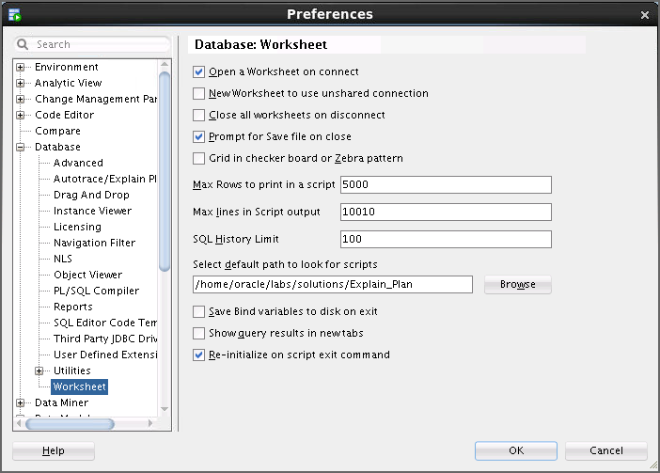/home/oracle/labs/solutions/Explain_Plan directory. Click Select, and then click OK.

* 1. 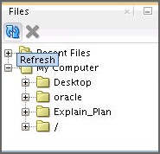In the navigator pane, click the Files tab (if the Files tab is not visible, from the menu, select View > Files). Expand ‘My Computer’. ‘Explain_Plan’ folder is shown. If ‘Explain_Plan’ folder is not shown, select My Computer and click the Refresh button. The default Worksheet directory appears in the list.

1. Display the explain plan for the following query using the hr user:
   1. On the SQL worksheet, enter the following command:

SELECT last_name, job_id, salary, department_name FROM employees, departments

WHERE departments.department_id = employees.department_id;

You may instead open the ep_join.sql script in the

/home/oracle/labs/solutions/Explain_Plan directory.

* 1. Click the Explain Plan button.
  2. Note the explain plan.

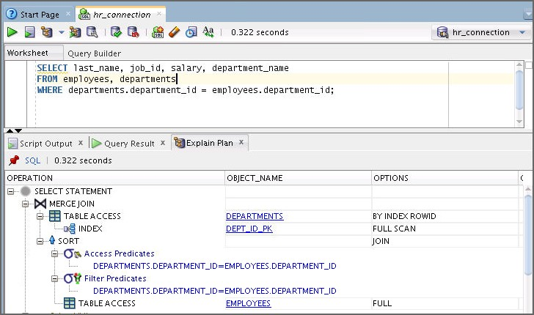

1. Change the query to the following and note the difference in the explain plan. You may instead open the ep_not_exists.sql script.

SELECT last_name,

FROM employees,

job_id,

salary, department_name

departments

WHERE departments.department_id = employees.department_id and not exists

(select * from jobs where employees.salary between min_salary and max_salary);

* 1. On the SQL worksheet, enter the preceding query.
  2. Click the Explain Plan button.
  3. Note the difference in the explain plan.

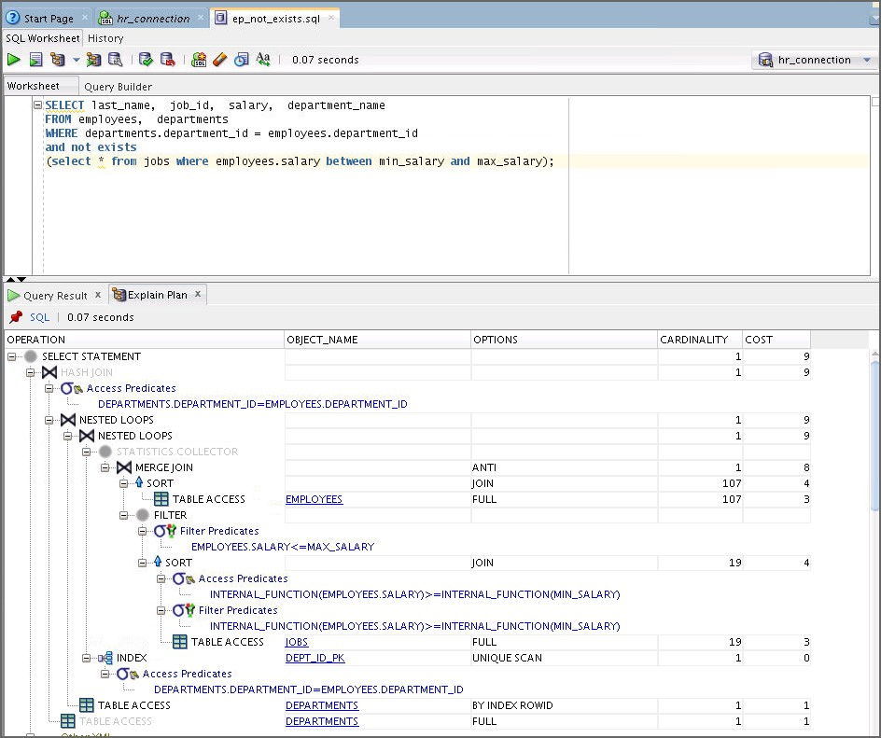

* 1. 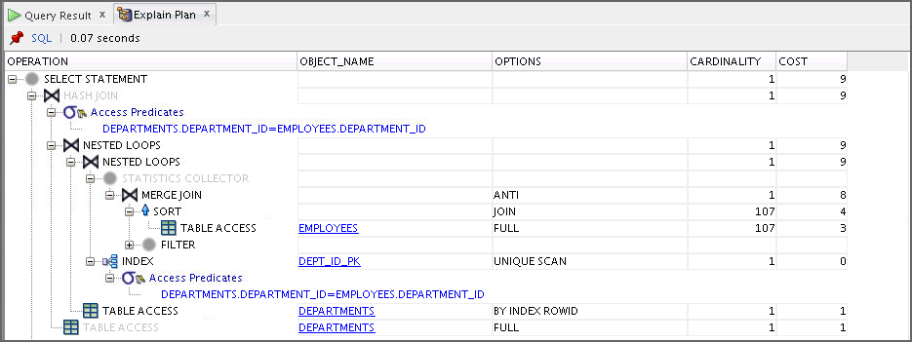Collapse the information about the filters.

1. From sys_connection, grant select_catalog_role and Select Any Dictionary

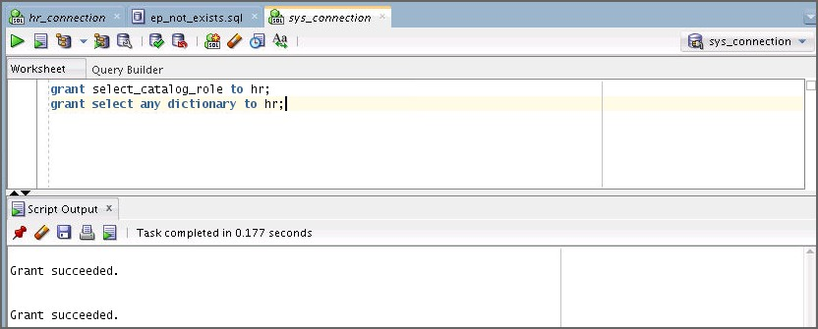to hr.

grant select_catalog_role to hr;

grant select any dictionary to hr;

1. Display Autotrace for the query in the ep_not_exists.sql script.
   1. In the hr connection, click the Autotrace button.
   2. 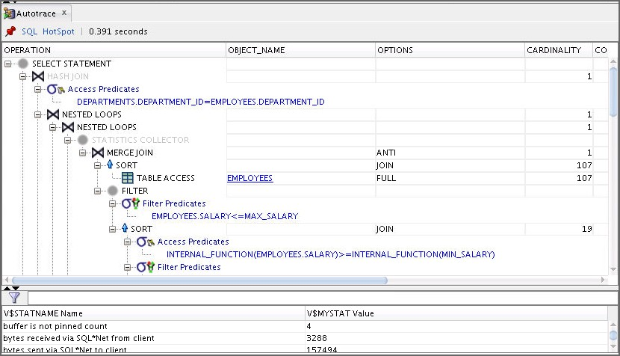Note the Autotrace output tab.

**Task**

Your environment should be initialized with the et_setup.sql script as shown below before starting next activity:

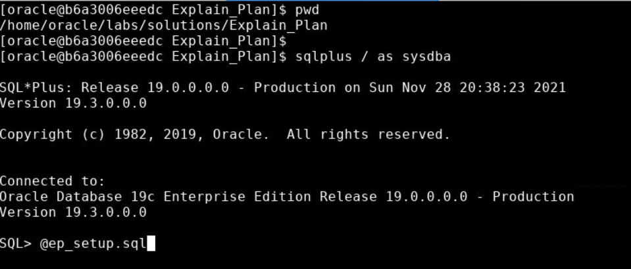

## Practice 5-2: Extracting Execution Plans

In this practice, you use various methods to extract the execution plan used by the optimizer to execute a query. Note that all scripts needed for this practice can be found in your

$HOME/labs/solutions/Explain_Plan directory.

1. Connected as the oracle user from a terminal session, change the working directory to

$HOME/labs/solutions/Explain_Plan, and then execute the ep_startup.sh script. This script initializes the environment for this practice. A user called EP and a table called TEST have already been created that will be used throughout this practice.

**$ cd /home/oracle/labs/solutions/Explain_Plan**

**$ ./ep_startup.sh**

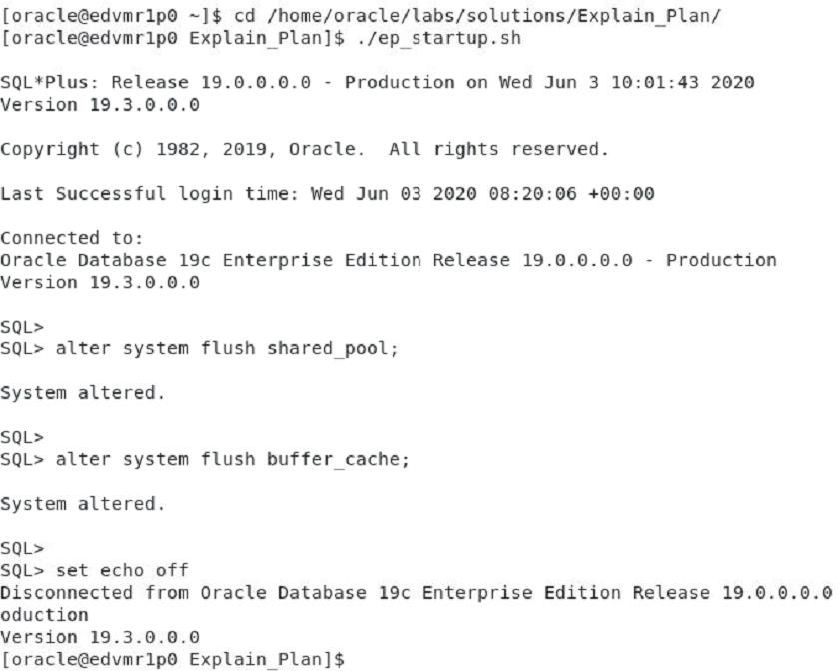

1. From the same terminal session (referred to as session 1 in the rest of this practice), be ready to execute the ep_session_issue.sh script. Enter the command, but do not execute it yet.

Session 1:

$ **./ep_session_issue.sh**

1. From a second terminal session (referred to as session 2 in the rest of this practice), connect as the oracle user. After this, connect to a SQL*Plus session as the SYS user. From this SQL*Plus session, be ready to use SQL Monitoring to monitor the execution plan used by session 1. You can execute the ep_monitor.sql script for this purpose. Enter the command, but do not execute it yet.

**Note:** Ensure that you understand the coordination between both sessions by pre-reading steps 4 and 5 before you continue.

Session 2:

**$ cd /home/oracle/labs/solutions/Explain_Plan**

$ **sqlplus / as sysdba**

**…**

SQL> **alter session set container = orclpdb;**

SQL> **@ep_monitor.sql**

1. After you are ready in both the sessions, press Enter in session 1 to start the execution of the ep_session_issue.sh script.

**Note:** Do not wait. Proceed with the next step immediately.

Session 1:

$ **./ep_session_issue.sh**

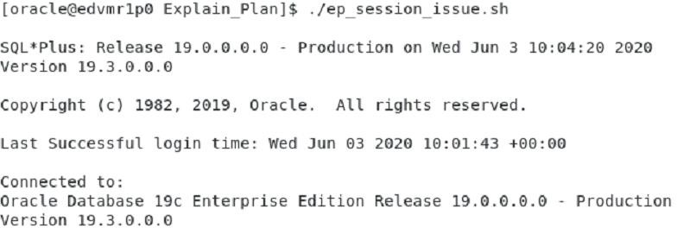

1. In session 2, press the Enter key to start the execution of the ep_monitor.sql script.

After the execution, enter “/” and go back to your SQL*Plus session as many times as necessary until session 1 is finished with its execution. What do you observe?

You can see that session 1 uses NESTED LOOPS on top of two INDEX RANGE SCANS to execute the query. It takes approximately 47 seconds to execute session 1’s query. The time depends on your environment. The big advantage of SQL Monitoring is that you can clearly see which steps in the execution plan take up most of the resources. In this case,

you clearly see that you do only one scan of the index, and that for each row returned, you execute another index scan to probe. This is not really efficient. Also, there is no cost information for this monitored plan.

Session 2:

SQL> **@ep_monitor.sql**

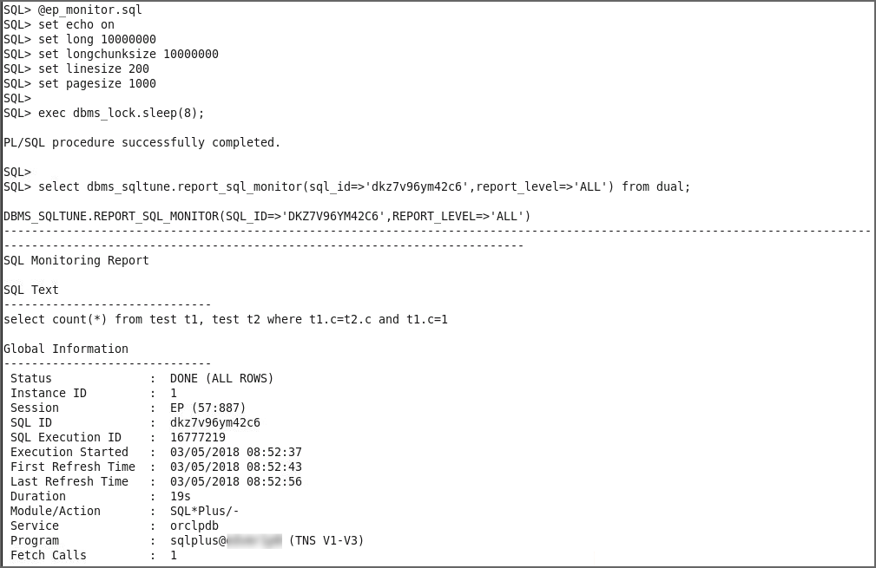

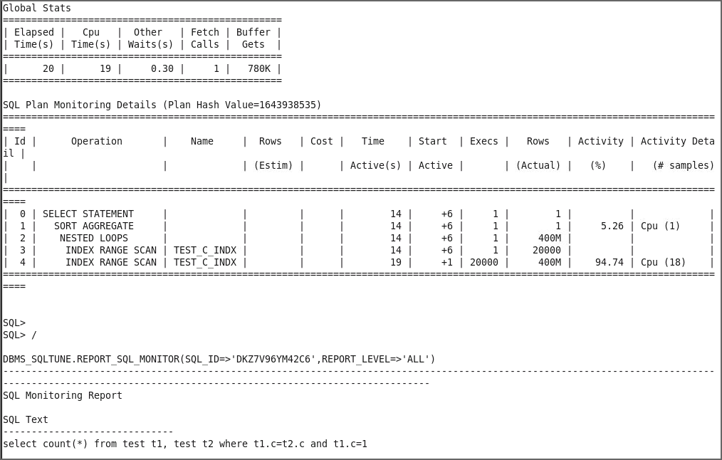

…

After 30–50 seconds (depending on your environment), you should see the following output in your session 1:

Session 1:

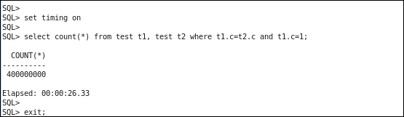

1. From session 1, connect as the EP user in the SQL*Plus session.

Session 1:

$ **sqlplus ep/ep@orclpdb**

…

SQL>

1. Use PLAN_TABLE to determine the execution plan of the query that was executed in step 4. Run the ep_explain.sql script. What do you observe?

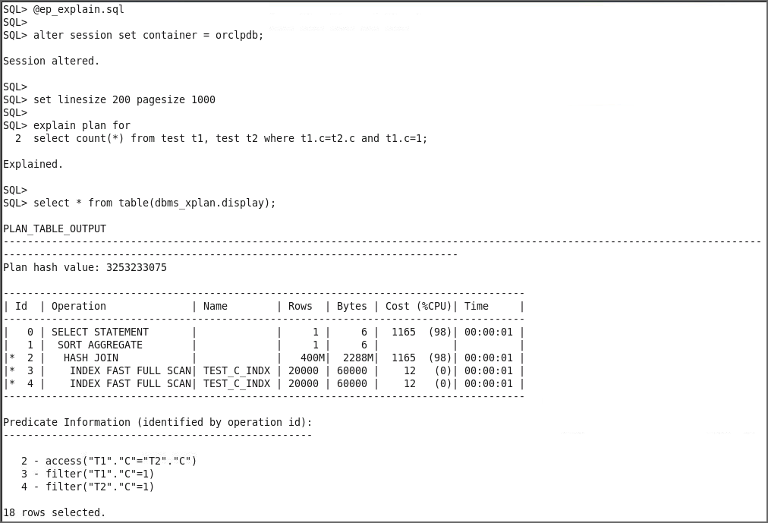This time, the execution plan uses a hash join on top of two index fast full scans.

1. Now, you want to monitor this execution plan that uses a hash join to compare it with the one generated in step 4. In addition, you want to make sure that you use the correct plan this time. So, in your session 1, start Autotrace and be ready to execute the following query. Do not execute it yet because you need to start SQL Monitoring in your session 2:

Session 1:

SQL> **set autotrace on**

SQL> **@ep_execute**

1. From your session 2, be ready to execute the SQL Monitoring command again. Do not execute it yet, though.

Session 2:

SQL> **@ep_monitor.sql**

1. Start the execution of your query from session 1 by pressing Enter.

**Note:** Move to the next step without waiting.

Session 1:

SQL> **@ep_execute**

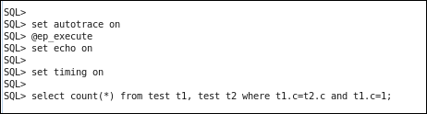

1. From session 2, start monitoring your query by pressing Enter. After the query is executed, enter “/” and go back to your SQL*Plus session as many times as necessary until session 1 is finished with its execution. What do you observe?

You can see that the optimizer uses a hash join on top of two index fast full scans. Looking at the various reports, you can clearly see how the optimizer processes a hash join by reading the driving index in memory first. This operation is quick. Though you cannot see it run, it is already done the first time you look at it. Then the probe is performed on the index again. This operation takes more time. Also, note that cost information is provided in the execution plan.

Session 2:

SQL> **@ep_monitor.sql**

SQL> set echo on

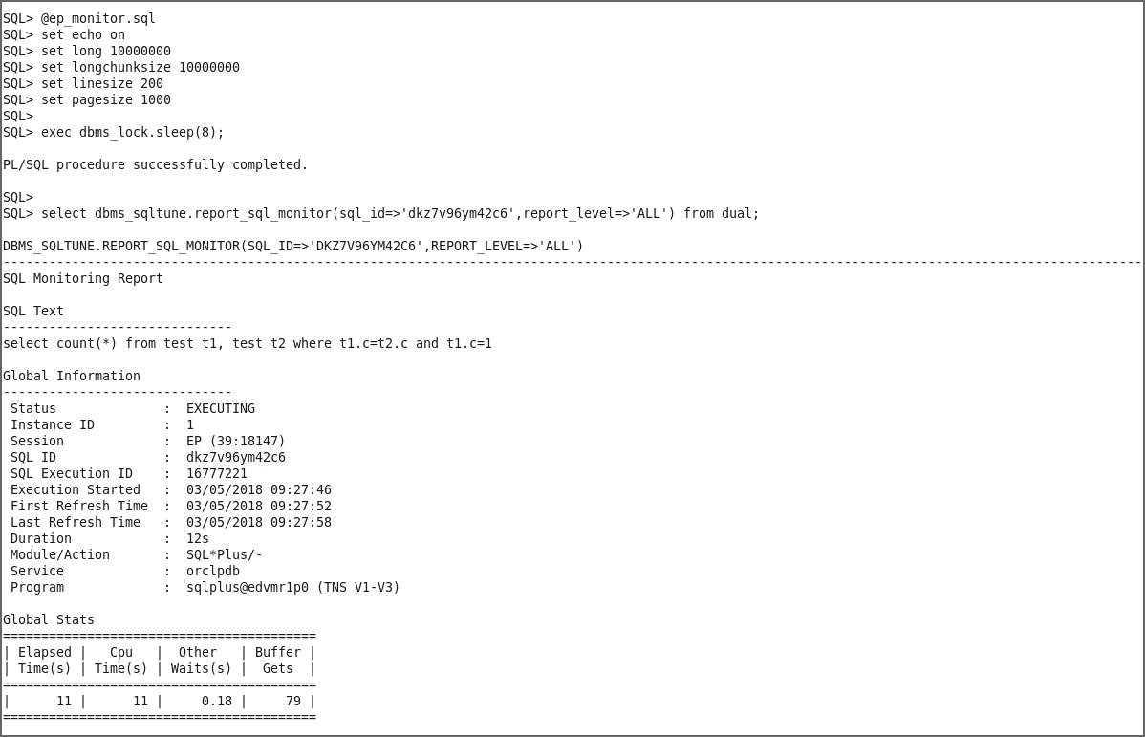

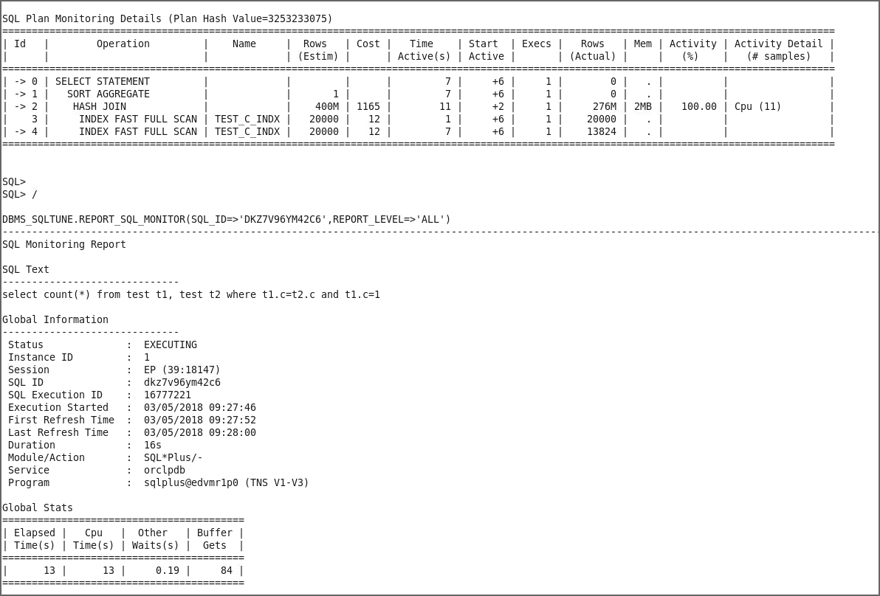

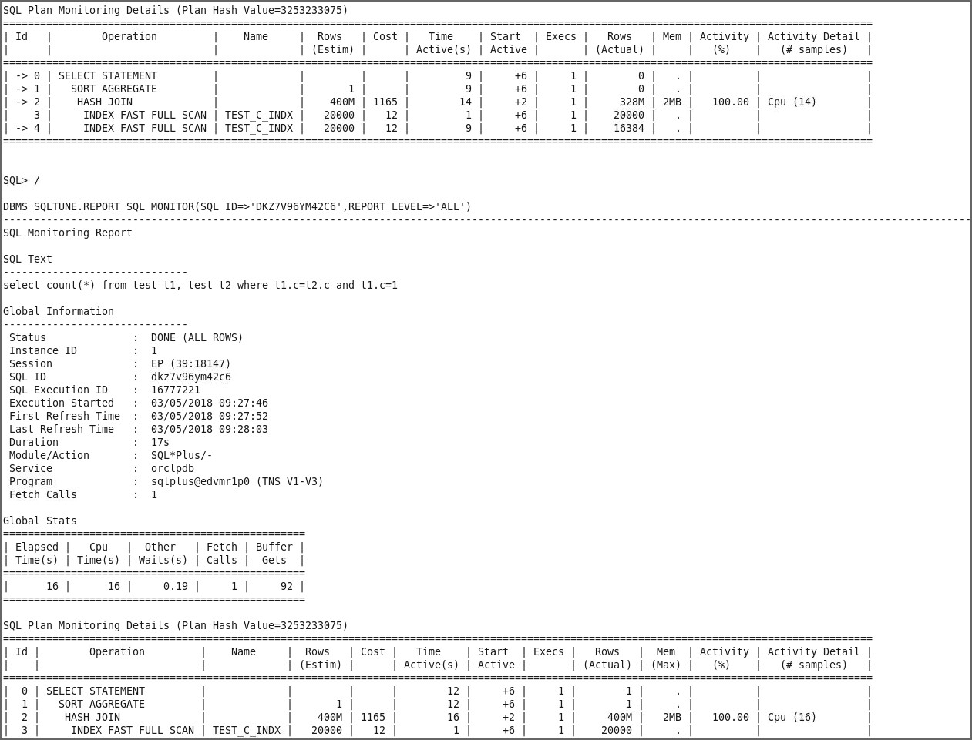

1. When your query is executed, what do you observe in your session 1?

Session 1 also reports the same execution plan as the one you observed in session 2.

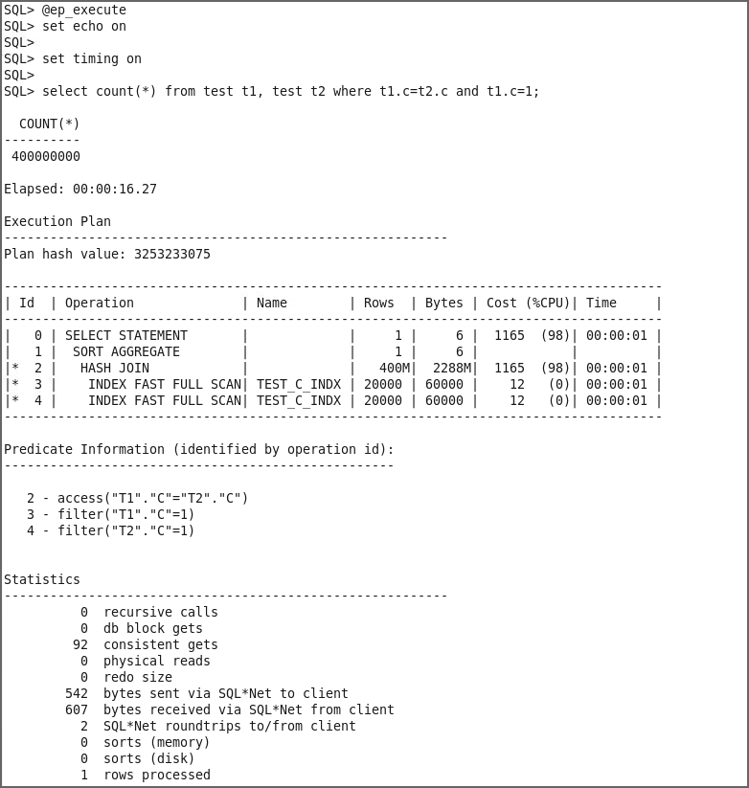

1. In session 1, disable Autotrace.

Session 1:

SQL> **set autotrace off**

SQL>

1. 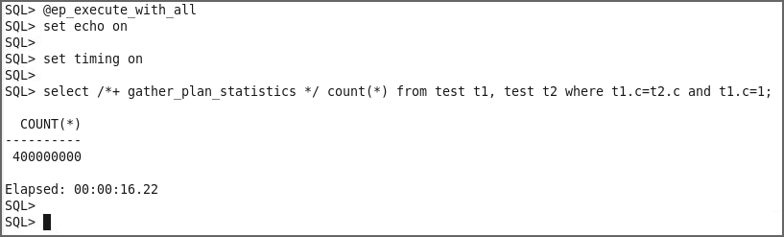From session 1, how can you ensure that you gather all execution plan statistics for the following query without changing any session parameters? Implement your solution.

Select /*+ gather_plan_statistics */ count(*) from test t1, test t2 where t1.c=t2.c and t1.c=1;

Session 1:

SQL> **@ep_execute_with_all**

1. From session 1, retrieve all execution plans corresponding to all the queries that you executed since the beginning of this practice. What is your conclusion?
   1. The easiest way to find all the plans is to look at the content of the SGA by using the dbms_xplan.display_cursor function. First, you must determine the SQL_IDs used to represent your queries. You essentially have two queries, and one that has two children. You should now understand what happened in step 4. There was no cost information due to the use of the rule-based optimizer instead of the cost-based one.

Session 1:

SQL> **@ep_retrieve_all_plans**

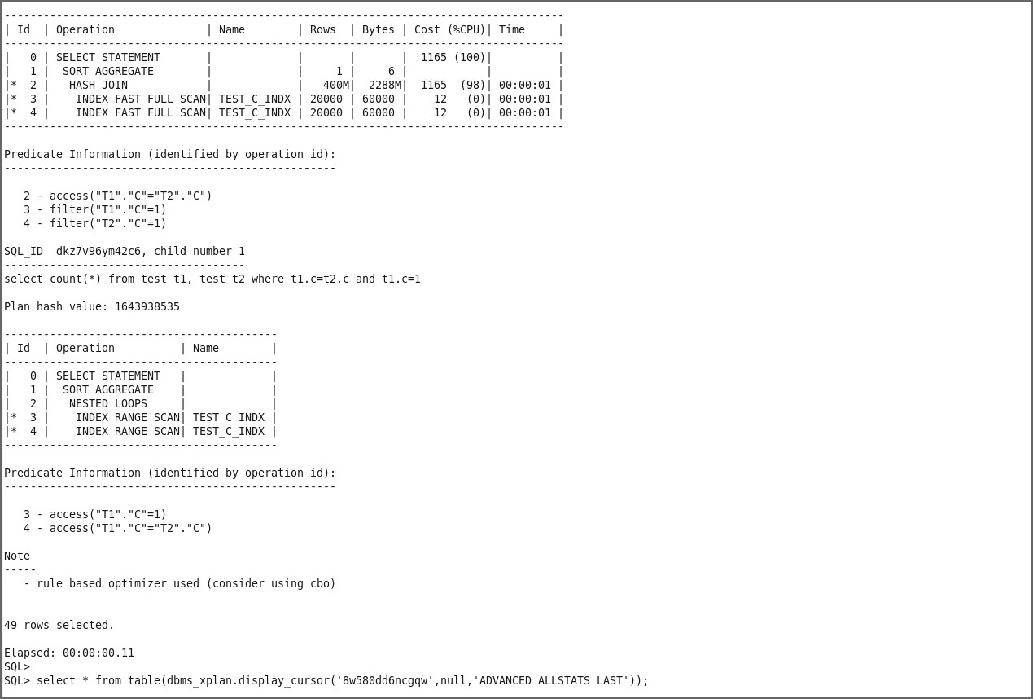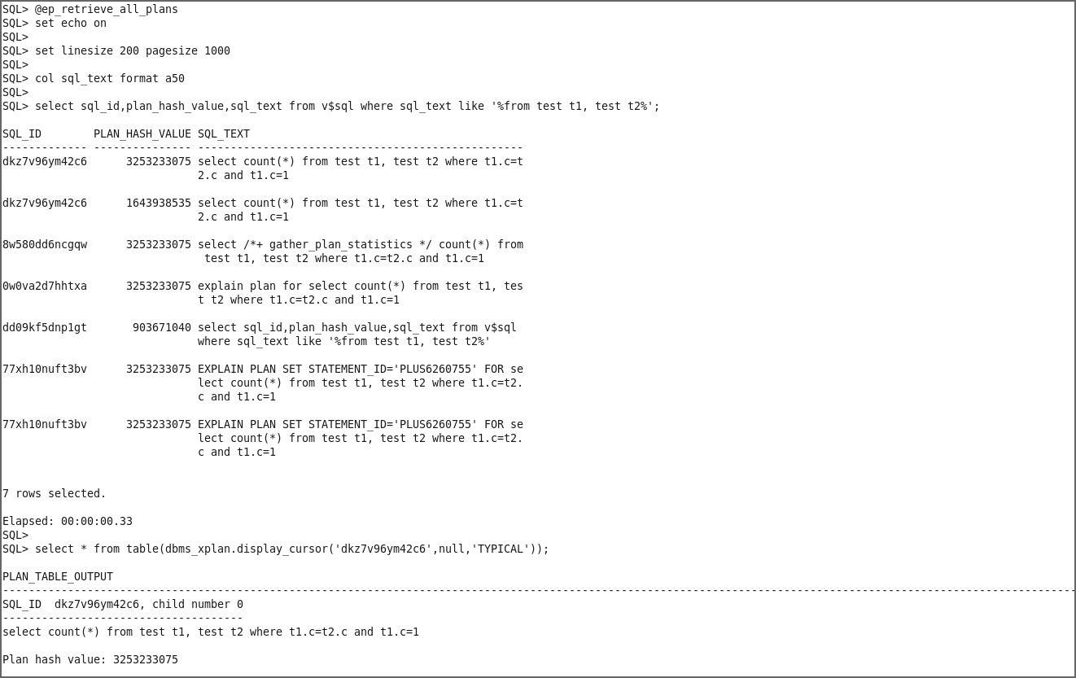

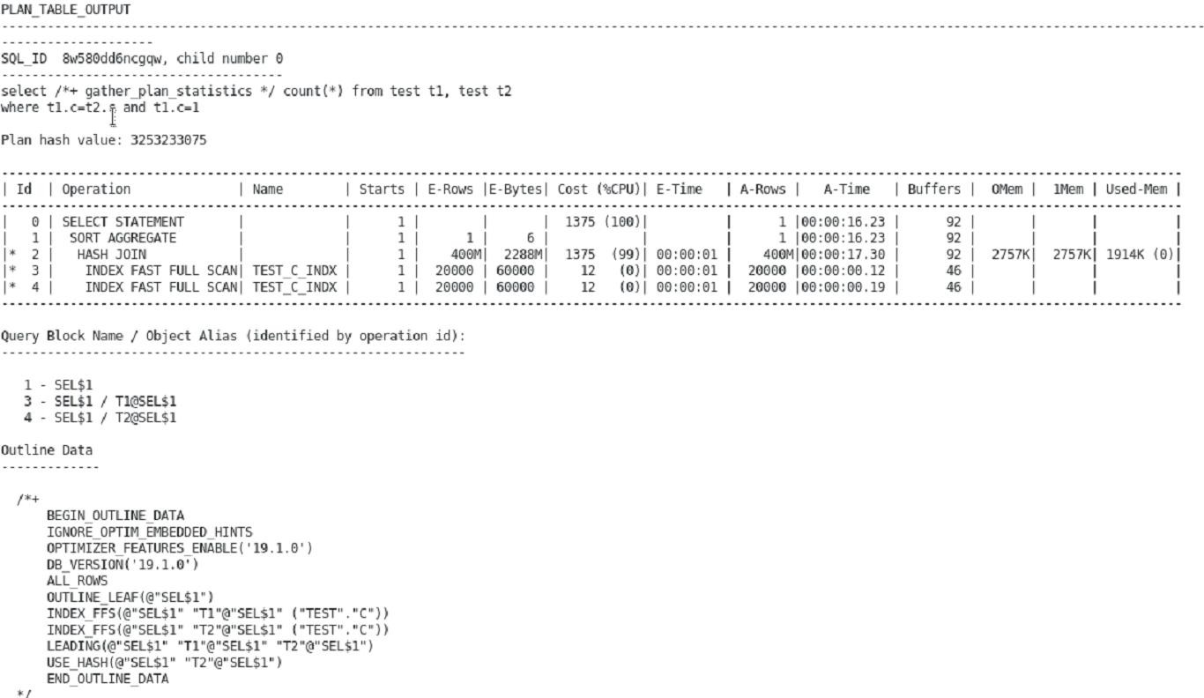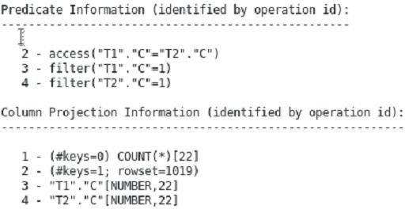

1. From session 1, try to retrieve your execution plans from the Automatic Workload Repository. What happens and why?
   1. You can use the previously found SQL_IDs to search through the DBA_HIST_SQLTEXT view. You should see that right now, none of your queries are stored in AWR.

**Note:** It is possible that a snapshot was taken during this practice. If so, some or all of your queries are stored in AWR.

Session 1:

SQL> **@ep_retrieve_awr**

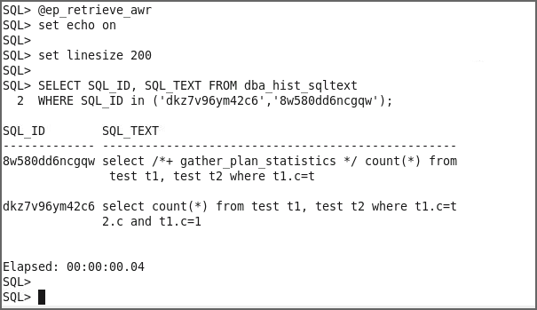

1. How can you ensure that you retrieve your queries from the Automatic Workload Repository? Implement your solution.
   1. You must flush the SGA information to AWR. You can use

DBMS_WORKLOAD_REPOSITORY.CREATE_SNAPSHOT for this purpose.

Session 1:

SQL> **@ep_save_awr**

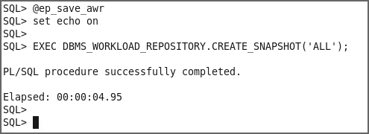

1. Verify that your solution works.

Session 1:

SQL> **@ep_show_awr**

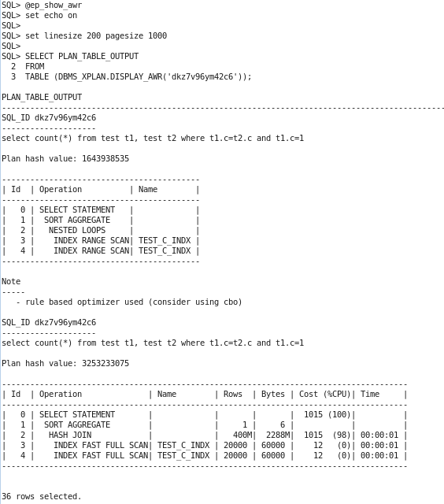

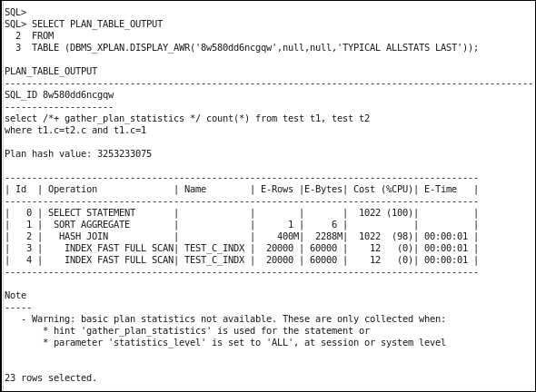

1. Exit from both SQL*Plus sessions.

Session 1:

SQL> **exit**

Disconnected …

$

Do not forget to exit from session 2:

Session 2:

SQL> **exit**

Disconnected …

$

# Practices for Lesson 6: Interpreting Execution Plans and Enhancements

## Practices for Lesson 6: Overview

### Overview

This practice covers the dynamic plans part of the Adaptive Execution Plans feature in Oracle Database 19c.

## Practice 6-1: Using Dynamic Plans

### Overview

In this practice, you use the dynamic plans part of the Adaptive Execution Plans feature.

#### Tasks

1. Start SQL*Plus as SYS.

$ **sqlplus / as sysdba**

$ **alter session set container = orclpdb;**

1. Grant the SELECT ANY DICTIONARY privilege to OE.

grant select any dictionary to oe;

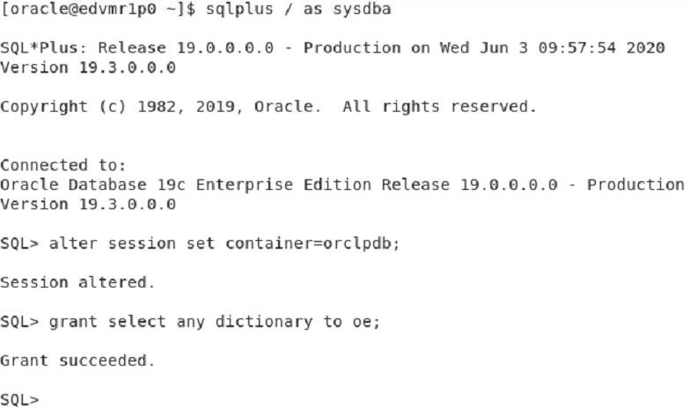

1. From the same SQL*Plus session, connect as the OE user and show the execution plan of the following query without executing it:

**SQL>** conn oe/oe@orclpdb

select /*+ monitor*/ product_name

from order_items o, product_information p where o.unit_price = 15

and quantity > 1

and p.product_id = o.product_id;

* 1. Connect as oe with oe as the password.
  2. Execute the following query:

EXPLAIN PLAN FOR

select /*+ monitor*/ product_name

from order_items o, product_information p where o.unit_price = 15

and quantity > 1

and p.product_id = o.product_id;

SQL> set linesize 132

SQL> select * from table(dbms_xplan.display());

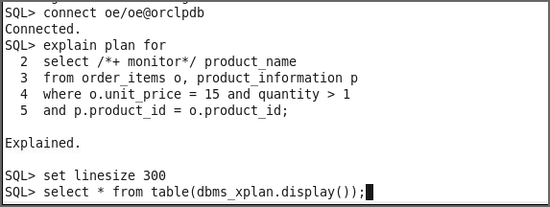

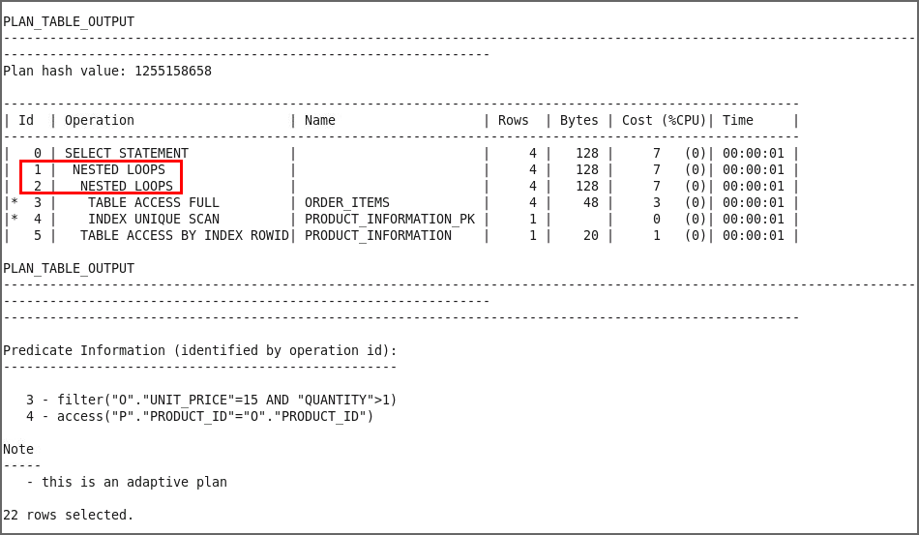

1. What do you observe?

The plan is using a simple NESTED LOOPS join.

1. 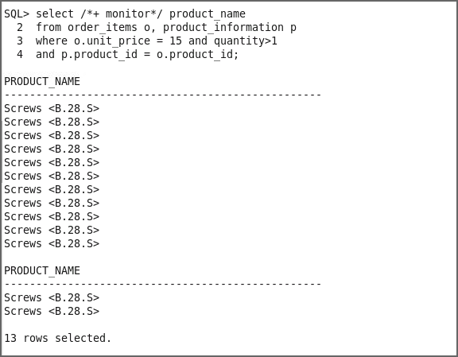Now, execute the same query, as follows:

select /*+ monitor*/ product_name

from order_items o, product_information p where o.unit_price = 15

and quantity > 1

and p.product_id = o.product_id;

1. Show the resulting execution plan by using the following command:

**select * from table(dbms_xplan.display_cursor());**

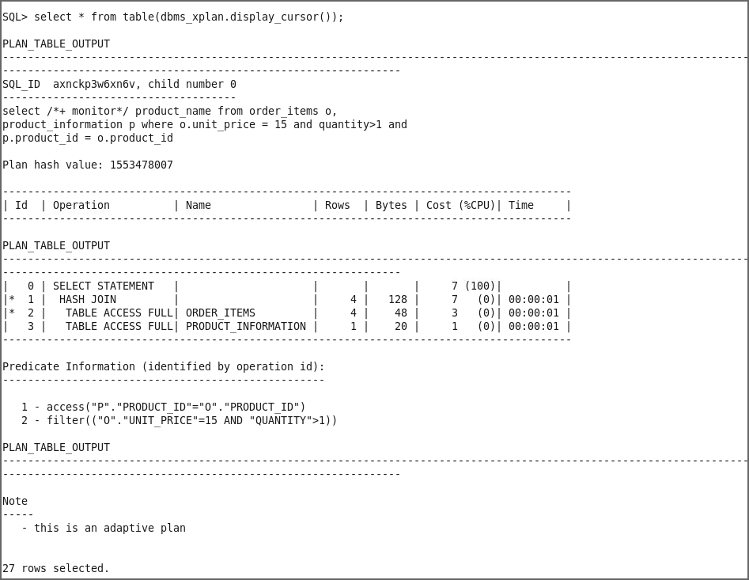

1. What do you observe and conclude?

**Answer:** The actual plan used at execution was a HASH_JOIN. Why did the plan change?

The plan changed because the optimizer realized during execution that the number of rows actually returned from the order_items table was much larger than expected. Multiple single-column predicates on the order_items table caused the initial cardinality estimate to be incorrect. The mis-estimation cannot be corrected by extended statistics because one of the predicates is a non-equality predicate.

1. How would you confirm whether the plan change was caused by dynamic plans? By looking in V$SQL and checking the value of the new column IS_RESOLVED_ADAPTIVE_PLAN

SQL> **column sql_text format a30**

SQL> **select sql_id, sql_text, is_resolved_adaptive_plan from v$sql**

**where sql_text like 'select /*+ monitor*/ product_name%';**

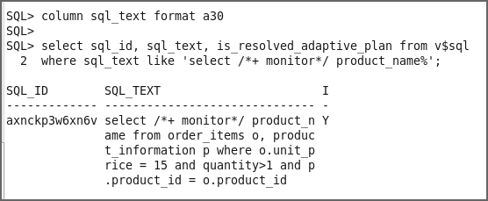

# Practices for Lesson 7: Optimizer: Table and Index Access Paths

## Practices for Lesson 7: Overview

### Practices Overview

In these practices, you will examine the access paths chosen by the optimizer for 12 different cases of table and index access.

### List of Cases:

* Case 1: With and Without Index
* Case 2: Compare Single Column Index Access
* Case 3: Concatenated Index
* Case 4: Bitmap Index Access
* Case 5: Complex Predicate with Bitmap Indexes
* Case 6: Index Only Access
* Case 7: Index Join
* Case 8: Bitmap Index Only Access
* Case 9: B*-Tree Index Only Access
* Case 10: Function Based Index
* Case 11: Index Organized Table
* Case 12: Index Skip Scan

## Practice 7-1: Using Different Access Paths

### Overview

In this practice, you explore various access paths that the optimizer can use, and compare them. You have the possibility of exploring 12 different scenarios, each of which is self- contained. All the scripts needed for this practice can be found in the

$HOME/labs/solutions/Access_Paths directory. It is helpful to set the worksheet preferences to use /home/oracle/labs/solutions/Access_Paths as the default lookup path for scripts.

### Tasks

#### Case 1: With and Without Index

* 1. Start SQLDeveloper.
  2. Use the SQL Developer Files tab and open the

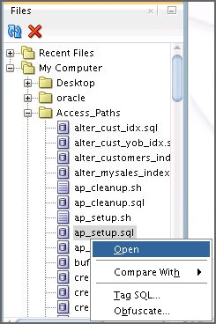$HOME/labs/solutions/Access_Paths/ap_setup.sql script.

* 1. Select sys_connection.

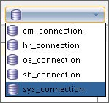

* 1. Execute the script (F5).

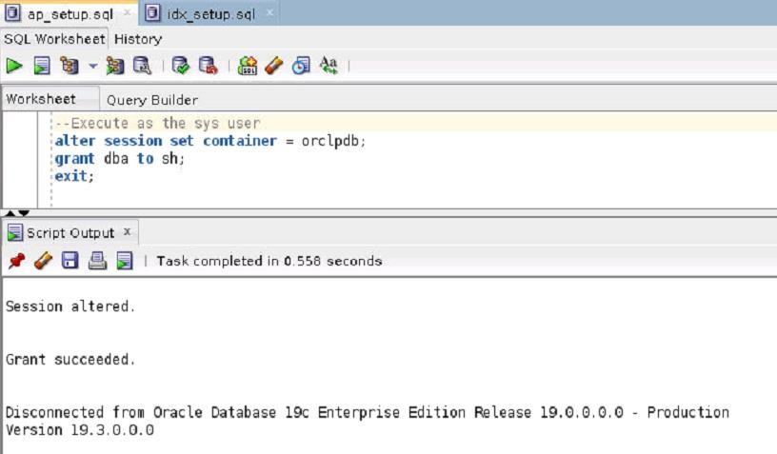

1. Open idx_setup.sql and execute it with sh_connection.

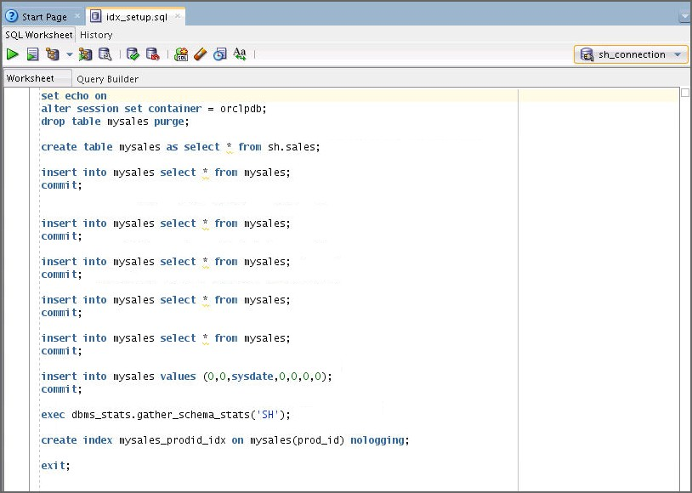

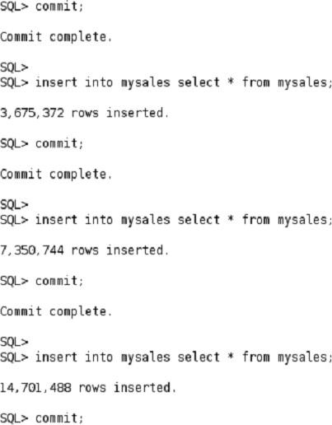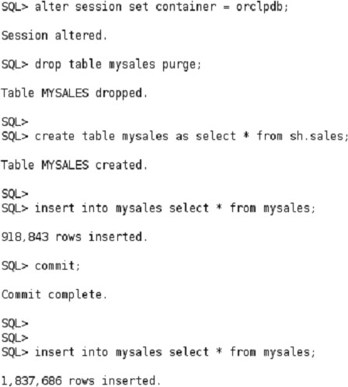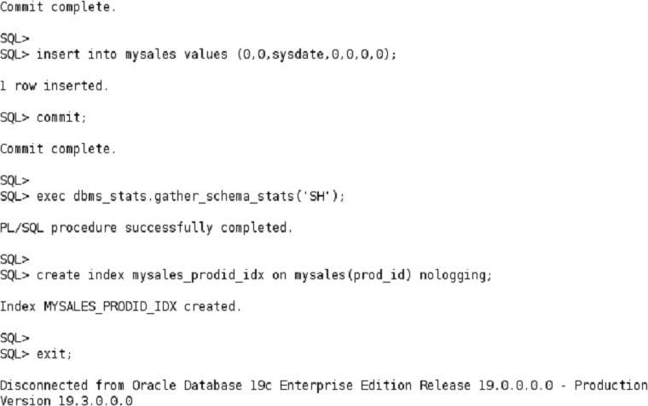

1. What do you observe when you execute the following query in the sh_connection

worksheet?

* 1. 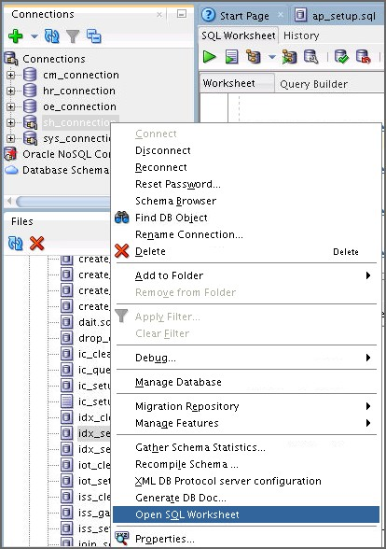Right-click sh_connection and select Open SQL Worksheet.
  2. Drop any indexes available on prod_id column of the MYSALES table.

DROP INDEX mysales_prodid_idx;

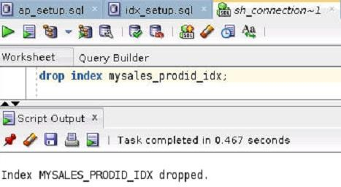

* 1. Autotrace the query.

select * from mysales where prod_id=0;

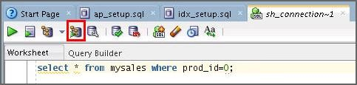

* 1. 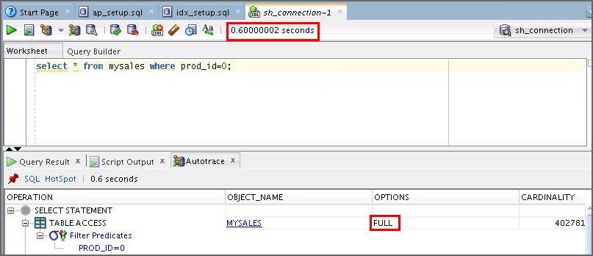Observe the output.
     + Basically, there are no indexes on the MYSALES table.
     + The only possibility for the optimizer is to use a full table scan to retrieve only one row. You can see that the full table scan takes a long time.

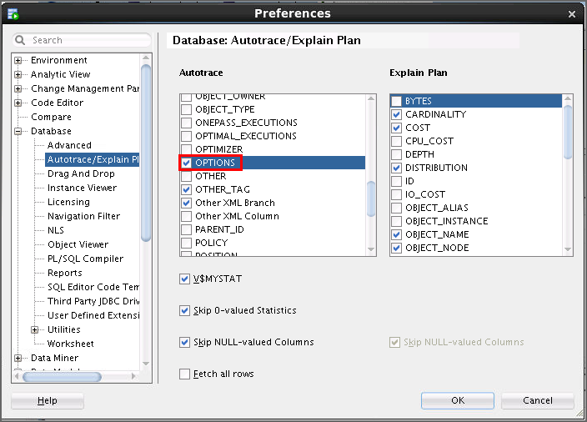**Note:** To see the options as a separate column in the execution plan, go to **Tools > Preferences > Database > Autotrace/Explain Plan** and select the **Options** check box under **Autotrace**. If you do not select the Options check box, the options will be attached to the Operations column in the plan.

1. To enhance the performance of the query in step 3, re-execute the query in step 3(b) after executing create_mysales_index.sql.
   1. Open the create_mysales_index.sql file and execute it with sh_connection.

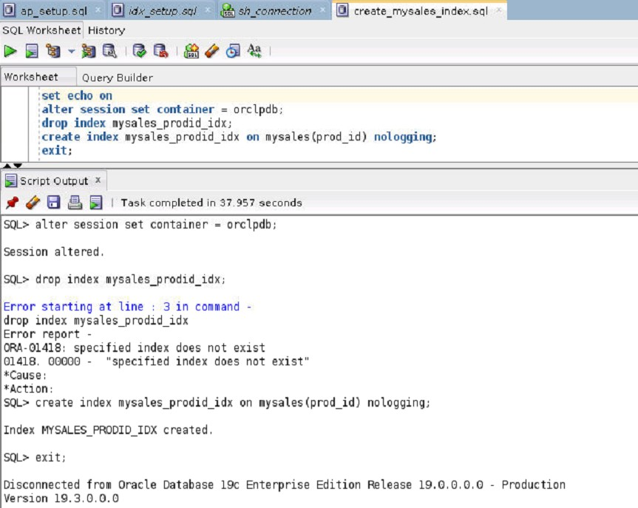

* 1. Autotrace the query in step 3(b) again. Observe the output.

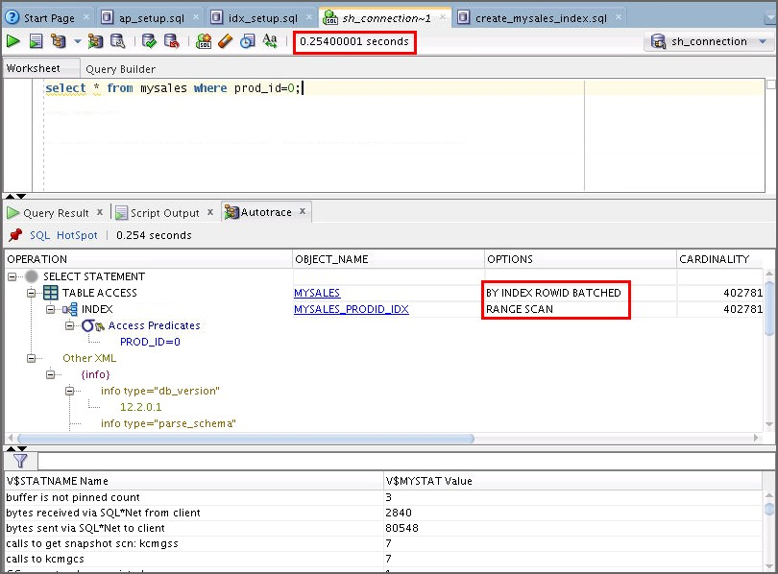

* + - You can see a dramatic improvement in performance. Notice the difference in time, cost, and physical reads.

1. Clean up your environment for case 1 by executing the idx_cleanup.sql script.

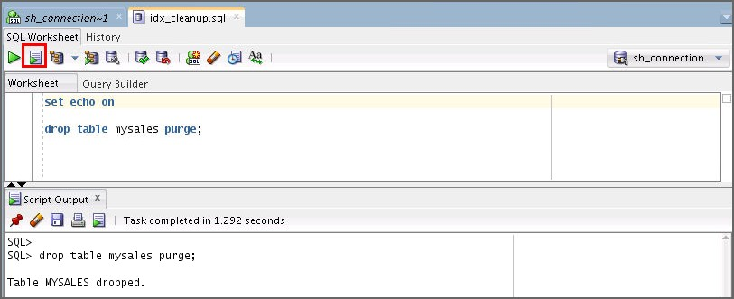

1. **Case 2: Compare Single Column Index Access:** Open a terminal window. Connect to sh and drop all the indexes that are currently created on the CUSTOMERS table, except its primary key index, by executing drop_customers_indexes.sql.

$ **cd /home/oracle/labs/solutions/Access_Paths/**

$ **sqlplus sh/sh@orclpdb**

…

Connected to:…

SQL> **@drop_customers_indexes.sql**

1. 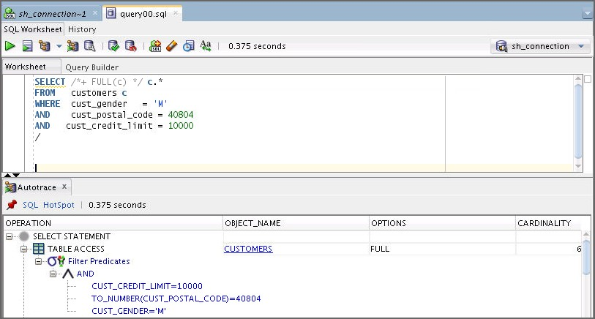Autotrace the query in query00.sql. What do you observe?
2. Create three B*-tree indexes on the following CUSTOMERS table columns by using

sh_connection: cust_gender cust_postal_code cust_credit_limit

* 1. 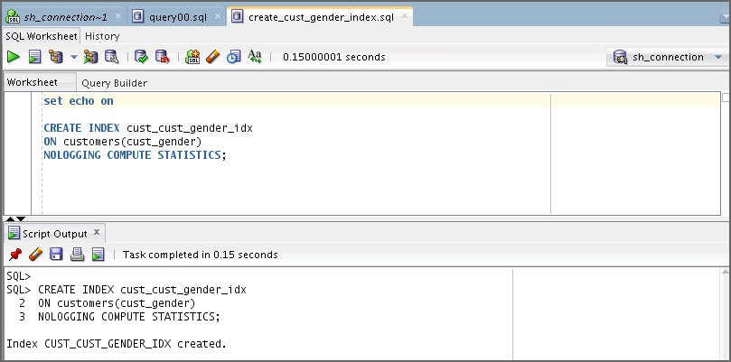Open and execute the create_cust_gender_index.sql script.
  2. Open and execute the create_cust_postal_code_index.sql script.

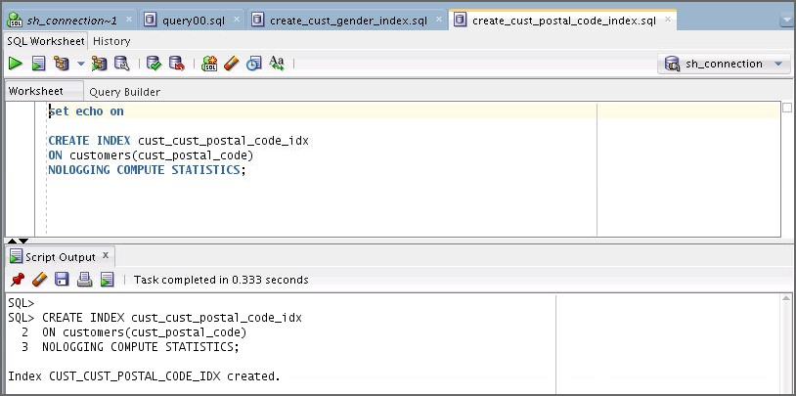

* 1. 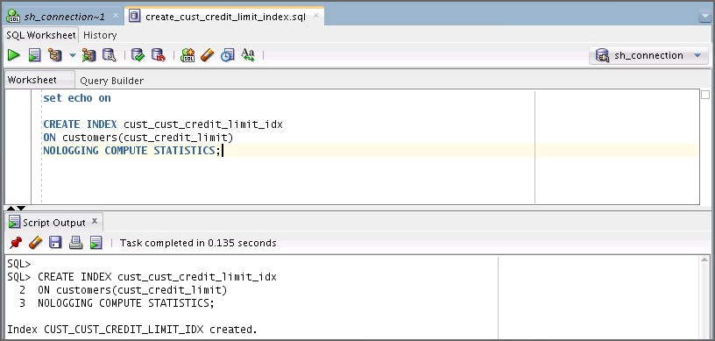Open and execute the create_cust_credit_limit_index.sql script.
  2. To verify that the indexes exist, execute list_customers_indexes.sql.

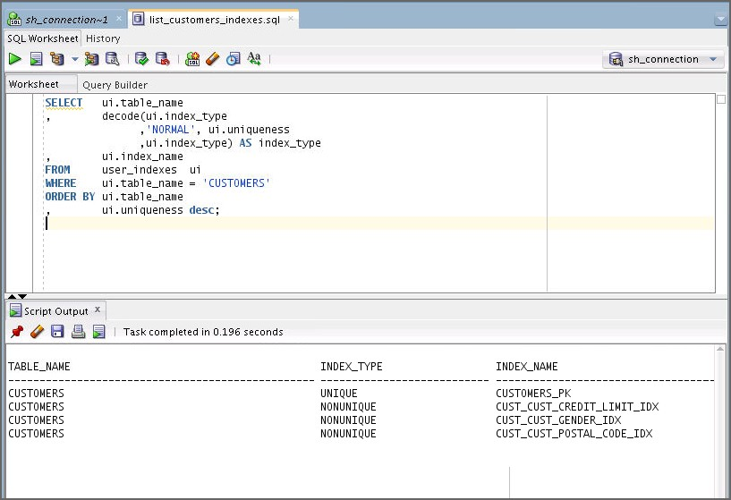

1. Start monitoring all the CUSTOMERS indexes. Notice that the value in the USED column is NO.
   1. Open and execute the start_monitoring_indexes.sql script by using

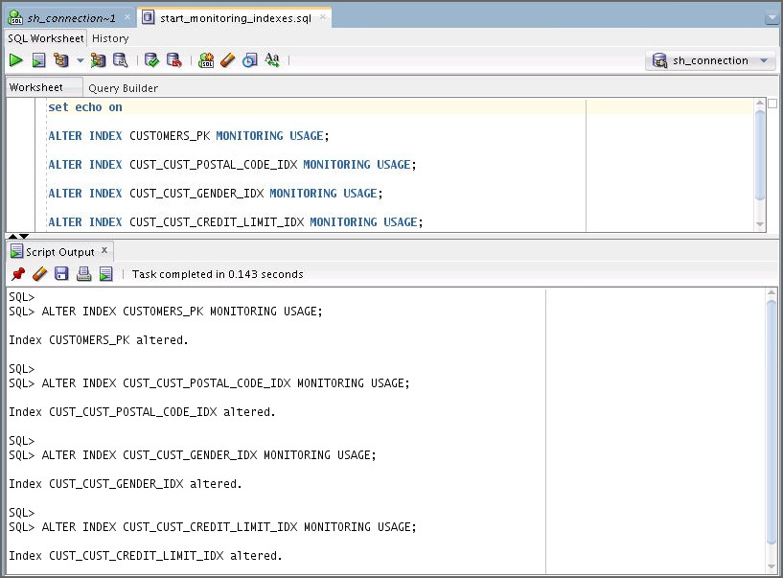sh_connection.

* 1. Open and execute the statement (Ctrl + Enter) in the show_index_usage.sql

script.

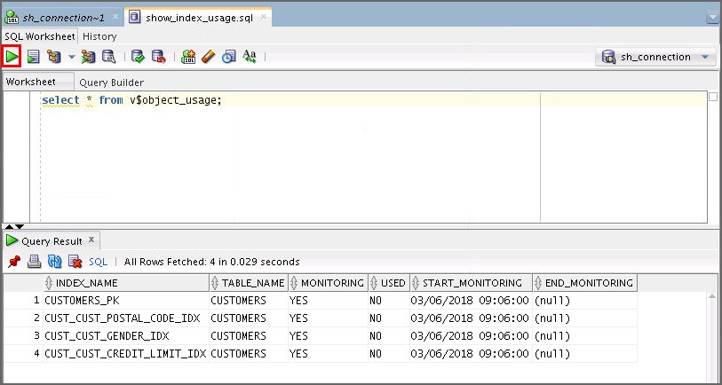

1. Autotrace the query in query01.sql. What do you observe?

SELECT /*+ INDEX(c) */ c.*

FROM WHERE AND AND

/

customers c

cust_gender

= 'M'

cust_postal_code = 40804

cust_credit_limit = 10000

**Hint:** Check the estimated cost in the execution plan and the sum of db block gets and consistent gets in the statistics.

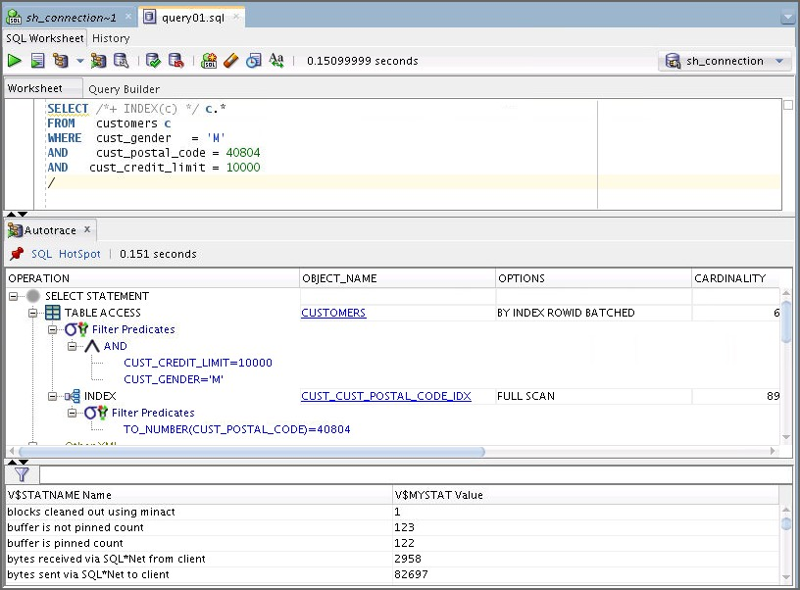

* The optimizer chooses to use only one index to do a full scan. The cost is lower than the full table scan.

1. Autotrace the query in query02.sql by using sh_connection. What do you observe?

SELECT /*+ INDEX_COMBINE(c) */ c.*

FROM WHERE AND

AND

customers c

cust_gender

= 'M'

cust_postal_code = 40804

cust_credit_limit = 10000;

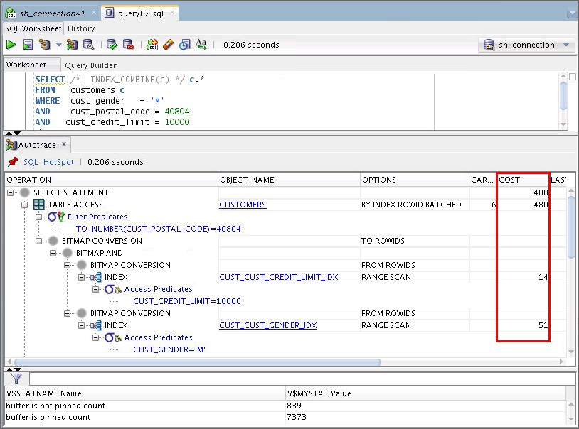

* This time the optimizer uses multiple indexes and combines them to access the table. However, the cost is higher than that from the previous step, but is still lower than the full table scan.

1. 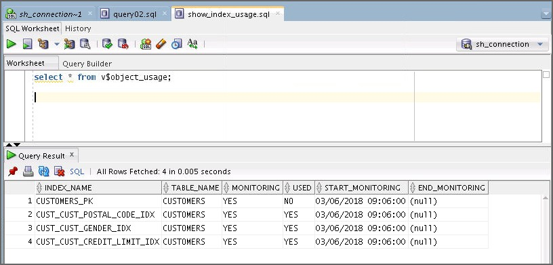Execute show_index_usage.sql to confirm the list of indexes that were accessed in this case.
2. **Case 3: Concatenated Index:** Open a terminal window. Connect to sh and drop all the indexes that are currently created on the CUSTOMERS table, except its primary key index, by executing drop_customers_indexes.sql.

$ **cd /home/oracle/labs/solutions/Access_Paths/**

$ **sqlplus sh/sh@orclpdb**

…

Connected to:…

SQL> **@drop_customers_indexes.sql**

1. Open and execute the create_gender_limit_code_index.sql script by using sh_connection to make sure that you create a concatenated index on the following CUSTOMERS columns, and in the order mentioned here:

cust_gender cust_credit_limit cust_postal_code

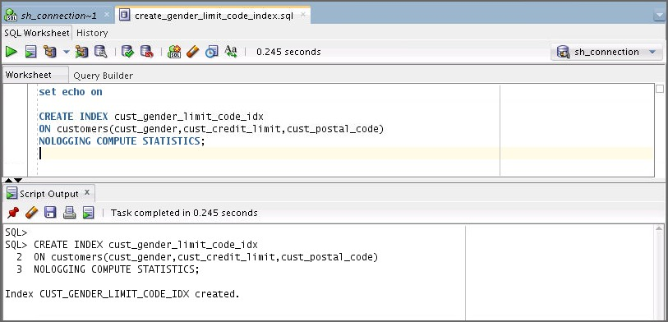

1. 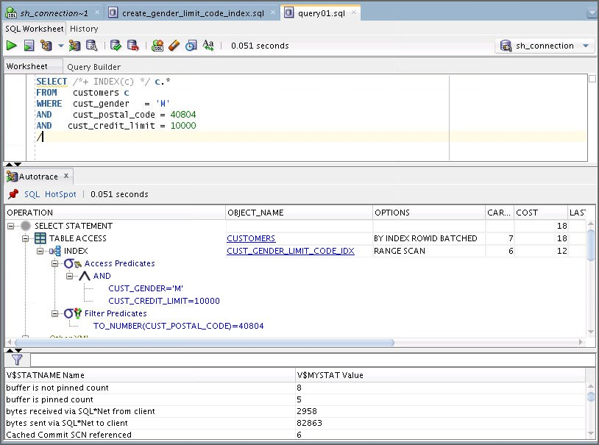Autotrace the query in query01.sql. What do you observe?

* The optimizer uses your concatenated index and the resulting cost is by far the best compared to the preceding steps.

1. 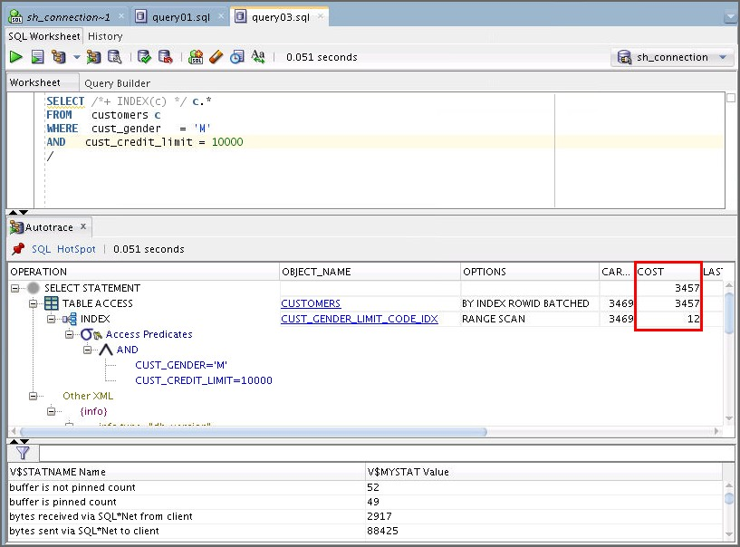Autotrace the query in query03.sql. What do you observe?

* The query is almost the same as in the previous step, but the predicate on cust_postal_code is removed. The optimizer can still use the concatenated index, but the resulting cost is much higher because neither cust_credit_limit nor cust_gender are very selective.

1. 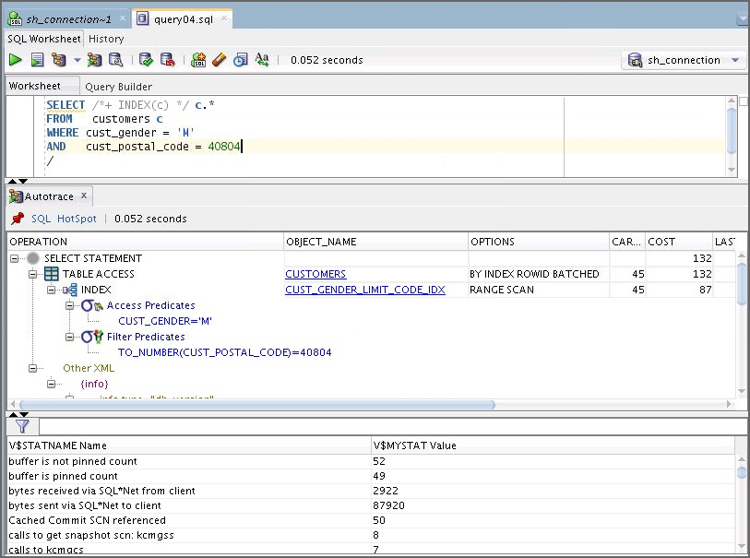Autotrace the query in query04.sql. What do you observe?

* You replaced cust_credit_limit with cust_postal_code, which has better selectivity. The index is used, and the resulting cost is better.

1. Autotrace the query in query05.sql. What do you observe?

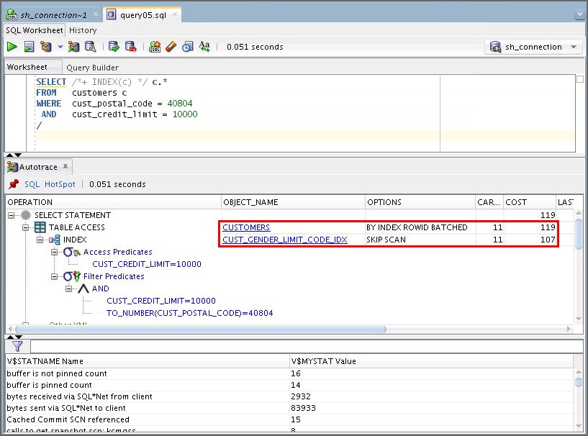

* The leading part of the concatenated index is no longer part of the query. However, the optimizer is still able to use the index by doing an index skip scan.

1. **Case 4: Bitmap Index Access:** Open a terminal window. Connect to sh and drop all the indexes that are currently created on the CUSTOMERS table, except its primary key index, by executing drop_customers_indexes.sql.

$ **cd /home/oracle/labs/solutions/Access_Paths/**

$ **sqlplus sh/sh@orclpdb**

…

Connected to:…

SQL> **@drop_customers_indexes.sql**

1. Open and execute three scripts by using sh_connection to create three different bitmap indexes on the following columns of the CUSTOMERS table:

cust_gender (create_cust_gender_bindex.sql) cust_postal_code (create_cust_postal_code_bindex.sql) cust_credit_limit (create_cust_credit_limit_bindex.sql)

* 1. 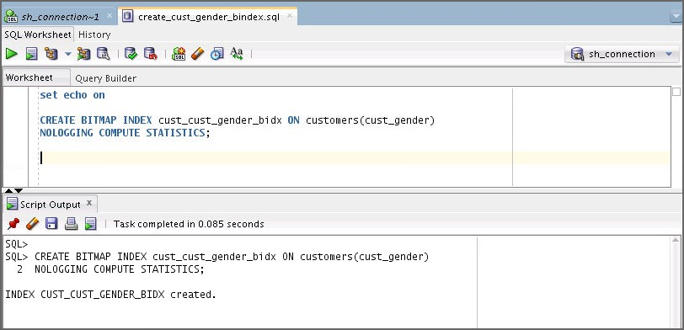Open and execute the create_cust_gender_bindex.sql script.
  2. Open and execute the create_cust_postal_code_bindex.sql script.

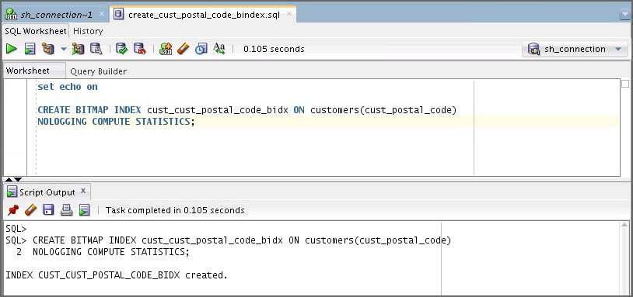

* 1. 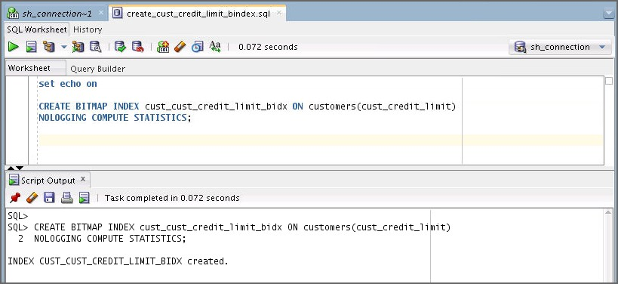Open and execute the create_cust_credit_limit_bindex.sql script.
  2. Confirm that the indexes have been created by executing the statement in the

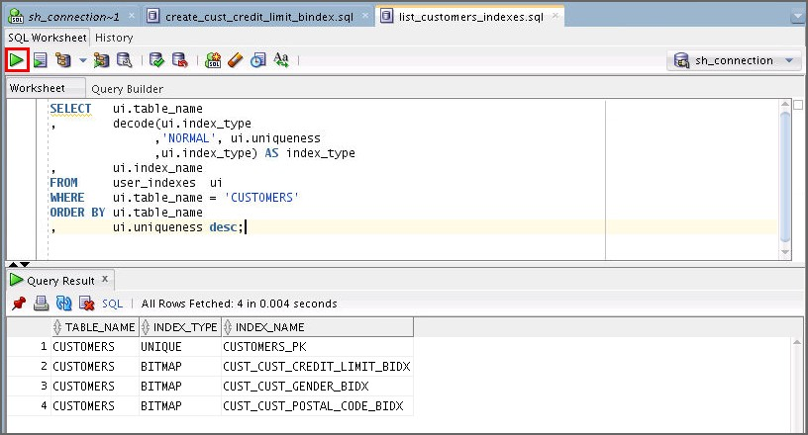list_customers_indexes.sql script.

1. 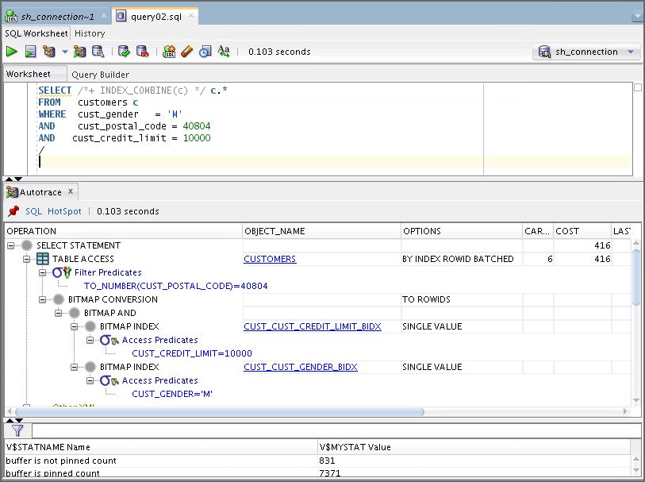Autotrace the query in query02.sql. What do you observe?

* The optimizer uses only two bitmap indexes to solve this query. However, the cost is not good. The cost is a little lower than the cost of the full table scan.

1. **Case 5: Complex Predicate with Bitmap Indexes:** Open a terminal window. Connect to sh and drop all the indexes that are currently created on the CUSTOMERS table, except its primary key index, by executing drop_customers_indexes.sql.

$ **cd /home/oracle/labs/solutions/Access_Paths/**

$ **sqlplus sh/sh@orclpdb**

…

Connected to:…

SQL> **@drop_customers_indexes.sql**

1. After this, create two bitmap indexes on the following columns of the CUSTOMERS table: cust_year_of_birth (create_cust_year_of_birth_bindex.sql) cust_credit_limit (create_cust_credit_limit_bindex.sql)
   1. Open and execute the create_cust_year_of_birth_bindex.sql script.

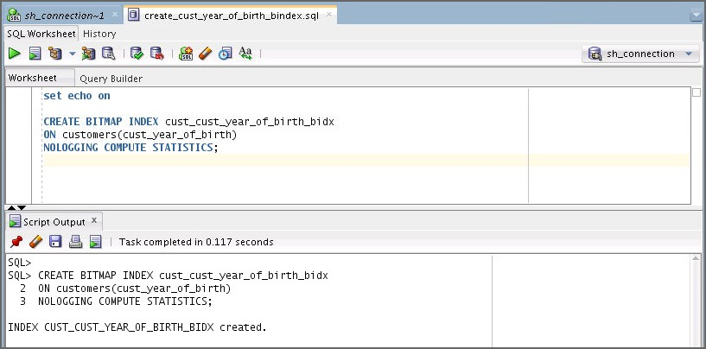

* 1. Open and execute the create_cust_credit_limit_bindex.sql script.

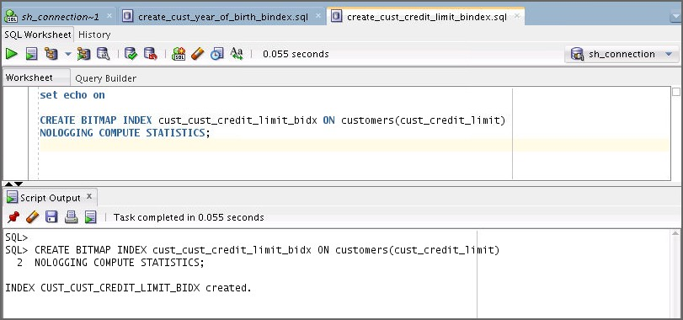

1. 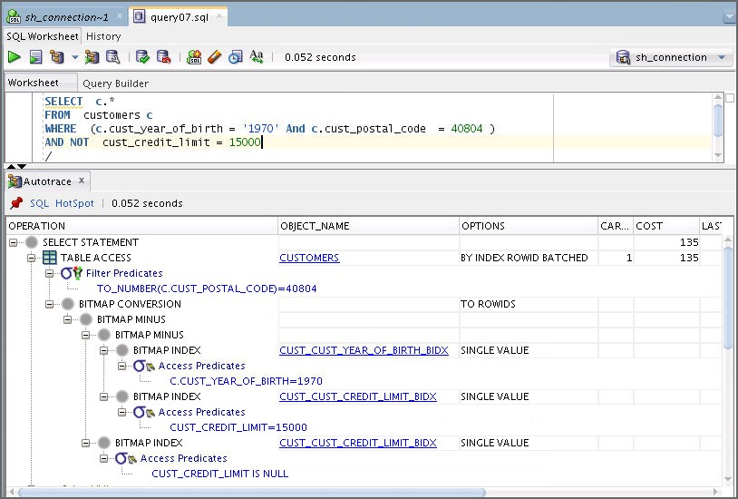Autotrace the query in query07.sql. What do you observe?

* The query has a complex WHERE clause that is well suited for using bitmap indexes. The optimizer uses two bitmap indexes and the resulting cost is better than the full table scan cost.

1. Make sure that the optimizer can no longer use the bitmap index that you created on the

cust_year_of_birth column.

* 1. The best solution is to render it invisible. Open and execute the alter_cust_yob_idx.sql script. Verify that the optimizer_use_invisible_indexes parameter is set to FALSE.

select * from v$parameter

where name = 'optimizer_use_invisible_indexes'; alter index cust_cust_year_of_birth_bidx invisible;

select index_name, visibility from user_indexes

where table_owner='SH' and table_name='CUSTOMERS';

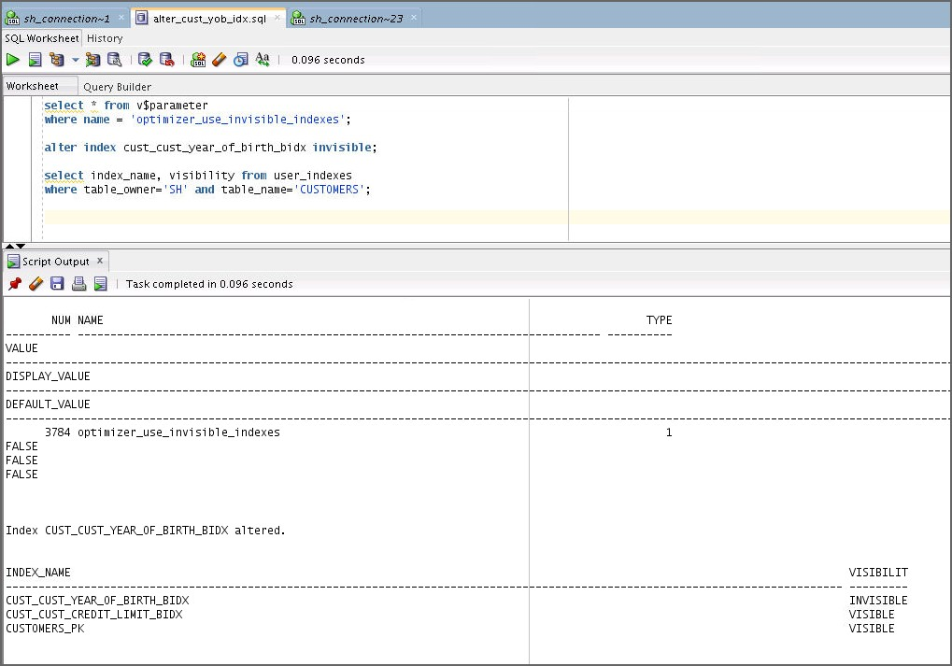

1. 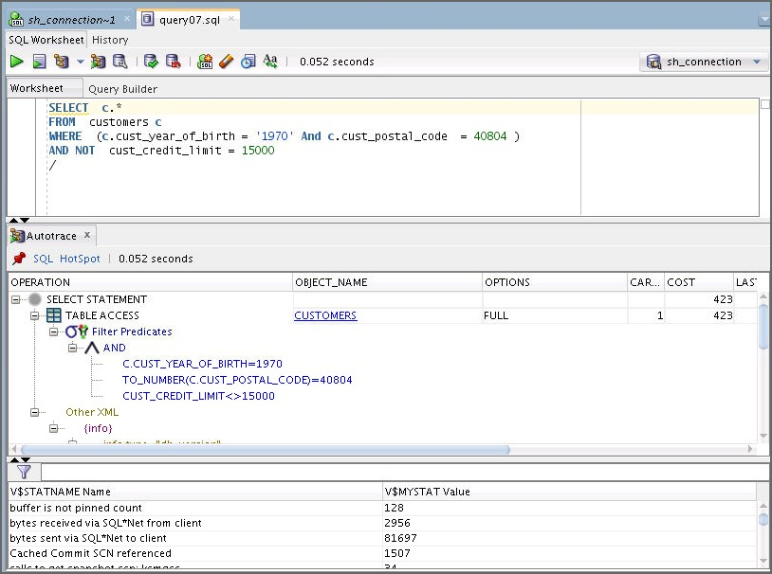Autotrace the query in query07.sql. What do you observe?

* This is the same query as in step 24. However, the optimizer can no longer find a good plan that uses bitmap indexes.

1. **Case 6: Index Only Access:** Open a terminal window. Connect to sh and drop all the indexes that are currently created on the CUSTOMERS table, except its primary key index, by executing drop_customers_indexes.sql.

$ **cd /home/oracle/labs/solutions/Access_Paths/**

$ **sqlplus sh/sh@orclpdb**

…

Connected to:…

SQL> **@drop_customers_indexes.sql**

1. After this, use create_last_first_name_index.sql to create a concatenated B*-tree index on the following columns of the CUSTOMERS table, and in the order shown here:

cust_last_name cust_first_name

Open and execute the create_last_first_name_index.sql script.

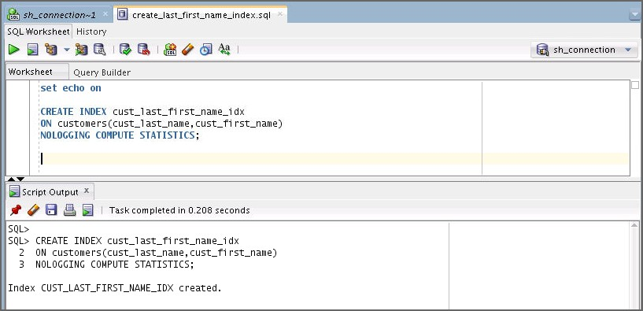

1. 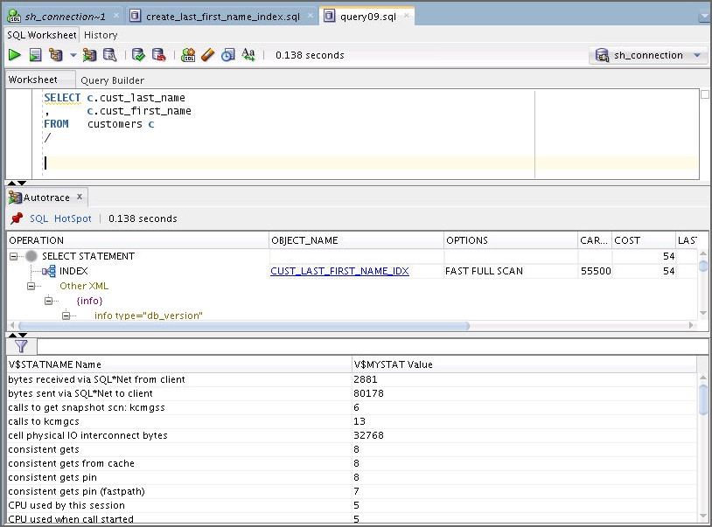Autotrace the query in query09.sql. What do you observe?

* The optimizer can use the index to retrieve the entire select list without accessing the table itself. The resulting cost is very good.

1. **Case 7: Index Join:** Open a terminal window. Connect to sh and drop all the indexes that are currently created on the CUSTOMERS table, except its primary key index, by executing drop_customers_indexes.sql.

$ **cd /home/oracle/labs/solutions/Access_Paths/**

$ **sqlplus sh/sh@orclpdb**

…

Connected to:…

SQL> **@drop_customers_indexes.sql**

1. After this, create two B*-tree indexes on the following columns of the CUSTOMERS table:

cust_last_name (create_last_name.index.sql) cust_first_name (create_first_name.index.sql)

* 1. Open and execute the create_last_name_index.sql script.

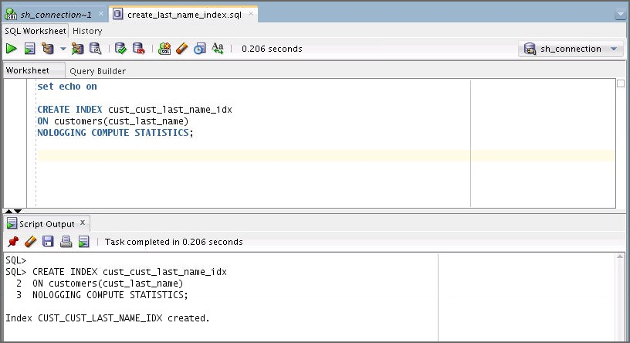

* 1. Open and execute the create_first_name_index.sql script.

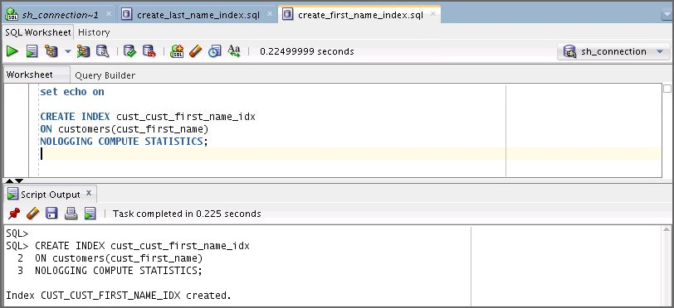

1. 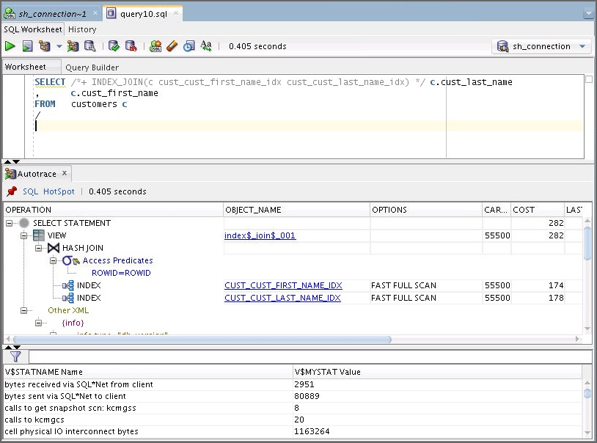Autotrace the query in the query10.sql script. What do you observe?

* Although the optimizer can use both the indexes, the resulting cost is not better than the concatenated index.

1. **Case 8: Bitmap Index Only Access:** Open a terminal window. Connect to sh and drop all the indexes that are currently created on the CUSTOMERS table, except its primary key index, by executing drop_customers_indexes.sql.

$ **cd /home/oracle/labs/solutions/Access_Paths/**

$ **sqlplus sh/sh@orclpdb**

…

Connected to:…

SQL> **@drop_customers_indexes.sql**

1. Then create one bitmap index on the following column of the CUSTOMERS table:

cust_credit_limit (create_cust_credit_limit_bindex.sql**)**

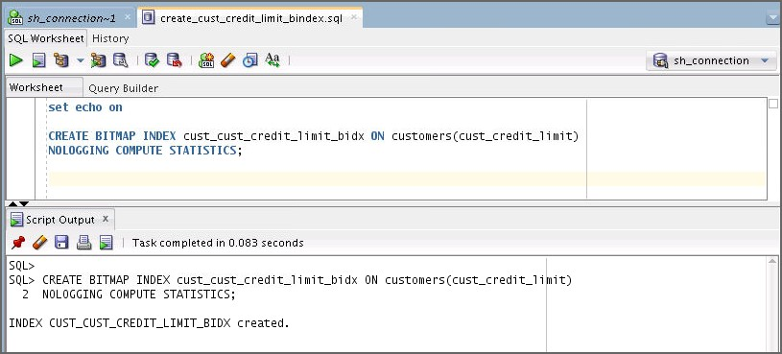You can open and execute the create_cust_credit_limit_bindex.sql script.

1. 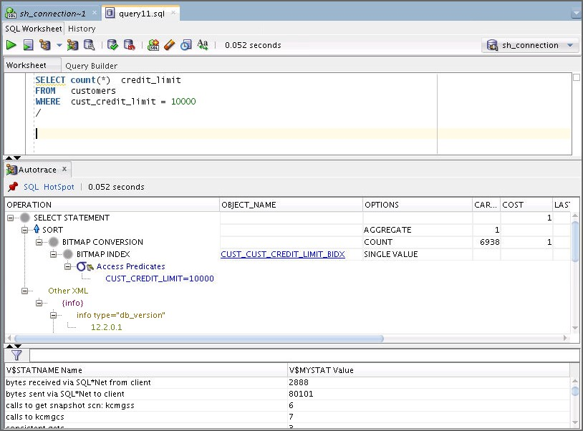Autotrace the query in query11.sql. What do you observe?

* Although cust_credit_limit is not a selective column, the COUNT operation on its bitmap index is very efficient.

1. **Case 9: B*-Tree Index Only Access:** Drop all the CUSTOMERS indexes, except its primary key index. Open a terminal window. Connect to sh and drop all the indexes that are currently created on the CUSTOMERS table, except its primary key index, by executing drop_customers_indexes.sql.

$ **cd /home/oracle/labs/solutions/Access_Paths/**

$ **sqlplus sh/sh@orclpdb**

…

Connected to:…

SQL> **@drop_customers_indexes.sql**

1. After this, create one B*-tree index on the following column of the CUSTOMERS table:

cust_credit_limit (create_cust_credit_limit_index.sql**)**

Open and execute the create_cust_credit_limit_index.sql script.

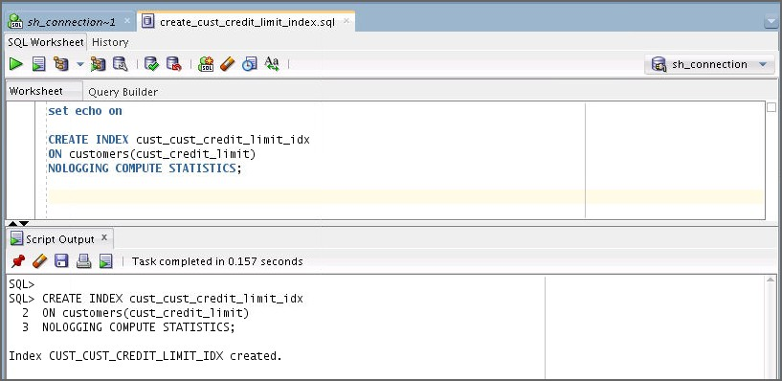

1. 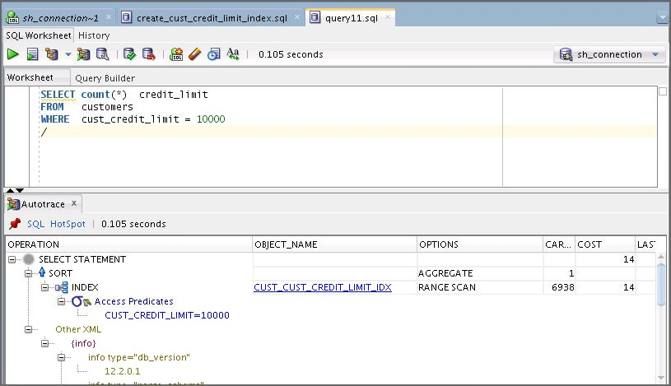Autotrace the query in query11.sql. What do you observe?

* The optimizer uses the B*-Tree index; however, this is less efficient compared to the corresponding bitmap index from the previous case in step 35.

1. **Case 10: Function Based Index:** Drop all the CUSTOMERS indexes, except its primary key index. Open a terminal window. Connect to sh and drop all the indexes that are currently created on the CUSTOMERS table, except its primary key index, by executing drop_customers_indexes.sql.

$ **cd /home/oracle/labs/solutions/Access_Paths/**

$ **sqlplus sh/sh@orclpdb**

…

Connected to:…

SQL> **@drop_customers_indexes.sql**

1. After this, create one B*-tree index on the following column of the CUSTOMERS table:

cust_last_name (create_last_name_index.sql)

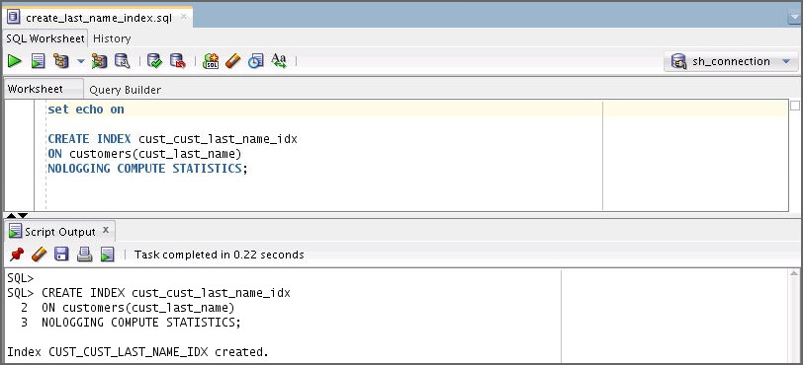

1. 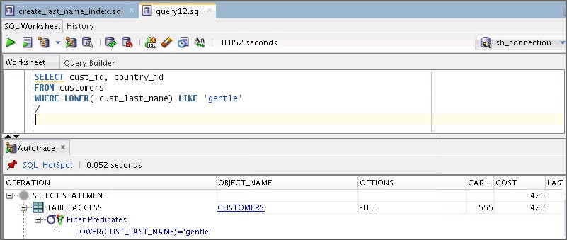Autotrace the query in query12.sql. What do you observe?

* Although there is an index, it cannot be used because its column is modified by a function.

1. How can you enhance the performance of the previous query without modifying the statement itself? Implement your solution.
   1. You can create a function-based index by using

create_lower_cust_last_name_index.sql.

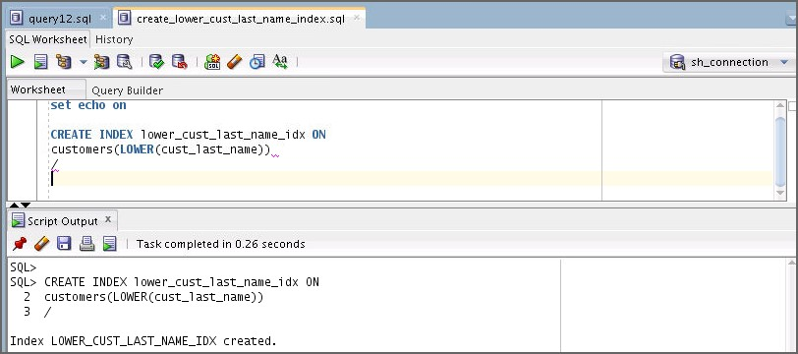

1. 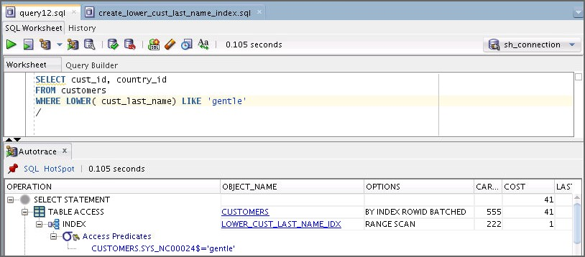Check if your solution executes faster than in the case of the query in step 41.
2. **Case 11: Index Organized Table:** Execute the iot_setup.sql script by using the sh

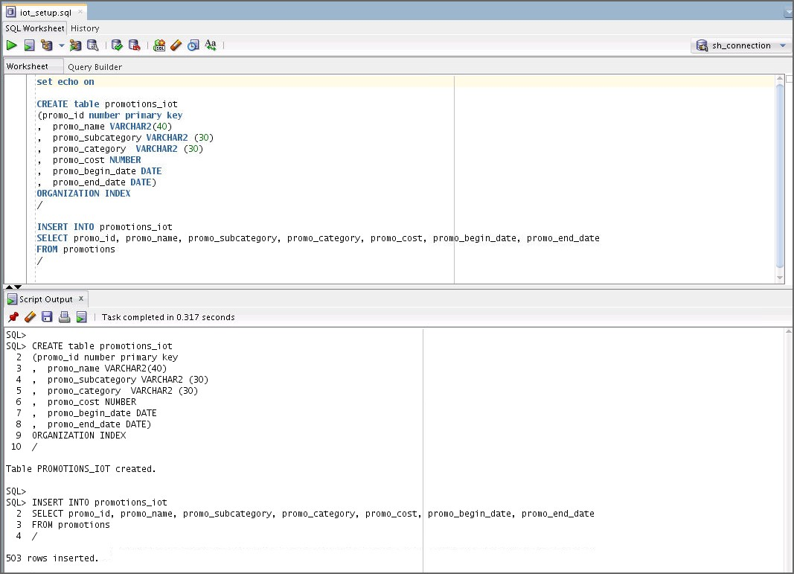user to set up the environment for this case.

1. 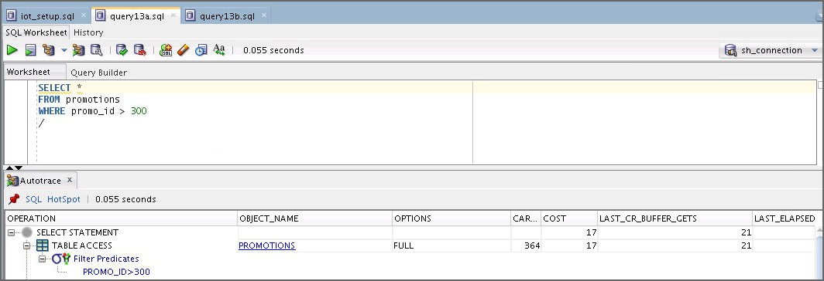Autotrace the query in query13a.sql and query13b.sql. What do you observe?

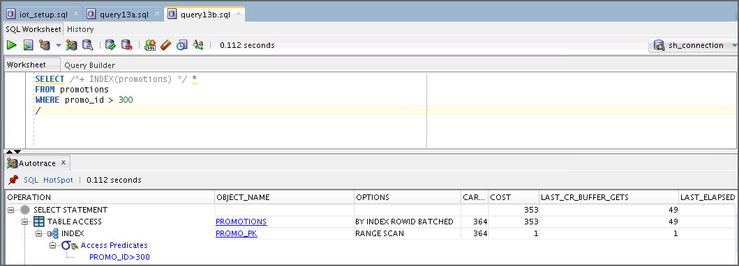

* The first query lets the optimizer decide the plan and the best that it can find is to perform a full table scan. Forcing the use of an index is not a good idea because it takes longer to execute.

1. Autotrace the query in query14.sql.

SELECT *

FROM promotions_iot

WHERE promo_id > 300;

What do you observe?

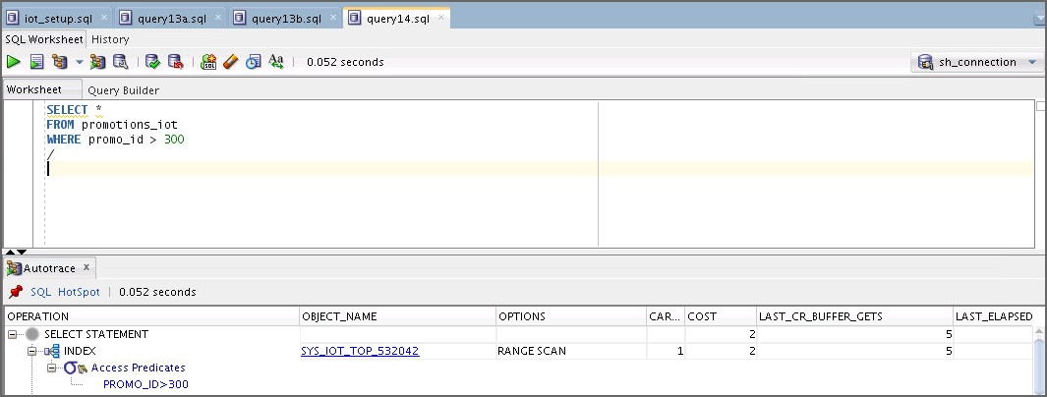

* The optimizer directly uses the index-organized structure, which is extremely efficient in this case compared to the previous step.

1. Open and execute the iot_cleanup.sql script to clean up your environment.

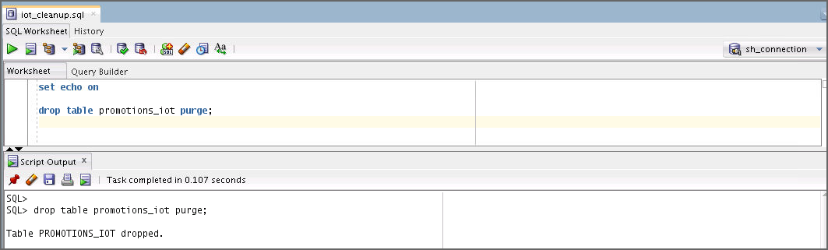

1. **Case 12: Index Skip Scan:** Execute the iss_setup.sql script by using the sh user to set up your environment for this practice.

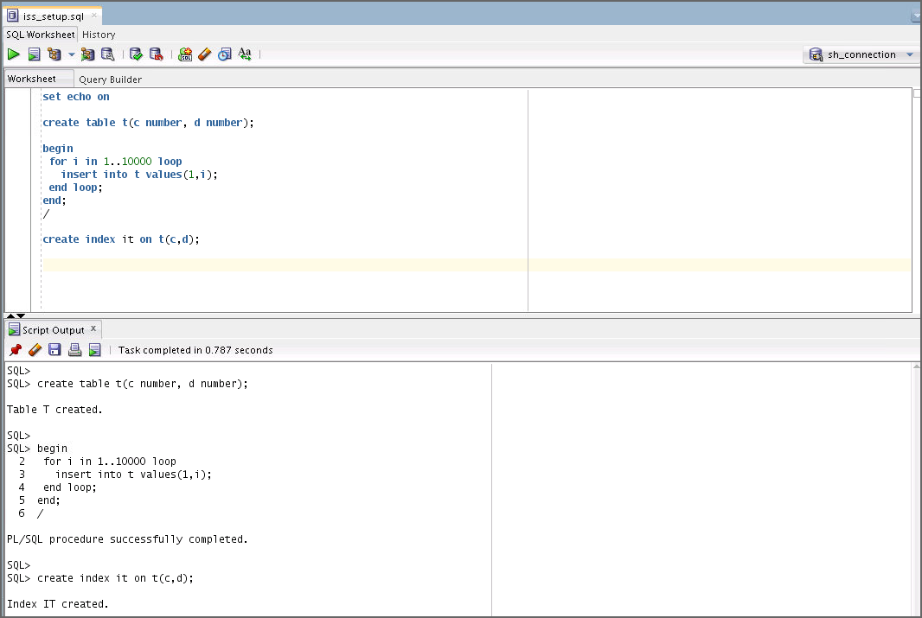

1. 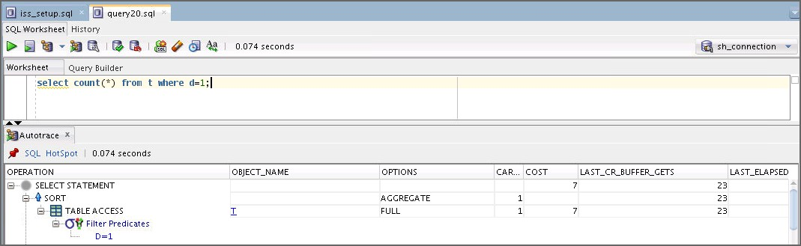Autotrace the query in query20.sql. What do you observe?

* The optimizer is not using the index and does a full table scan.

1. How would you improve the performance of a query, such as the one in the previous step? Implement your solution.
   1. Execute iss_gather_stats.sql to make sure that you gather the statistics for your table correctly so that the index skip scan can be used.

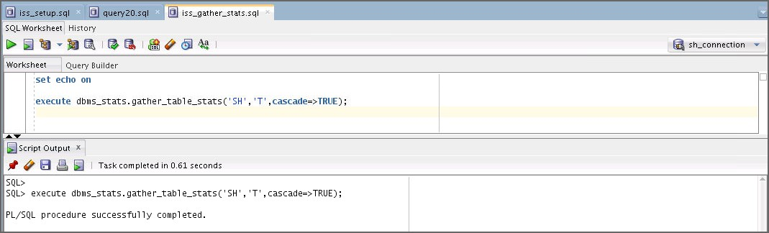

1. 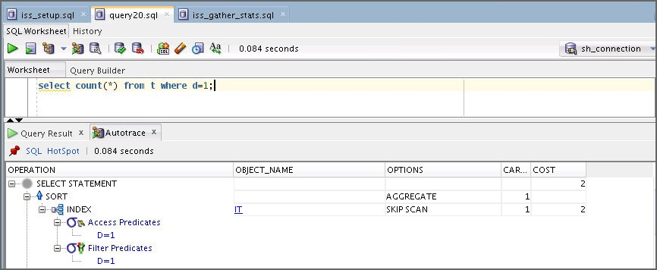Autotrace the query in query20.sql. What do you observe?

* The optimizer now uses the index to perform an index skip scan.

1. Compare the result of query20.sql with the result that you obtain when you autotrace the following query (query21.sql):

select /*+ INDEX_FFS(t it) */ count(*) from t where d=1;

What do you observe?

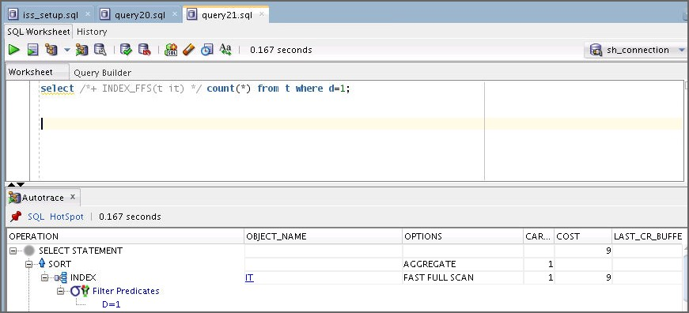

* The optimizer uses a fast full index scan, but this is not better than the index skip scan.

1. Execute the iss_cleanup.sql script to clean up your environment for this case.

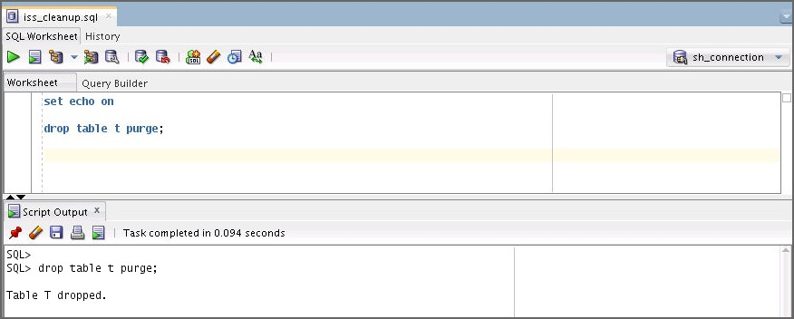

# Practices for Lesson 8: Optimizer: Join Operators

## Practices for Lesson 8: Overview

### Practices Overview

In these practices, you will examine three SQL statements and compare the different join methods for each statement.

## Practice 8: Using Join Paths

### Overview

In this practice, you explore the various access paths that the optimizer can use and compare them. You have the possibility of exploring different scenarios, each of which is self-contained. All scripts needed for this practice can be found in your

$HOME/labs/solutions/Access_Paths directory.

### Tasks

1. Start SQLDevloper.
2. Open and execute the join_setup.sql script by using sys_connection.

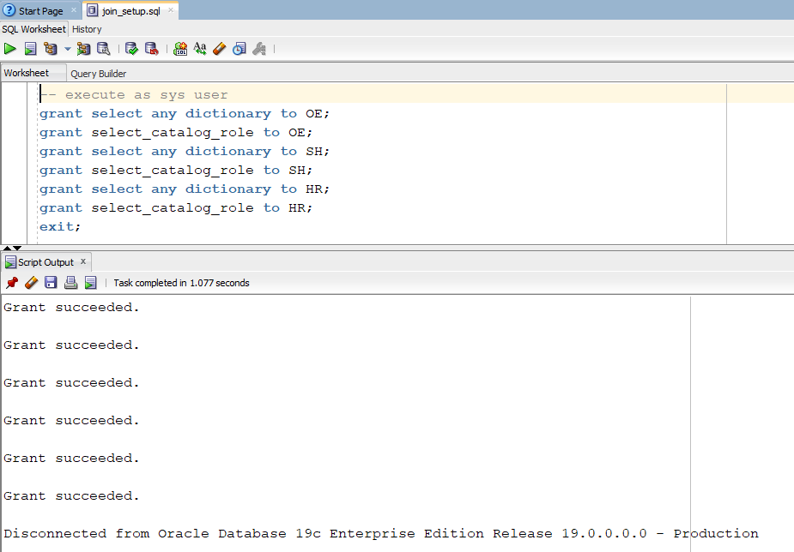

1. Open the connection named hr that you created in Practice 2. If you have not created this connection, create it now with the following attributes.

Create a connection with the following specifications: Name: hr_connection

Username: hr

Password: hr

Select Save Password. Service Name: orclpdb Click Test.

Click Connect.

1. **Case 1: Nested Loops Join Path:** The nested loops join method works well with very small tables, and larger tables with indexes on the join column, and at least one table that produces a small row source. The nested loops method will produce joined rows as soon as a match is found, so it is sometimes the preferred method for the FIRST_ROWS access goal.
   1. Enter the following query or open small_tables_join.sql as the hr user:

select department_name, d.location_id, l.location_id, l.street_address

from departments d, locations l

where d.location_id = l.location_id and department_name like 'S%';

Run Autotrace twice to load the buffer cache. Observe the statistics in the second run. What do you observe?

* 1. The optimizer chooses the nested loops join method for this query by default. The cost is low. This is expected because both tables in the query are very small.

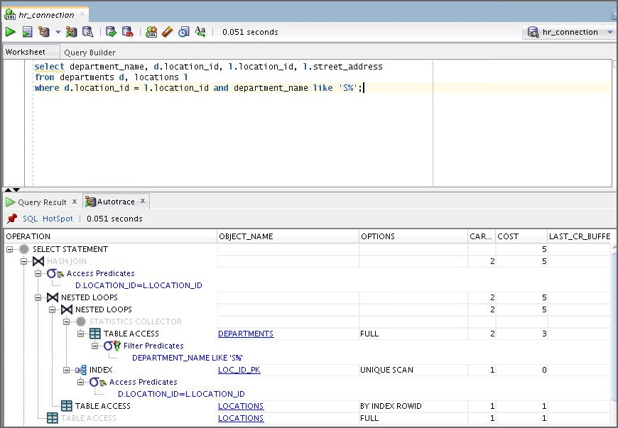

* 1. Enter the same query in SQL Developer or open the small_tables_hash_join.sql script, but force the use of a hash join by using the following query with hints. Then use Autotrace to observe the differences in the execution plan and statistics.

select /*+ USE_HASH(D L) */ department_name, d.location_id, l.location_id, l.street_address

from departments d, locations l where d.location_id = l.location_id

and department_name like 'S%';

What do you observe?

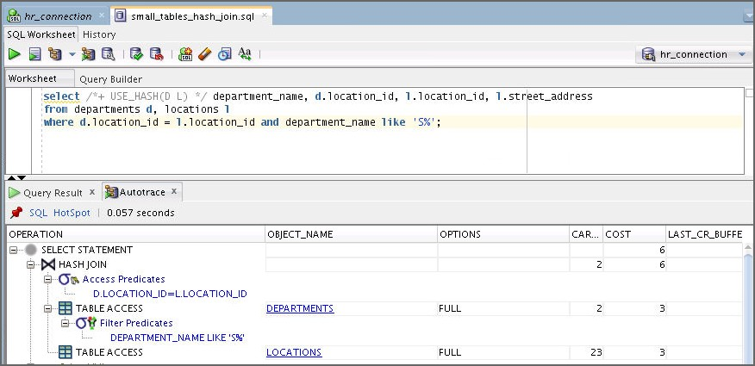The optimizer is forced to use the hash join method. The number of consistent gets is higher and the estimated cost is higher. Note that the elapsed time may vary depending on any other activity on the machine.

* 1. Enter the same query in SQL Developer or open small_tables_merge_join.sql, but force the use of a sort-merge join by using the following query with hints. Then use Autotrace to observe the differences in the execution plan and statistics.

select /*+ USE_MERGE(D L) */ department_name, d.location_id, l.location_id, l.street_address

from departments d, locations l where d.location_id = l.location_id

and department_name like 'S%';

What do you observe?

The optimizer is forced to use the sort-merge join method. The number of consistent gets is lower than nested loops, but there is the additional cost of the sorts that is not included in the consistent gets. The estimated cost is higher. Note that the elapsed time may vary depending on any other activity on the machine.

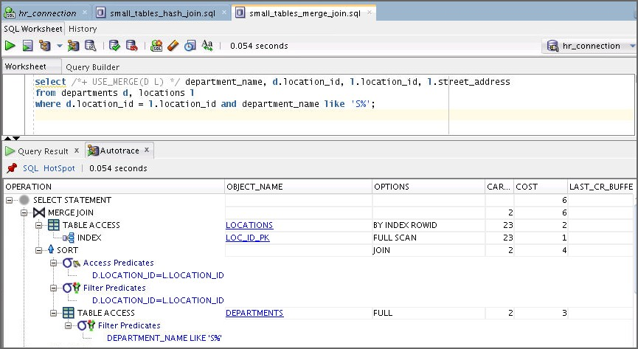

1. Open the connection named oe_connection that you created in Practice 2. If you have not created this connection, create it now with the following attributes.
   1. Click the Add Connection button.
   2. Create a connection with following specifications: Name: oe_connection

Username: oe

Password: oe

Select Save Password. Service Name: orclpdb Click Test.

Click Connect.

1. **Case 2: Merge Join:** The merge join is a general-purpose join method that can work when other methods cannot. The merge join must sort each of the two row sources before performing the join. Because both row sources must be sorted before the first joined row is returned, the merge join method is not well suited for use with the FIRST_ROWS goal.
   1. Enter the following query in a SQL Developer worksheet connected as the OE user or open the oe_query.sql script.

SELECT *

FROM orders h, order_items l

WHERE l.order_id = h.order_id;

* 1. Autotrace this query twice to warm the buffer cache. What do you observe?

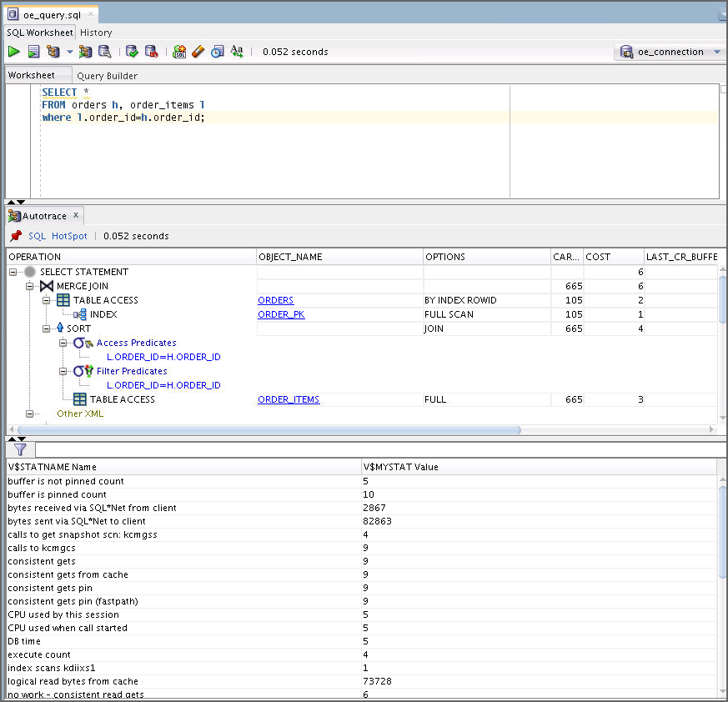Notice that the merge join is chosen by the optimizer.

* 1. Enter the same query with a hint to force the use of a hash join or open the

oe_query_hash.sql script.

SELECT /*+ USE_HASH(h l) */ * FROM orders h, order_items l

WHERE l.order_id = h.order_id;

What do you observe?

Compare the estimated cost to the merge join in the preceding step, and the consistent gets. In this case, the additional sort required by the merge join method does not raise the cost enough to cause the hash join to be chosen by the optimizer.

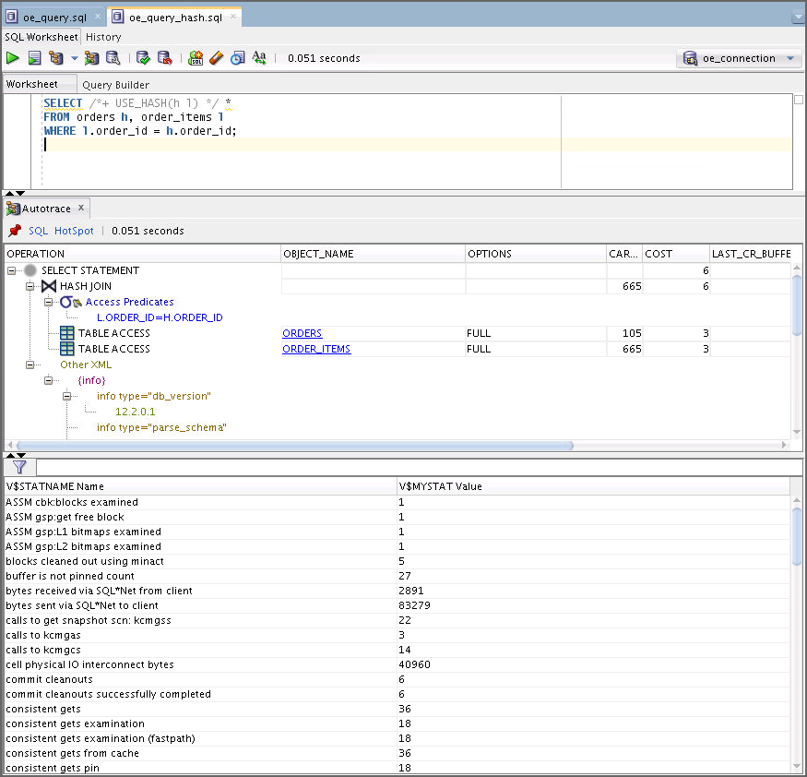

* 1. Enter the same query again, changing the hint to force the use of nested loops, or open the oe_query_nl.sql script.

SELECT /*+ USE_NL(h l) */ * FROM orders h, order_items l

WHERE l.order_id = h.order_id;

Autotrace this query.

What do you observe?

Notice the estimated cost and the consistent gets. The cost of the nested loops join method is much higher than either the hash join method or the merge join method. The nested loops method depends on either very small tables or indexes to be an efficient access path.

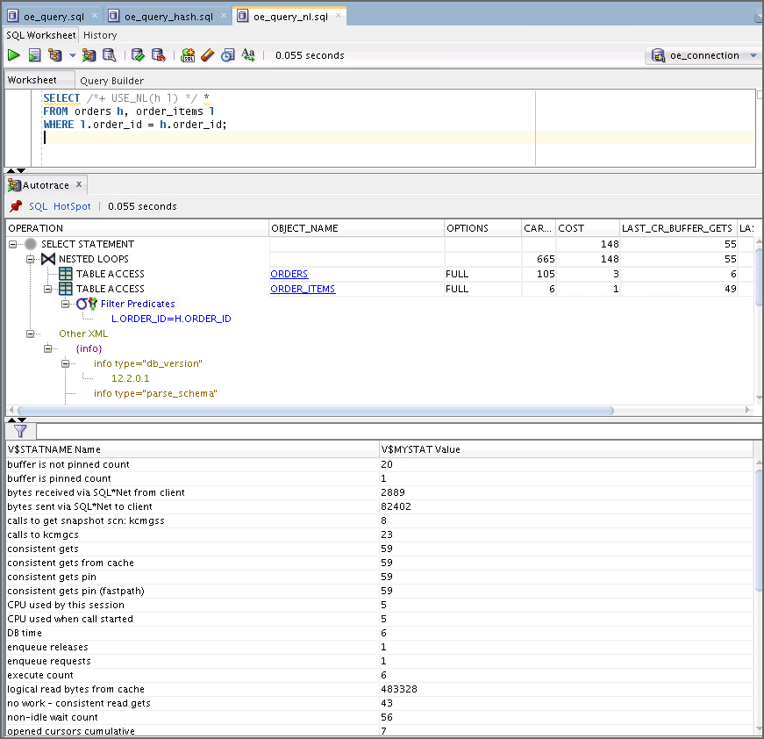

1. Open the connection named sh_connection that you created in Practice 2. If you have not created this connection, create it now with the following attributes.
   1. Click the Add Connection button.
   2. Create a connection with the following specifications: Name: sh_connection

Username: sh

Password: sh

Select Save Password. Service Name: orclpdb Click Test.

Click Connect.

1. **Case 3: Hash Join:** The hash join method performs very well on large row sources and on row sources where one row source is smaller. The hash join builds a hash table in memory (and overflows to the temp tablespace if the row source is too large) on the smaller of the row sources. The procedure then reads the second row source, probing for the hash value in the first. Because the rows are joined as soon as a match is found, the hash join method is also preferred for the FIRST_ROWS goal.
   1. Enter the following query in SQL Developer or open sh_query.sql:

SELECT p.prod_name, p.prod_id FROM sh.products p, sh.sales s where p.prod_id = s.prod_id

and s.prod_id < 100;

Run Autotrace twice to warm the buffer cache. What do you observe?

Notice the consistent gets and the estimated cost.

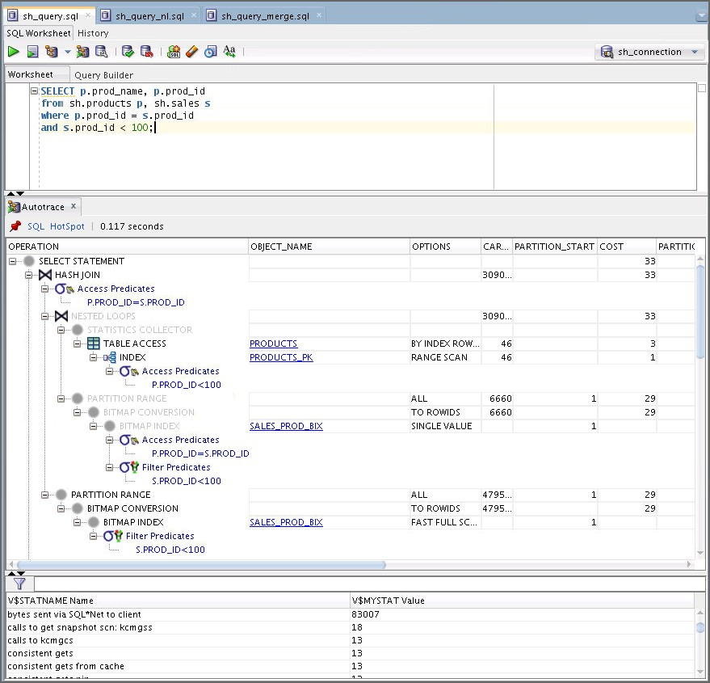

* 1. Enter the same query again, but use a hint to force the nested loops method or open the sh_query_nl.sql script.

SELECT /*+ USE_NL(p s) */ p.prod_name, p.prod_id FROM sh.products p, sh.sales s

where p.prod_id = s.prod_id

and s.prod_id < 100 ;

Run Autotrace. What do you observe?

The consistent gets and estimated cost values are much higher than the values for the hash join method.

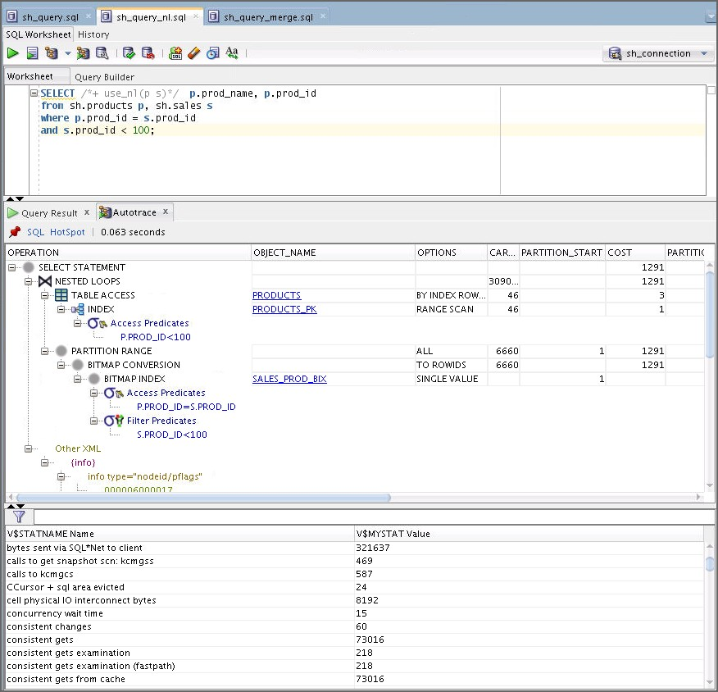

* 1. Enter the same query again. This time use a hint to force the merge join method or open the sh_query_merge.sql script.

SELECT /*+ USE_MERGE(p s) */ p.prod_name, p.prod_id FROM sh.products p, sh.sales s

where p.prod_id = s.prod_id

and s.prod_id < 100 ;

Run Autotrace. What do you observe?

The estimated cost is higher than the hash join and nested loops method, but the consistent gets is lower than the nested loops method.

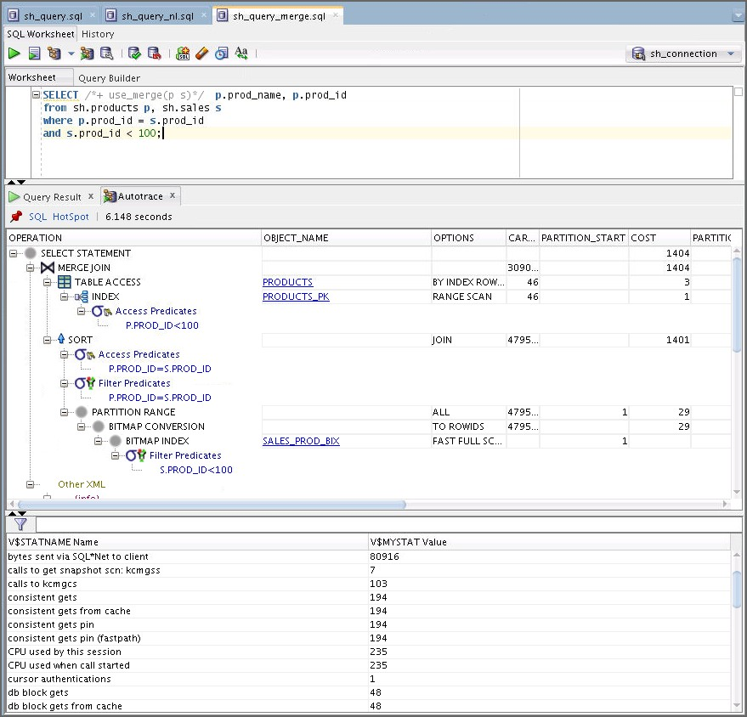

# Practices for Lesson 9: Other Optimizer Operators

## Practices for Lesson 9: Overview

### Practices Overview

In these practices, you use the Results Cache to improve SQL performance with repeated queries and examine the SQL statements that use other access paths.

## Practice 9-1: Using the Result Cache

In this practice, you explore the various possibilities of caching query results in the system global area (SGA). Perform the following steps to understand the use of Query Result Cache. All the scripts for this practice can be found in the

$HOME/labs/solutions/Query_Result_Cache/ directory.

1. The result_cache_setup.sh script was executed in the setup of this practice as the

SYS user to create and populate the QRC schema. This script is listed as follows:

[oracle@edvmr1p0 Query_Result_Cache]$ **./result_cache_setup.sh**

… #!/bin/bash

cd /home/oracle/labs/solutions/Query_Result_Cache sqlplus sys/fenago as sysdba <<FIN!

set echo on

alter session set container = orclpdb; drop user qrc cascade;

create user qrc identified by qrc default tablespace users temporary tablespace temp;

grant connect, resource, dba to qrc; connect qrc/qrc@orclpdb

exec dbms_result_cache.flush; drop table cachejfv purge;

create table cachejfv(c varchar2(500)) tablespace users;

insert into cachejfv values('aaaaaaaaaaaaaaaaaaaaaaaaaaaaaaaaaaaaaaaaaaaaaaaaaaaaaaaa aaaaaaaaaaaaaaaaaaaaaaaaaaaaaaaaaaa');

insert into cachejfv select * from cachejfv; insert into cachejfv select * from cachejfv; insert into cachejfv select * from cachejfv;

insert into cachejfv select * from cachejfv;

insert into cachejfv select * from cachejfv; insert into cachejfv select * from cachejfv; insert into cachejfv select * from cachejfv; insert into cachejfv select * from cachejfv; insert into cachejfv select * from cachejfv; insert into cachejfv select * from cachejfv; insert into cachejfv select * from cachejfv; insert into cachejfv select * from cachejfv; insert into cachejfv select * from cachejfv; insert into cachejfv select * from cachejfv; insert into cachejfv select * from cachejfv; insert into cachejfv select * from cachejfv; insert into cachejfv select * from cachejfv; insert into cachejfv select * from cachejfv; insert into cachejfv select * from cachejfv; insert into cachejfv select * from cachejfv; insert into cachejfv select * from cachejfv;

insert into cachejfv values('b');

commit;

alter system flush buffer_cache;

FIN!

$

1. Start SQLDeveloper.
2. Create a connection for the qrc user.
   1. Click the New Connection button.
   2. Create a connection with the following specifications: Name: qrc

Username: qrc

Password: qrc

Select “Save Password.” Service Name: orclpdb

Click Test. Click Connect.

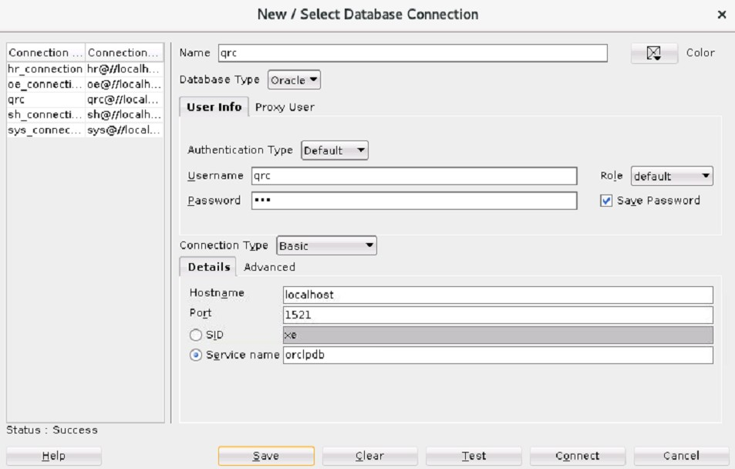

1. As the qrc user, determine the current content of the query cache by using the following statement or open and execute the statement in the check_result_cache.sql file in the $HOME/labs/solutions/Query_Result_Cache/ directory. From now on, execute all scripts as the qrc user.

select type,status,name,object_no,row_count,row_size_avg

from v$result_cache_objects order by 1;

What do you observe?

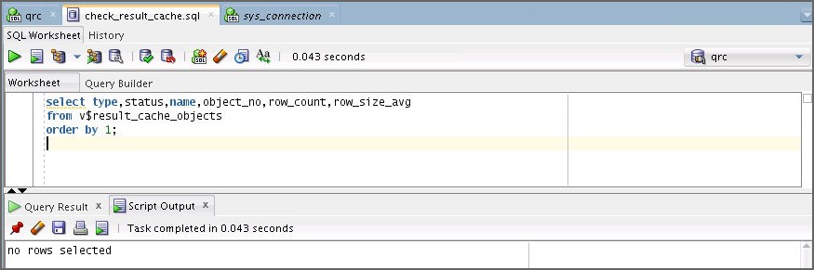

* No row is selected because the query cache is empty.

**Note:** If the result shows some rows, then execute the following query by using the sys user and then execute the check_result_cache.sql script again by using the qrc user.

begin dbms_result_cache.flush;

end;

Disconnect from the SYS connection.

1. Open and execute the query1.sql script. Note the time it takes for this statement to execute.

SELECT /*+ result_cache q_name(Q1) */ COUNT(*)

FROM cachejfv c1, cachejfv c2, cachejfv c3, cachejfv c4,

cachejfv c5, cachejfv c6, cachejfv c7

WHERE c1.c='b' AND c2.c ='b' AND c3.c

='b' AND c7.c

='b' AND c4.c

='b';

='b'

AND c5.c

='b' AND c6.c

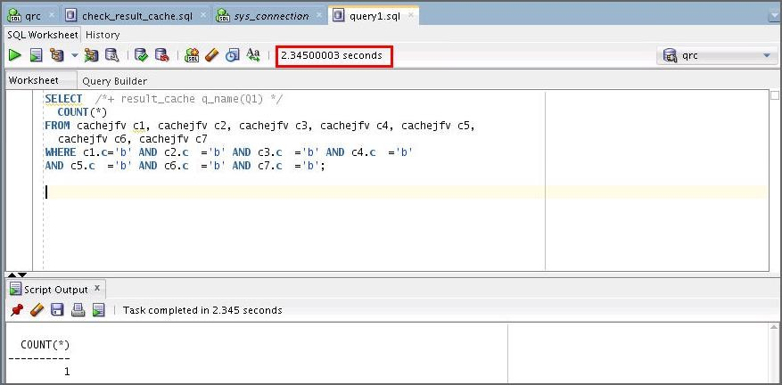

1. Determine the execution plan of the query in query1.sql. What do you observe?

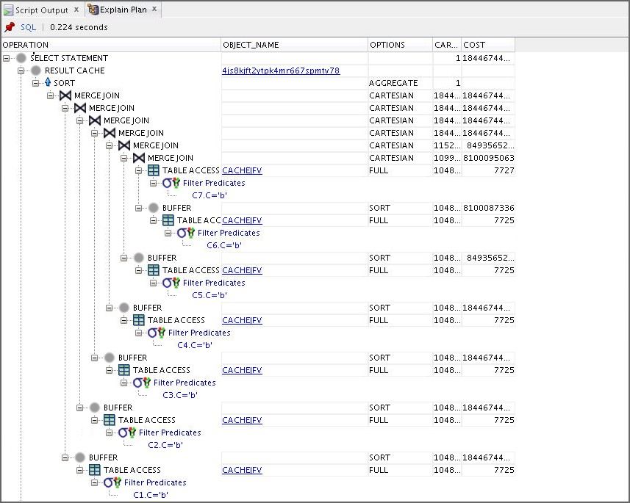

* Because of the result_cache hint, the result of the query is computed using the result cache.

1. 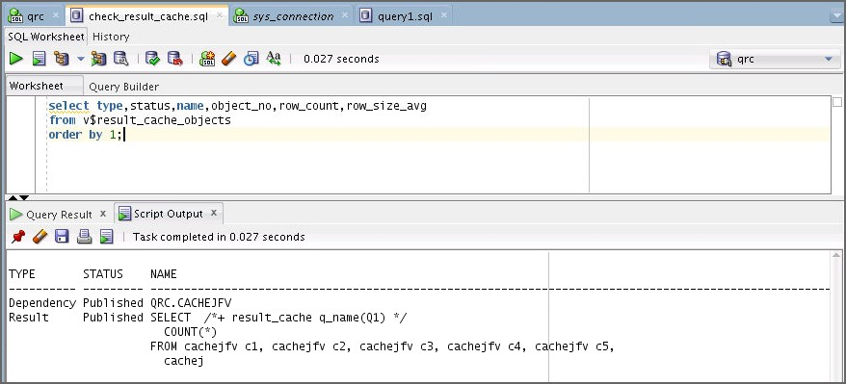As the qrc user, determine the current content of the query cache by using the following statement or the check_result_cache.sql script. What do you observe?

select type,status,name,object_no,row_count,row_size_avg

from v$result_cache_objects order by 1;

* You can now see that the result of your query is cached.

1. Flush the buffer cache of your instance.

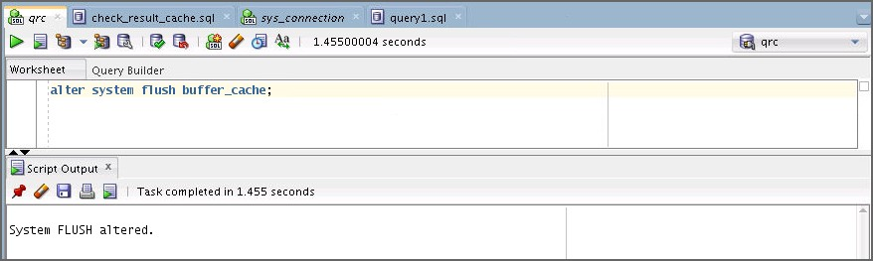

alter system flush buffer_cache;

1. Rerun query1.sql. What do you observe?

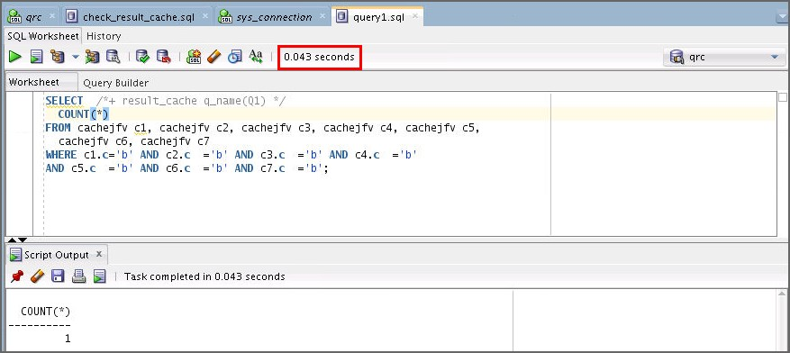

* The execution time for the query is now almost instantaneous.

1. 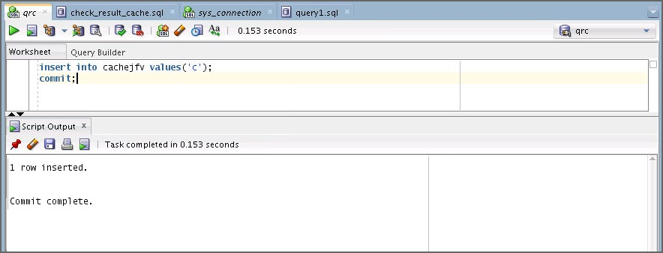Insert a new row into the CACHEJFV table by using the following statement:

insert into cachejfv values('c');

commit;

1. 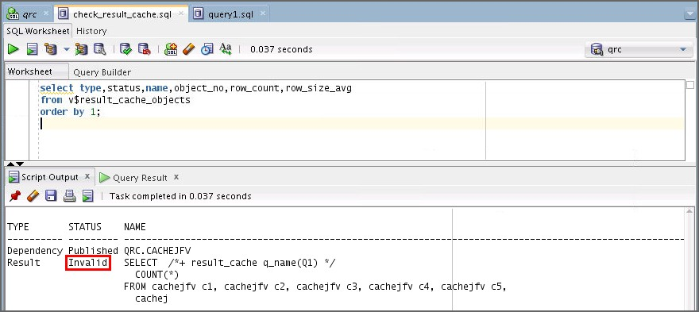As the qrc user, determine the current content of the query cache by using the following statement or the check_result_cache.sql script. What do you observe?

select type,status,name,object_no,row_count,row_size_avg

from v$result_cache_objects order by 1;

* The corresponding result cache entry is automatically invalidated.

1. 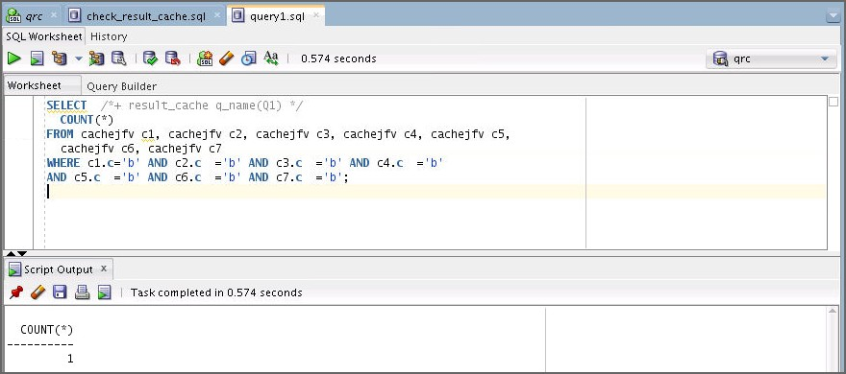Rerun query1.sql.
2. As the qrc user, determine the current content of the query cache by using the following statement or execute the check_result_cache.sql script. What do you observe?

select type,status,name,object_no,row_count,row_size_avg

from v$result_cache_objects order by 1;

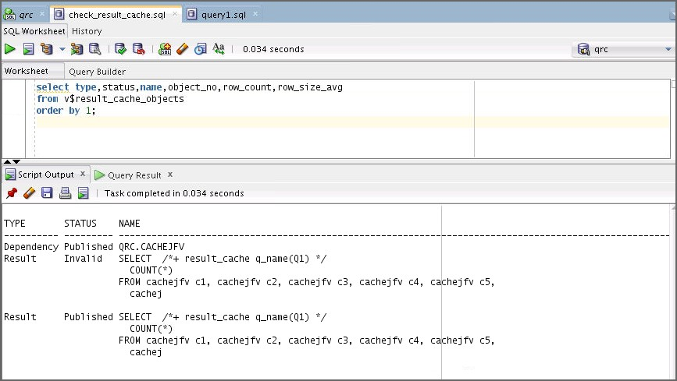

* Again, it takes some time to execute the query. The result cache shows that a new entry has been added for the new result.

1. Generate a detailed result cache memory report by entering the following commands:

set serveroutput on

EXEC DBMS_RESULT_CACHE.MEMORY_REPORT(detailed=>true);

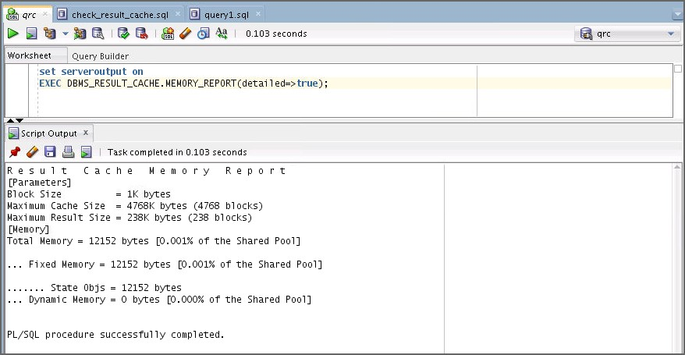

1. 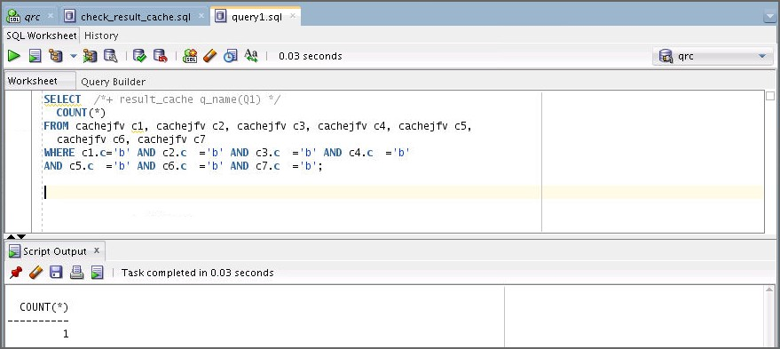Rerun the query1.sql script. What do you observe?

* The query again uses the result that was previously cached.

1. Ensure that you bypass the result cache before performing the next step.

exec DBMS_RESULT_CACHE.BYPASS(bypass_mode=>true);

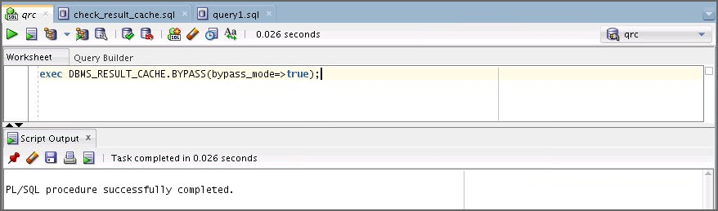

1. 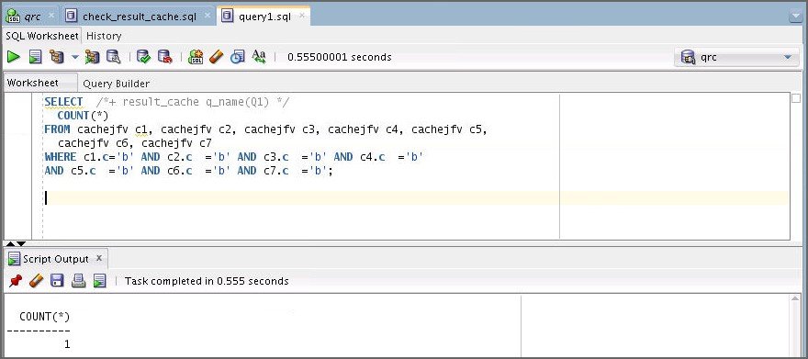Rerun query1.sql. What do you observe?

* The query again takes longer to execute because it no longer uses the result cache.

1. Ensure that you no longer bypass the result cache and check whether your query uses it again.
   1. Execute the following statement:

exec DBMS_RESULT_CACHE.BYPASS(bypass_mode=>false);

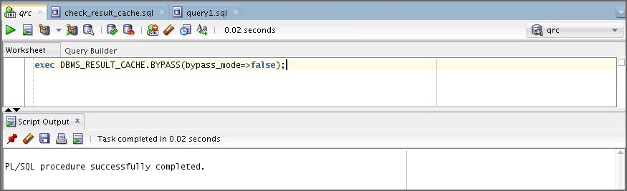

* 1. 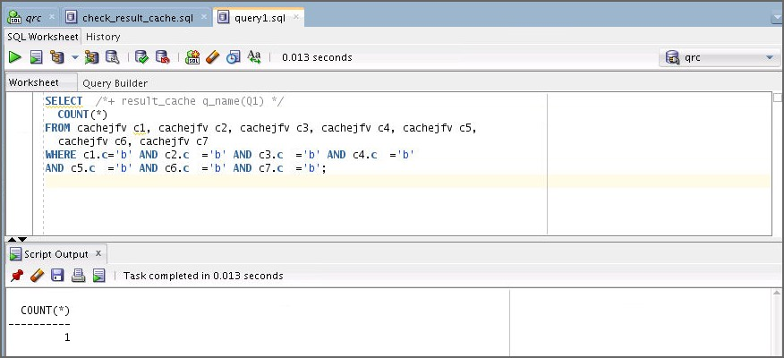Rerun query1.sql.

1. Open and execute the query2.sql script or enter the following query:

SELECT COUNT(*)

FROM cachejfv c1, cachejfv c2, cachejfv c3, cachejfv c4,

cachejfv c5, cachejfv c6, cachejfv c7

WHERE c1.c='b' AND c2.c ='b' AND c3.c

='b' AND c7.c

='b' AND c4.c

='b';

='b'

AND c5.c

='b' AND c6.c

What do you observe?

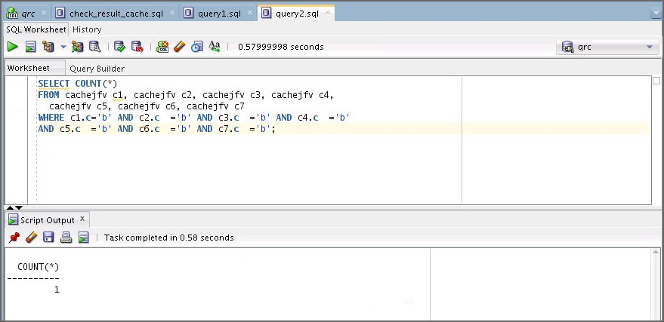

* Although the query is the same as the one in query1.sql, it is not recognized as cached because it does not contain the hint. So its execution time is long again.

1. How would you force the previous query to use the cached result without using hints?
   1. Use the following code to force the use of the cached result or open and execute the

force_result_cache.sql script.

set echo on

show parameter result_cache_mode

select type,status,name,object_no,row_count,row_size_avg from v$result_cache_objects order by 1;

alter session set result_cache_mode=force;

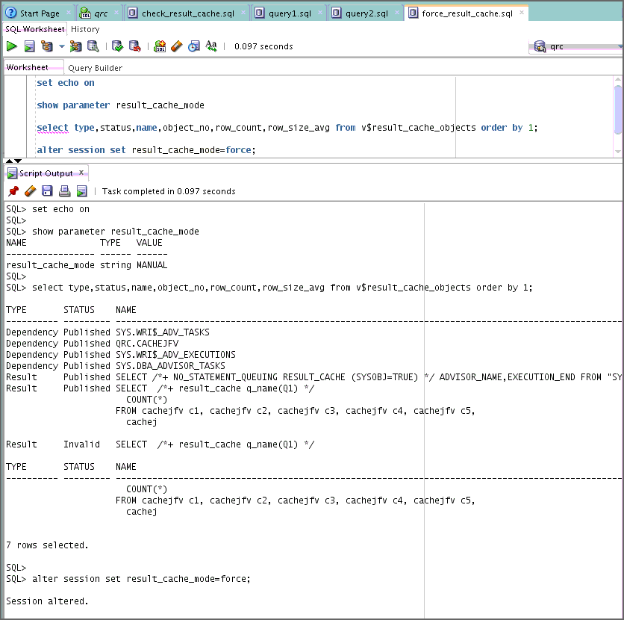

* 1. 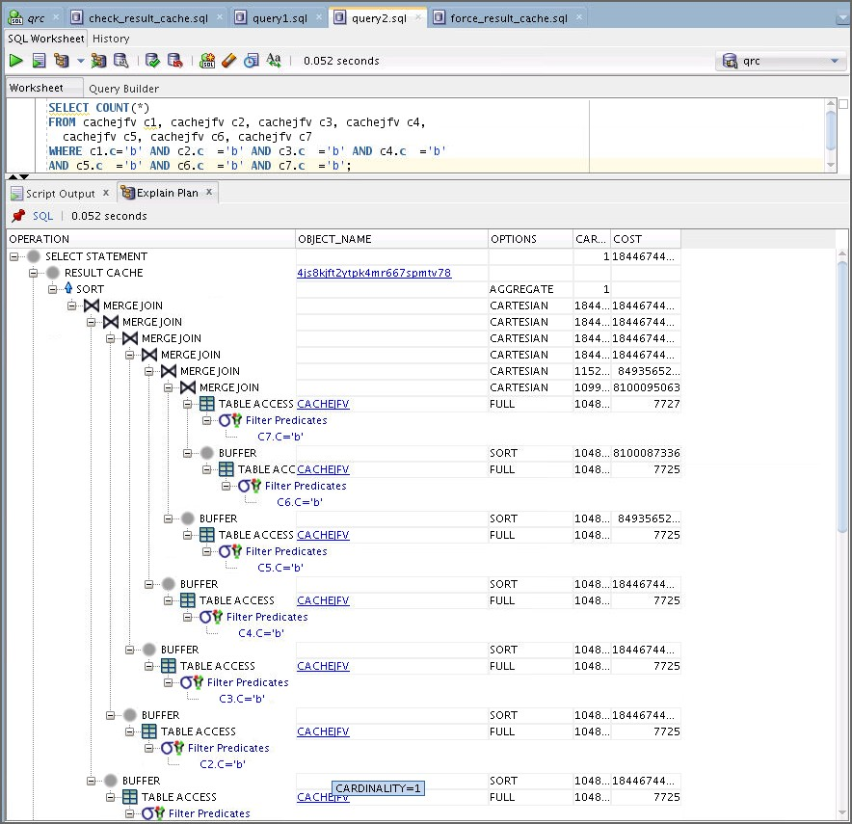View the explain plan for the query2.sql script.
  2. Rerun the query2.sql script to verify that the query runs instantaneously because you successfully used the cached result.

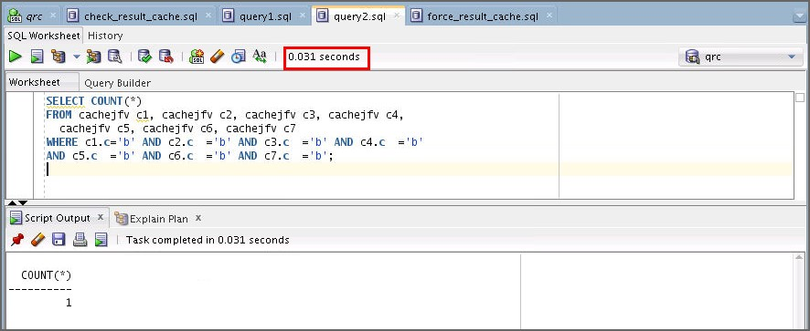

* 1. Finally, undo your change.

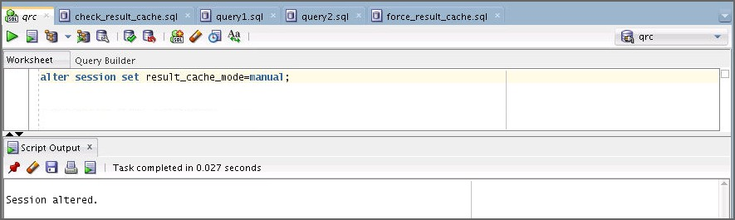alter session set result_cache_mode=manual;

1. Clear the result cache. Query V$RESULT_CACHE_OBJECTS to verify the clear operation.

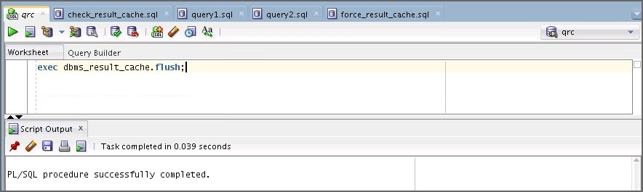exec dbms_result_cache.flush;

1. 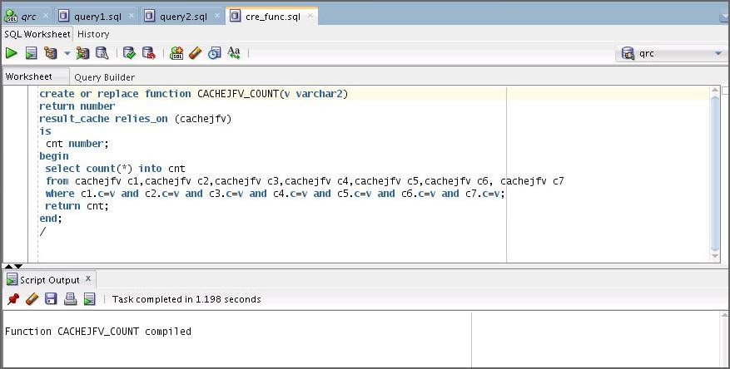Open and execute the cre_func.sql script. This script creates a PL/SQL function that uses the result cache.
2. Determine what is in the result cache by querying V$RESULT_CACHE_OBJECTS. (This is the check_result_cache.sql script.)

select type,status,name,object_no,row_count,row_size_avg from v$result_cache_objects

order by 1;

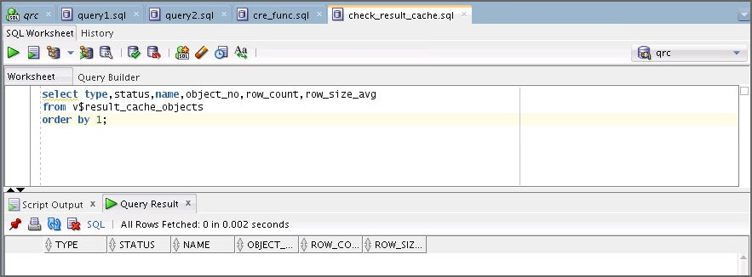

1. 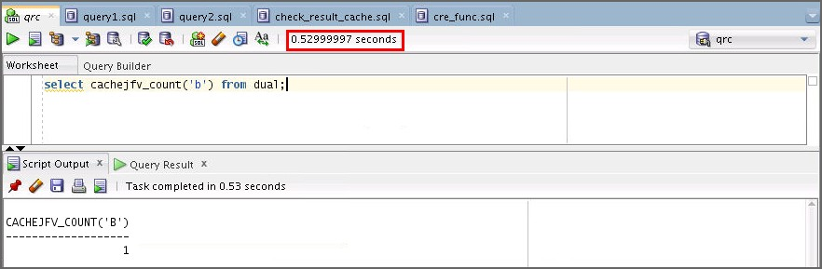Call the new function with 'b' as its argument. What do you observe?

select cachejfv_count('b') from dual;

* It takes a long time to execute because the result is not cached yet. After executing the function, the function’s result for the 'b' argument is cached.

1. 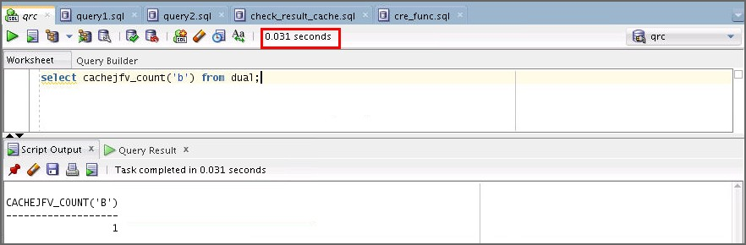Call the new function with 'b' as its argument again. What do you observe?

select cachejfv_count('b') from dual;

* This time the function executes almost instantaneously.

1. Call the new function again, but with 'c' as its argument. What do you observe?

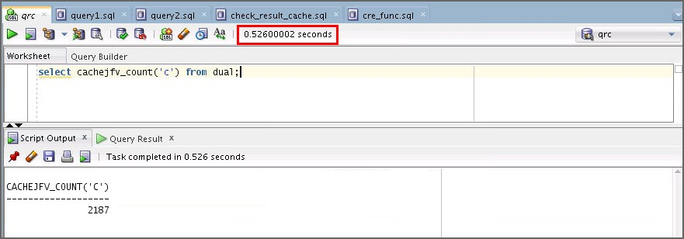

* Again, it takes a long time to execute the function because of the new value for the argument. After execution, the second result is cached.

## Practice 9-2: Using Other Access Paths (Optional)

### Overview

In this practice, you explore the various access paths that the optimizer can use, and compare them. You have the possibility of exploring three scenarios, each of which is self-contained. All scripts needed for this practice can be found in your

$HOME/labs/solutions/Access_Paths directory.

### Tasks

1. Open the connection named sh_connection that you created in Practice 2. If you have not created this connection, create it now with the following attributes:
   1. Click the New Connection button.
   2. Create a connection with the following specifications: Name: sh_connection

Username: sh

Password: sh

Select “Save Password.” Service Name: orclpdb Click Test.

Click Connect.

1. **Case 1: Inlist Iterator:** Open the

$HOME/labs/solutions/Access_Paths/query08.sql script. Use sh_connection

to autotrace the query.

SELECT c.*

FROM customers c

WHERE cust_id IN (88340,104590,44910);

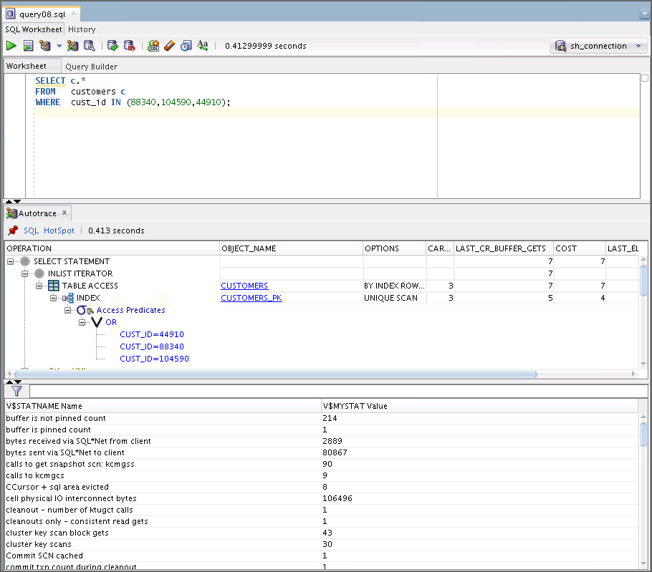What do you observe?

* The optimizer can use the CUSTOMERS primary key index to resolve this query. The cost is very low for the resulting plan.

1. **Case 2: Using Hash Clusters:** The SHC schema was created and populated in the practice setup using $HOME/labs/solutions/Access_Paths/shc_setup.sql to set up your environment for this practice. This script creates the bigemp_fact table as a member of bigemp_cluster. bigemp_cluster is a single-table hash cluster. The rows of the table are sorted on the deptno and sal columns before the hash function is applied. The script is listed as follows:

-- run with sqlplus /nolog @shc_setup.sql connect sys/fenago as sysdba

alter session set container =orclpdb;

drop user shc cascade;

create user shc identified by shc; Grant DBA to SHC;

GRANT select_catalog_role to SHC; GRANT select any dictionary to SHC;

connect shc/shc@orclpdb

set echo on

set linesize 200

drop cluster bigemp_cluster including tables;

CREATE CLUSTER bigemp_cluster (deptno number, sal number sort)

HASHKEYS 10000

single table HASH IS deptno SIZE 50 tablespace users;

create table bigemp_fact (

empno number primary key, sal number sort, job varchar2(12) not null,

deptno number not null, hiredate date not null) CLUSTER bigemp_cluster (deptno, sal);

begin

for i in 1..1400000 loop

insert into bigemp_fact values(i,i,'J1',10,sysdate); end loop;

commit; end;

/

begin

for i in 1..1400000 loop

insert into bigemp_fact values(1400000+i,i,'J1',20,sysdate); end loop;

commit; end;

/

exec dbms_stats.gather_schema_stats('SHC'); exit

1. Create a connection for the shc user. Use this connection for all the scripts in the Hash Cluster case.
   1. Click the New Connection button.
   2. Create a connection with the following specifications: Name: shc

Username: shc

Password: shc

Select “Save Password.” Service Name: orclpdb Click Test.

Click Connect.

1. 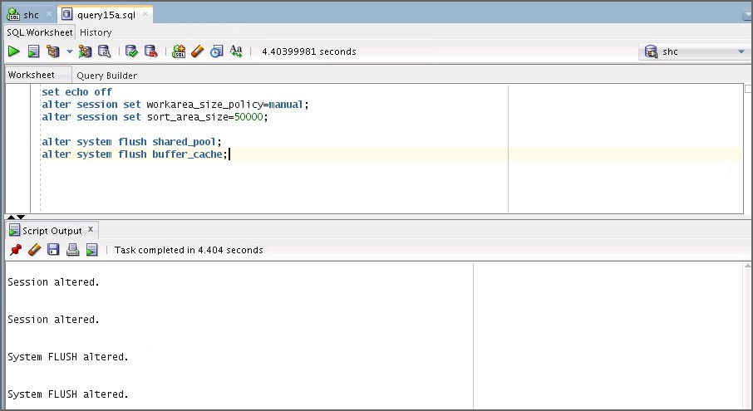Use the shc connection to execute the query15a.sql script. This script sets workarea_size_policy to MANUAL, and sort_area_size to a small value. Because you may have a lot of memory on your system, the script reduces the amount of memory available to your session. It then flushes the cache and shared pool to eliminate the possibility of the cost being reduced by previous queries loading the cache.
2. Use the shc connection to autotrace the query in the query15b.sql script. What do you observe?

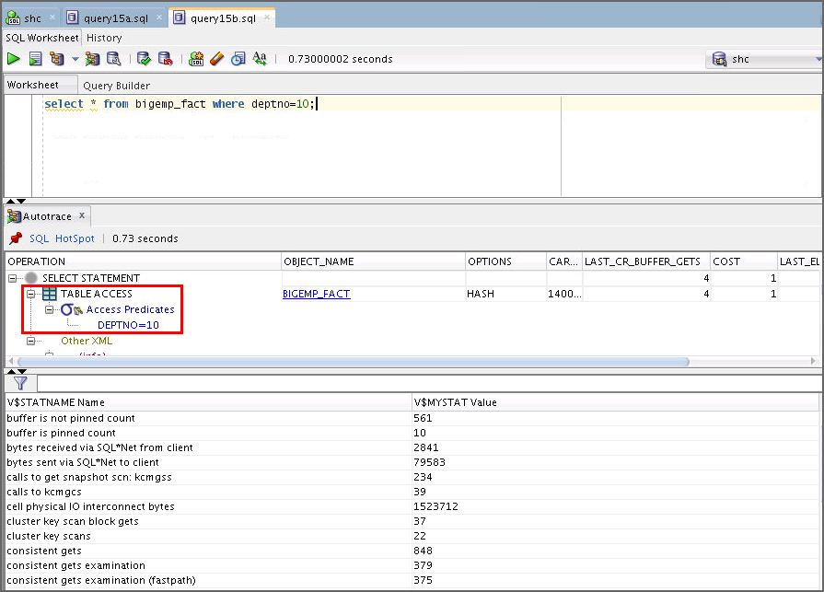

* The optimizer decides to use the cluster access path to retrieve data. The cost is minimal.

1. 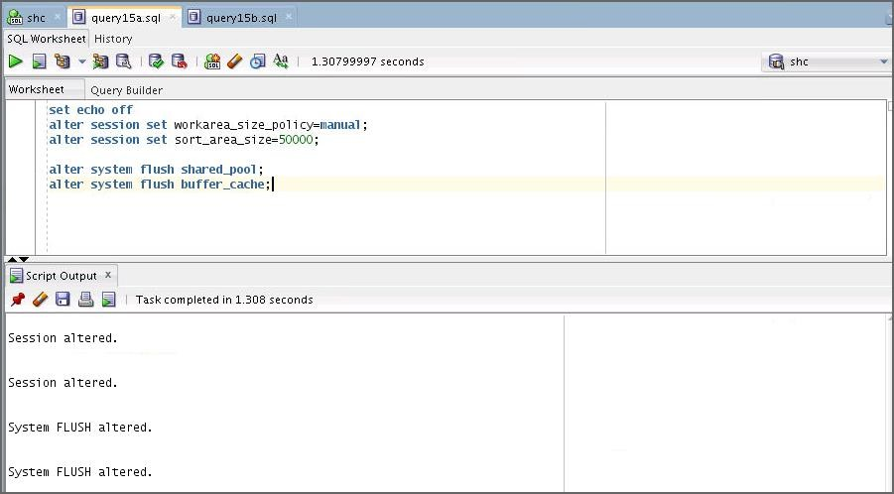Execute the query15a.sql script again.
2. Open and autotrace the query in the query16.sql script as the SHC user. What do you observe?

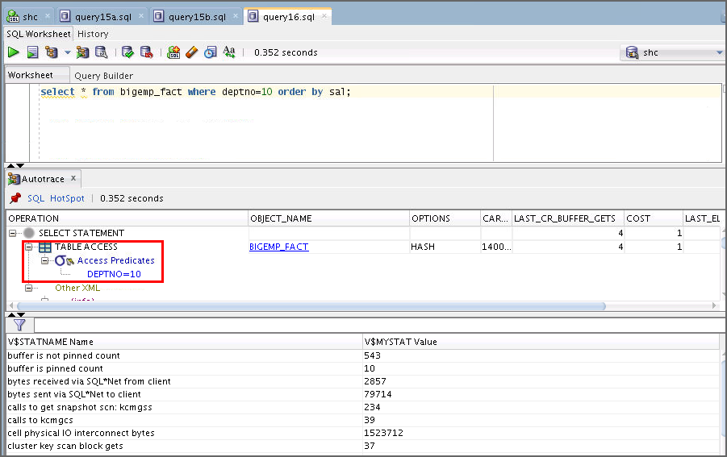

* The script executes a slightly different query, one that requires ordering the result based on the sorted sal column. The optimizer can still use the cluster access path without sorting the data. The cost is still minimal.

1. 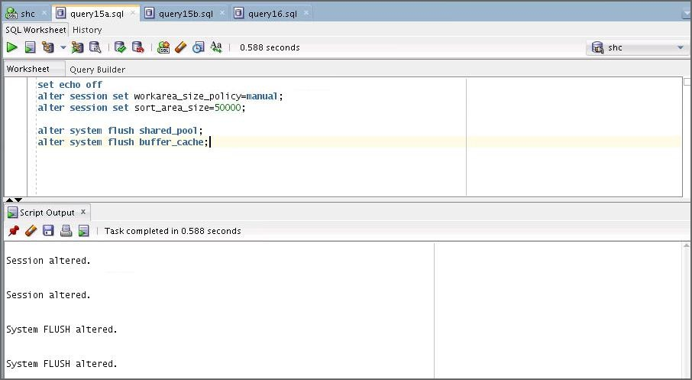Execute the query15a.sql script again.
2. 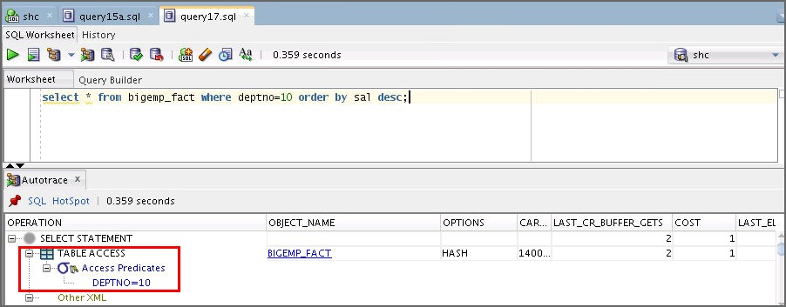Autotrace the query in the query17.sql script. What do you observe?

* The query17.sql script executes the query; the difference is that the result is ordered based on the sorted sal column in descending order. The optimizer can still use the cluster access path without sorting the data. The cost is still minimal.

1. Execute the query15a.sql script again.

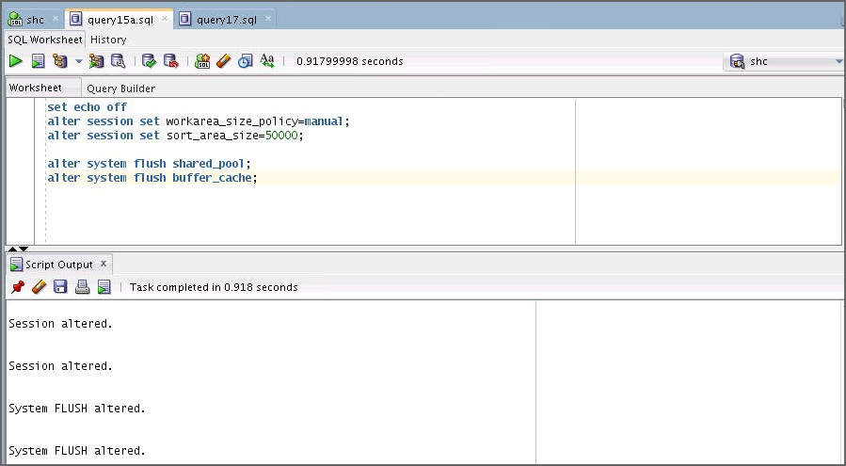

1. 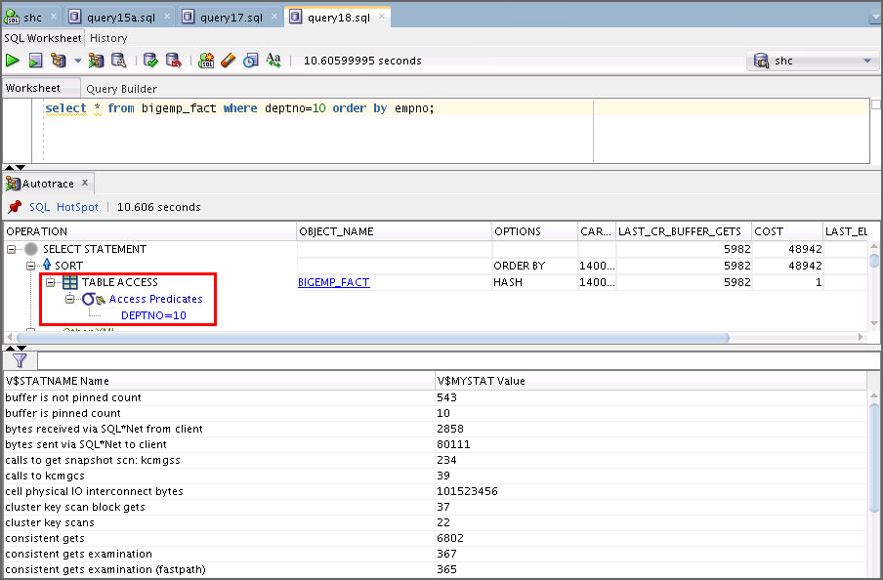Open and autotrace the query in the query18.sql script as the SHC user. What do you observe?

* The script executes the same query, but this time asks to order the result based on the nonsorted empno column. The optimizer can still make use of the cluster access path, but must sort the data making the cost of the query higher.

1. 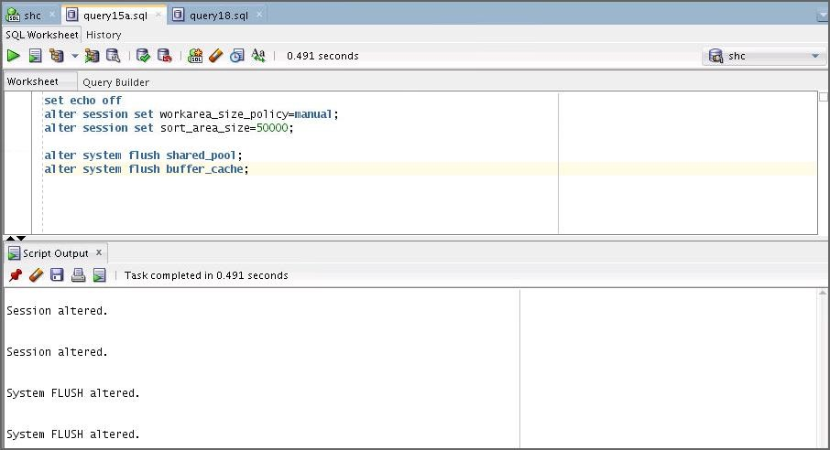Execute the query15a.sql script again.
2. 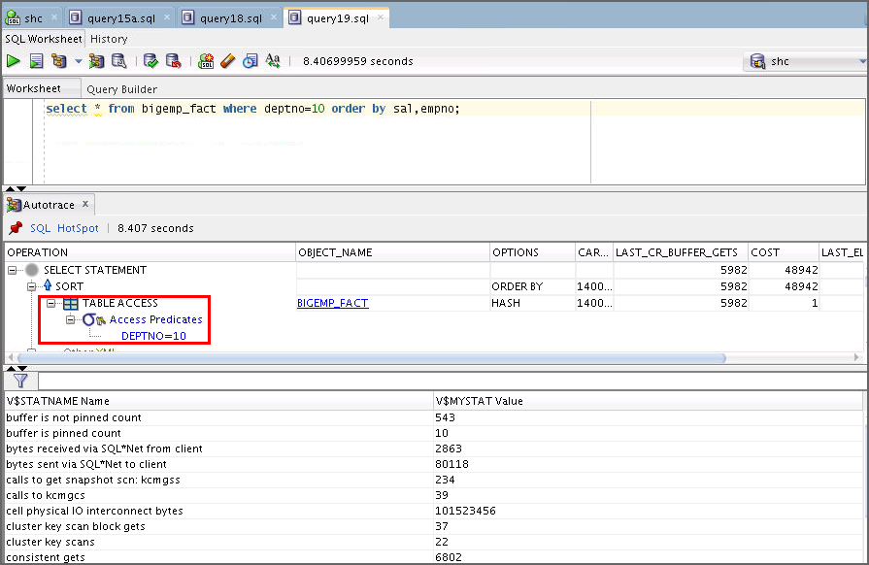Autotrace the query in the query19.sql script. What do you observe?

* The script executes the same query, but this time asks to order the result based on the sal, empno key. The optimizer can make use of the cluster access path, but must sort the data making the cost of the query higher.

1. **Case 3: Using Index Cluster:** The nic_setup.sql script was executed as part of the setup for this practice. This script creates and populates the nic schema to set up your environment for this case. It creates large emp and dept tables. Each of these tables has an index on the deptno value. The nic_setup.sql script is listed as follows:

-- run with sqlplus /nolog connect sys/fenago as sysdba

alter session set container = orclpdb; DROP user NIC cascade;

create user nic identified by nic; GRANT DBA to NIC;

GRANT SELECT_CATALOG_ROLE to NIC;

GRANT select any dictionary to NIC; connect nic/nic@orclpdb

set echo on

drop cluster emp_dept including tables;

drop table emp purge; drop table dept purge;

CREATE TABLE emp (

empno NUMBER(7) , ename VARCHAR2(15) NOT NULL, job VARCHAR2(9) ,

mgr NUMBER(7) ,

hiredate DATE ,

sal NUMBER(7) ,

comm NUMBER(7) ,

deptno NUMBER(3)

);

CREATE TABLE dept (

deptno NUMBER(3) , dname VARCHAR2(14), loc VARCHAR2(14),

c VARCHAR2(500)

);

CREATE INDEX emp_index ON emp(deptno) TABLESPACE users STORAGE (INITIAL 50K

NEXT 50K MINEXTENTS 2

MAXEXTENTS 10

PCTINCREASE 33);

CREATE INDEX dept_index ON dept(deptno) TABLESPACE users STORAGE (INITIAL 50K

NEXT 50K MINEXTENTS 2

MAXEXTENTS 10

PCTINCREASE 33);

begin

for i in 1..999 loop

insert into dept values (i,'D'||i,'L'||i,dbms_random.string('u',500));

end loop; commit;

end;

/

begin

for i in 1..500000 loop insert into emp values

(i,dbms_random.string('u',15),dbms_random.string('u',9),i,sysdate,i,i, mod(i,999));

end loop; commit;

end;

/

exec dbms_stats.gather_schema_stats('NIC'); exit;

1. Create a connection for the nic user.
   1. Click the New Connection button.
   2. Create a connection with the following specifications: Name: nic

Username: nic

Password: nic

Select “Save Password.” Service Name: orclpdb Click Test.

Click Connect.

1. Use the nic connection to execute the nic_query_a.sql script.

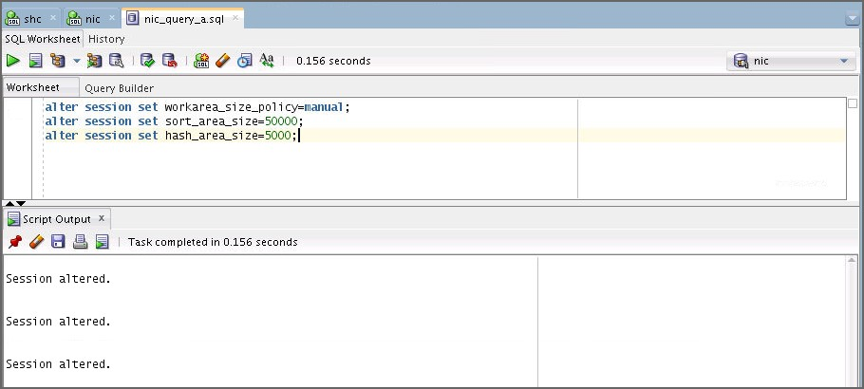**Note:** sort_area_size remains small and hash_area_size is also set to a small value.

1. 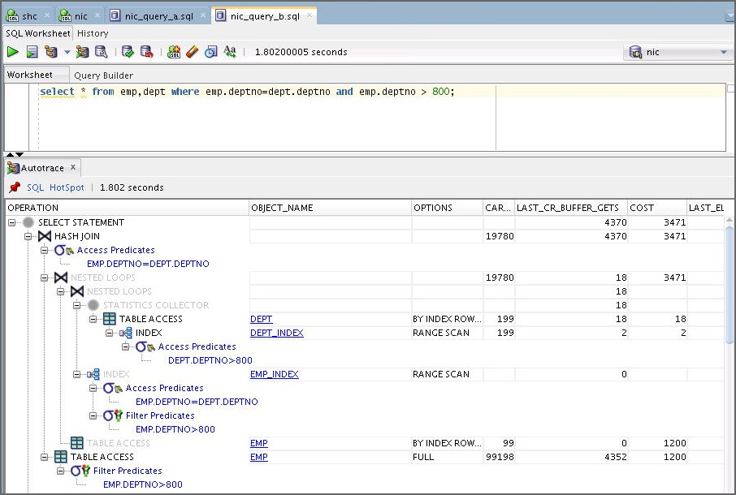Open and autotrace the query in the nic_query_b.sql script as the NIC user. What do you observe?

The script executes a join between the EMP and DEPT tables. The optimizer is able to make use of the index to resolve the join.

1. How would you enhance the performance of the previous query? Implement your solution.

The ic user was created in the setup of the practices with the ic_setup.sql script to create an index cluster to store the two tables. These tables have exactly the same rows in both the nic and ic schemas. This script creates an index cluster containing the emp and dept tables. The rows of these tables are stored together clustered by the deptno value. This script is listed as follows:

-- run with sqlplus /nolog

connect sys/fenago as sysdba

alter session set container = orclpdb;

DROP user IC cascade;

CREATE USER ic IDENTIFIED BY ic; GRANT DBA TO ic;

GRANT SELECT_CATALOG_ROLE TO ic; GRANT SELECT ANY DICTIONARY TO ic;

connect ic/ic@orclpdb set echo on

drop table emp purge; drop table dept purge;

drop cluster emp_dept including tables;

CREATE CLUSTER emp_dept (deptno NUMBER(3)) SIZE 600

TABLESPACE users STORAGE (INITIAL 200K

NEXT 300K MINEXTENTS 2

PCTINCREASE 33);

CREATE TABLE emp (

empno ename job mgr

hiredate sal

comm

NUMBER(7)

,

VARCHAR2(15) NOT NULL,

VARCHAR2(9) NUMBER(7) DATE NUMBER(7)

NUMBER(7)

,

,

,

,

,

deptno

NUMBER(3))

CLUSTER emp_dept (deptno);

CREATE TABLE dept (

deptno NUMBER(3) , dname VARCHAR2(14), loc VARCHAR2(14),

c VARCHAR2(500))

CLUSTER emp_dept (deptno);

CREATE INDEX emp_dept_index ON CLUSTER emp_dept TABLESPACE users

STORAGE (INITIAL 50K NEXT 50K MINEXTENTS 2

MAXEXTENTS 10

PCTINCREASE 33);

begin

for i in 1..999 loop insert into dept values

(i,'D'||i,'L'||i,dbms_random.string('u',500)); end loop;

commit; end;

/

begin

for i in 1..500000 loop insert into emp values

(i,dbms_random.string('u',15),dbms_random.string('u',9),i,sysdate,i,i, mod(i,999));

end loop; commit;

end;

/

exec dbms_stats.gather_schema_stats('IC'); exit;

1. Create a connection for the ic user.
   1. Click the New Connection button.
   2. Create a connection with the following specifications:

Name: ic Username: ic Password: ic

Select “Save Password.” Service Name: orclpdb Click Test.

Click Connect.

1. 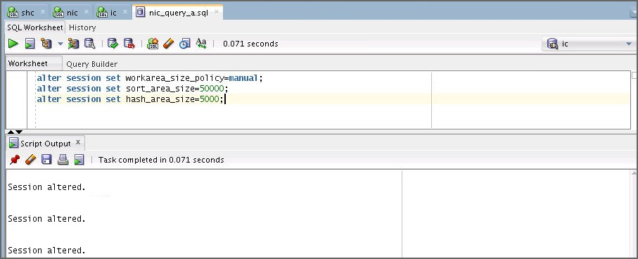Open and execute the nic_query_a.sql script as the ic user.
2. Use the ic connection to autotrace the query in the nic_query_b.sql script again.

select *

from emp,dept

where emp.deptno=dept.deptno and emp.deptno > 800;

What do you observe?

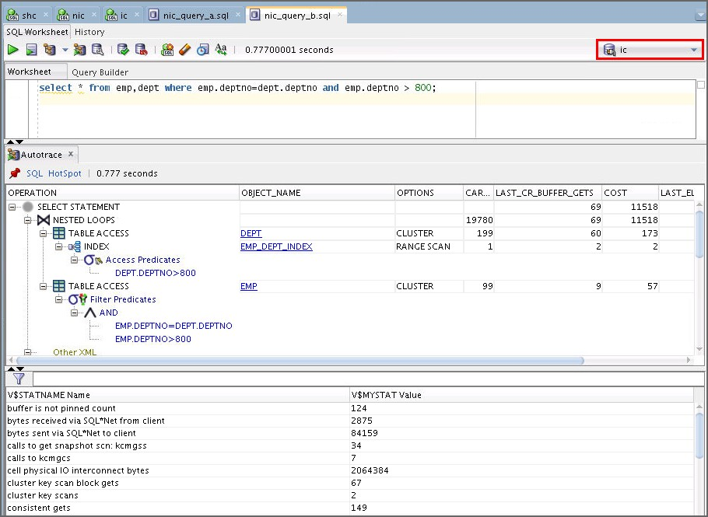

* + The optimizer is able to use the cluster access path that makes the query execute faster.

1. **Important:** Close all connections to the SH user. In SQL Developer, find and close all sh_connection windows. Select sh_connection in the Connections pane and disconnect. Close all SQL*Plus sessions.
2. Execute the ap_cleanup.sh script to clean up your environment for this practice. This script rebuilds the SH schema. If the User dropped message does not appear, or there is an error message in place of it, wait until the script finishes, find and exit from any sessions that are connected as the SH user, and then execute this script again.

**Note:** Ignore the OLAP errors.

$ cd /home/oracle/labs/solutions/Access_Paths/

$ ./ap_cleanup.sh

$ ORACLE_SID = [orcl]?

…

Connected to:…

SQL>

SQL> @ORACLE_HOME/demo/schema/sales_history/sh_main sh users temp fenago

/u01/app/oracle/product/12.2.0/dbhome_1/demo/schema/sales_histor y/ /home/oracle/ v3 localhost:1521/orclpdb

SQL> Rem

SQL> Rem $Header: rdbms/demo/schema/sales_history/sh_main.sql

/main/12 2015/03/19 10:23:26 smtaylor Exp $ SQL> Rem

SQL> Rem sh_main.sql SQL> Rem

SQL> Rem Copyright (c) 2001, 2015, Oracle and/or its affiliates. All rights reserved.

SQL> Rem

SQL> Rem NAME

SQL> Rem sh_main.sql - Main schema creation and load script

SQL> Rem

SQL> Rem DESCRIPTION

SQL> Rem SH is the Sales History schema of the Oracle Sample

SQL> Rem Schemas SQL> Rem

SQL> Rem NOTES

SQL> Rem CAUTION: use absolute pathnames as parameters 5 and 6.

SQL> Rem Example (UNIX) echo

$ORACLE_HOME/demo/schema/sales_history

SQL> Rem Please make sure that parameters 5 and 6 are specified

SQL> Rem INCLUDING the trailing directory delimiter, since the

SQL> Rem directory parameters and the filenames are concatenated

SQL> Rem without adding any delimiters. SQL> Rem Run this as SYS or SYSTEM

SQL> Rem

SQL> Rem MODIFIED (MM/DD/YY)

SQL> Rem smtaylor 03/19/15 - added parameter 8, connect_string

SQL> Rem smtaylor 03/19/15 - added @&connect_string to CONNECT

SQL> Rem smtaylor 03/19/15 - added pararmeter &connect_string to script calls

SQL> Rem awesley 04/03/12 - Remove cwm_user

SQL> Rem jmadduku 02/18/11 - Grant Unlimited Tablespace priv with RESOURCE

SQL> Rem cbauwens 03/06/08 - NLS settings for load SQL> Rem cbauwens 07/10/07 - NLS fix bug 5684394

SQL> Rem glyon 06/28/07 - grant CWM_USER role, if it exists

SQL> Rem cbauwens 02/23/05 - depricating connect role

SQL> Rem ahunold 10/14/02 -

* Rem hyeh 08/29/02 - hyeh_mv_comschema_to_rdbms

|  |  |  |  |  |
| --- | --- | --- | --- | --- |
| SQL> | Rem | ahunold | 08/20/02 | - path > dir |
| SQL> | Rem | ahunold | 08/15/02 | - versioning |
| SQL> | Rem | ahunold | 04/30/02 | - Reduced DIRECTORY privileges |
| SQL> | Rem | ahunold | 08/28/01 | - roles |
| SQL> | Rem | ahunold | 07/13/01 | - NLS Territory |
| SQL> | Rem | ahunold | 04/13/01 | - spool, notes |
| SQL> | Rem | ahunold | 04/10/01 | - flexible log and data paths |
| SQL> | Rem | ahunold | 03/28/01 | - spool |
| SQL> | Rem | ahunold | 03/23/01 | - absolute path names |
| SQL> | Rem | ahunold | 03/14/01 | - prompts |
| SQL> | Rem | ahunold | 03/09/01 | - privileges |
| SQL> | Rem | hbaer | 03/01/01 | - changed loading from COSTS |

table from

SQL> Rem SQL*Loader to external table with GROUP BY

SQL> Rem Added also CREATE DIRECTORY privilege

SQL> Rem SQL>

SQL> SET ECHO OFF

specify password for SH as parameter 1:

specify default tablespace for SH as parameter 2:

specify temporary tablespace for SH as parameter 3:

specify password for SYS as parameter 4:

specify directory path for the data files as parameter 5:

writeable directory path for the log files as parameter 6:

specify version as parameter 7:

specify connect string as parameter 8:

Session altered.

##### User dropped.

**old 1: CREATE USER sh IDENTIFIED BY &pass new 1: CREATE USER sh IDENTIFIED BY sh**

User created.

old 1: ALTER USER sh DEFAULT TABLESPACE &tbs new 1: ALTER USER sh DEFAULT TABLESPACE example old 2: QUOTA UNLIMITED ON &tbs

new 2: QUOTA UNLIMITED ON example

User altered.

old 1: ALTER USER sh TEMPORARY TABLESPACE &ttbs new 1: ALTER USER sh TEMPORARY TABLESPACE temp

User altered.

Grant succeeded.

…

<<<<< FINAL PROCESSING >>>>>

- Changes have been committed

PL/SQL procedure successfully completed.

Commit complete.

gathering statistics ...

PL/SQL procedure successfully completed.

PL/SQL procedure successfully completed. Disconnected …

$

# Practices for Lesson 10: Introduction to Optimizer Statistics Concepts

## Practices for Lesson 10: Overview

### Practices Overview

In these practices, you perform the following:

* Experiment with the index clustering factor
* Create expression statistics
* Enable automatic statistics gathering (optional)
* Use system statistics (optional)

## Practice 10-1: Index Clustering Factor

### Overview

In this practice, you experiment with the index clustering factor. Here, you learn how the optimizer uses the index clustering factor to determine whether using an index is more effective than a full table scan.

### Tasks

1. Start SQLDeveloper.
2. 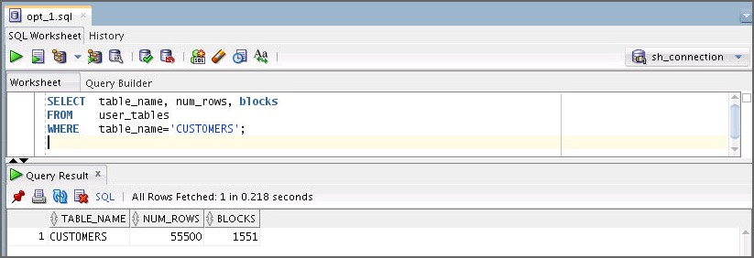Change directories to $HOME/labs/solutions/Optimizer_Statistics. Start a SQL Developer session, connect to the database as the SH user, and then query the number of rows and blocks in the sh.customers table. Use the opt_1.sql file.

SELECT table_name, num_rows, blocks FROM user_tables

WHERE table_name='CUSTOMERS';

Note: If SH connection isn’t there, then create a one by using the following specifications: Name: sh

Username: sh

Password: sh

Select “Save Password.” Service Name: orclpdb Click Test.

Click Connect.

1. 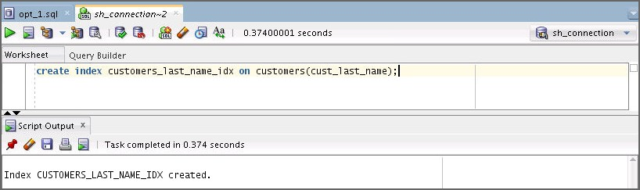Drop all the CUSTOMERS indexes, except its primary key index. Open a terminal window. Connect to sh and drop all the indexes that are currently created on the CUSTOMERS table, except its primary key index, by executing drop_customers_indexes.sqlscript. And create an index on the customers.cust_last_name column. Use the opt_2.sql file.

**$ cd /home/oracle/labs/solutions/Access_Paths/**

**$ sqlplus sh/sh@orclpdb**

…

Connected to:…

SQL> **@drop_customers_indexes.sql**

CREATE INDEX CUSTOMERS_LAST_NAME_IDX ON

customers(cust_last_name);

1. Query the index clustering factor of the newly created index. The following query shows that the customers_last_name_idx index has a high clustering factor because the clustering factor is significantly more than the number of blocks in the table. Use the opt_3.sql file.

SELECT index_name, blevel, leaf_blocks, clustering_factor FROM user_indexes

WHERE table_name='CUSTOMERS'

AND index_name= 'CUSTOMERS_LAST_NAME_IDX';

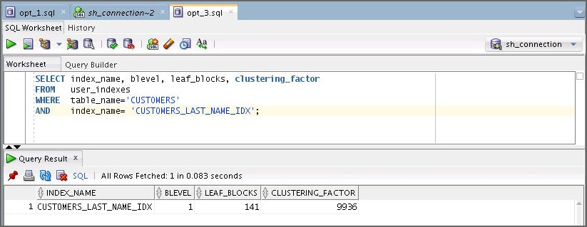

1. Create a new copy of the customers table, with rows ordered by cust_last_name. Use the opt_4.sql file.

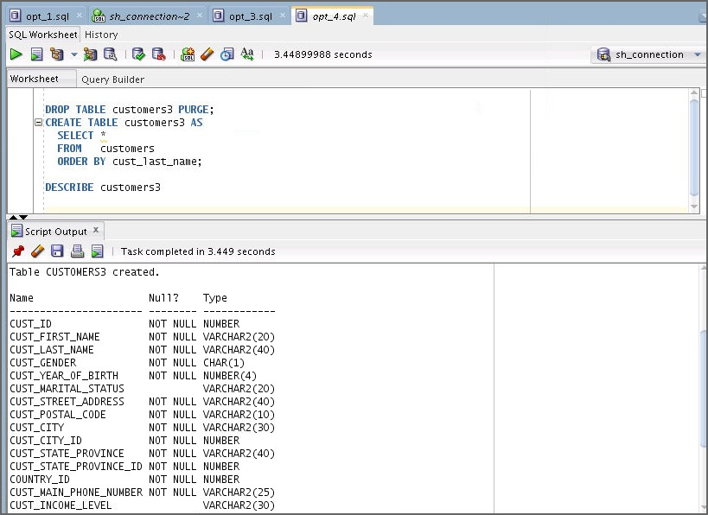

DROP TABLE customers3 PURGE; CREATE TABLE customers3 AS

SELECT *

FROM customers

ORDER BY cust_last_name;

DESCRIBE customers3;

##### …

1. Gather statistics on the CUSTOMERS3 table. Use the opt_5.sql file.

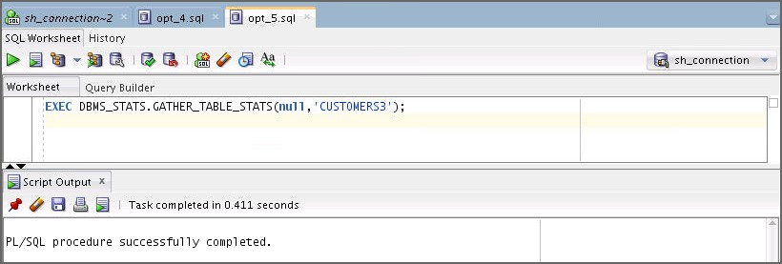

EXEC DBMS_STATS.GATHER_TABLE_STATS(null,'CUSTOMERS3');

1. Query the number of rows and blocks in the CUSTOMERS3 table by using the following code. Use the opt_6.sql file.

SELECT FROM

WHERE

TABLE_NAME, NUM_ROWS, BLOCKS USER_TABLES

TABLE_NAME='CUSTOMERS3';

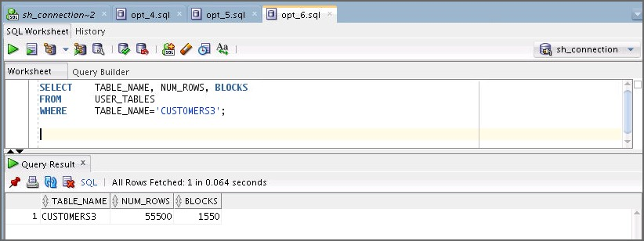

1. Create an index on the cust_last_name column of the CUSTOMERS3 table. Use the

opt_7.sql file.

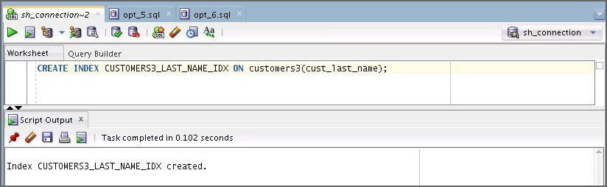

CREATE INDEX CUSTOMERS3_LAST_NAME_IDX ON

customers3(cust_last_name);

1. 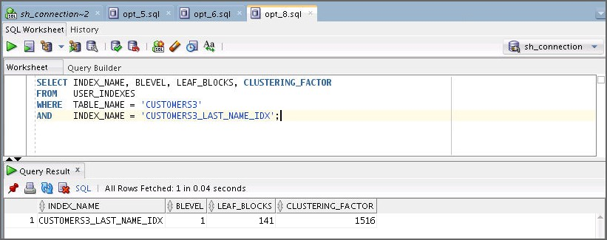Query the index clustering factor of the customers3_last_name_idx index. The following query shows that the customers3_last_name_idx index has a lower clustering factor. Use the opt_8.sql file.

SELECT INDEX_NAME, BLEVEL, LEAF_BLOCKS, CLUSTERING_FACTOR FROM USER_INDEXES

WHERE TABLE_NAME = 'CUSTOMERS3'

AND INDEX_NAME = 'CUSTOMERS3_LAST_NAME_IDX';

**Note:** The CUSTOMERS3 table has the same data as the original customers table, but the index on CUSTOMERS3 has a much lower clustering factor because the data in the table is ordered by cust_last_name. The clustering factor is now about 10 times the number of blocks instead of 70 times.

1. Query the CUSTOMERS table. Use the opt_9.sql file.

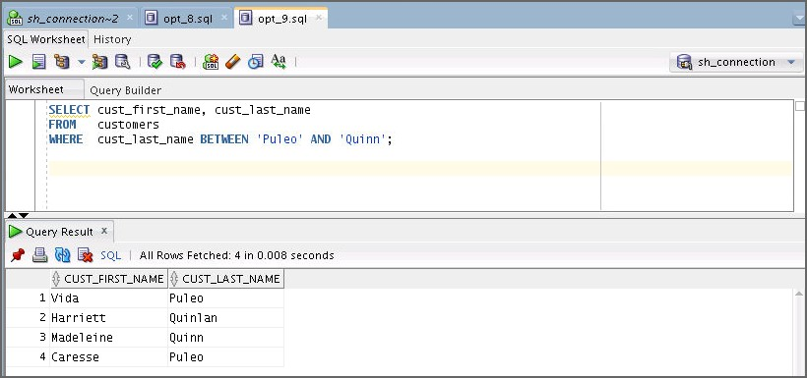

SELECT cust_first_name, cust_last_name FROM customers

WHERE cust_last_name BETWEEN 'Puleo' AND 'Quinn';

1. 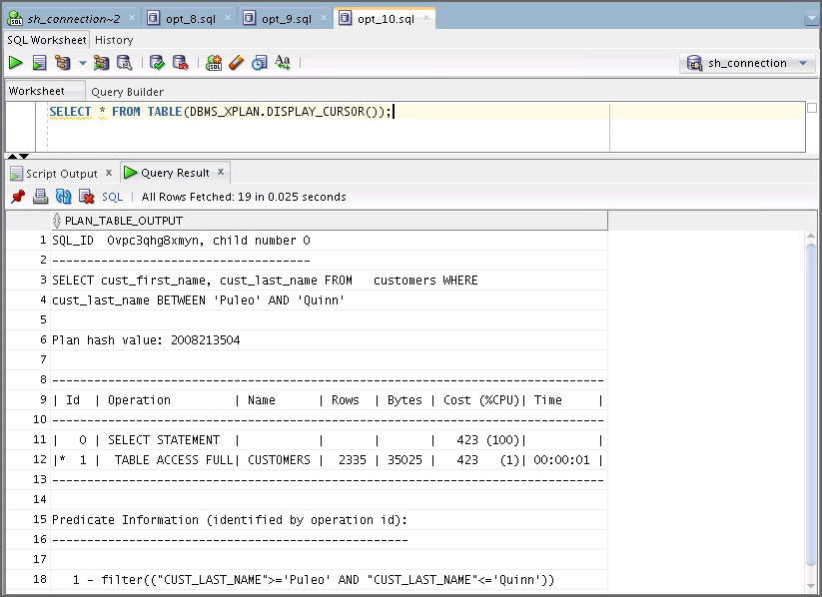Execute the following query to display the cursor for the query. Use the opt_10.sql file.

SELECT * FROM TABLE(DBMS_XPLAN.DISPLAY_CURSOR());

1. Query the CUSTOMERS3 table. Use the opt_11.sql file.

SELECT cust_first_name, cust_last_name FROM customers3

WHERE cust_last_name BETWEEN 'Puleo' AND 'Quinn';

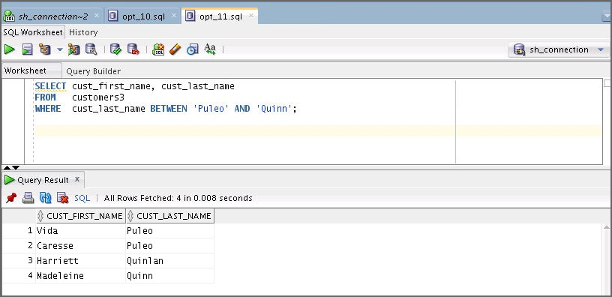

1. Execute the following query to display the cursor for the query. Use the opt_12.sql file.

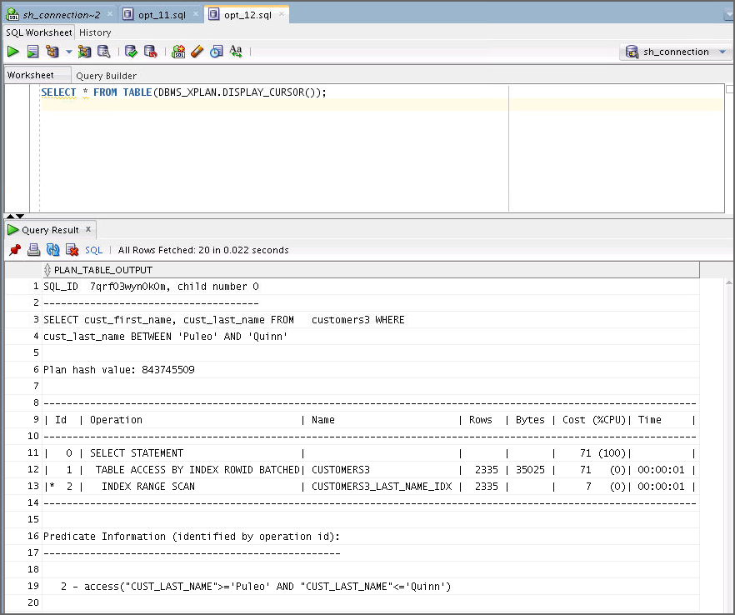

SELECT * FROM TABLE(DBMS_XPLAN.DISPLAY_CURSOR());

## Practice 10-2: Creating Expression Statistics

In this practice, you investigate the use of expression statistics.

1. You can find all the necessary scripts for this practice in your

$HOME/labs/solutions/Optimizer_Statistics directory.

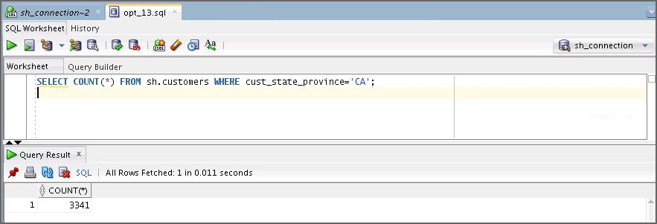Run the following query on the CUSTOMERS table or use the opt_13.sql file.

SELECT COUNT(*) FROM sh.customers WHERE cust_state_province='CA';

1. Run the EXPLAIN PLAN command for the same query with the LOWER() function applied. Use the opt_14.sql file.

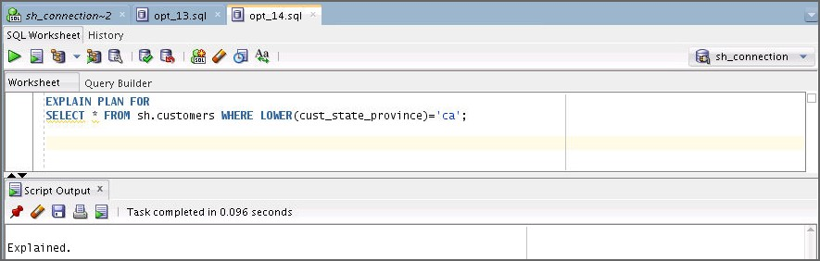

EXPLAIN PLAN FOR

SELECT * FROM sh.customers WHERE LOWER(cust_state_province)='ca';

1. 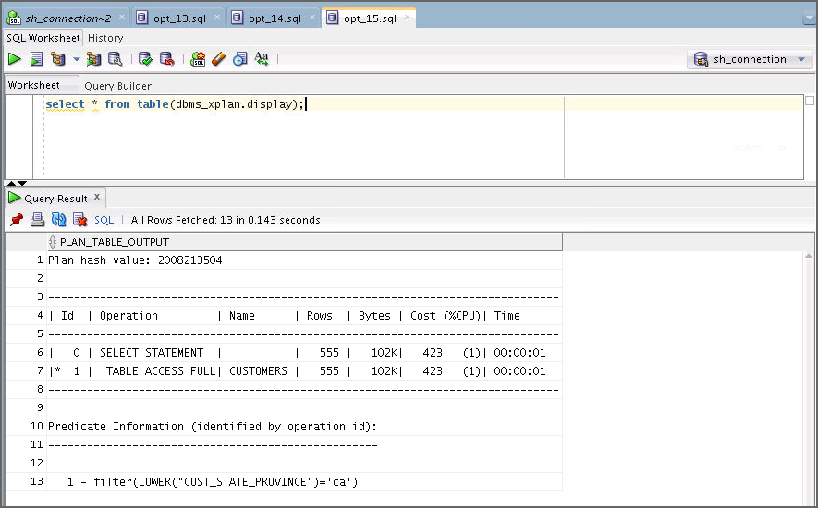Run the query to display the plan. Use the opt_15.sql file.

select * from table(dbms_xplan.display);

**Note:** Because no expression statistics exist for LOWER(cust_state_province)='ca', the optimizer estimate is significantly off. You can use DBMS_STATS procedures to correct these estimates.

1. You can use DBMS_STATS to create statistics for a user-specified expression. Gather table statistics using the following code. Use the opt_16.sql file.

BEGIN

DBMS_STATS.GATHER_TABLE_STATS( 'sh','customers', method_opt => 'FOR ALL COLUMNS SIZE SKEWONLY FOR

COLUMNS(LOWER(cust_state_province)) SIZE SKEWONLY'); END;

/

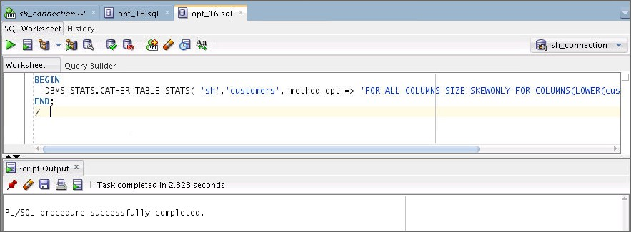

1. You can use the database view DBA_STAT_EXTENSIONS and

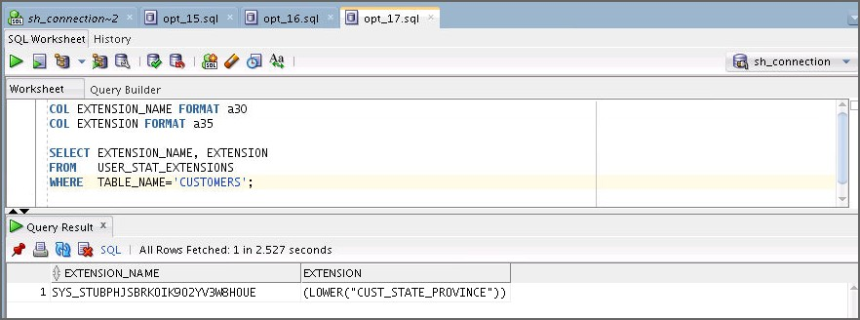the DBMS_STATS.SHOW_EXTENDED_STATS_NAME function to obtain information about expression statistics. Query the name and definition of the statistics extension by using the following code or use the opt_17.sql file:

COL EXTENSION_NAME FORMAT a30 COL EXTENSION FORMAT a35

SELECT EXTENSION_NAME, EXTENSION FROM USER_STAT_EXTENSIONS

WHERE TABLE_NAME='CUSTOMERS';

1. Run the following code to query the number of distinct values and find whether a histogram has been created for the expression. Use the opt_18.sql file.

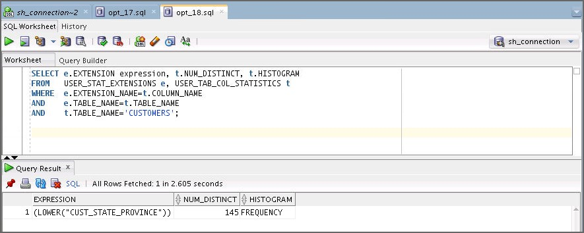

SELECT e.EXTENSION expression, t.NUM_DISTINCT, t.HISTOGRAM FROM USER_STAT_EXTENSIONS e, USER_TAB_COL_STATISTICS t WHERE e.EXTENSION_NAME=t.COLUMN_NAME

AND e.TABLE_NAME=t.TABLE_NAME

AND t.TABLE_NAME='CUSTOMERS';

1. You created extended statistics for the LOWER(cust_state_province) expression. Now to drop the expression statistics, use the following code. Use the opt_19.sql file.

BEGIN

DBMS_STATS.DROP_EXTENDED_STATS('sh','customers','(LOWER(cust_stat e_province))');

END;

/

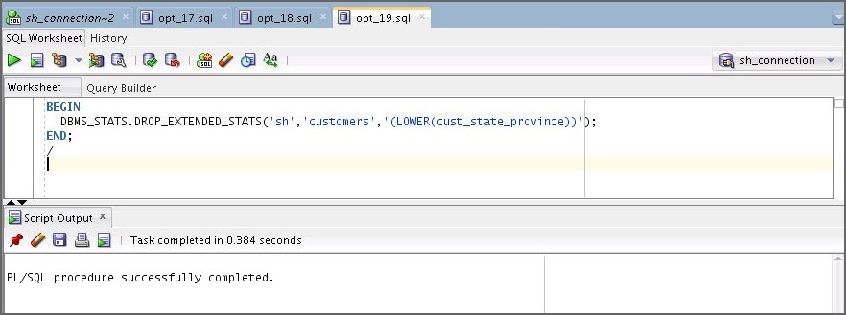

1. Drop all the CUSTOMERS indexes, except its primary key index. Open a terminal window. Connect to sh and drop all the indexes that are currently created on the CUSTOMERS table, except its primary key index, by executing the drop_customers_indexes.sql script. And create an index on the customers.cust_last_name column. Use the opt_2.sql file.

**$ cd /home/oracle/labs/solutions/Access_Paths/**

**$ sqlplus sh/sh@orclpdb**

…

Connected to:…

SQL> **@drop_customers_indexes.sql**

## Practice 10-3: Enabling Automatic Statistics Gathering (Optional)

In this practice, you manipulate object statistics to see the effect of your SQL statements on the execution plans.

**Note:** All the scripts needed for this practice can be found in your

$HOME/labs/solutions/Automatic_Gather_Stats directory.

1. Note: The environment for this practice has been set up with the ags_setup.sh script. This script created a user called AGS that you use throughout this practice. The script also created a table called EMP and an index. The script is listed as follows:

#!/bin/bash

cd /home/oracle/labs/solutions/Automatic_Gather_Stats sqlplus / as sysdba @ags_setup.sql

alter session set container = orclpdb;

set echo on

drop user ags cascade;

create user ags identified by ags; grant dba to ags;

connect ags/ags@orclpdb drop table emp purge;

create table emp (

empno number,

ename varchar2(20), phone varchar2(20), deptno number

);

insert into emp with tdata as

(select rownum empno

from all_objects

where rownum <= 1000) select rownum,

dbms_random.string ('u', 20),

dbms_random.string ('u', 20), case

when rownum/100000 <= 0.001 then mod(rownum, 10) else 10

end

from tdata a, tdata b where rownum <= 100000;

commit;

create index emp_i1 on emp(deptno); exit;

1. Execute the ags_start.sql script in SQL*Plus from the

$HOME/labs/solutions/Automatic_Gather_Stats directory.

$ **cd $HOME/labs/solutions/Automatic_Gather_Stats**

$ **./ags_start.sh**

… SQL>

SQL> connect / as sysdba Connected.

SQL>

SQL> alter system flush shared_pool; System altered.

SQL> SQL> --

SQL> -- Turn off AUTOTASK SQL> --

SQL>

SQL> alter system set "_enable_automatic_maintenance"=0; System altered.

SQL>alter session set container = orclpdb;

Session altered.

SQL>

SQL> exec dbms_stats.delete_schema_stats('AGS'); PL/SQL procedure successfully completed.

SQL>

SQL> exit;

Disconnected …

$

1. Connect as the ags user in a SQL*Plus session.

$ **sqlplus ags/ags@orclpdb**

… SQL>

1. Create a new connection in SQL Developer for the ags user with the following properties: Name: ags

User: ags

Password: ags

Service Name: orclpdb

Click Test. Click Connect.

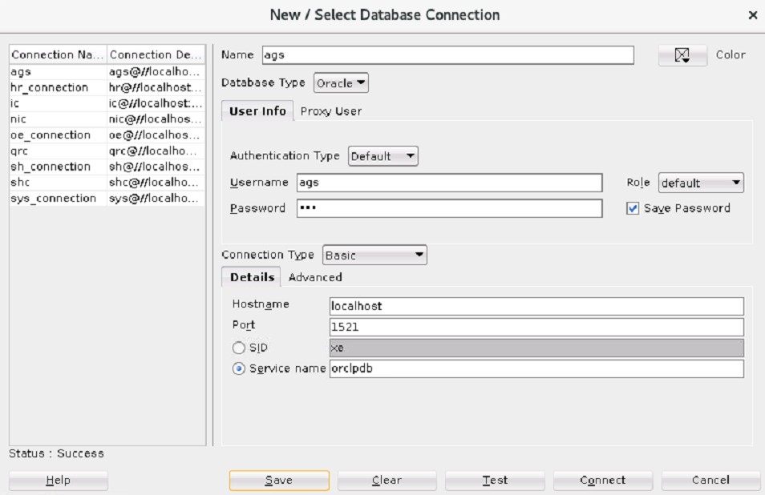

1. Using ags, determine the distribution of the deptno values found in the EMP table. What do you observe?

Open and execute the show_deptno_distribution.sql file in the

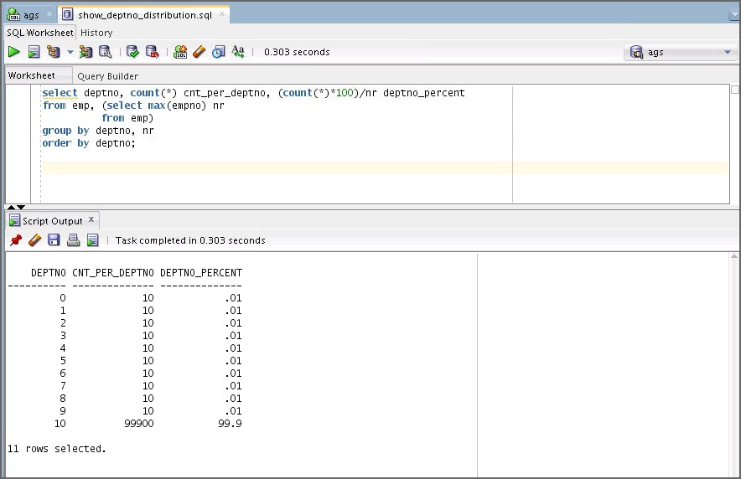$HOME/labs/solutions/Automatic_Gather_Stats directory. You can see that there are 11 department values, each repeating 0.01% of the time, except value 10 that repeats 99.9% of the time.

1. Determine if there are histograms available on any column of the EMP table. What do you observe?

Open the check_emp_histogram.sql file and execute it in SQL Developer. Currently, there are no histograms defined on any column of the EMP table.

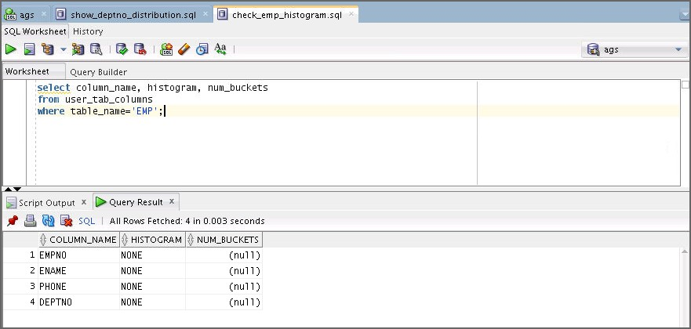

1. Determine if you currently have statistics gathered on your EMP table. What do you observe?
   1. In the SQL Developer navigator pane, click the Connections tab. Expand ags connection, and then the Tables node and the EMP table node. Select the EMP table node.
   2. On the EMP tab, click the Statistics subtab.
   3. 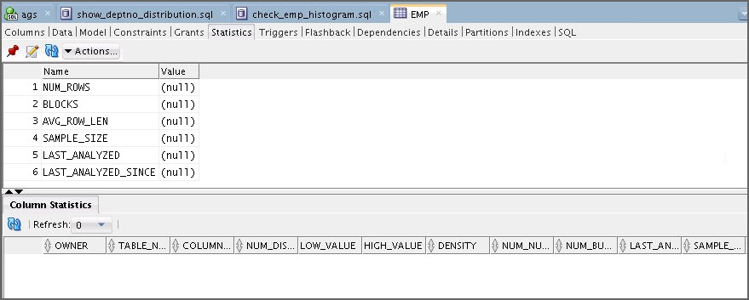Currently, there are no statistics gathered on your EMP table.
2. Determine if you currently have statistics gathered on the index that is created on top of the

EMP table. What do you observe?

* 1. 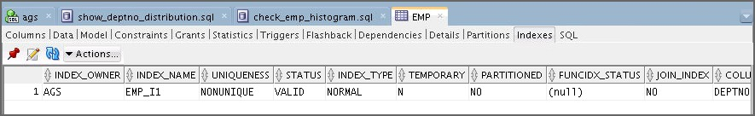Click the Indexes subtab of the EMP pane.
  2. In the Connections navigator pane, under ags connection, expand the indexes node, and then select the EMP_I1 index. In the EMP_I1 pane, click the Statistics subtab. Currently, EMP_I1 has no statistics gathered.

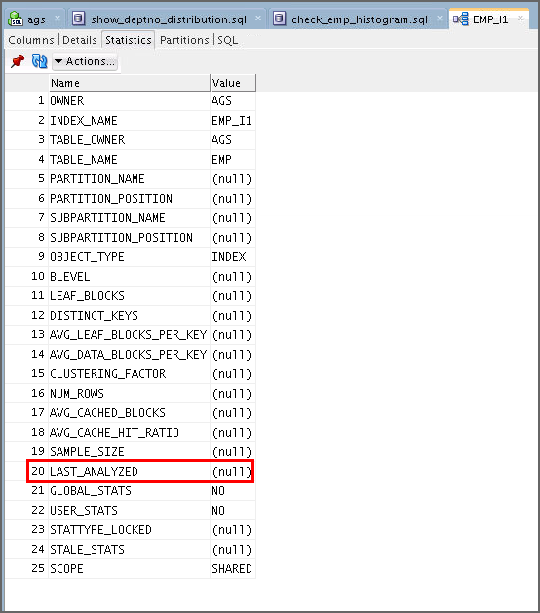

1. Autotrace the following two statements and determine their execution plans:

select count(*), max(empno) from emp where deptno = 9;

select count(*), max(empno) from emp where deptno = 10;

These statements are in the literal9.sql and literal10.sql files. What do you observe and why?

* 1. 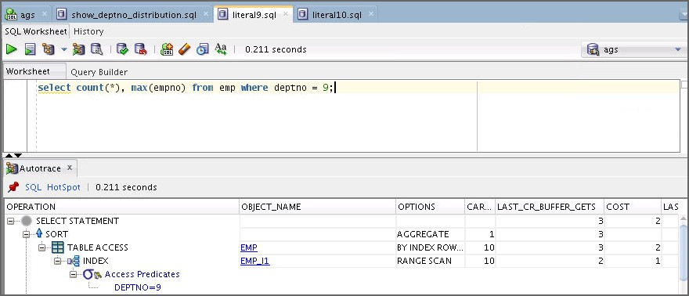Open the literal9.sql file and autotrace using ags. You see that for deptno = 9, the optimizer decided to use the index.
  2. Open the literal10.sql file and autotrace using ags. Notice that for deptno = 10, the optimizer decided to do TABLE ACCESS FULL. The optimizer determined the correct plan in both cases. This is because dynamic statistics was used and there were no statistics gathered on either object.

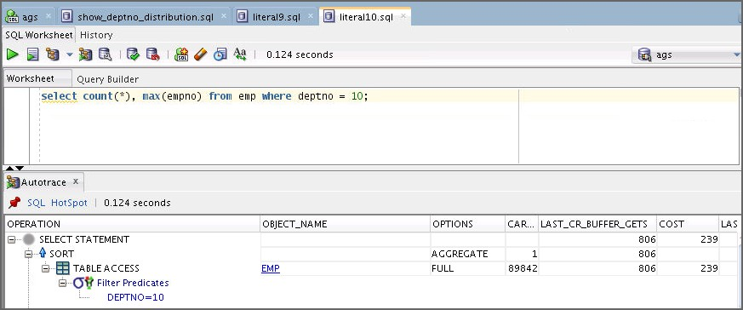

1. Confirm your assumption from the previous step.

On the ags tab, enter the following query and execute:

SELECT * FROM v$parameter WHERE NAME LIKE '%dynamic%';

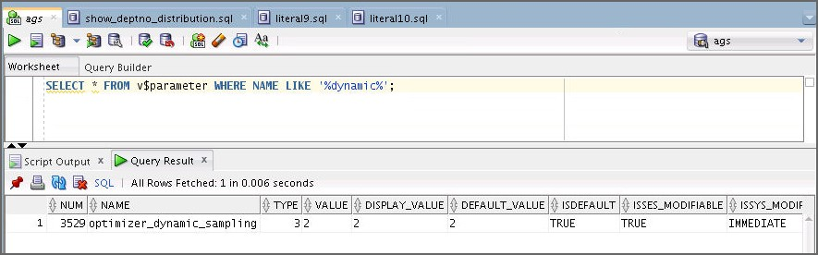**Note:** In SQL Developer, there is only one session for a connection even though there may be multiple windows using that session.

1. Turn off dynamic statistics.
   1. Set the parameter for your session to 0. Use the following command.

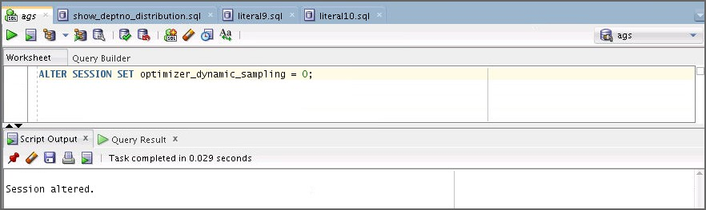ALTER session SET optimizer_dynamic_sampling = 0;

* 1. 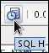Confirm that the parameter has changed. Open SQL_HISTORY , select the

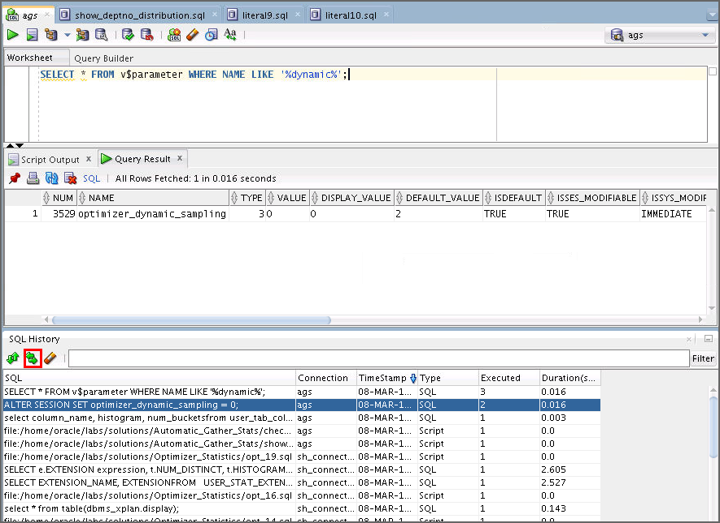select * from V$parameter command, click **Replace**, and execute.

1. Autotrace both literal9.sql and literal10.sql again. What do you observe and why?

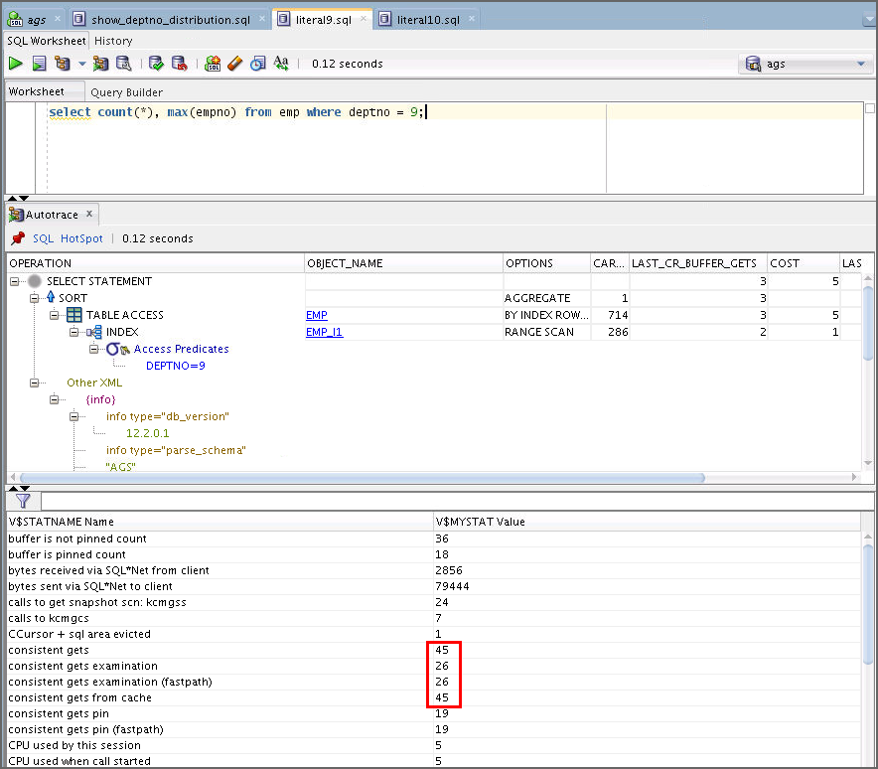Because dynamic statistics is not used, the optimizer cannot use any real-time statistics. It uses default statistics that are not a good choice for the second statement. The cost is estimated to be the same, but when you compare the actual statistics, you can see the difference.

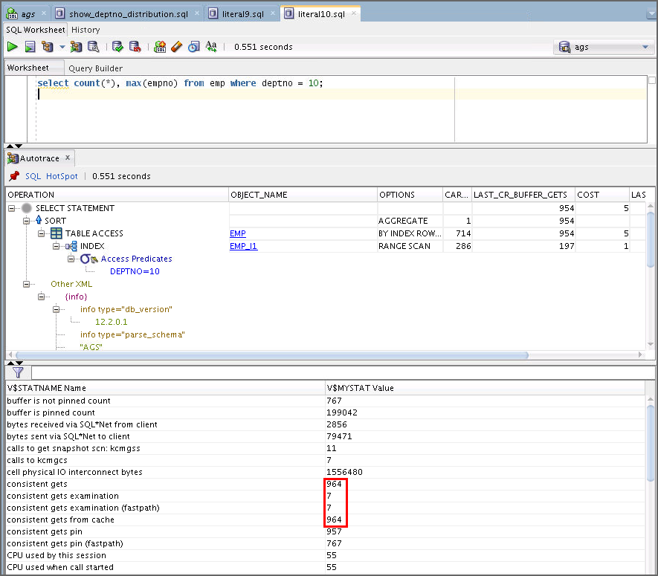

1. Reset dynamic statistics as it was at the beginning of this practice. Use the following command:

ALTER session SET optimizer_dynamic_sampling = 2;

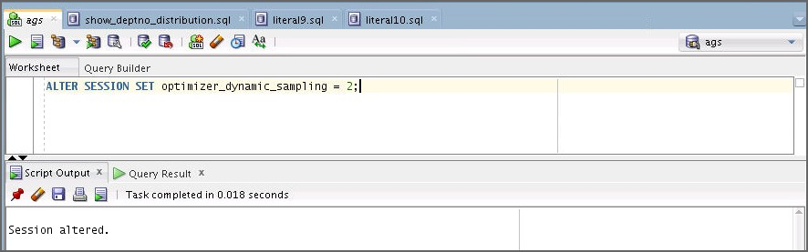

1. Set the following wrong statistic values for your EMP table:

* Set its number of rows to 10.
* Set its number of blocks to 5.

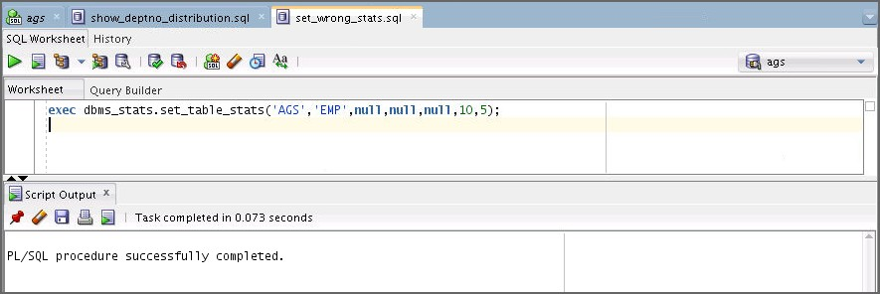Open the set_wrong_stats.sql file and execute.

1. Verify that you modified the statistics of the EMP table correctly.

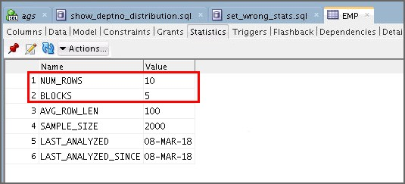In the navigator pane, select the EMP table under ags. On the EMP tab, click the Statistics subtab.

1. Autotrace both literal9.sql and literal10.sql again. What do you observe and why?

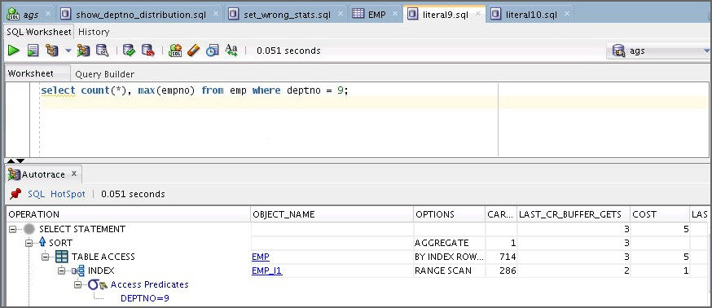Because there are statistics defined on the EMP table, the optimizer uses them, and not dynamic statistics. However, because the statistics are incorrect, the generated plans are also incorrect, at least for the second statement. This is noticeable in the execution time.

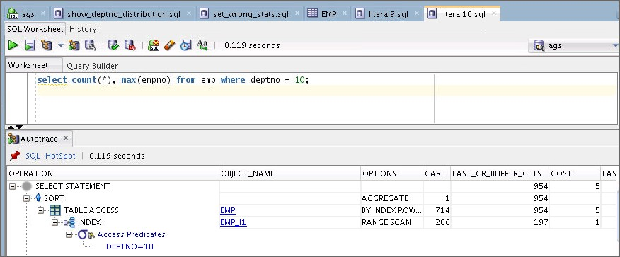

1. Make sure that you manually gather statistics on your EMP table and its corresponding index. Enter the following or execute the gather_stats_manually.sql script:

exec dbms_stats.gather_table_stats('AGS', 'EMP', cascade => true);

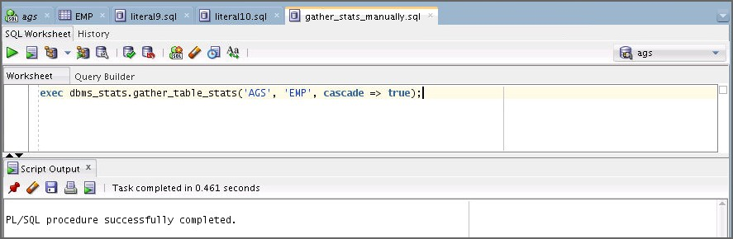

1. 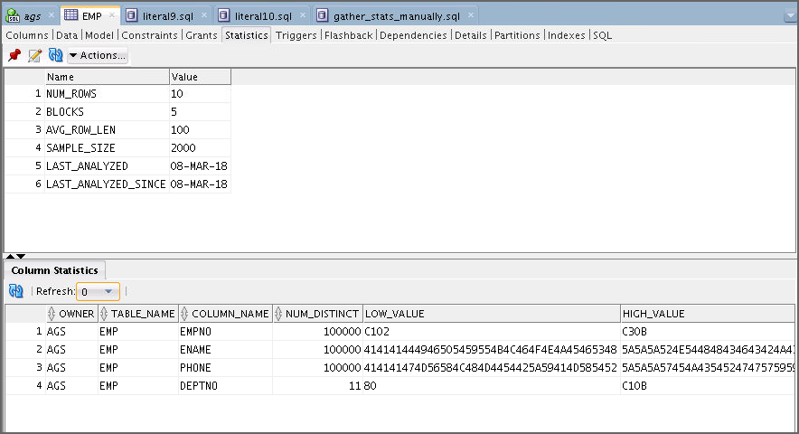Make sure that statistics were gathered on your objects. Select the EMP table in the navigator pane. Click the Statistics subtab on the EMP tab. Click the Refresh button to ensure that the latest statistics are displayed. Notice that Column Statistics are populated.
2. Autotrace both literal9.sql and literal10.sql again. What do you observe and why?

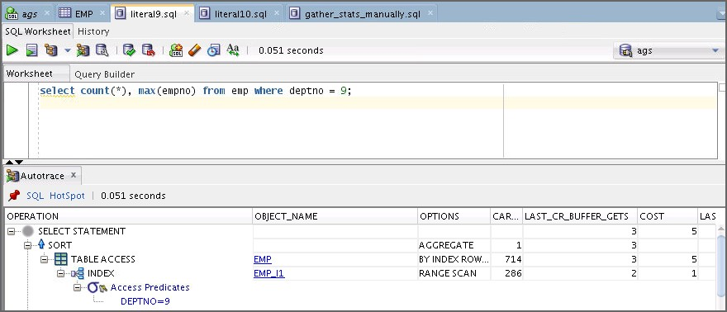Because statistics were correctly gathered on both objects, the optimizer is able to use the correct execution plans for both statements.

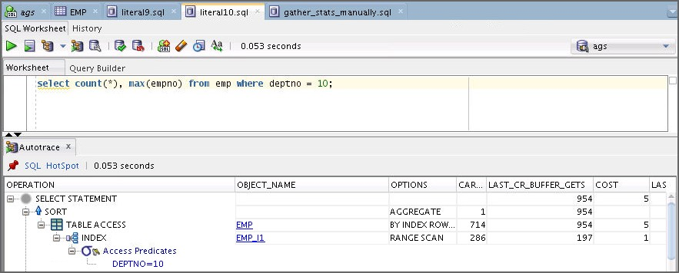

1. Delete all the statistics that were previously generated on the EMP tab and the EMP_I1

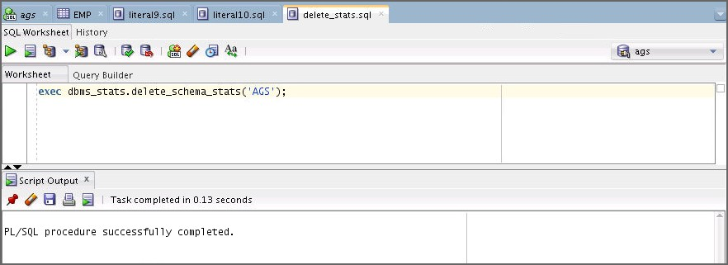index. Open and execute the delete_stats.sql script.

1. Verify that you no longer have statistics gathered on both objects.
   1. In the navigator pane, select the EMP table and click the Statistics subtab on the EMP

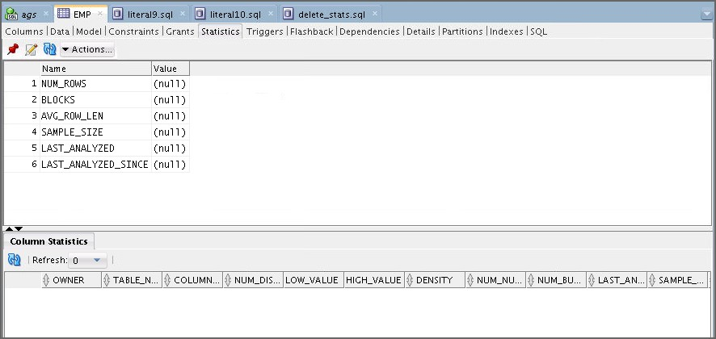tab, and refresh.

* 1. In the navigator pane, select the EMP_I1 index, click the Statistics subtab on the

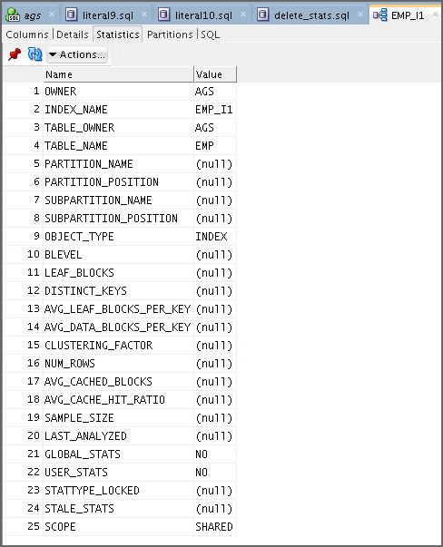EMPI1 tab, and refresh.

1. How would you determine the list of automated tasks that exist on your database?
   1. Use the DBA_AUTOTASK_TASK table as shown by the following statement:

select task_name from dba_autotask_task;

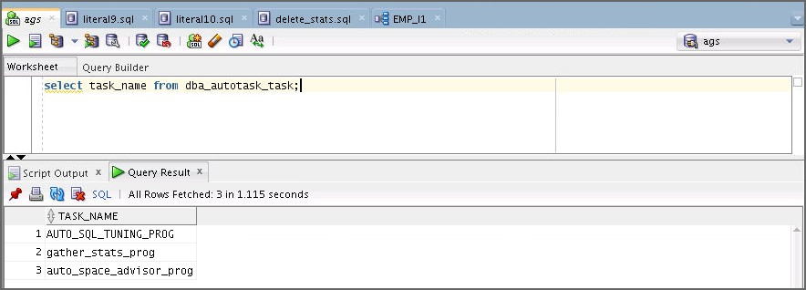

1. You now want to observe the effects of the automatic statistics gathering feature of your database. However, you do not want to wait until the database automatically opens the next maintenance window. Run the following command from the terminal as the sys user:

alter system set “_enable_automatic_maintenance”=1;

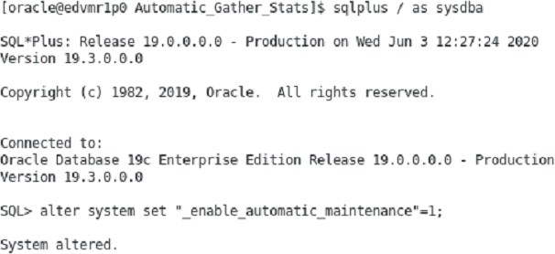

1. From SQL Developer, open and execute the run_ags_pl.sql script. This script forces the execution of the automatic statistics gathering task.
   1. If you do not already have a sys_connection, create a connection as the sysdba user. Name: sys_connection

Username: sys Password: fenago Role: sysdba

Service Name: orclpdb

* 1. Test and save the connection.
  2. Open the run_ags_pl.sql file.
  3. 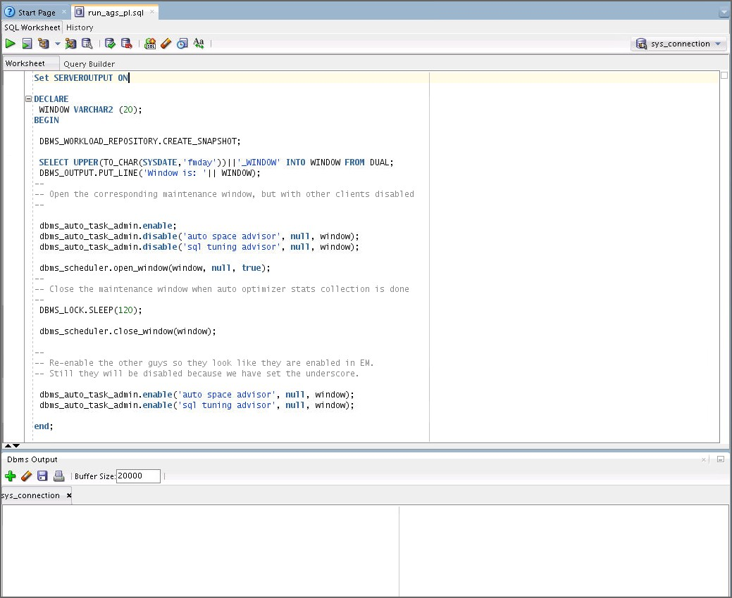Open the Dbms Output pane (View > Dbms Output) and click the green plus sign to connect to sys_connection.
  4. Execute the run_ags_pl.sql script as the sys user. Use the sys_connection

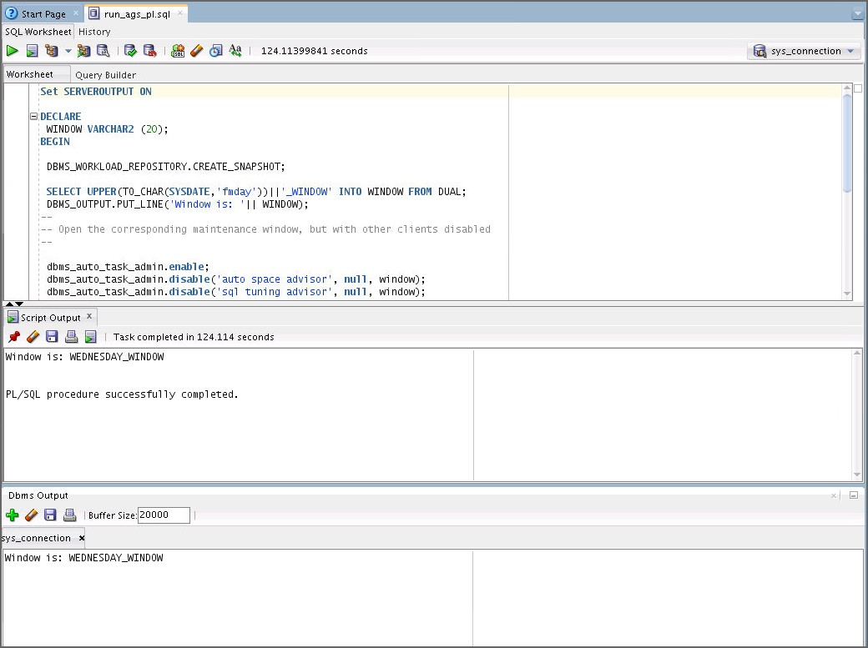connection. This script takes two minutes to run.

* 1. Close the Dbms Output pane.

1. Navigate to the EMP table and view the statistics. Be sure to refresh the view. What do you observe and why?

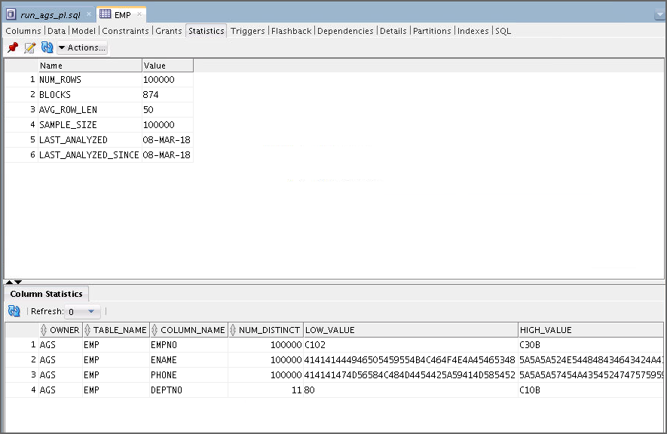The statistics were automatically gathered by the database during the maintenance window. The important thing is that the database automatically gathered the right statistics and histograms. Depending on your environment, you may see different sample sizes.

1. 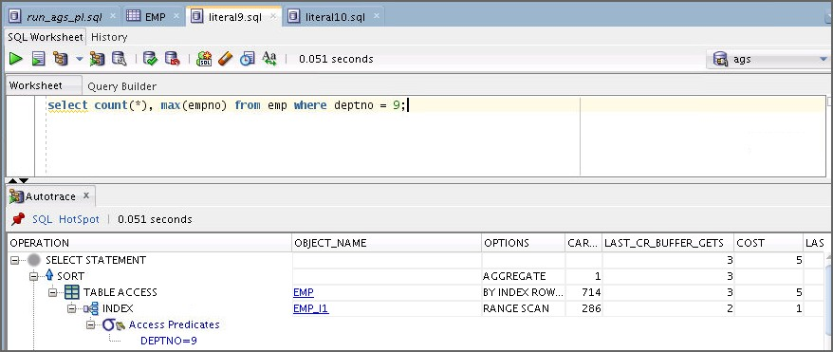Autotrace literal9.sql and literal10.sql again. What do you observe and why? The optimizer can make the right decisions for both statements. This is because of the statistics that were automatically gathered by the database previously.

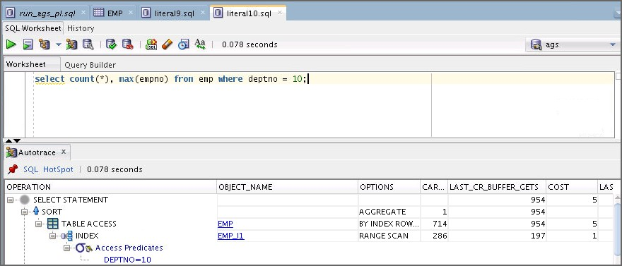

Note: The output is different in literal10.sql AUTOTRACE, it doesn’t use index. Please, verify once.

1. Close the ags connection and the file tabs in SQL Developer.
2. From your terminal window, clean up your environment by executing the

ags_cleanup.sh script.

$ **./ags_cleanup.sh**

**…**

SQL>

SQL> alter system set "_enable_automatic_maintenance"=1; System altered.

SQL>

SQL> exit;

Disconnected …

$

## Practice 10-4: Using System Statistics (Optional)

### Overview

In this practice, you manipulate system statistics and show that they are important for the optimizer to select the correct execution plans. All the scripts used in this practice are located in the $HOME/labs/solutions/System_Stats directory.

### Tasks

1. The sysstats_setup.sh script located in your

$HOME/labs/solutions/System_Stats directory was run as part of the class setup. This script creates a user called JFV and some tables that are used throughout this practice. The script also makes sure that object statistics are correctly gathered. The script is listed as follows:

#!/bin/bash

cd /home/oracle/labs/solutions/System_Stats sqlplus / as sysdba @sysstats_setup.sql

set echo on

connect sys/fenago as sysdba; alter session set container = orclpdb; drop user jfv cascade;

create user jfv identified by jfv default tablespace users temporary tablespace temp;

grant connect, resource, dba to jfv;

connect jfv/jfv@orclpdb drop table t purge; drop table z purge;

create table t(c number);

insert into t values (1);

commit;

insert into t select * from t;

/

/

/

/

/

/

/

/

/

/

commit;

insert into t select * from t;

/

/

/

/

/

/

/

commit;

create table z(d number);

begin

for i in 1..100 loop

insert into z values (i); end loop;

commit; end;

/

create unique index iz on z(d);

execute dbms_stats.gather_table_stats('JFV','T',cascade=>true);

execute dbms_stats.gather_table_stats('JFV','Z',cascade=>true);

exit;

1. In a terminal window, execute the sysstats_start.sh script to flush the caches, and set

CPUSPEEDNW to 0 in the system statistics.

$ **cd /home/oracle/labs/solutions/System_Stats**

$ **./sysstats_start.sh**

…

SQL> alter session set container = orclpdb; Session altered.

SQL>

SQL> alter system flush shared_pool;

System altered.

SQL>

SQL> alter system flush buffer_cache;

System altered.

SQL>

SQL> execute dbms_stats.delete_system_stats;

PL/SQL procedure successfully completed.

SQL>

SQL> execute DBMS_STATS.SET_SYSTEM_STATS (pname => 'cpuspeednw', pvalue => 0);

PL/SQL procedure successfully completed.

SQL>

SQL> select sname,pname,pval1 from aux_stats$;

SNAME PNAME PVAL1

SYSSTATS_INFO STATUS

SYSSTATS_INFO DSTART

SYSSTATS_INFO DSTOP

SYSSTATS_INFO FLAGS 1

SYSSTATS_MAIN CPUSPEEDNW 0

SYSSTATS_MAIN IOSEEKTIM 10

SYSSTATS_MAIN IOTFRSPEED 4096

SYSSTATS_MAIN SREADTIM

SYSSTATS_MAIN MREADTIM

SYSSTATS_MAIN CPUSPEED

SYSSTATS_MAIN MBRC

SNAME PVAL1

PNAME

SYSSTATS_MAIN

SYSSTATS_MAIN

MAXTHR

SLAVETHR

13 rows selected.

SQL>

SQL> exit;

…

$

1. From your terminal session, connect as the JFV user in a SQL*Plus session. Then execute the select_without_sysstats.sql script, which contains the following statement, and determine how long it takes to execute:

$ **sqlplus jfv/jfv@orclpdb**

…

SQL> **@select_without_sysstats**

SQL>

SQL> set timing on SQL>

SQL> select /* Without system stats */ count(*)

1. from t,z
2. where t.c=z.d; COUNT(*)

524288

Elapsed: 00:00:00.23 SQL>

SQL> set timing off SQL>

SQL>

select /* Without system stats */ count(*) from t,z

where t.c=z.d;

1. Determine the execution plan that was used to execute the previous statement. In addition, determine the optimizer’s cost, CPU cost, and I/O cost for the previous execution. Use the show_latest_exec_plan.sql script. What do you observe?

The optimizer does not use CPU costing. This is because system statistics were deleted during the first step of this practice. The plan chosen by the optimizer might not be the best one.

SQL> **@show_latest_exec_plan**

SQL> set echo on SQL>

SQL> select * from table(dbms_xplan.display_cursor);

PLAN_TABLE_OUTPUT

SQL_ID 6avdu58tamzju, child number 0

select /* Without system stats */ count(*) from t,z where t.c=z.d Plan hash value: 3698032250

|  |  |  |  |  |  |  |  |  |  |  |
| --- | --- | --- | --- | --- | --- | --- | --- | --- | --- | --- |
| | | Id | | Operation | | Name | | | Rows | | | Bytes | | | | Cost | |
| | | 0 | | SELECT STATEMENT | | | | | |  | | |  | | | 134 | |
| | | 1 | | SORT AGGREGATE | | | | | | 1 | | | 6 | | | | |

PLAN_TABLE_OUTPUT

| 2 | NESTED LOOPS | | 524K| 3072K| 134 |

| 3 | TABLE ACCESS FULL| T | 524K| 1536K| 134 |

|* 4 | INDEX UNIQUE SCAN| IZ | 1 | 3 | |

Predicate Information (identified by operation id):

4 - access("T"."C"="Z"."D")

Note

PLAN_TABLE_OUTPUT

- cpu costing is off (consider enabling it)

|  |  |  |  |
| --- | --- | --- | --- |
| TABLE ACCESS | T | FULL | 134 -- -- 134 |
| INDEX | IZ | UNIQUE SCAN | -- -- |
| SQL> |  |  |  |
| SQL> |  |  |  |

1. How can you ensure that the optimizer finds a better plan during future executions of the same statement? Implement your solution.

25 rows selected.

SQL>

SQL> col operations

format a20

SQL> col object_name format a11 SQL> col options format a15 SQL> col cost_cpu_io format a30 SQL>

SQL>

SQL> select operation operations, object_name, options,

1. cost||' -- '||cpu_cost||' -- '||io_cost cost_cpu_io
2. from (select * from v$sql_plan where address in (select address
3. from v$sql

5

'%system stats%' and

6

'%connect%'));

where sql_text like

sql_text not like

OPERATIONS

OBJECT_NAME OPTIONS

COST_CPU_IO

SELECT STATEMENT SORT

NESTED LOOPS

134 -- --

AGGREGATE -- --

134 -- -- 134

Gather system statistics again. Because you do not have a real workload yet, you can gather system statistics in NOWORKLOAD mode.

SQL> **connect / as sysdba;**

Connected.

SQL> **alter session set container = orclpdb;**

Session altered.

SQL> **@gather_system_stats**

SQL> set echo on SQL>

SQL> execute DBMS_STATS.GATHER_SYSTEM_STATS(gathering_mode => 'NOWORKLOAD');

PL/SQL procedure successfully completed.

SQL>

SQL> select sname,pname,pval1 from aux_stats$;

SNAME

PNAME

PVAL1

SYSSTATS_INFO SYSSTATS_INFO SYSSTATS_INFO SYSSTATS_INFO SYSSTATS_MAIN SYSSTATS_MAIN SYSSTATS_MAIN SYSSTATS_MAIN SYSSTATS_MAIN SYSSTATS_MAIN

SYSSTATS_MAIN

STATUS DSTART DSTOP FLAGS CPUSPEEDNW IOSEEKTIM IOTFRSPEED SREADTIM MREADTIM CPUSPEED

MBRC

1

1882.885

10.506

4096

SNAME PVAL1

PNAME

SYSSTATS_MAIN

SYSSTATS_MAIN

MAXTHR

SLAVETHR

13 rows selected.

SQL>

1. Before verifying your solution, you should flush the System Global Area (SGA) pools, such as the shared pool and the buffer cache. This is done to prevent the already loaded buffers or SQL plans from affecting the results.

SQL> **@flush_sga**

SQL>

SQL> set echo on SQL>

SQL> alter system flush shared_pool; System altered.

SQL>

SQL> alter system flush buffer_cache; System altered.

SQL> SQL>

1. Connected as the JFV user again, check your solution against the following query in the

select_with_sysstats.sql script:

select /* With system stats */ count(*) from t,z

where t.c=z.d;

What do you observe?

The optimizer can make a better decision because it was able to use meaningful system statistics. You can see that the execution time is now half the value it was previously, and the execution plan now includes CPU costing information.

SQL> **connect jfv/jfv@orclpdb**

Connected.

SQL> **@select_with_sysstats**

SQL> set timing on SQL>

SQL> select /* With system stats */ count(*)

1. from t,z
2. where t.c=z.d; COUNT(*)

524288

Elapsed: 00:00:00.11 SQL>

SQL> set timing off SQL>

SQL>

SQL> **@show_latest_exec_plan**

SQL> set echo on SQL>

SQL> select * from table(dbms_xplan.display_cursor); PLAN_TABLE_OUTPUT

SQL_ID 2x55txn3742by, child number 0

select /* With system stats */ count(*) from t,z where t.c=z.d Plan hash value: 2407521827

| Id | Operation

|

| Name | Rows | Bytes | Cost (%CPU)| Time

|  |  |  |  |  |  |  |  |  |
| --- | --- | --- | --- | --- | --- | --- | --- | --- |
| | | 0 | SELECT STATEMENT | | | | | | | | | 123 | (100)| | | |
| | | 1 | SORT AGGREGATE | | | | | 1 | | 6 | |  | | | | |

PLAN_TABLE_OUTPUT

|* 2 | HASH JOIN | | 524K| 3072K| 123 (3)| 00:00:01 |

| 3 | INDEX FULL SCAN | IZ | 100 | 300 | 1 (0)| 00:00:01 |

| 4 | TABLE ACCESS FULL| T | 524K| 1536K| 121 (2)| 00:00:01 |

Predicate Information (identified by operation id):

2 - access("T"."C"="Z"."D")

21 rows selected.

SQL>

SQL> col operations format a20 SQL> col object_name format a11 SQL> col options format a15

SQL> col cost_cpu_io format a30 SQL>

SQL>

SQL> select operation operations, object_name, options,

* 1. cost||' -- '||cpu_cost||' -- '||io_cost cost_cpu_io
  2. from (select * from v$sql_plan where address in (select address
  3. from v$sql
  4. where sql_text like

'%system stats%' and

* 1. sql_text not like

'%connect%'));

OPERATIONS OBJECT_NAME OPTIONS COST_CPU_IO

|  |  |  |
| --- | --- | --- |
| SELECT STATEMENT SORT |  | 123 -- --  AGGREGATE -- -- |
| HASH JOIN |  | 123 -- 137938260 -- 120 |
| INDEX | IZ FULL SCAN 1 -- 27121 -- 1 | |
| TABLE ACCESS  SQL> | T | FULL 121 -- 84867339 -- 119 |

1. Exit your SQL*Plus session and clean up your environment for this practice by executing the systats_cleanup.sh script.

SQL> **exit**

…

$ **./sysstats_cleanup.sh**

…

SQL> alter session set container = orclpdb;

Session altered.

SQL>

SQL> drop user jfv cascade; User dropped.

SQL>

SQL> alter system flush shared_pool; System altered.

SQL>

SQL> exit;

# Practices for Lesson 11: Using Bind Variables

## Practices for Lesson 11: Overview

### Practices Overview

In these practices, you examine the behavior of adaptive cursor sharing and the effect of various settings of the CURSOR_SHARING parameter on execution plans.

## Practice 11-1: Using Adaptive Cursor Sharing

### Overview

In this practice, you experiment with bind variable peeking and adaptive cursor sharing.

### Tasks

1. **Note:** The acs_setup.sh script was executed as part of the class setup to set up the environment used for this practice. This script is in your

$HOME/labs/solutions/Adaptive_Cursor_Sharing directory and is listed as follows:

#!/bin/bash

cd /home/oracle/labs/solutions/Adaptive_Cursor_Sharing sqlplus / as sysdba @acs_setup.sql

set echo on

alter session set container = orclpdb; drop user acs cascade;

create user acs identified by acs default tablespace users temporary tablespace temp;

grant dba, connect to acs; connect acs/acs@orclpdb drop table emp purge;

create table emp (

empno number,

ename varchar2(20), phone varchar2(20), deptno number

);

insert into emp with tdata as

(select rownum empno from all_objects where rownum <= 1000)

select rownum,

dbms_random.string ('u', 20),

dbms_random.string ('u', 20), case

when rownum/100000 <= 0.001 then mod(rownum, 10) else 10

end

from tdata a, tdata b where rownum <= 100000;

create index emp_i1 on emp(deptno);

exec dbms_stats.gather_table_stats(null, 'EMP', METHOD_OPT => 'FOR COLUMNS DEPTNO SIZE 10', CASCADE => TRUE);

alter system flush shared_pool; exit;

1. Change directories to $HOME/labs/solutions/Adaptive_Cursor_Sharing. In your terminal session, connect to the SQL*Plus session as the ACS user. Ensure that you stay connected to the same SQL*Plus session until the end of this practice. After you are connected, identify the columns of the EMP table that have histograms. Flush the shared pool before you start.

Only the DEPTNO column has a 10-buckets histogram.

$ **cd $HOME/labs/solutions/Adaptive_Cursor_Sharing**

$ **sqlplus acs/acs@orclpdb**

…

SQL> **alter system flush shared_pool;**

System altered.

SQL> **@check_emp_histogram**

SQL>

SQL> select column_name, histogram, num_buckets

1. from user_tab_columns
2. where table_name='EMP';

COLUMN_NAME

HISTOGRAM

NUM_BUCKETS

EMPNO ENAME PHONE

DEPTNO

NONE NONE NONE

TOP-FREQUENCY

10

SQL>

1. Determine the distribution of all the distinct values found in the DEPTNO column of the EMP

table. What do you find?

Values distribution is uniform for all (0.01%), except for value 10 (99.9%). This is typical of what is called data skew.

|  |  |  |
| --- | --- | --- |
| 1. from emp) 2. group by deptno, nr 3. order by deptno; |  | |
| DEPTNO CNT_PER_DEPTNO |  | DEPTNO_PERCENT |
| 0 10 |  | .01 |
| 1 10 |  | .01 |
| 2 10 |  | .01 |
| 3 10 |  | .01 |
| 4 10 |  | .01 |
| 5 10 |  | .01 |
| 6 10 |  | .01 |
| 7 10 |  | .01 |
| 8 10 |  | .01 |
| 9 10 |  | .01 |
| 10 99900 |  | 99.9 |
| 11 rows selected. |  |  |

1. Before you study the adaptive cursor–sharing feature, disable its functionality by setting the OPTIMIZER_FEATURES_ENABLE session parameter back to 10.2.0.1. After this is done, ensure that you execute the following command in your SQL*Plus session: set lines 200 pages 10000. This is used in the practice to print the execution plans correctly.

SQL> **@show_deptno_distribution**

SQL> set echo on SQL>

SQL> select deptno, count(*) cnt_per_deptno, (count(*)*100)/nr deptno_percent

2 from emp, (select max(empno) nr

SQL> **alter session set optimizer_features_enable="10.2.0.1";**

Session altered.

SQL> **set lines 200 pages 10000**

SQL>

1. Determine the execution plan for the following statement:

select /*ACS_L9*/ count(*), max(empno) from emp

where deptno = 9;

This statement is in the select_deptno_literal_9.sql file. What do you notice and why?

The optimizer uses an index range scan because value 9 is very selective.

SQL> **@select_deptno_literal_9**

SQL> set echo on SQL>

SQL> select /*ACS_L9*/ count(*), max(empno)

1. from emp
2. where deptno = 9;

COUNT(*) MAX(EMPNO)

10

99

SQL>

SQL> **@show_latest_exec_plan.sql**

SQL> set echo on SQL>

SQL> select * from table(dbms_xplan.display_cursor(null,null,'TYPICAL

+PEEKED_BINDS'));

PLAN_TABLE_OUTPUT

SQL_ID 64ngy4j55d1z5, child number 0

select /*ACS_L9*/ count(*), max(empno) from emp where deptno = 9 Plan hash value: 3184478295

| Id | Operation

| Name | Rows | Bytes | Cost

(%CPU)| Time |

(0)| 00:00:01 |

|  |  |  |  |  |  |  |  |  |  |
| --- | --- | --- | --- | --- | --- | --- | --- | --- | --- |
| | | 0 | | SELECT STATEMENT | | | | | | | | | | | 2 |
| (100)| | | | |  |  |  |  |  |  | |
| | 1 |  | | | SORT AGGREGATE  | |  | | |  | | | 1 | | 16 | | |
| | 2 | | | TABLE ACCESS BY | INDEX | ROWID| | EMP | | | 10 | | 160 | 2 | |

|* 3 |

INDEX RANGE SCAN

| EMP_I1 |

10 |

|

1

(0)| 00:00:01 |

Predicate Information (identified by operation id):

3 - access("DEPTNO"=9)

20 rows selected.

SQL>

1. Determine the execution plan for the following statement:

select /*ACS_L10*/ count(*), max(empno) from emp

where deptno = 10;

This statement is in the select_deptno_literal_10.sql file. What do you notice and why?

The optimizer uses a full table scan because value 10 is not a selective value.

SQL> **@select_deptno_literal_10**

SQL> set echo on SQL>

SQL> select /*ACS_L10*/ count(*), max(empno)

1. from emp
2. where deptno = 10;

COUNT(*) MAX(EMPNO)

99900

100000

SQL>

SQL> **@show_latest_exec_plan**

SQL> set echo on SQL>

SQL> select * from table(dbms_xplan.display_cursor(null,null,'TYPICAL

+PEEKED_BINDS'));

PLAN_TABLE_OUTPUT

SQL_ID 3232j5gkp2u5h, child number 0

|  |  |  |  |  |  |  |  |
| --- | --- | --- | --- | --- | --- | --- | --- |
| | | Id | | Operation | | Name | | | Rows | | Bytes | | Cost (%CPU)| Time |
| | |  |  |  |  |  |  |  |

|  |  |  |  |  |  |  |  |  |  |  |  |
| --- | --- | --- | --- | --- | --- | --- | --- | --- | --- | --- | --- |
| | | 0 | | | SELECT STATEMENT | | | | | | | | |  | 120 | (100)| | | |
| | | 1 | | | SORT AGGREGATE | | | | | 1 | | 16 | | |  | | | | |
| |* 2 |  00:00:02 | | | TABLE ACCESS FULL|  | | | EMP | | 99900 | | | 1560K| | | 120 | (1)| |

1. Define a bind variable called DEPTNO in your SQL*Plus session, set it to value 9, execute the following query, and determine its execution plan:

select /*ACS_1*/ count(*), max(empno) from emp

where deptno = :deptno;

select /*ACS_L10*/ count(*), max(empno) from emp where deptno = 10

Plan hash value: 2083865914

Predicate Information (identified by operation id):

2 - filter("DEPTNO"=10)

19 rows selected.

SQL>

This statement is in the select_deptno_bind.sql file. What do you notice and why?

Because the optimizer uses bind peeking the first time you execute a statement with a bind variable and because, for this first execution, value 9 is used, the execution plan with index access is used.

SQL> **variable deptno number;**

SQL> **exec :deptno := 9**

PL/SQL procedure successfully completed. SQL> **@select_deptno_bind**

SQL> set echo on SQL>

SQL> select /*ACS_1*/ count(*), max(empno)

1. from emp
2. where deptno = :deptno;

COUNT(*) MAX(EMPNO)

10 99

SQL>

SQL> **@show_latest_exec_plan**

SQL> set echo on SQL>

SQL> select * from table(dbms_xplan.display_cursor(null,null,'TYPICAL

+PEEKED_BINDS'));

PLAN_TABLE_OUTPUT

SQL_ID 272gr4hapc9w1, child number 0

select /*ACS_1*/ count(*), max(empno) from emp where deptno = :deptno

Plan hash value: 3184478295

| Id | Operation | Name | Rows | Bytes | Cost (%CPU)| Time |

|  |  |  |  |  |  |  |  |  |  |  |  |
| --- | --- | --- | --- | --- | --- | --- | --- | --- | --- | --- | --- |
| | | 0 | | SELECT STATEMENT | | | | | | | | | | | | | 2 |
| (100)| | | | | |  |  |  |  |  |  | | |
| | 1 |  | | | | SORT AGGREGATE  | |  | | |  | | | 1 | | 16 | | | |
| | 2 | (0)| | | | TABLE ACCESS BY 00:00:01 | | INDEX | ROWID| | EMP | | | 10 | | 160 | 2 | | |
| |* | 3 | (0)| | | INDEX RANGE SCAN 00:00:01 | | | | EMP_I1 | | | 10 | | | | | 1 | |

Peeked Binds (identified by position):

1 - :DEPTNO (NUMBER): 9

Predicate Information (identified by operation id):

3 - access("DEPTNO"=:DEPTNO)

25 rows selected.

SQL> SQL>

1. Determine the execution statistics in terms of child cursors, executions, and buffer gets for the previously executed statement. What do you observe?

In V$SQL, only one child cursor exists, and it has been executed only once (first time ever in this case). Also, the number of buffer gets is small due to the efficient access path that was used.

SQL> **@show_latest_exec_stats**

SQL> set echo on SQL>

SQL> select child_number, executions, buffer_gets

1. from v$sql
2. where sql_text like 'select /*ACS_1%';

CHILD_NUMBER EXECUTIONS BUFFER_GETS

0

1

3

SQL>

1. Perform steps 7 and 8 again, but this time using 10 as the bind value for DEPTNO. What do you observe and why?

The execution plan is identical. The index path is used, although value 10 is not selective. This is because bind peeking operates only the first time you execute your statement. Notice that the PEEK_BIND value is still 9. Looking at V$SQL, you can clearly see that there is still only one child cursor associated with your statement.

However, this time, the number of buffer gets was raised significantly due to the number of accesses required to retrieve all the rows from first the index, and then the table.

SQL> **exec :deptno := 10**

PL/SQL procedure successfully completed. SQL> **@select_deptno_bind**

SQL> set echo on SQL>

SQL> select /*ACS_1*/ count(*), max(empno)

2 from emp

3 where deptno = :deptno;

COUNT(*) MAX(EMPNO)

99900 100000

SQL>

SQL> **@show_latest_exec_plan**

SQL> set echo on SQL>

SQL> select * from table(dbms_xplan.display_cursor(null,null,'TYPICAL

+PEEKED_BINDS'));

PLAN_TABLE_OUTPUT

SQL_ID 272gr4hapc9w1, child number 0

select /*ACS_1*/ count(*), max(empno) from emp where deptno = :deptno

Plan hash value: 3184478295

| Id | Operation | Name | Rows | Bytes | Cost (%CPU)| Time |

|  |  |  |  |  |  |  |  |  |  |  |  |
| --- | --- | --- | --- | --- | --- | --- | --- | --- | --- | --- | --- |
| | | 0 | | SELECT STATEMENT | | | | | | | | | | | | | 2 |
| (100)| | | | | |  |  |  |  |  |  | | |
| | 1 |  | | | | SORT AGGREGATE  | |  | | |  | | | 1 | | 16 | | | |
| | 2 | (0)| | | | TABLE ACCESS BY 00:00:01 | | INDEX | ROWID| | EMP | | | 10 | | 160 | 2 | | |
| |* | 3 | (0)| | | INDEX RANGE SCAN 00:00:01 | | | | EMP_I1 | | | 10 | | | | | 1 | |

Peeked Binds (identified by position):

1 - :DEPTNO (NUMBER): 9

Predicate Information (identified by operation id):

3 - access("DEPTNO"=:DEPTNO)

25 rows selected. SQL>

SQL> **@show_latest_exec_stats**

SQL> set echo on SQL>

SQL> select child_number, executions, buffer_gets

1. from v$sql
2. where sql_text like 'select /*ACS_1%';

CHILD_NUMBER EXECUTIONS BUFFER_GETS

0

2

957

SQL>

1. Before the next step, flush your shared pool to make sure that you clear all the cursor information.

SQL> **alter system flush shared_pool;**

System altered.

SQL>

1. Perform step 9 again. This time, set the bind variable to 10. What do you observe and why?

The execution plan is a full table scan because you used value 10 as your first bind value. You can see this in the peeked binds. There is only one child cursor that is created so far to handle your statement.

SQL> **exec :deptno := 10**

PL/SQL procedure successfully completed. SQL> **@select_deptno_bind**

SQL> set echo on SQL>

SQL> select /*ACS_1*/ count(*), max(empno)

1. from emp
2. where deptno = :deptno;

COUNT(*) MAX(EMPNO)

99900 100000

SQL>

SQL> **@show_latest_exec_plan**

SQL> set echo on SQL>

SQL> select * from table(dbms_xplan.display_cursor(null,null,'TYPICAL

+PEEKED_BINDS'));

PLAN_TABLE_OUTPUT

SQL_ID 272gr4hapc9w1, child number 0

select /*ACS_1*/ count(*), max(empno) from emp where deptno = :deptno

Plan hash value: 2083865914

|  |  |  |  |  |  |  |  |
| --- | --- | --- | --- | --- | --- | --- | --- |
| | | Id | | Operation | | Name | | | Rows | | Bytes | | Cost (%CPU)| Time |
| | |  |  |  |  |  |  |  |

|  |  |  |  |  |  |  |  |  |  |  |  |
| --- | --- | --- | --- | --- | --- | --- | --- | --- | --- | --- | --- |
| | | 0 | | | SELECT STATEMENT | | | | | | | | |  | 120 | (100)| | | |
| | | 1 | | | SORT AGGREGATE | | | | | 1 | | 16 | | |  | | | | |
| |* 2 |  00:00:02 | | | TABLE ACCESS FULL|  | | | EMP | | 99900 | | | 1560K| | | 120 | (1)| |

Peeked Binds (identified by position):

* 1. - :DEPTNO (NUMBER): 10

Predicate Information (identified by operation id):

* 1. - filter("DEPTNO"=:DEPTNO)

24 rows selected. SQL>

SQL>

SQL> **@show_latest_exec_stats**

SQL> set echo on SQL>

SQL> select child_number, executions, buffer_gets

1. from v$sql
2. where sql_text like 'select /*ACS_1%';

CHILD_NUMBER EXECUTIONS BUFFER_GETS

0

1

878

SQL>

1. Perform step 9 again, but this time, use 9 as your bind value. What do you observe and why?

Although value 9 is very selective, a full table scan is still used. This is because the second time you execute your statement, bind peeking is not done. So you continue to use the same child cursor.

SQL> **exec :deptno := 9**

PL/SQL procedure successfully completed. SQL> **@select_deptno_bind**

SQL> set echo on SQL>

SQL> select /*ACS_1*/ count(*), max(empno)

1. from emp
2. where deptno = :deptno;

COUNT(*) MAX(EMPNO)

10

99

SQL>

SQL> **@show_latest_exec_plan**

SQL> set echo on SQL>

SQL> select * from table(dbms_xplan.display_cursor(null,null,'TYPICAL

+PEEKED_BINDS')); PLAN_TABLE_OUTPUT

SQL_ID 272gr4hapc9w1, child number 0

select /*ACS_1*/ count(*), max(empno) from emp where deptno = :deptno

Plan hash value: 2083865914

|  |  |  |  |  |  |  |  |
| --- | --- | --- | --- | --- | --- | --- | --- |
| | | Id | | Operation | | Name | | | Rows | | Bytes | | Cost (%CPU)| Time |
| | |  |  |  |  |  |  |  |

|  |  |  |  |  |  |  |  |  |  |  |  |
| --- | --- | --- | --- | --- | --- | --- | --- | --- | --- | --- | --- |
| | | 0 | | | SELECT STATEMENT | | | | | | | | |  | 120 | (100)| | | |
| | | 1 | | | SORT AGGREGATE | | | | | 1 | | 16 | | |  | | | | |
| |* 2 |  00:00:02 | | | TABLE ACCESS FULL|  | | | EMP | | 99900 | | | 1560K| | | 120 | (1)| |

Peeked Binds (identified by position):

1. - :DEPTNO (NUMBER): 10

Predicate Information (identified by operation id):

1. - filter("DEPTNO"=:DEPTNO)
2. rows selected.

SQL>

SQL> **@show_latest_exec_stats**

SQL> set echo on SQL>

SQL> select child_number, executions, buffer_gets

* 1. from v$sql
  2. where sql_text like 'select /*ACS_1%';

CHILD_NUMBER EXECUTIONS BUFFER_GETS

0 2 1684

SQL>

1. Before the next step, reset your session to use adaptive cursor sharing and ensure that you flush your shared pool again.

SQL> **alter session set optimizer_features_enable="12.2.0.1";**

Session altered.

SQL> **alter system flush shared_pool;**

System altered.

SQL>

1. Perform step 12 again. What do you observe and why?

Because this is the first time you execute the statement, bind peeking is used, and because value 9 is very selective, the index path is used. Only one child cursor is used to handle this statement.

SQL> **exec :deptno := 9**

PL/SQL procedure successfully completed. SQL> **@select_deptno_bind**

SQL> set echo on SQL>

SQL> select /*ACS_1*/ count(*), max(empno)

1. from emp
2. where deptno = :deptno;

COUNT(*) MAX(EMPNO)

10

99

SQL>

SQL> **@show_latest_exec_plan**

SQL> set echo on SQL>

SQL> select * from table(dbms_xplan.display_cursor(null,null,'TYPICAL

+PEEKED_BINDS'));

PLAN_TABLE_OUTPUT

SQL_ID 272gr4hapc9w1, child number 0

select /*ACS_1*/ count(*), max(empno) from emp where deptno = :deptno

Plan hash value: 588610755

|  |  |  |  |  |  |  |  |  |  |
| --- | --- | --- | --- | --- | --- | --- | --- | --- | --- |
| | Id | | Operation |  | | | Name | | | Rows | | | Bytes | | |
| Cost | (%CPU)| Time | | |  |  |  |  |  |  |  |

|  |  |  |  |  |  |  |  |  |  |  |  |  |
| --- | --- | --- | --- | --- | --- | --- | --- | --- | --- | --- | --- | --- |
| | 0 | SELECT STATEMENT 2 (100)| | | | | | | | | | | | | | | | | | |
| | 1 | SORT AGGREGATE | | | | | | | | | | 1 | | | | 16 | | |
|  | | | | | |  |  | |  |  |  |  |  |  |
| |  | | 2 | 2 | TABLE ACCESS BY INDEX (0)| 00:00:01 | | | ROWID | BATCHED| EMP | | | |  | 10 | | |  | 160 |
| |* 1 | 3 | (0)| | INDEX RANGE SCAN 00:00:01 | | |  | | EMP_I1 | | | 10 | | |  |  | | |  |

Peeked Binds (identified by position):

1 - :DEPTNO (NUMBER): 9

Predicate Information (identified by operation id):

3 - access("DEPTNO"=:DEPTNO)

1. rows selected. SQL>

SQL> **@show_latest_exec_stats**

SQL> set echo on SQL>

SQL> select child_number, executions, buffer_gets

1. from v$sql
2. where sql_text like 'select /*ACS_1%';

CHILD_NUMBER EXECUTIONS BUFFER_GETS

0 1 72

SQL>

1. Perform step 14 again, but this time using value 10 as your bind value. What do you observe and why?

Although value 10 is not selective, the same index path as in the previous step is used. Only one child cursor is currently needed to represent your statement.

SQL> **exec :deptno := 10**

PL/SQL procedure successfully completed.

SQL> **@select_deptno_bind**

SQL> set echo on SQL>

SQL> select /*ACS_1*/ count(*), max(empno)

1. from emp
2. where deptno = :deptno;

COUNT(*) MAX(EMPNO)

99900 100000

SQL>

SQL> **@show_latest_exec_plan**

SQL> set echo on SQL>

SQL> select * from table(dbms_xplan.display_cursor(null,null,'TYPICAL

+PEEKED_BINDS'));

PLAN_TABLE_OUTPUT

SQL_ID 272gr4hapc9w1, child number 0

select /*ACS_1*/ count(*), max(empno) from emp where deptno = :deptno

Plan hash value: 588610755

|  |  |  |  |  |  |  |  |  |  |
| --- | --- | --- | --- | --- | --- | --- | --- | --- | --- |
| | Id | | Operation |  | | | Name | | | Rows | | | Bytes | | |
| Cost | (%CPU)| Time | | |  |  |  |  |  |  |  |

|  |  |  |  |  |
| --- | --- | --- | --- | --- |
| | 0 | SELECT STATEMENT 2 (100)| | | | | | | | | | |
| | 1 | SORT AGGREGATE  | | | | | | | 1 | | 16 | |

| 2 |

TABLE ACCESS BY INDEX ROWID BATCHED| EMP (0)| 00:00:01 |

|

10 | 160

|

2

|* 3 | INDEX RANGE SCAN | EMP_I1 | 10 | | 1 (0)| 00:00:01 |

Peeked Binds (identified by position):

1 - :DEPTNO (NUMBER): 9

Predicate Information (identified by operation id):

3 - access("DEPTNO"=:DEPTNO)

25 rows selected. SQL>

SQL> **@show_latest_exec_stats**

SQL> set echo on SQL>

SQL> select child_number, executions, buffer_gets

1. from v$sql
2. where sql_text like 'select /*ACS_1%';

CHILD_NUMBER EXECUTIONS BUFFER_GETS

0

2

1026

1. Perform step 15 again. What do you observe and why?

Because you now use adaptive cursor sharing, the system realizes that you benefit from another child cursor for handling your statement. This time, a full table access path is used to better handle your statement.

SQL> **exec :deptno := 10**

PL/SQL procedure successfully completed. SQL> **@select_deptno_bind**

SQL> set echo on SQL>

SQL> select /*ACS_1*/ count(*), max(empno)

1. from emp
2. where deptno = :deptno;

COUNT(*) MAX(EMPNO)

99900 100000

SQL>

SQL> **@show_latest_exec_plan**

SQL> set echo on SQL>

SQL> select * from table(dbms_xplan.display_cursor(null,null,'TYPICAL

+PEEKED_BINDS'));

PLAN_TABLE_OUTPUT

SQL_ID 272gr4hapc9w1, child number 1

select /*ACS_1*/ count(*), max(empno) from emp where deptno = :deptno

\Plan hash value: 2083865914

|  |  |  |  |  |  |  |  |  |
| --- | --- | --- | --- | --- | --- | --- | --- | --- |
| | | Id | | | Operation | | Name | | | Rows | | Bytes | | Cost (%CPU)| Time |
| | |  |  |  |  |  |  |  |  |

|  |  |  |  |  |  |  |  |  |  |  |  |
| --- | --- | --- | --- | --- | --- | --- | --- | --- | --- | --- | --- |
| | | 0 | | | SELECT STATEMENT | | | | | | | | |  | 120 | (100)| | | |
| | | 1 | | | SORT AGGREGATE | | | | | 1 | | 16 | | |  | | | | |
| |* 2 |  00:00:01 | | | TABLE ACCESS FULL|  | | | EMP | | 99900 | | | 1560K| | | 120 | (1)| |

Peeked Binds (identified by position):

1. - :DEPTNO (NUMBER): 10

Predicate Information (identified by operation id):

1. - filter("DEPTNO"=:DEPTNO)

24 rows selected. SQL>

SQL**> @show_latest_exec_stats**

SQL> set echo on SQL>

SQL> select child_number, executions, buffer_gets

1. from v$sql
2. where sql_text like 'select /*ACS_1%';

CHILD_NUMBER EXECUTIONS BUFFER_GETS

0

1

2

1

1026

809

SQL>

1. Flush the shared pool to clean up your environment, and then exit your SQL*Plus session.

SQL> **alter system flush shared_pool;**

System altered.

SQL> **exit;**

## Practice 11-2: Using CURSOR_SHARING (Optional)

In this practice, you investigate the use of the CURSOR_SHARING initialization parameter.

1. **Note:** You can find all the necessary scripts for this practice in your

$HOME/labs/solutions/Cursor_Sharing directory. The environment for this practice has been set up with the class setup, using the cs_setup.sh script. This script created a new user called CS and the EMP table that are used throughout this practice. The script is listed as follows:

#!/bin/bash

cd /home/oracle/labs/solutions/Cursor_Sharing sqlplus / as sysdba @cs_setup.sql

set echo on

alter session set container = orclpdb; drop user cs cascade;

create user cs identified by cs default tablespace users temporary tablespace temp;

grant dba, connect to cs; connect cs/cs@orclpdb drop table emp purge;

create table emp (

empno number,

ename varchar2(20), phone varchar2(20), deptno number

);

insert into emp with tdata as

(select rownum empno from all_objects where rownum <= 1000)

select rownum,

dbms_random.string ('u', 20),

dbms_random.string ('u', 20),

case

when rownum/100000 <= 0.001 then mod(rownum, 10) else 10

end

from tdata a, tdata b where rownum <= 100000;

create index emp_i1 on emp(deptno);

execute dbms_stats.gather_table_stats(null, 'EMP', cascade => true);

--alter system flush shared_pool;

--connect / as sysdba

--shutdown immediate;

--startup; exit;

1. In a terminal session, change the directory to the

$HOME/labs/solutions/Cursor_Sharing directory. Connect as the CS user in a SQL*Plus session and stay connected to that session until the end of this practice. For formatting reasons, after you have connected in the SQL*Plus session, execute the following command:

set linesize 200 pagesize 1000

$ **cd $HOME/labs/solutions/Cursor_Sharing**

$ **sqlplus cs/cs@orclpdb**

…

Connected to: …

SQL> **set linesize 200 pagesize 1000**

SQL>

1. Check the existence of histograms on the columns of the EMP table by using the check_emp_histogram.sql script, and then determine the data distribution in the DEPTNO column of the EMP table with the statement in the show_deptno_distribution.sql file. What do you observe?

Currently, there are no histograms created on the columns of the EMP table. Also, it is clear that you have data skew in the DEPTNO column. Value 10 repeats most of the time (99.9%), whereas all other values repeat only 0.01%.

SQL> **@check_emp_histogram**

SQL>

SQL> select column_name, histogram, num_buckets

2 from user_tab_columns

|  |  |
| --- | --- |
| 3 where table_name='EMP'; |  |
| COLUMN_NAME HISTOGRAM | NUM_BUCKETS |
| EMPNO NONE | 1 |
| ENAME NONE | 1 |
| PHONE NONE | 1 |
| DEPTNO NONE | 1 |
| SQL> |  |
| SQL> **@show_deptno_distribution** |  |
| SQL> set echo on |  |
| SQL> |  |
| SQL> select deptno, count(*) cnt_per_deptno, | (count(*)*100)/nr |
| deptno_percent  2 from emp, (select max(empno) nr |  |

|  |  |  |
| --- | --- | --- |
| 1. from emp) 2. group by deptno, nr 3. order by deptno; |  | |
| DEPTNO CNT_PER_DEPTNO |  | DEPTNO_PERCENT |
| 0 10 |  | .01 |
| 1 10 |  | .01 |
| 2 10 |  | .01 |
| 3 10 |  | .01 |
| 4 10 |  | .01 |
| 5 10 |  | .01 |
| 6 10 |  | .01 |
| 7 10 |  | .01 |
| 8 10 |  | .01 |
| 9 10 |  | .01 |
| 10 99900 |  | 99.9 |
| 11 rows selected. |  |  |

SQL>

1. Before you continue, ensure that you flush your shared pool.

SQL> **alter system flush shared_pool;**

System altered.

SQL>

1. How would you force your SQL*Plus session to automatically replace statement literals with bind variables to make sure that the same cursor is used independently of the literal values?

SQL> **alter session set cursor_sharing = force;**

Session altered.

SQL>

1. From the same SQL*Plus session, execute the following two queries. Then determine how many cursors are generated to handle these two statements and what execution plans were used. What do you observe and why?

select /*CS*/ count(*), max(empno) from emp where deptno = 9;

select /*CS*/ count(*), max(empno) from emp where deptno = 10;

* 1. Because of the previous step, literal values are replaced with bind variables. The FORCE option forces the system to share only one child cursor in this case and use the exact same execution plan (index range scan).

SQL> **@select_deptno_literal_9**

SQL> set echo on SQL>

SQL> select /*CS*/ count(*), max(empno) from emp where deptno = 9;

COUNT(*) MAX(EMPNO)

10

99

SQL>

SQL> **@select_deptno_literal_10**

SQL> set echo on SQL>

SQL> select /*CS*/ count(*), max(empno) from emp where deptno = 10;

COUNT(*) MAX(EMPNO)

99900

100000

SQL>

* 1. Now execute the show_latest_cursors.sql file to check the latest cursors.

SQL> **@show_latest_cursors**

SQL> set echo on SQL>

SQL> col sql_text format a70 SQL>

SQL> select sql_text,hash_value

1. from v$sql
2. where sql_text like '%select /*CS%'; SQL_TEXT

HASH_VALUE

select /*CS*/ count(*), max(empno) from emp where deptno =

:"SYS_B_0"

3434097775

* 1. 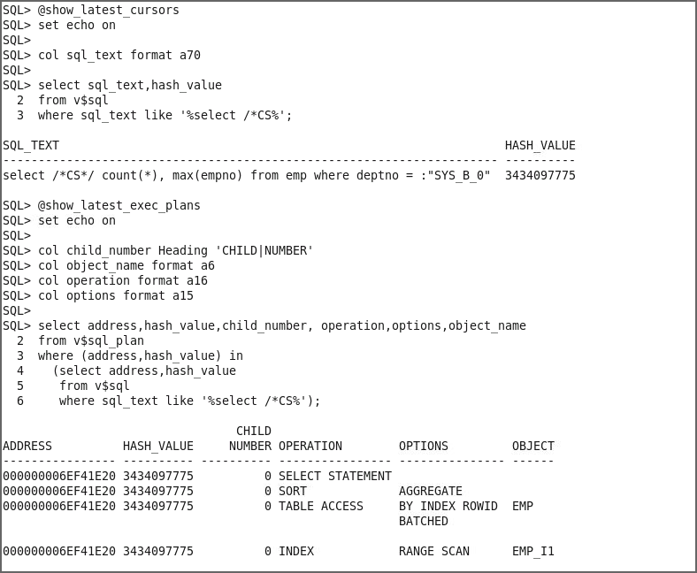Execute the show_latest_exec_plans.sql file to check the latest execution plans.

SQL> **@show_latest_exec_plans**

1. Ensure that you create a 10-bucket histogram on the DEPTNO column of the EMP table.

SQL> **exec dbms_stats.gather_table_stats(null, 'EMP', METHOD_OPT => 'FOR COLUMNS DEPTNO SIZE 10', CASCADE => TRUE);**

PL/SQL procedure successfully completed. SQL> **@check_emp_histogram**

SQL> set echo on SQL>

SQL> select column_name, histogram, num_buckets

1. from user_tab_columns
2. where table_name='EMP';

COLUMN_NAME

HISTOGRAM

NUM_BUCKETS

|  |  |  |  |  |  |
| --- | --- | --- | --- | --- | --- |
|  | | | | |  |
| EMPNO |  | NONE |  |  | 1 |
| ENAME |  | NONE |  |  | 1 |
| PHONE DEPTNO |  | NONE  TOP-FREQUENCY |  | 10 | 1 |
| SQL> |  |  |  |  |  |

1. Before you continue, ensure that you flush your shared pool.

SQL> **alter system flush shared_pool;**

System altered.

SQL>

1. Perform step 6 again. What do you observe and why?

Although you captured a histogram for the DEPTNO column that shows data skew, the system continues to share only one child cursor to handle both statements. This behavior is due to the FORCE option for the CURSOR_SHARING initialization parameter.

SQL> **@select_deptno_literal_9**

SQL> set echo on SQL>

SQL> select /*CS*/ count(*), max(empno) from emp where deptno = 9;

COUNT(*) MAX(EMPNO)

10

99

SQL>

SQL> **@select_deptno_literal_10**

SQL> set echo on SQL>

SQL> select /*CS*/ count(*), max(empno) from emp where deptno = 10;

COUNT(*) MAX(EMPNO)

99900

100000

SQL>

SQL> **@show_latest_cursors**

SQL> set echo on

SQL>

SQL> col sql_text format a70 SQL>

SQL> select sql_text,hash_value

1. from v$sql
2. where sql_text like '%select /*CS%'; SQL_TEXT

HASH_VALUE

select /*CS*/ count(*), max(empno) from emp where deptno = :"SYS_B_0" 3434097775

1. Flush the shared pool script to clean up your environment for this practice. Then exit your SQL*Plus session.

SQL> **alter system flush shared_pool;**

System altered.

SQL> **exit**

Disconnected …

$

# Practices for Lesson 12: SQL Plan Management

## Practices for Lesson 12: Overview

### Practices Overview

SQL Plan Management (SPM) is an Oracle Database 11g feature that provides controlled execution plan evolution.

With SPM, the optimizer automatically manages execution plans and ensures that only known or verified plans are used.

When a new plan is found for a SQL statement, it will not be used until it has been verified to have comparable or better performance than the current plan.

SPM has three main components:

* Plan Capture
* Plan Selection
* Plan Verification

In these practices, you see each of these components in action.

## Practice 12-1: Using SQL Plan Management (SPM)

### Overview

In this practice, you see all the phases of using SQL Plan Management.

### Tasks

1. Before you start this practice, change directories to the $HOME/labs/solutions/SPM directory. Flush the shared pool to be sure that there is no interference from preceding practices.

$ **cd /home/oracle/labs/solutions/SPM**

$ **sqlplus / as sysdba**

SQL> **alter session set container = orclpdb;**

Session altered.

SQL> **alter system flush shared_pool;**

System altered.

SQL> exit;

##### Automatic Plan Capture

1. The first component of SPM is Plan Capture. There are two main ways to capture plans: automatically (at run time) or bulk load. In this practice, you enable automatic plan capture so that the SPM repository is automatically populated for any repeatable SQL statement. Enable automatic plan capture by setting the optimizer_capture_sql_plan_baselines initialization parameter to TRUE in your SQL*Plus session, connected as the SPM user. After you have connected in your session, do not disconnect.

$ **sqlplus spm/spm@orclpdb**

-- Execute the below Statement SQL> **show parameter baseline**

NAME

TYPE

VALUE

optimizer_capture_sql_plan_baselines boolean

optimizer_use_sql_plan_baselines boolean

FALSE

TRUE

-- Execute the below Statement

SQL> **alter session set optimizer_capture_sql_plan_baselines = TRUE;**

Session altered.

SQL> **alter session set optimizer_mode = all_rows;**

Session altered.

SQL>

1. Execute the following query in your SQL*Plus session. (**Note:** There are no spaces in

/*LOAD_AUTO*/.)

select /*LOAD_AUTO*/ * from sh.sales

where quantity_sold > 40 order by prod_id;

Use the query1.sql script to execute the query and execute twice.

SQL> **@query1.sql**

SQL> select /*LOAD_AUTO*/ * from sh.sales

2> where quantity_sold > 40 order by prod_id; no rows selected

SQL> **@query1.sql**

SQL> select /*LOAD_AUTO*/ * from sh.sales

2> where quantity_sold > 40 order by prod_id;

no rows selected

1. An initial plan baseline is automatically created for a new statement. Check whether the plan baseline was loaded for the previous statement. What do you observe?

You can see from the output that a baseline has been created and enabled for this SQL statement. You can also tell that this plan was captured automatically by checking the values of the ORIGIN column. (Use the check_baselines.sql script.)

-- You should see one accepted entry SQL> **@check_baselines.sql**

SQL> set echo on SQL> set pagesize 30 SQL>

SQL> select signature, sql_handle, sql_text, plan_name,

1. origin, enabled, accepted, fixed, autopurge
2. from dba_sql_plan_baselines
3. where sql_text like 'select /*LOAD_AUTO*/%';

SIGNATURE SQL_HANDLE

SQL_TEXT

PLAN_NAME ORIGIN ENA ACC FIX AUT

8.0622E+18 SQL_6fe28d438dfc352f

select /*LOAD_AUTO*/ * from sh.sales where quantity_sold > 40 order by prod_id

SQL_PLAN_6zsnd8f6zsd9g54bc8843 **AUTO-CAPTURE YES YES** NO YES

SQL>

1. Change or alter the optimizer mode to use FIRST_ROWS optimization and execute your statement. Describe what happens.

This causes the optimizer to create a different plan for the SQL statement execution.

SQL> **alter session set optimizer_mode = first_rows;**

Session altered.

-- Execute the query1.sql SQL> **@query1.sql**

SQL> set echo on SQL>

SQL> select /*LOAD_AUTO*/ * from sh.sales

2 where quantity_sold > 40 order by prod_id; no rows selected

SQL>

* 1. Because the SQL statement has a new plan, another plan baseline is automatically captured. You can confirm this by checking the plan baseline again.

SQL> **@check_baselines.sql**

SQL> set echo on SQL> set pagesize 30 SQL>

SQL> select signature, sql_handle, sql_text, plan_name,

1. origin, enabled, accepted, fixed, autopurge
2. from dba_sql_plan_baselines
3. where sql_text like 'select /*LOAD_AUTO*/%'; SIGNATURE SQL_HANDLE

SQL_TEXT

PLAN_NAME

ORIGIN

ENA ACC FIX AUT

8.0622E+18 SQL_6fe28d438dfc352f

select /*LOAD_AUTO*/ * from sh.sales where quantity_sold > 40 order by prod_id

SQL_PLAN_6zsnd8f6zsd9g11df68d0 AUTO-CAPTURE YES YES NO YES

8.0622E+18 SQL_6fe28d438dfc352f

select /*LOAD_AUTO*/ * from sh.sales where quantity_sold > 40 order by prod_id

SQL_PLAN_6zsnd8f6zsd9g54bc8843 AUTO-CAPTURE YES **NO** NO YES

SQL>

* 1. Now you see two plan baselines for your query, but notice that the new plan has not been accepted. This new plan will have to be validated before it is acceptable as a good plan to use.

1. Reset the optimizer mode to the default values and disable automatic capture of plan baselines.

-- Execute the below Statement

SQL> **alter session set optimizer_mode = all_rows;**

Session altered**.**

-- Execute the below Statement

SQL> **alter session set optimizer_capture_sql_plan_baselines = FALSE;**

Session altered.

1. Purge the plan baselines and confirm that the SQL plan baseline is empty. Use

purge_auto_baseline.sql.

SQL> **@purge_auto_baseline.sql**

SQL> set echo on SQL>

SQL> variable cnt number; SQL>

SQL> exec :cnt := dbms_spm.drop_sql_plan_baseline('SQL_6fe28d438dfc352f');

PL/SQL procedure successfully completed. SQL>

SQL> select signature, sql_handle, sql_text, plan_name,

1. origin, enabled, accepted, fixed, autopurge
2. from dba_sql_plan_baselines
3. where sql_text like 'select /*LOAD_AUTO*/%'; no rows selected

SQL>

##### Loading Plans from SQL Tuning Sets

1. Still connected to your SQL*Plus session, check the execution plan for the following SQL statement, and then execute it. (Use explain_query2.sql and query2.sql.)

select /*LOAD_STS*/ * from sh.sales

where quantity_sold > 40 order by prod_id;

SQL> **@explain_query2.sql**

-- **You should see a Full Table Scan**

SQL> set echo on SQL>

SQL> explain plan for

1. select /*LOAD_STS*/ * from sh.sales
2. where quantity_sold > 40 order by prod_id; Explained.

SQL>

SQL> select * from table(dbms_xplan.display(null,null,'basic')); PLAN_TABLE_OUTPUT

Plan hash value: 3803407550

| Id | Operation

| Name |

|

|

|

|

0 | SELECT STATEMENT

1 |

2 |

3 |

SORT ORDER BY

|

|

PARTITION RANGE ALL|

|

|

|

TABLE ACCESS FULL | SALES |

10 rows selected.

-- Execute the query2.sql Statement SQL> **@query2.sql**

SQL> set echo on SQL>

SQL> select /*LOAD_STS*/ * from sh.sales

2 where quantity_sold > 40 order by prod_id;

no rows selected

1. Alter the optimizer mode to use FIRST_ROWS optimization, check the execution plan, and execute the query.

-- Execute the below Statement

SQL> **alter session set optimizer_mode = first_rows;**

Session altered.

**-- You should see a different plan**

**-- (Table Access By Local Index)**

SQL> **@explain_query2.sql**

SQL> set echo on SQL>

SQL> explain plan for

1. select /*LOAD_STS*/ * from sh.sales
2. where quantity_sold > 40 order by prod_id; Explained.

SQL>

SQL> select * from table(dbms_xplan.display(null,null,'basic')); PLAN_TABLE_OUTPUT

Plan hash value: 899219946

| Id | Operation

| Name

|  |  |  |  |  |  |  |
| --- | --- | --- | --- | --- | --- | --- |
| | | 0 | | | SELECT STATEMENT |  | | | |
| | | 1 | | | SORT ORDER BY |  | | | |
| | | 2 | | | PARTITION RANGE | ALL | | | |
| | | 3 | | | TABLE ACCESS BY LOCAL INDEX ROWID| | | | SALES |
| | | 4 | | | BITMAP CONVERSION TO ROWIDS | | | |  |
| | | 5 | | | BITMAP INDEX FULL SCAN | | | | SALES_PROMO_BIX |

PLAN_TABLE_OUTPUT

12 rows selected. SQL>

-- Execute the query2.sql Statement

SQL> **@query2.sql** SQL> set echo on SQL>

SQL> select /*LOAD_STS*/ * from sh.sales

2 where quantity_sold > 40 order by prod_id; no rows selected

SQL>

1. Reset the optimizer mode to ALL_ROWS optimization.

-- Execute the below Statement

SQL> **alter session set optimizer_mode = all_rows;**

Session altered.

1. Verify that there are no baseline plans for your statement. (Use the

check_baselines2.sql script.)

SQL> **@check_baselines2.sql**

SQL> set echo on SQL>

SQL> select signature, sql_handle, sql_text, plan_name,

1. origin, enabled, accepted, fixed, autopurge
2. from dba_sql_plan_baselines
3. where sql_text like 'select /*LOAD_STS*/%'; no rows selected

SQL>

1. Create a SQL tuning set that captures the SELECT statements that contain the LOAD_STS hint. These statements are in the cursor cache. The STS should be called SPM_STS and owned by the SPM user. Use the catchup_sts.sql script to capture these statements.

SQL> **@catchup_sts.sql**

SQL> set echo on SQL>

SQL> exec sys.dbms_sqltune.create_sqlset(-

* sqlset_name => 'SPM_STS', sqlset_owner => 'SPM'); PL/SQL procedure successfully completed.

SQL>

SQL> DECLARE

2

3

4

5

6

7

8

9

10

11

12

13

14

15

stscur

BEGIN

dbms_sqltune.sqlset_cursor;

OPEN stscur FOR

SELECT VALUE(P)

FROM

TABLE(dbms_sqltune.select_cursor_cache( 'sql_text like ''select /*LOAD_STS*/%''',

null, null, null, null, null, null, 'ALL')) P;

-- populate the sqlset dbms_sqltune.load_sqlset(sqlset_name

populate_cursor sqlset_owner

END;

/

=> 'SPM_STS',

=> stscur,

=> 'SPM');

PL/SQL procedure successfully completed.

SQL>

1. Verify the SQL statements that are in SPM_STS. (Use the check_sts.sql script.)

SPM_STS has your SQL statement with two different plans.

SQL> **@check_sts.sql** SQL> set echo on SQL>

SQL> select sql_text from dba_sqlset_statements

2 where sqlset_name='SPM_STS';

SQL_TEXT

select /*LOAD_STS*/ * from sh.sales where quantity_sold > 40 order by prod_id

select /*LOAD_STS*/ * from sh.sales

where quantity_sold > 40 order by prod_id

SQL>

1. Populate the plan baseline repository with the plans found in SPM_STS. Use the

populate_baseline.sql script:

SQL> **@populate_baseline.sql**

SQL> set echo on SQL>

SQL> variable cnt number; SQL>

SQL> exec :cnt := dbms_spm.load_plans_from_sqlset( -

>

>

sqlset_name

=> 'SPM_STS', -

basic_filter => 'sql_text like ''select

/*LOAD_STS*/%''');

PL/SQL procedure successfully completed. SQL>

1. Confirm whether the plan baselines are loaded and note the value in the origin column. What do you observe? (Use check_baselines2.sql.)

You should see MANUAL-LOAD because you manually loaded these plans. Also note that this time, both plans are accepted.

SQL> **@check_baselines2.sql**

SQL> set echo on SQL> set pagesize 30 SQL>

SQL> select signature, sql_handle, sql_text, plan_name,

1. origin, enabled, accepted, fixed, autopurge
2. from dba_sql_plan_baselines
3. where sql_text like 'select /*LOAD_STS*/%';

SIGNATURE SQL_HANDLE

|  |  |  |  |  |  |  |  |  |
| --- | --- | --- | --- | --- | --- | --- | --- | --- |
| 1.2134E+19 SQL_a8632bd857a4a25e  select /*LOAD_STS*/ * from sh.sales  where quantity sold > 40 order by prod_id |  | | | | | | | |
| SQL_PLAN_ahstbv1bu98ky11df68d0 MANUAL-LOAD |  | YES |  | **YES** |  | NO |  | YES |
| 1.2134E+19 SQL_a8632bd857a4a25e |  |  |  |  |  |  |  |  |
| select /*LOAD_STS*/ * from sh.sales |  |  |  |  |  |  |  |  |
| where quantity sold > 40 order by prod_id  SQL_PLAN_ahstbv1bu98ky54bc8843 MANUAL-LOAD |  | YES |  | **YES** |  | NO |  | YES |

1. Purge the plan baselines and drop SPM_STS. Use the purge_sts_baseline.sql script.

SQL> **@purge_sts_baseline.sql**

SQL> set echo on SQL>

SQL> variable cnt number; SQL>

SQL> exec :cnt := dbms_spm.drop_sql_plan_baseline(-

> 'SQL_a8632bd857a4a25e');

PL/SQL procedure successfully completed. SQL>

SQL> print cnt;

CNT

2

SQL>

SQL> select signature, sql_handle, sql_text, plan_name,

1. origin, enabled, accepted, fixed, autopurge
2. from dba_sql_plan_baselines
3. where sql_text like 'select /*LOAD_STS*/%';

no rows selected

SQL_TEXT

PLAN_NAME

ORIGIN

ENA ACC FIX AUT

SQL>

SQL> exec sys.dbms_sqltune.drop_sqlset(-

>

>

sqlset_name

=> 'SPM_STS', -

sqlset_owner => 'SPM');

PL/SQL procedure successfully completed.

SQL>

##### Loading Plans from the Cursor Cache

1. Now, you see how to directly load plan baselines from the cursor cache. Before you begin, you need some SQL statements. Still connected to your SQL*Plus session, check the execution plan for the following SQL statement, and then execute it. (Use the explain_query3.sql and query3.sql scripts.)

select /*LOAD_CC*/ * from sh.sales

where quantity_sold > 40 order by prod_id;

SQL> **@explain_query3.sql**

SQL> set echo on SQL>

SQL> explain plan for

1. select /*LOAD_CC*/ * from sh.sales
2. where quantity_sold > 40 order by prod_id; Explained.

SQL>

SQL> select * from table(dbms_xplan.display(null,null,'basic'));

PLAN_TABLE_OUTPUT

Plan hash value: 3803407550

| Id | Operation

| Name |

|

|

|

0 | SELECT STATEMENT

1 |

2 |

SORT ORDER BY

|

|

PARTITION RANGE ALL|

|

|

|

| 3 |

TABLE ACCESS FULL | SALES |

10 rows selected.

SQL> SQL>

-- Execute the query3.sql SQL> **@query3.sql**

SQL> set echo on SQL>

SQL> select /*LOAD_CC*/ * from sh.sales

2 where quantity_sold > 40 order by prod_id; no rows selected

SQL>

1. Now, change the optimizer mode to use FIRST_ROWS optimization and execute the same script as in the previous step. What do you observe?

You should see a different execution plan.

-- Execute the below Statement

SQL> **alter session set optimizer_mode = first_rows;**

Session altered.

-- Execute the explain_query3.sql SQL> **@explain_query3.sql**

SQL> set echo on SQL>

SQL> explain plan for

1. select /*LOAD_CC*/ * from sh.sales
2. where quantity_sold > 40 order by prod_id; Explained.

SQL>

SQL> select * from table(dbms_xplan.display(null,null,'basic'));

|  |  |  |  |  |  |  |  |  |
| --- | --- | --- | --- | --- | --- | --- | --- | --- |
| | | Id |  | | | Operation |  | | | Name | | |
| | |  | 0 | | | SELECT STATEMENT |  | | |  | | |
| | |  | 1 | | | SORT ORDER BY |  | | |  | | |
| | |  | 2 | | | PARTITION RANGE | ALL | | |  | | |
| | | 3 | | | | TABLE ACCESS BY LOCAL INDEX ROWID| | | | SALES | | |
| | | 4 | | | | BITMAP CONVERSION TO ROWIDS | | | |  | | |
| | | 5 | | | | BITMAP INDEX FULL SCAN | | | | SALES_PROMO_BIX | | |

1. Reset the optimizer mode to ALL_ROWS.

-- Execute the below Statement

SQL> **alter session set optimizer_mode = all_rows;**

Session altered.

PLAN_TABLE_OUTPUT

Plan hash value: 899219946

12 rows selected.

SQL> SQL>

-- Execute the query3.sql SQL> **@query3.sql**

SQL> set echo on SQL>

SQL> select /*LOAD_CC*/ * from sh.sales

2 where quantity_sold > 40 order by prod_id; no rows selected

SQL>

1. Now that the cursor cache is populated, you must get the SQL ID for your SQL statement. Use the SQL ID to filter the content of the cursor cache and load the baselines with these two plans. Use the load_cc_baseline.sql script.

SQL> **@load_cc_baseline.sql**

SQL> set echo on SQL>

SQL> variable cnt number; SQL>

SQL> variable sqlid varchar2(20); SQL>

SQL> begin

1. select distinct sql_id into :sqlid from v$sql
2. where sql_text like 'select /*LOAD_CC*/%';
3. end;

5 /

PL/SQL procedure successfully completed. SQL>

SQL> print sqlid; SQLID

6qc9wxhgzzz8g

SQL>

SQL> exec :cnt := dbms_spm.load_plans_from_cursor_cache(-

* sql_id => :sqlid);

PL/SQL procedure successfully completed. SQL**>**

1. Confirm whether the baselines were loaded. (Use check_baselines3.sql.)

SQL> **@check_baselines3.sql**

SQL> set echo on SQL> set pagesize 30 SQL>

SQL> select signature, sql_handle, sql_text, plan_name,

2 origin, enabled, accepted, fixed, autopurge

1. from dba_sql_plan_baselines
2. where sql_text like 'select /*LOAD_CC*/%';

SIGNATURE SQL_HANDLE

SQL_TEXT

PLAN_NAME ORIGIN ENA ACC FIX AUT

1.7783E+19 SQL_f6cb7f742ef93547

select /*LOAD_CC*/ * from sh.sales

where quantity_sold > 40 order by prod_id SQL_PLAN_gdkvzfhrgkda711df68d0 MANUAL-LOAD- YES YES NO YES

FROM-CURSOR-CACHE

1.7783E+19 SQL_f6cb7f742ef93547

select /*LOAD_CC*/ * from sh.sales

|  |  |  |  |  |  |
| --- | --- | --- | --- | --- | --- |
| where quantity_sold > 40 order | by prod_id |  | | | |
| SQL_PLAN_gdkvzfhrgkda754bc8843 | MANUAL-LOAD | YES | YES | NO | YES |

FROM-CURSOR-CACHE

SQL>

##### -- You should see two accepted baselines

1. Purge the plan baselines. Use the purge_cc_baselines.sql script.

SQL> **@purge_cc_baseline.sql**

SQL> set echo on SQL>

SQL> variable cnt number; SQL>

SQL> exec :cnt := dbms_spm.drop_sql_plan_baseline(-

> 'SQL_f6cb7f742ef93547');

PL/SQL procedure successfully completed. SQL>

SQL> print cnt;

CNT

2

SQL>

SQL> REM Check that plan baselines were purged: SQL>

SQL> select signature, sql_handle, sql_text, plan_name,

1. origin, enabled, accepted, fixed, autopurge
2. from dba_sql_plan_baselines
3. where sql_text like 'select /*LOAD_CC*/%'; no rows selected

SQL>

##### Optimizer Plan Selection

1. Now that you know how to capture plans, look at how the optimizer selects which plan baselines to use. First, you create two baselines for a statement and show them being used. Then you disable one of the baselines and see the second baseline being used. Finally, you disable both baselines and show that now the optimizer falls back to the default behavior of a cost-based plan. Start by executing the same query twice, with different plans. Determine the execution of the following statement, and then execute it. (Use the explain_query4.sql and query4.sql scripts.)

select /*SPM_USE*/ * from sh.sales

where quantity_sold > 40 order by prod_id

SQL> **@explain_query4.sql**

SQL> set echo on SQL>

SQL> explain plan for

1. select /*SPM_USE*/ * from sh.sales
2. where quantity_sold > 40 order by prod_id; Explained.

SQL>

SQL> select * from table(dbms_xplan.display(null,null,'basic')); PLAN_TABLE_OUTPUT

Plan hash value: 3803407550

| Id | Operation

| Name |

|

|

|

|

0 | SELECT STATEMENT

1 |

2 |

3 |

SORT ORDER BY

|

|

PARTITION RANGE ALL|

|

|

|

TABLE ACCESS FULL | SALES |

10 rows selected.

SQL>

SQL> **@query4.sql** SQL> set echo on SQL>

SQL> select /*SPM_USE*/ * from sh.sales

2 where quantity_sold > 40 order by prod_id; no rows selected

SQL**>**

1. Change the optimizer mode to use FIRST_ROWS optimization and execute the same script as in the previous step. What do you observe?

You should see a different execution plan.

-- Execute the below Statement

SQL> **alter session set optimizer_mode = first_rows;**

Session altered.

SQL> **@explain_query4.sql**

SQL> set echo on SQL>

SQL> explain plan for

1. select /*SPM_USE*/ * from sh.sales
2. where quantity_sold > 40 order by prod_id; Explained.

SQL>

SQL> select * from table(dbms_xplan.display(null,null,'basic'));

PLAN_TABLE_OUTPUT

|  |  |  |  |  |  |  |  |  |
| --- | --- | --- | --- | --- | --- | --- | --- | --- |
| | | Id |  | | | Operation |  | | | Name | | |
| | |  | 0 | | | SELECT STATEMENT |  | | |  | | |
| | |  | 1 | | | SORT ORDER BY |  | | |  | | |
| | |  | 2 | | | PARTITION RANGE | ALL | | |  | | |
| | | 3 | | | | TABLE ACCESS BY LOCAL | | INDEX ROWID| | SALES | | |
| | | 4 | | | | BITMAP CONVERSION TO | | ROWIDS | |  | | |

1. Reset the optimizer mode to ALL_ROWS.

-- Execute the below Statement

SQL> **alter session set optimizer_mode = all_rows;**

Session altered.

Plan hash value: 899219946

| 5 |

BITMAP INDEX FULL SCAN

| SALES_PROMO_BIX|

PLAN_TABLE_OUTPUT

12 rows selected.

SQL>

SQL> **@query4.sql** SQL> set echo on SQL>

SQL> select /*SPM_USE*/ * from sh.sales

2 where quantity_sold > 40 order by prod_id; no rows selected

SQL>

1. Populate the baseline with the two plans for your statement directly from the cursor cache. Use the load_use_baseline.sql script. Then verify that the baselines were loaded. What do you observe?

You should see both plan baselines loaded. Note that both plans have been marked acceptable. This is because both plans were present in the cursor cache at the time of

the load, and because these plans have been manually loaded, it is assumed that both plans have acceptable performance.

##### SQL> @load_use_baseline.sql

SQL> set echo on SQL>

SQL> variable cnt number; SQL>

SQL> variable sqlid varchar2(20); SQL>

SQL> begin

1. select distinct sql_id into :sqlid from v$sql
2. where sql_text like 'select /*SPM_USE*/%';
3. end;

5 /

PL/SQL procedure successfully completed.

SQL>

SQL> print sqlid;

SQLID

2pma6tcaczdc8

SQL>

SQL> exec :cnt := dbms_spm.load_plans_from_cursor_cache(-

* sql_id => :sqlid);

PL/SQL procedure successfully completed.

SQL>

SQL> print cnt;

CNT

2

SQL>

SQL> select signature, sql_handle, sql_text, plan_name,

1. origin, enabled, accepted, fixed, autopurge
2. from dba_sql_plan_baselines

4 where sql_text like 'select /*SPM_USE*/%'; SIGNATURE SQL_HANDLE

SQL_TEXT

PLAN_NAME

ORIGIN

ENA ACC FIX AUT

7.6492E+17 SQL_0a9d872600ece455

select /*SPM_USE*/ * from sh.sales

where quantity_sold > 40 order by prod_id

SQL_PLAN_0p7c74s0ftt2p54bc8843 MANUAL-LOAD

YES YES NO YES

FROM-CURSOR-CACHE

7.6492E+17 SQL_0a9d872600ece455

select /*SPM_USE*/ * from sh.sales

where quantity_sold > 40 order by prod_id

SQL_PLAN_0p7c74s0ftt2pce885bc0 MANUAL-LOAD

YES YES NO YES

FROM-CURSOR-CACHE

SQL>

SQL>

1. Determine the baseline and the execution plan used to execute the following query:

select /*SPM_USE*/ * from sh.sales

where quantity_sold > 40 order by prod_id.

What do you observe?

The note at the end of the explain output tells you that the system is using a baseline. From the execution plan, you can see that you are using the first baseline, a full table scan. Use the explain_query4_note.sql script.

SQL> **@explain_query4_note.sql**

SQL> set echo on SQL>

SQL> explain plan for

1. select /*SPM_USE*/ * from sh.sales
2. where quantity_sold > 40 order by prod_id;

Explained.

SQL>

SQL> select * from table(dbms_xplan.display(null,null,'basic

+note'));

PLAN_TABLE_OUTPUT

Plan hash value: 3803407550

| Id | Operation

| Name |

|

|

|

|

0 | SELECT STATEMENT

1 |

2 |

3 |

SORT ORDER BY

|

|

PARTITION RANGE ALL|

|

|

|

TABLE ACCESS FULL | SALES |

Note

- SQL plan baseline "SQL_PLAN_0p7c74s0ftt2p54bc8843" used for this statement

14 rows selected.

SQL> SQL>

1. Disable this plan baseline, and check whether the system uses the other plan baseline when executing the statement again. Use the check_baseline_used.sql script. What do you observe?

Now from the execution plan, you see that you are using an index scan instead of a full table scan. So this is the second baseline.

SQL> **@check_baseline_used.sql**

SQL> set echo on SQL>

SQL> variable cnt number; SQL>

SQL> select sql_handle,plan_name

1. from dba_sql_plan_baselines
2. where sql_text like 'select /*SPM_USE*/%';

SQL_HANDLE PLAN_NAME

SQL_0a9d872600ece455 SQL_PLAN_0p7c74s0ftt2p54bc8843 SQL_0a9d872600ece455 SQL_PLAN_0p7c74s0ftt2pce885bc0

SQL> SQL>

SQL> exec :cnt := dbms_spm.alter_sql_plan_baseline( -

> sql_handle => 'SQL_0a9d872600ece455', -

* plan_name => 'SQL_PLAN_0p7c74s0ftt2p54bc8843', -
* attribute_name => 'ENABLED', -
* attribute_value => 'NO');

PL/SQL procedure successfully completed.

SQL>

SQL> select signature, sql_handle, sql_text, plan_name,

1. origin, enabled, accepted, fixed, autopurge
2. from dba_sql_plan_baselines
3. where sql_text like 'select /*SPM_USE*/%';

SIGNATURE SQL_HANDLE

SQL_TEXT

PLAN_NAME ORIGIN ENA ACC FIX AUT

7.6492E+17 SQL_0a9d872600ece455

select /*SPM_USE*/ * from sh.sales

where quantity_sold > 40 order by prod_id SQL_PLAN_0p7c74s0ftt2p54bc8843 MANUAL-LOAD-

FROM-CURSOR-CACHE NO YES NO YES

7.6492E+17 SQL_0a9d872600ece455

select /*SPM_USE*/ * from sh.sales

where quantity_sold > 40 order by prod_id SQL_PLAN_0p7c74s0ftt2pce885bc0 MANUAL-LOAD-

FROM-CURSOR-CACHE YES YES NO YES

SQL> SQL>

SQL> explain plan for select /*SPM_USE*/ * from sh.sales

|  |  |  |  |  |  |  |  |  |
| --- | --- | --- | --- | --- | --- | --- | --- | --- |
| | | Id |  | | | Operation |  | | | Name | | |
| | |  | 0 | | | SELECT STATEMENT |  | | |  | | |
| | |  | 1 | | | SORT ORDER BY |  | | |  | | |
| | |  | 2 | | | PARTITION RANGE | ALL | | |  | | |
| | | 3 | | | | TABLE ACCESS BY LOCAL INDEX ROWID| | | | SALES | | |
| | | 4 | | | | BITMAP CONVERSION TO ROWIDS | | | |  | | |
| | | 5 | | | | BITMAP INDEX FULL SCAN | | | | SALES_PROMO_BIX | | |

1. Disable the other plan baseline and check whether the system falls back to the cost-based approach when executing the explain plan for the statement. Use the check_baseline_used2.sql script.

2

where quantity_sold > 40 order by prod_id;

Explained.

SQL>

SQL> select * from table(dbms_xplan.display(null, null, 'BASIC NOTE'));

PLAN_TABLE_OUTPUT

Plan hash value: 899219946

Note

- SQL plan baseline " SQL_PLAN_0p7c74s0ftt2pce885bc0" used for this statement

16 rows selected.

You know that the optimizer has gone back to the default cost-based approach because there is no note at the end of the plan stating that a baseline was used.

SQL> **@check_baseline_used2.sql**

SQL> set echo on SQL>

SQL> variable cnt number; SQL>

SQL> exec :cnt := dbms_spm.alter_sql_plan_baseline( -

> sql_handle => 'SQL_0a9d872600ece455', -

* plan_name => 'SQL_PLAN_0p7c74s0ftt2pce885bc0', -
* attribute_name => 'ENABLED', -
* attribute_value => 'NO');

PL/SQL procedure successfully completed.

SQL>

SQL> select signature, sql_handle, sql_text, plan_name,

1. origin, enabled, accepted, fixed, autopurge
2. from dba_sql_plan_baselines
3. where sql_text like 'select /*SPM_USE*/%';

SIGNATURE SQL_HANDLE

SQL_TEXT

PLAN_NAME ORIGIN ENA ACC FIX AUT

7.6492E+17 SQL_0a9d872600ece455

select /*SPM_USE*/ * from sh.sales

where quantity_sold > 40 order by prod_id SQL_PLAN_0p7c74s0ftt2p54bc8843 MANUAL-LOAD-

FROM-CURSOR-CACHE NO YES NO YES

7.6492E+17 SQL_0a9d872600ece455

select /*SPM_USE*/ * from sh.sales

where quantity_sold > 40 order by prod_id SQL_PLAN_0p7c74s0ftt2pce885bc0 MANUAL-LOAD-

FROM-CURSOR-CACHE NO YES NO YES

SQL> SQL>

SQL> explain plan for select /*SPM_USE*/ * from sh.sales

2 where quantity_sold > 40 order by prod_id;

Explained.

SQL>

SQL> select * from table(dbms_xplan.display(null, null, 'basic

+note'));

PLAN_TABLE_OUTPUT

Plan hash value: 3803407550

| Id | Operation

| Name |

|

|

|

|

0 | SELECT STATEMENT

1 |

2 |

3 |

SORT ORDER BY

|

|

PARTITION RANGE ALL|

|

|

|

TABLE ACCESS FULL | SALES |

10 rows selected.

SQL>

1. Drop the plan baselines and check whether they are purged. Use the

purge_use_baseline.sql script.

SQL> **@purge_use_baseline**

SQL> set echo on SQL>

SQL> variable cnt number; SQL>

SQL> exec :cnt := dbms_spm.drop_sql_plan_baseline(-

* 'SQL_0a9d872600ece455');

PL/SQL procedure successfully completed. SQL>

SQL> print cnt;

CNT

2

SQL>

SQL> select signature, sql_handle, sql_text, plan_name,

* 1. origin, enabled, accepted, fixed, autopurge
  2. from dba_sql_plan_baselines

4 where sql_text like 'select /*SPM_USE*/%'; no rows selected

SQL>

1. One of the methods used to enable plan evolution (or plan verification) is Automatic SQL Tuning that is run as an automated task in a maintenance window. Automatic SQL Tuning targets only the high-load SQL statements; for them, it automatically implements actions such as making a successfully verified plan an accepted plan. Here, you manually trigger SQL tuning to find a better plan for a given SQL statement. First, determine the execution plan of the following statement:

select /*+ USE_NL(s c) FULL(s) FULL(c) */ c.cust_id, sum(s.quantity_sold)

from sh.sales s, sh.customers c

where s.cust_id = c.cust_id and c.cust_id < 2 group by c.cust_id

Some optimizer hints to the statements have been added to ensure that you get a less than optimal plan at first. Use the check_evolve_plan.sql script. What do you observe?

As you can see, the execution plan is being forced by the hints to perform two full table scans, followed by a nested loop join.

SQL> **@check_evolve_plan.sql**

SQL> set echo on SQL>

SQL> explain plan for

1. select /*+ USE_NL(s c) FULL(s) FULL(c) */
2. c.cust_id, sum(s.quantity_sold)
3. from sh.sales s, sh.customers c
4. where s.cust_id = c.cust_id and c.cust_id < 2
5. group by c.cust_id; Explained.

SQL>

SQL> select * from table(dbms_xplan.display(null, null)); PLAN_TABLE_OUTPUT

Plan hash value: 212151715

| Id | Operation | Name | Rows | Bytes | Cost (%CPU)| Time

| Pstart| Pstop |

|  |  |  |  |  |  |  |  |  |  |  |  |  |  |
| --- | --- | --- | --- | --- | --- | --- | --- | --- | --- | --- | --- | --- | --- |
| | | 0 | | | SELECT STATEMENT | | | | | | 1 | | | 23 | | 471 | | (2)| | 00:00 |
| :01 | | |  | | | |  |  | |  |  |  |  | |  |  |
| | | 1 | | | HASH GROUP BY | | | | | | | | 1 | | | 23 | | 471 | (2)| |

00:00

:01 | | |

| 2 | NESTED LOOPS | | 1 | 23 | 471 (2)|

00:00

:01 | | |

| 3 | VIEW | VW_GBC_5 | 1 | 18 | 260 (3)|

00:00

:01 | | |

| 4 | HASH GROUP BY | | 1 | 8 | 260 (3)| 00:00

:01 | | |

| 5 | PARTITION RANGE ALL| | 130 | 1040 | 259

(2)| 00:00

PLAN_TABLE_OUTPUT

|  |  |  |  |  |  |
| --- | --- | --- | --- | --- | --- |
| :01 | | | 1 | 28 | | | | |
| |* | 6 | 259 | TABLE ACCESS FULL | SALES (2)| 00:00 | | | 130 | | 1040 | |
| :01 | | | 1 | 28 | |  |  |  |

|* 7 | TABLE ACCESS FULL | CUSTOMERS | 1 | 5 | 211 (1)| 00:00

:01 |

|

|

Predicate Information (identified by operation id):

1. - filter("S"."CUST_ID"<2)
2. - filter("C"."CUST_ID"<2 AND "ITEM_1"="C"."CUST_ID")

20 rows selected. SQL>

1. Now execute the statement so that you can get the plan in the cursor cache and load the corresponding plan baseline. Use the load_evolve_baseline.sql script. What do you observe?

You see that the current plan is both enabled and accepted, but not fixed.

SQL> **@load_evolve_baseline**

SQL> set echo on SQL>

SQL> variable cnt number; SQL>

SQL> variable sqlid varchar2(20); SQL>

SQL> select /*+ USE_NL(s c) FULL(s) FULL(c) */

1. c.cust_id, sum(s.quantity_sold)
2. from sh.sales s, sh.customers c
3. where s.cust_id = c.cust_id and c.cust_id < 2
4. group by c.cust_id; no rows selected

SQL>

SQL> begin

1. select sql_id into :sqlid from v$sql
2. where sql_text like 'select /*+ USE_NL(s c) FULL(s) FULL(c) */%';
3. end;

5 /

PL/SQL procedure successfully completed.

SQL>

SQL> exec :cnt := dbms_spm.load_plans_from_cursor_cache(-

* sql_id => :sqlid);

PL/SQL procedure successfully completed. SQL>

SQL> select signature, sql_handle, sql_text, plan_name,

* 1. origin, enabled, accepted, fixed, autopurge
  2. from dba_sql_plan_baselines
  3. where sql_text like 'select /*+ USE_NL(s c) FULL(s) FULL(c)

*/%';

SIGNATURE SQL_HANDLE SQL_TEXT

PLAN_NAME

ORIGIN

ENA ACC FIX AUT

1.7750E+18 SQL_18a1ef14c17f5b75

select /*+ USE_NL(s c) FULL(s) FULL(c) */ c.cust_id, sum(s.quantity_sold)

SQL_PLAN_1j8gg2m0ryqvpa496391d MANUAL-LOAD-

FROM-CURSOR-CACHE YES YES NO YES

SQL>

1. Manually create and execute a SQL tuning task to tune your statement. Use the

tune_evolve_sql.sql script.

SQL> **@tune_evolve_sql.sql**

SQL> set echo on SQL>

SQL> variable sqltext varchar2(4000); SQL>

SQL> BEGIN

1. :sqltext := q'# select /*+ USE_NL(s c) FULL(s) FULL(c) */
2. c.cust_id, sum(s.quantity_sold)
3. from sh.sales s, sh.customers c

5

6

7

8

9

10

where s.cust_id = c.cust_id and c.cust_id < 2

group by c.cust_id

#';

END;

/

PL/SQL procedure successfully completed.

SQL>

SQL> variable spmtune varchar2(30); SQL>

SQL> exec :spmtune := dbms_sqltune.create_tuning_task(-

* sql_text => :sqltext);

PL/SQL procedure successfully completed. SQL>

SQL> exec dbms_sqltune.execute_tuning_task(:spmtune); PL/SQL procedure successfully completed.

SQL>

1. Now that the tuning task has been completed, run the report and see what recommendations have been made for your statement. What do you observe?

There are two recommendations: a SQL profile or a new index creation. Use the

report_evolve_tuning.sql script.

SQL> **@report_evolve_tuning.sql**

SQL> set echo on SQL>

SQL> set long 10000 SQL>

SQL> select dbms_sqltune.report_tuning_task(:spmtune,'TEXT')

2 from dual;

-- **Report is not included here –**

-- **For a sample report see the sql_tuning_report.lst file –**

1. Accept the SQL profile proposed by the SQL Tuning Advisor. Use the accept_evolve_baseline.sql script to accept the recommended SQL profile. What happens?

Accepting the profile causes a new SQL profile and plan baseline to be created for your statement. Now you see two baselines for your statement. Both of them are enabled and accepted.

**Note:** One is MANUAL-LOAD and the other is MANUAL-SQLTUNE.

SQL> **@accept_evolve_baseline.sql**

SQL> set echo on SQL>

SQL> select signature, sql_handle, sql_text, plan_name,

1. origin, enabled, accepted, fixed, autopurge
2. from dba_sql_plan_baselines
3. where sql_text like
4. 'select /*+ USE_NL(s c) FULL(s) FULL(c) */%'; SIGNATURE SQL_HANDLE

SQL_TEXT

PLAN_NAME

ORIGIN

ENA ACC FIX AUT

1.7750E+18 SQL_18a1ef14c17f5b75

select /*+ USE_NL(s c) FULL(s) FULL(c) */ c.cust_id, sum(s.quantity_sold)

from sh.sales s, sh.customers c

where s.cust_id = c.cust_id and c.cust_id < 2 group by c.cust_id

SQL_PLAN_1j8gg2m0ryqvpdc5f94e5 MANUAL-LOAD YES YES NO YES

SQL>

SQL> exec dbms_sqltune.accept_sql_profile(-

* task_name => :spmtune,-
* name => 'SPM_SQL_PROF');

PL/SQL procedure successfully completed. SQL>

SQL> select signature, category, name, sql_text

2 from dba_sql_profiles where name like 'SPM%';

SIGNATURE CATEGORY NAME

SQL_TEXT

1.7750E+18 DEFAULT SPM_SQL_PROF

select /*+ USE_NL(s c) FULL(s) FULL(c) */ c.cust_id, sum(s.quantity_sold)

from sh.sales s, sh.customers c

where s.cust_id = c.cust_id and c.cust_id < 2 group by c.cust_id

SQL>

SQL> select signature, sql_handle, sql_text, plan_name,

1. origin, enabled, accepted, fixed, autopurge
2. from dba_sql_plan_baselines
3. where sql_text like
4. 'select /*+ USE_NL(s c) FULL(s) FULL(c) */%';

SIGNATURE SQL_HANDLE

SQL_TEXT

PLAN_NAME ORIGIN ENA ACC FIX AUT

1.7750E+18 SQL_18a1ef14c17f5b75

select /*+ USE_NL(s c) FULL(s) FULL(c) */ c.cust_id, sum(s.quantity_sold)

from sh.sales s, sh.customers c

where s.cust_id = c.cust_id and c.cust_id < 2 group by c.cust_id

SQL_PLAN_1j8gg2m0ryqvp08763816 MANUAL-SQLTUNE YES YES NO YES

1.7750E+18 SQL_18a1ef14c17f5b75

select /*+ USE_NL(s c) FULL(s) FULL(c) */ c.cust_id, sum(s.quantity_sold)

from sh.sales s, sh.customers c

where s.cust_id = c.cust_id and c.cust_id < 2 group by c.cust_id

SQL_PLAN_1j8gg2m0ryqvpa496391d MANUAL-LOAD

YES YES NO YES

SQL>

1. Determine the plan used for your statement when executing it. What do you observe?

The next time you execute the query, it uses the plan baseline and the SQL profile. Use the explain_query5.sql script.

SQL> **@explain_query5.sql**

SQL> set echo on SQL>

SQL> explain plan for

1. select /*+ USE_NL(s c) FULL(s) FULL(c) */
2. c.cust_id, sum(s.quantity_sold)
3. from sh.sales s, sh.customers c
4. where s.cust_id = c.cust_id and c.cust_id < 2
5. group by c.cust_id; Explained.

SQL>

SQL> select * from table(dbms_xplan.display(null,

2 null, 'basic +note'));

PLAN_TABLE_OUTPUT

Plan hash value: 34974602

|  |  |  |  |  |  |  |  |  |  |
| --- | --- | --- | --- | --- | --- | --- | --- | --- | --- |
| | | Id |  | | | Operation | | | | Name | | |  |
| | | 0 | | | | SELECT STATEMENT |  | | | | | | |
| | | 1 | | | | HASH GROUP BY |  | | | | | | |
| | | 2 | | | | NESTED LOOPS |  | | | | | | |
| | | 3 | | | | PARTITION RANGE | ALL | | | | | | |
| | | 4 | | | | TABLE ACCESS BY LOCAL INDEX | | |  |  | |
|  |  | |  | ROWID BATCHED| | | | SALES | | | |
| | | 5 | | | | BITMAP CONVERSION TO ROWIDS | | | |  | | | |
| | | 6 | | | | BITMAP INDEX RANGE SCAN | | | | SALES_CUST_BIX | | | |
| | | 7 | | | | INDEX UNIQUE SCAN | | | | CUSTOMERS_PK | | | |

Note

* SQL profile "SPM_SQL_PROF" used for this statement
* SQL plan baseline "SQL_PLAN_1j8gg2m0ryqvp08763816" used for this statement

19 rows selected.

1. Execute the cleanup_spm.sql script to purge your environment for this practice.

SQL> **@cleanup_spm.sql**

SQL> set echo on SQL>

SQL> exec dbms_sqltune.drop_sql_profile(-

* name => 'SPM_SQL_PROF');

PL/SQL procedure successfully completed. SQL>

SQL> exec :cnt := dbms_spm.drop_sql_plan_baseline(-

* 'SQL_18a1ef14c17f5b75');

PL/SQL procedure successfully completed.

SQL>

SQL> select signature, sql_handle, sql_text, plan_name,

* 1. origin, enabled, accepted, fixed, autopurge
  2. from dba_sql_plan_baselines
  3. where sql_text like
  4. 'select /*+ USE_NL(s c) FULL(s) FULL(c) */%'; no rows selected

SQL>

SQL> select signature, category, name, sql_text

2 from dba_sql_profiles where name like 'SPM%';

no rows selected SQL>

SQL> alter system set optimizer_use_sql_plan_baselines=FALSE; System altered.

SQL>

SQL> **exit**

# Workshop 1

## Workshop 1: Overview

### Workshop Overview

In this workshop, you will perform the following tasks:

* Analyze a SQL query statement.
* Create a new index.
* Perform additional tasks.

### Scripts Used in the Workshop

#### setup01.sql

* ws01.sql
* w1_s1_e.sql

#### ws01a.sql

* w1_s2_b.sql

#### cleanup01.sql

**Note:** Use the scripts provided for each workshop rather than copying and pasting the codes.

## Workshop 1: Enhancing the Performance of a SQL Query Statement

### Overview

In this workshop, you have to find a workaround to enhance performance. You analyze a poorly written SQL statement and perform additional tasks such as creating a function-based index, redesigning a simple table, and rewriting the SQL statement.

##### Index Information

Index Name: HR.DEPT_DEPT_ID_IDX1 : DEPT_ID

### Tasks

1. Analyze a SQL query statement.
   1. Open Oracle SQL Developer.

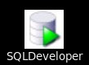On the desktop, double-click the SQL Developer desktop icon.

* 1. Connect to the hr schema.

The connection details are as follows:

Connection Name: hr_connection

Username: hr Password: hr Hostname: localhost Port: 1521

Service name: orclpdb

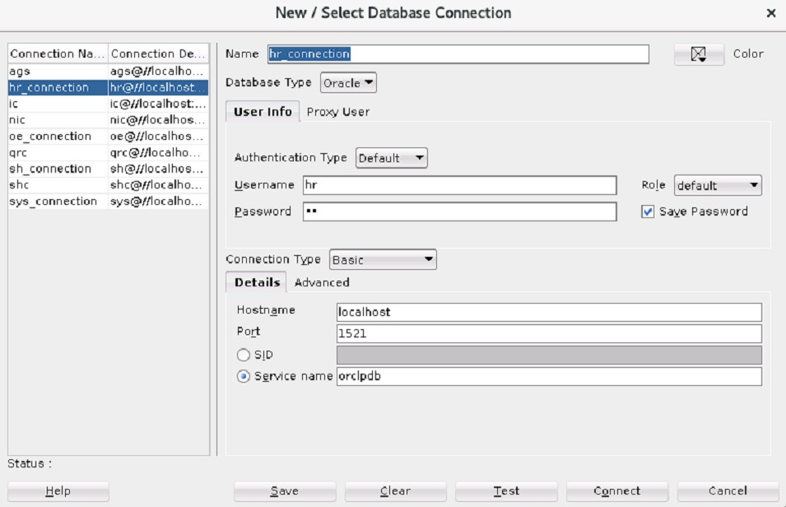

* 1. Execute setup01.sql to set up the environment for this workshop.

**Note:** The scripts for this workshop are available in the workshops folder located in

/home/oracle/labs/workshops.

##### setup01.sql

set echo on

DROP TABLE hr.emp PURGE

/

CREATE TABLE hr.emp AS SELECT * FROM hr.employees

/

DESCRIBE HR.EMP

/

DROP TABLE hr.dept PURGE

/

CREATE TABLE hr.dept AS

SELECT (department_id||'-'||department_name) dept_id, manager_id, location_id

FROM hr.departments

/

DESCRIBE HR.DEPT

/

DROP INDEX hr.dept_dept_id_idx1

/

CREATE INDEX hr.dept_dept_id_idx1 ON hr.dept (dept_id)

NOLOGGING

COMPUTE STATISTICS

/

exec DBMS_STATS.GATHER_TABLE_STATS('HR','EMP')

/

exec DBMS_STATS.GATHER_TABLE_STATS('HR','DEPT')

/

Set echo off

* 1. Review and check the execution plan of the SQL statement in ws01.sql. Click the Explain Plan tool to check the plan.

SELECT employee_id, first_name, last_name, salary, substr (b.dept_id, instr (b.dept_id,'-') +1) dept_name

FROM hr.emp a, hr.dept b

WHERE a.department_id = substr (b.dept_id, 1, instr (b.dept_id,'-')-1)

AND salary >= 1000

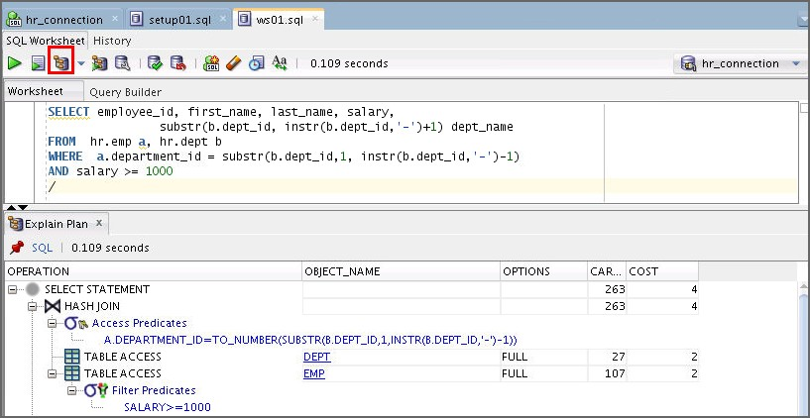



**Note:** You can use either the EXPLAIN PLAN command, as shown in the script

w1_s1_e.sql, or the SQL Developer EXPLAIN PLAN tool Worksheet to gather the execution plan.

icon in the SQL

* 1. Gather the execution plan of the SQL statement by using the following EXPLAIN PLAN

command. Use the **w1_s1_e.sql** file and click the **Run script** icon.

EXPLAIN PLAN FOR SELECT employee_id, first_name, last_name, salary, substr (b.dept_id, instr (b.dept_id,'-') +1) dept_name

FROM hr.emp a, hr.dept b

WHERE a.department_id = substr (b.dept_id, 1, instr (b.dept_id,'-')-1)

AND salary >= 1000

/

SELECT * FROM TABLE (dbms_xplan.display);

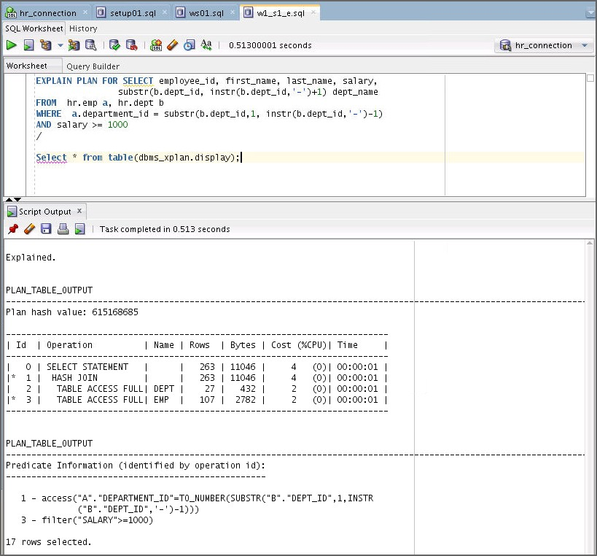

**Note:** The EXPLAIN PLAN command is used to gather the execution plan.

* 1. Review the execution plan. What do you observe?
     1. Was the DEPT_DEPT_ID_IDX1 index used?
     2. If the index is not used, try to explain why the index is not used.

##### Answer:

1. No, the index DEPT_DEPT_ID_IDX1 is not used.
2. Internal transformation occurred due to the function in the indexed column.
3. Create a new index.
   1. Execute the following sample code to create a new index DEPT_DEPT_ID_IDX2 that is usable by the optimizer, or you can use the **ws01a.sql**file.

DROP INDEX hr.dept_dept_id_idx2

/

CREATE INDEX hr.dept_dept_id_idx2

ON hr.dept (substr (dept_id, 1, instr (dept_id,'-')-1)) NOLOGGING

COMPUTE STATISTICS

/

* 1. Use the sample code to gather the execution plan of the SQL statement or you can use the **w1_s2_b.sql** file.

EXPLAIN PLAN FOR SELECT employee_id, first_name, last_name, salary, substr (b.dept_id, instr (b.dept_id,'-') +1) dept_name

FROM hr.emp a, hr.dept b

WHERE a.department_id = substr (b.dept_id, 1, instr (b.dept_id,'-')-1)

AND salary >= 1000

/

SELECT * FROM TABLE (dbms_xplan.display);

* 1. Review the execution plan. What do you observe?
     1. Was the DEPT_DEPT_ID_IDX2 index used?
     2. If the index is not used, try to explain why the index is not used.

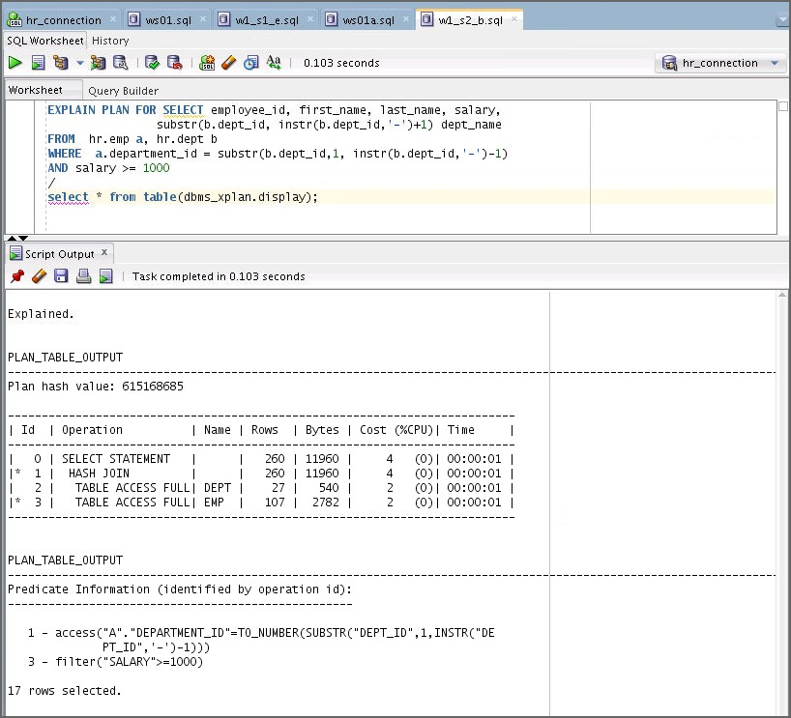

##### Answer:

1. No, the index DEPT_DEPT_ID_IDX2 is not used.
2. There was a data type mismatch. emp.department_id (NUMBER) dept.dept_id (CHAR).
3. Perform additional tasks.
   1. Perform additional tasks and rewrite the SQL statements to take advantage of an index.

* Assume that you have a chance to redesign the DEPT table.

**Note:** To normalize the DEPT table, check all the columns with matching data type. You can create an index on the dept_id column and check the execution plan.

* 1. Gather the execution plan of the SQL statement by using the EXPLAIN PLAN

command.

* 1. Review the execution plan. What do you observe? Was an index used?
  2. Execute cleanup01.sql to clean up your environment for the next task.

DROP INDEX hr.dept_dept_id_idx1

/

DROP INDEX hr.dept_dept_id_idx2

/

DROP TABLE hr.emp PURGE

/

DROP TABLE hr.dept PURGE

/

1. After a function-based index is created, it is always chosen by the optimizer even if there is a condition that forces implicit data type conversion.
   1. True
   2. False

##### Answer: b

1. When computing selectivity on predicates of the form function (Column) = constant (for example, function-based index or built-in functions), the optimizer assumes a static selectivity value of 1 percent.
   1. True
   2. False

**Answer: b**

**Note:** The EXPLAIN PLAN command will be used in subsequent practices.

# Workshop 2

## Workshop 2: Overview

##### Workshop Overview

In this workshop, you will perform the following tasks:

* Display an execution plan by using the EXPLAIN PLAN command.
* Display an execution plan by using the V$ view.
* Analyze and fix the issue.

##### Scripts Used in the Workshop

* setup02.sql
* ws02.sql
* w2_s2_b.sql
* w2_s2_b1.sql
* cleanup02.sql

## Workshop 2: Reviewing the Execution Steps of the SQL Statement

### Overview

This workshop is to review the execution steps of a SQL statement section. You review the SQL statement that uses a bind variable in the indexed column. You also analyze two execution plans of the SQL statement using the EXPLAIN PLAN command and the V$ view. After completing this workshop, you should be able to understand why the two execution plans are different for the same SQL statement.

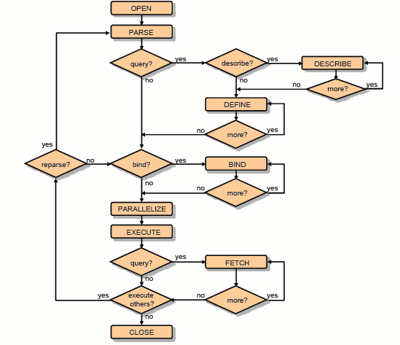

##### Index Information

* Index Name: HR.EMP_ID_PK : EMP_ID

### Tasks

1. Display an execution plan using the EXPLAIN PLAN command.
   1. Connect to the hr schema in SQL Developer.
   2. Execute setup02.sql to set up the environment for this workshop.

**Note:** The scripts used in this workshop are available in the workshops folder located in

/home/oracle/labs/workshops.

DROP TABLE hr.emp PURGE

/

CREATE TABLE emp (

emp_id varchar2(5) CONSTRAINT emp_id_pk PRIMARY KEY, emp_fn varchar2(20),

emp_ln varchar2(20), dept_id varchar2(5)

)

/

INSERT INTO emp

SELECT employee_id, first_name, last_name, department_id from employees

/ commit

/

exec DBMS_STATS.GATHER_TABLE_STATS ('HR','EMP', METHOD_OPT =>

'for all indexed columns', CASCADE => TRUE)

/

* 1. Execute the ws02.sql script and analyze the execution plan by using the EXPLAIN PLAN command. Click the Run Script  icon to run the script.

Was the EMP_ID_IDX index used?

variable empid number exec :empid:= 190

EXPLAIN PLAN FOR

SELECT * FROM hr.emp WHERE emp_id = :empid

/

SELECT * FROM TABLE (dbms_xplan.display);

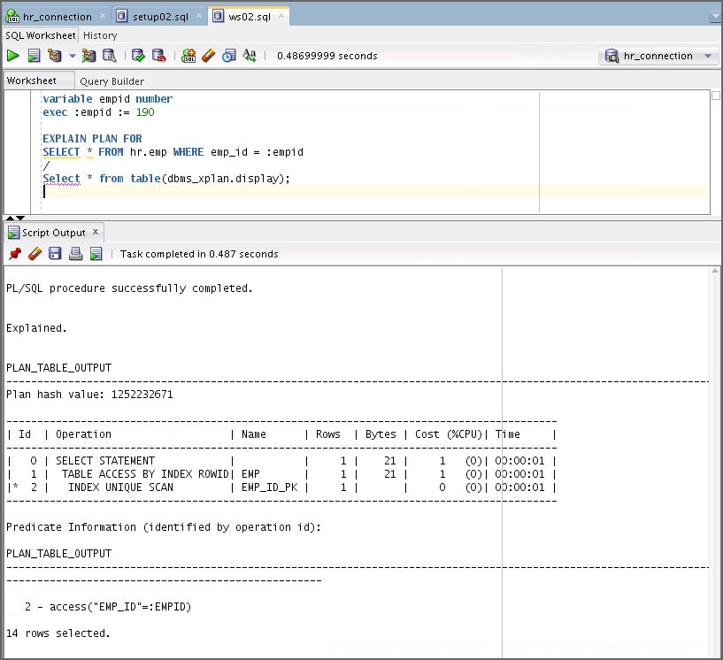

##### Answer:

Yes, the EMP_ID_IDX index is used.

1. Display an execution plan by using the V$ view.
   1. Execute the SQL statement in the ws02.sql script again.
   2. Use the following sample codes to review the execution plan by using the V$SQLAREA view and format it by using the DBMS_XPLAN package; or you can use w2_s2_b.sql and w2_s2_b1.sql files.

variable empid number exec: empid: =190

SELECT * FROM hr.emp WHERE emp_id=:empid

/

select sql_id, plan_hash_value, sql_text

from v$sqlarea

where sql_text = 'SELECT * FROM hr.emp WHERE emp_id=: empid';

select * from table(dbms_xplan.display_cursor(<<**'Please Enter the**

**SQL_ID value'>>**));

* + 1. What is the SQL_ID of the SQL statement?
    2. What function of DBMS_XPLAN is used to format and display the contents of the execution plan of any loaded cursor?
    3. Was the EMP_ID_IDX index used?

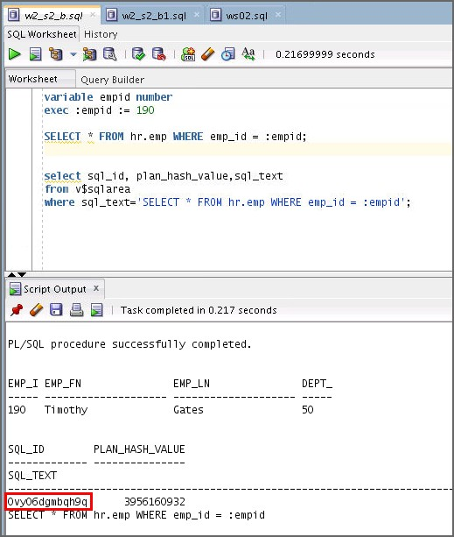

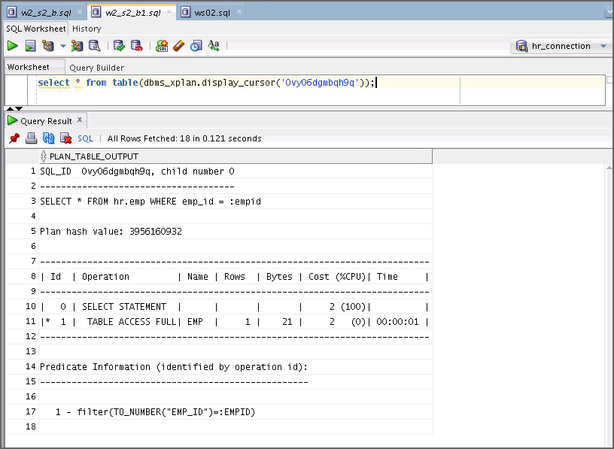

##### Answer:

1. 0vy06dgmbqh9q SQL_ID
2. dbms_xplan.display_cursor is used to format and display the contents of the execution plan of any loaded cursor.
3. No, EMP_ID_IDX index is not used.
4. Analyze and fix the issue.
   1. Discuss why the two plans shown in Task 1 and Task 2 are different.

**Note:** In Task 1, the plan is executed before peeking at the value in the bind variable. And in Task 2, the plan is executed after peeking at the value in the bind variable. Data types are mismatched between the bind variable and indexed column.

* 1. Determine a cause and fix it to use the emp_id_pk index.
  2. Execute the cleanup02.sql script for the next workshop.

DROP TABLE hr.emp PURGE

/

1. What statements are true?
   1. The EXPLAIN PLAN command is used to generate an optimizer execution plan.
   2. The EXPLAIN PLAN command executes the statement.
   3. When a bind variable is used, the EXPLAIN PLAN command peeks at the value in the bind variable.

##### Answer: a

1. The following steps are involved in query execution. Fill in the blank.

Parse → ( ) → Execute → Fetch

**Answer:** Bind

# Workshop 3

## Workshop 3: Overview

### Workshop Overview

In this workshop, you will perform the following tasks:

* Perform an initial setup.
* Examine the indexed ORDER BY columns.

##### Scripts Used in the Workshop

* setup03.sql
* ws03.sql
* w3_s1_c.sql
* w3_s2_a.sql
* w3_s2_b.sql
* w3_s2_b1.sql
* w3_s2_c.sql
* w3_s2_d.sql
* w3_s3_a.sql
* w3_s3_b.sql
* w3_s3_b1.sql
* cleanup03.sql

## Workshop 3: Learn to Tune Sort Operation Using an Index in the

**ORDER BY Clauses**

### Overview

This workshop shows the possible usage of an index in the ORDER BY clause to tune a sort operation. You perform several tasks to be able to use the indexed ORDER BY column. After all tasks are done, you verify if the index always produces a better plan cost.

|  |  |  |
| --- | --- | --- |
| **Table Name** | **Column Name** | **Constraint** |
| SH.CUST | CUST_ID | PRIMARY KEY |
| CUST_FN |  |
| CUST_LN |  |
| CUST_CREDIT_LIMIT |  |
| CUST_STATE_PROVINCE |  |

### Tasks

1. Initial Setup
   1. Connect to the sh schema in SQL Developer. Connection details are as follows:

Connection Name: sh_connection

Username: sh Password: sh Hostname: localhost Service name: orclpdb

**Note:** The scripts used in this workshop are available under the workshops folder located in

/home/oracle/labs/workshops.

Make sure the sh user has the following privilege:

GRANT DBA to sh;

If not, connect as the **sys** user in SQL Developer and grant the privilege to sh.

* 1. Execute the **setup03.sql** to set up the environment for this workshop.

DROP TABLE sh.country PURGE

/

CREATE TABLE sh.country ( country_id number primary key, country_name varchar(40), country_subregion varchar(30), country_region varchar2(20)

)

/

INSERT INTO sh.country

SELECT country_id, country_name, country_subregion, country_region

FROM sh.countries

/

commit

/

CREATE INDEX sh.count_country_region_idx ON sh.country(country_region)

NOLOGGING

COMPUTE STATISTICS

/

exec dbms_stats.gather_table_stats('SH','COUNTRY',method_opt=>'for all indexed columns',cascade=>true)

/

DESC sh.country

/

* 1. Review the ws03.sql file.
  2. Gather the execution plan of the SQL statement in the ws03.sql file using the

EXPLAIN PLAN command given as follows or you can use w3_s1_c.sql file.

EXPLAIN PLAN FOR SELECT country_name, country_subregion FROM sh.country

WHERE country_region = 'Europe'

ORDER BY country_name

/

SELECT * FROM TABLE(dbms_xplan.display);

* + 1. What is the name of the index used?
    2. 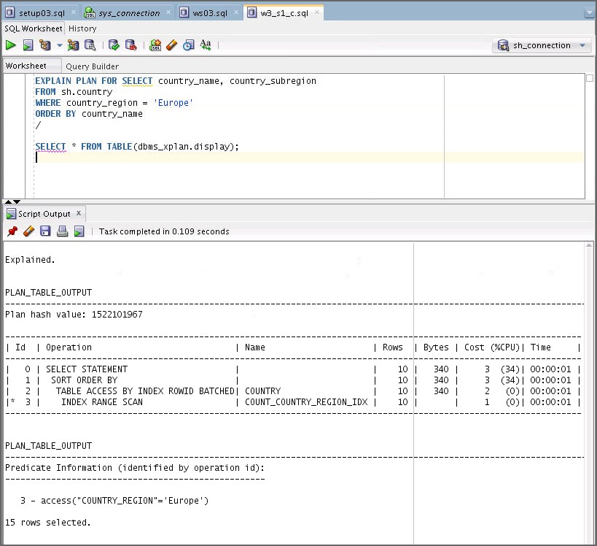What is the total cost?

##### Answer:

1. The COUNT_COUNTRY_REGION_IDX index is used.
2. Cost is 3.

**Note:** Your cost might differ depending on your environment.

1. Examine the indexed ORDER BY columns.
   1. Use the following sample code to create a composite index, COUNT_CN_CSR_IDX or you can use the w3_s2_a.sql file.

**Note:** Index order: country_name, country_subregion

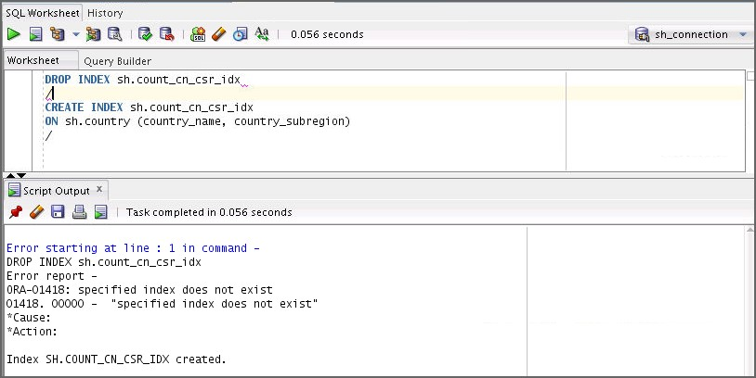

DROP INDEX sh.count_cn_csr_idx

/

CREATE INDEX sh.count_cn_csr_idx

ON sh.country (country_name, country_subregion)

/

* 1. Gather and analyze the execution plan of the SQL statement again by using the

EXPLAIN PLAN command or you can use the w3_s2_b.sql file.

EXPLAIN PLAN FOR SELECT country_name, country_subregion FROM sh.country

WHERE country_region = 'Europe'

ORDER BY country_name, country_subregion

/

SELECT * FROM TABLE(dbms_xplan.display);

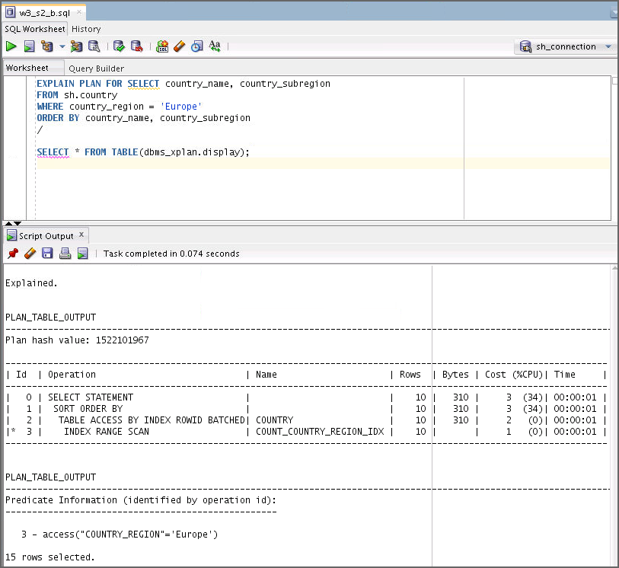

* + 1. Was the COUNT_CN_CSR_IDX index used? If not, add an index hint to allow the optimizer to use the COUNT_CN_CSR_IDX index and gather the execution plan by using the EXPLAIN PLAN command. You can use w3_s2_b1.sql.

EXPLAIN PLAN FOR SELECT /*+ index (count_cn_csr_idx) */ country_name, country_subregion

FROM sh.country

WHERE country_region = 'Europe'

ORDER BY country_name, country_subregion

/

SELECT * FROM TABLE(dbms_xplan.display);

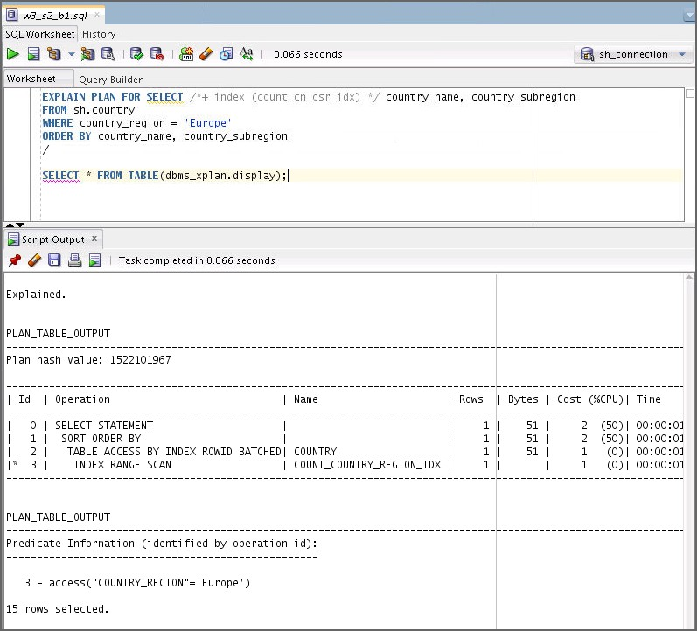

* + 1. Was a sort operation avoided?
    2. Was the cost of the plan better than the one in Task 1?

**Note:** sh.count_cn_csr_idx is not used. At least, one of the indexed columns in the ORDER BY clause should have the NOT NULL constraint.

* 1. If the index is not used, take additional tasks to use the indexed ORDER BY columns.

**Hint:** Consider adding the NOT NULL constraint.

Use the sample code or you can use the w3_s2_c.sql file.

ALTER TABLE sh.country MODIFY (country_name NOT NULL)

/

* 1. After step c is performed, repeat Step b to verify if the composite index is used. Use the w3_s2_d.sql file.

**Note:** If the composite index is not used even after adding a NOT NULL constraint to the

ORDER BY columns, then move to Task 3.

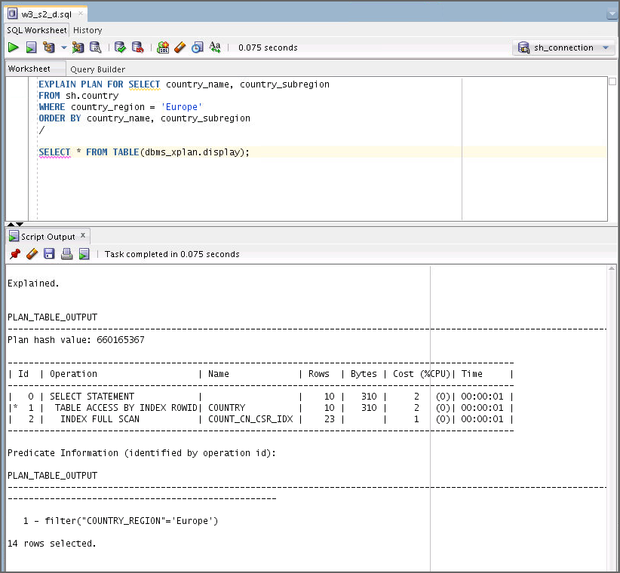

1. Examine the indexed ORDER BY columns.
   1. Use the sample code to create another composite index, COUNT_CSR_CN_IDX, on the

ORDER BY columns or you can use the w3_s3_a.sql file.

**Note:** Index order: country_subregion, country_name

DROP INDEX sh.count_csr_cn_idx

/

CREATE INDEX sh.count_csr_cn_idx

ON sh.country (country_subregion, country_name)

/

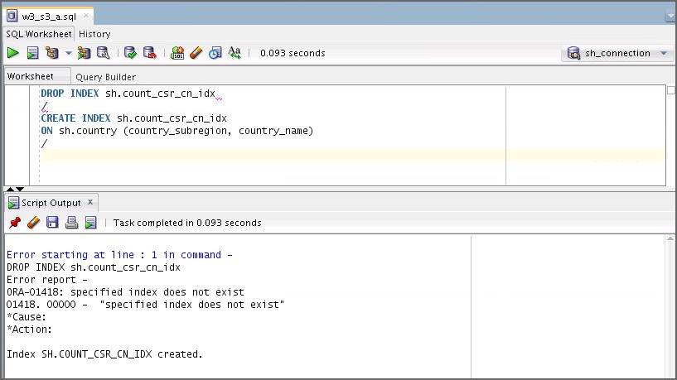

* 1. Gather and analyze the execution plan of the SQL statement again by using the

EXPLAIN PLAN command. You can use the w3_s3_b.sql file.

EXPLAIN PLAN FOR SELECT country_name, country_subregion FROM sh.country

WHERE country_region = 'Europe'

ORDER BY country_name, country_subregion

/

SELECT * FROM TABLE (dbms_xplan.display);

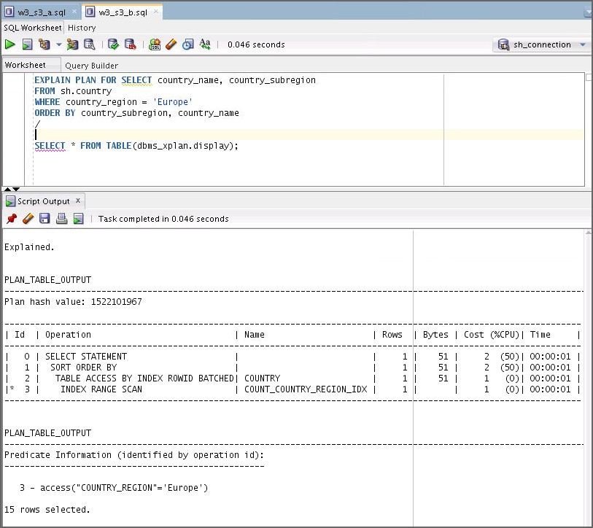

* + 1. Was the COUNT_CSR_CN_IDX index used? If not, add an index hint to allow the optimizer to use the count_csr_cn_idx index and gather the execution plan using the EXPLAIN PLAN command. You can use the w3_s3_b1.sql file.

EXPLAIN PLAN FOR SELECT /*+ index (count_csr_cn_idx) */ country_name, country_subregion

FROM sh.country

WHERE country_region = 'Europe'

ORDER BY country_subregion, country_name

/

SELECT * FROM TABLE (dbms_xplan.display);

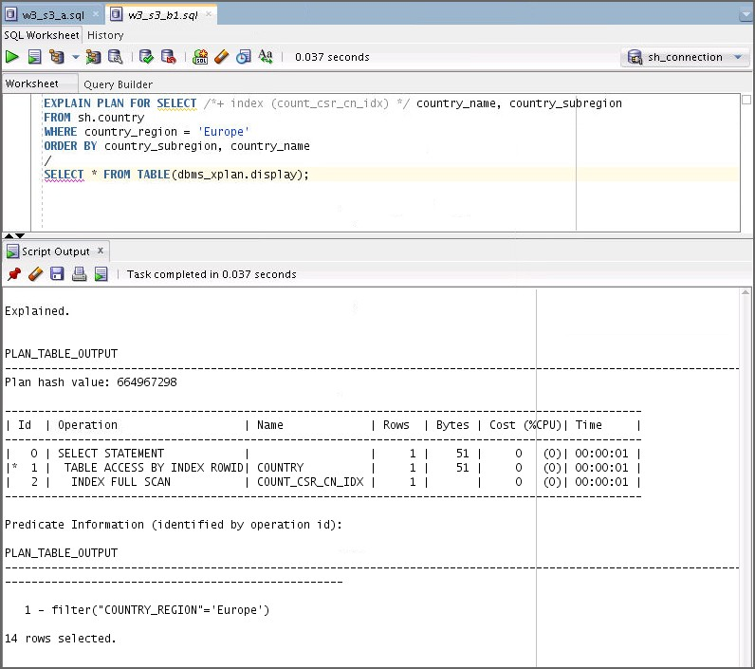

* + 1. Was a sort operation avoided?
    2. Was the cost of the plan better than the one in Task 1?

**Note:** The COUNT_CSR_CN_IDX index is used. However, you learned that using the indexed ORDER by column that avoids a sort operation doesn’t always produce better performance.

1. Your Observation

**Note:** You have performed several tasks to see the possible usage of an index in the ORDER BY clause to tune a sort operation. Take a minute to answer the following questions based on your observation.

* 1. What do you observe?
  2. Execute the cleanup03.sql script for the next workshop.

DROP INDEX sh.count_country_region_idx

/

DROP INDEX sh.count_cn_csr_idx

/

DROP INDEX sh.count_csr_cn_idx

/

DROP TABLE sh.country PURGE

/

1. When using the indexed ORDER BY column to avoid a sort operation, you should consider the following:
   1. All the order by columns should be in the composite index.
   2. ORDER BY columns should be of the same order as those of the composite index.
   3. At least one of the composite columns should have the NOT NULL constraint.
   4. All composite columns should have the NOT NULL constraint.
   5. Using the indexed ORDER BY column that avoids a sort operation always produces better performance.

**Answer:** a, b, and c

# Workshop 4

## Workshop 4: Overview

### Workshop Overview

In this workshop, you will perform the following tasks:

* Identify a poorly written SQL statement.
* Tune the SQL statement by rewriting it.

##### Scripts Used in the Workshop

* setup04.sql
* ws04.sql
* w4_s1_d.sql
* w4_s2_a.sql
* w4_s2_b.sql

## Workshop 4: Identifying and Tuning a Poorly Written SQL Statement

### Overview

In this workshop, you assume that you have identified a poorly running SQL statement. You already noticed that the root cause of the issue is the table design. However, re-creating the table is not an option at this point. The table is already in use. Try to tune the SQL statement by rewriting it.

**Index Information**

|  |  |
| --- | --- |
| **Index Name** | **Columns** |
| TIME_IDX | YYYY + MM + DD |

### Tasks

1. Initial setup
   1. Connect to the sh schema in SQL Developer.
   2. Use setup04.sql to set up the environment for this workshop.

**Note:** The scripts used in this workshop are available in the workshops folder located in

/home/oracle/labs/workshops.

DROP TABLE sh.sales1 PURGE

/

CREATE TABLE sh.sales1 ( sales_id number primary key, prod_id number,

yyyy char(4), mm char(2), dd char(2),

amount_sold number(10,2)

)

/

DROP SEQUENCE sh.sales_id_seq

/

CREATE SEQUENCE sh.sales_id_seq START WITH 1

INCREMENT BY 1 NOCACHE NOCYCLE

/

INSERT INTO sh.sales1

SELECT sales_id_seq.nextval, prod_id,

to_char (time_id, 'YYYY'), to_char (time_id, 'MM'), to_char (time_id, 'DD'), amount_sold

FROM sh.sales

/

COMMIT

/

DROP TABLE sh.prod1 PURGE

/

CREATE TABLE sh.prod1 AS SELECT * FROM sh.products

/

DROP INDEX sh.time_idx

/

CREATE INDEX sh.time_idx

ON sh.sales1 (YYYY, MM, DD, sales_id) NOLOGGING

COMPUTE STATISTICS

/

exec DBMS_STATS.GATHER_TABLE_STATS ('SH','SALES1', METHOD_OPT => 'FOR ALL INDEXED COLUMNS',CASCADE => TRUE)

/

exec DBMS_STATS.GATHER_TABLE_STATS('SH','PROD1', METHOD_OPT => 'FOR ALL INDEXED COLUMNS',CASCADE => TRUE)

/

DESC sh.sales1 DESC sh.prod1

* 1. Review the SQL statement in ws04.sql.

SELECT (s.yyyy || s.mm || s.dd) TIME, s.prod_id, sum (amount_sold)

FROM sh.sales1 s, sh.prod1 p WHERE s.prod_id = p.prod_id

AND s.yyyy || s.mm || s.dd BETWEEN '19980901' AND '19980907'

AND p.prod_category = 'Hardware'

GROUP BY s.prod_id, s.yyyy || s.mm || s.dd ORDER BY 1

/

* 1. Gather the execution plan of the SQL statement by using the EXPLAIN PLAN

command by using the following sample code, or you can use the w4_s1_d.sql file.

EXPLAIN PLAN FOR SELECT (s.yyyy || s.mm || s.dd) TIME, s.prod_id, sum (amount_sold)

FROM sh.sales1 s, sh.prod1 p WHERE s.prod_id = p.prod_id

AND s.yyyy || s.mm || s.dd BETWEEN '19980901' AND '19980907'

AND p.prod_category = 'Hardware'

GROUP BY s.prod_id, s.yyyy || s.mm || s.dd ORDER BY 1

/

SELECT * FROM TABLE (dbms_xplan.display);

* + 1. Was the TIME_IDX index used?
    2. What is the total cost?

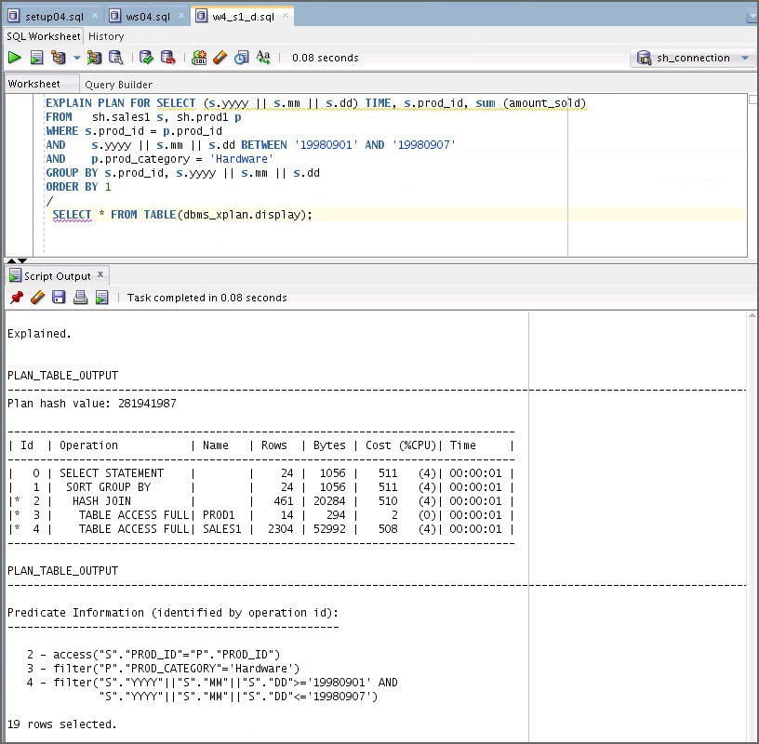

##### Answer:

1. The TIME_IDX index is not used.
2. Cost is 511 in this case.

**Note:** In this case, the cost is 511. It might differ also.

1. Rewrite the SQL statement.
   1. If the TIME_IDX is not used, rewrite and review the SQL statement in w4_s2_a.sql

to take advantage of the index.

**Hint:** Modify the BETWEEN operator.

SELECT (s.yyyy || s.mm || s.dd) TIME, s.prod_id, sum (amount_sold)

FROM sh.sales1 s, sh.prod1 p WHERE s.prod_id = p.prod_id

AND (s.yyyy = '1998' AND s.mm = '09' AND s.dd BETWEEN '01' AND '07')

AND p.prod_category = 'Hardware'

GROUP BY s.yyyy || s.mm || s.dd, s.prod_id ORDER BY 1

/

* 1. Use the sample code to gather the execution plan of the rewritten SQL statement by using the EXPLAIN PLAN command. You can use the w4_s2_b.sql file.

EXPLAIN PLAN FOR SELECT (s.yyyy || s.mm || s.dd) TIME, s.prod_id, sum (amount_sold)

FROM sh.sales1 s, sh.prod1 p WHERE s.prod_id = p.prod_id

AND (s.yyyy = '1998' AND s.mm = '09' AND s.dd BETWEEN '01' AND '07')

AND p.prod_category = 'Hardware'

GROUP BY s.yyyy || s.mm || s.dd, s.prod_id ORDER BY 1

/

SELECT * FROM TABLE (dbms_xplan.display);

* + 1. Was the TIME_IDX index used?
    2. What is the total cost?

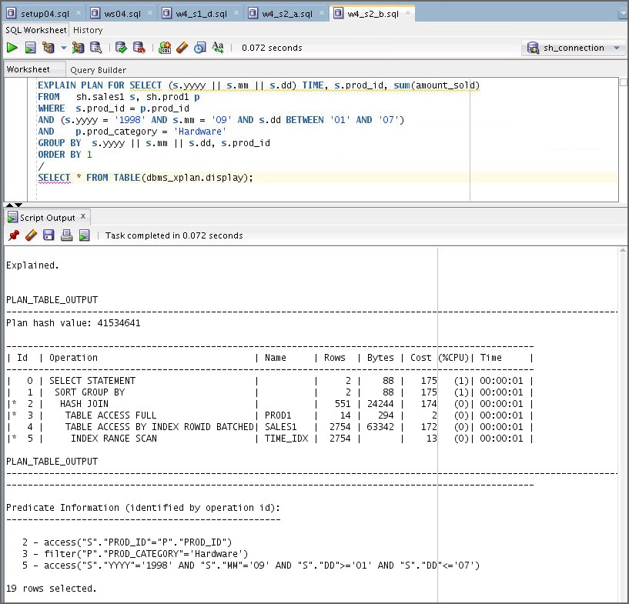

##### Answer:

1. The TIME_IDX index is used.

**Note:** Redesigning the SALES1 table would be a better choice. But if the table is already in use, you could rewrite the SQL statement to take advantage of the index.

1. The total cost is 175.

**Note:** In this case, the cost is 175. It might differ also.

1. Your observation

What was your observation?

# Workshop 5

## Workshop 5: Overview

### Workshop Overview

In this workshop, you will perform the following tasks:

* Write several SQL statements that return the same output to see which SQL statement is more efficient.
* Examine the effects of changing the column order in a composite index.

##### Scripts Used in the Workshop

* setup05.sql
* ws05.sql
* w5_s1_c.sql
* w5_s2_b.sql
* w5_s3_b.sql
* w5_s4_a.sql
* w5_s4_b.sql
* w5_s5_a.sql
* w5_s5_c.sql
* w5_s5_d.sql
* cleanup05.sql

## Workshop 5: Effects of Changing the Column Order in a Composite Index

### Overview

In this workshop, you write several SQL statements that return the same output to see which SQL statement is more efficient. You also examine the effects of changing the column order in a composite index.

**Index Information**

|  |  |  |
| --- | --- | --- |
| **Index Name** | **Columns** | **Initial Status** |
| cust_state_idx | cust_state_province | Visible |
| cust_income_state_idx | cust_income_level + cust_state_province | Invisible |
| cust_state_gender_idx | cust_state_province + cust_gender | Invisible |

### Tasks

1. Set up.
   1. Connect to the sh schema in SQL Developer.
   2. Use the setup05.sql script to set up your environment for this task.

**Note:** The scripts used in this workshop are available under the workshops folder located in /home/oracle/labs/workshops.

DROP TABLE sh.cust PURGE

/

CREATE TABLE sh.cust as SELECT * FROM sh.customers

/

DROP INDEX sh.cust_state_idx

/

CREATE INDEX sh.cust_state_idx ON sh.cust (cust_state_province) NOLOGGING

COMPUTE STATISTICS

/

DROP INDEX sh.cust_state_gender_idx

/

CREATE INDEX sh.cust_state_gender_idx

ON sh.cust(cust_state_province,cust_gender) NOLOGGING

COMPUTE STATISTICS

/

ALTER INDEX sh.cust_state_gender_idx INVISIBLE

/

DROP INDEX sh.cust_income_state_idx

/

CREATE INDEX sh.cust_income_state_idx

ON sh.cust(cust_income_level,cust_state_province) NOLOGGING

COMPUTE STATISTICS

/

ALTER INDEX sh.cust_income_state_idx INVISIBLE

/

exec DBMS_STATS.GATHER_TABLE_STATS('SH','CUST', METHOD_OPT => 'FOR ALL INDEXED COLUMNS', CASCADE => TRUE)

/

* 1. Make two indexes, CUST_INCOME_STATE_IDX and CUST_STATE_GENDER_IDX visible to the optimizer by using the following code, or you can use the w5_s1_c.sql file.

ALTER INDEX sh.cust_income_state_idx VISIBLE

/

ALTER INDEX sh.cust_state_gender_idx VISIBLE

/

1. Test the first query.
   1. Review the SQL statement (Query 1) in ws05.sql. In the first query, you transformed the indexed columns, CUST_STATE_PROVINCE and CUST_GENDER explicitly on purpose.

SELECT cust_first_name, cust_last_name, cust_income_level, cust_credit_limit

FROM sh.cust

WHERE cust_income_level like 'F%'

AND cust_state_province||'' in ('NJ', 'NY')

AND cust_gender ||'' = 'M'

* 1. Execute the following sample code and gather the execution plan of the SQL statement by using the EXPLAIN PLAN command. You can use the w5_s2_b.sql file.

EXPLAIN PLAN FOR SELECT cust_first_name, cust_last_name, cust_income_level, cust_credit_limit

FROM sh.cust

WHERE cust_income_level like 'F%'

AND cust_state_province in ('NJ', 'NY') AND cust_gender = 'M'

/

SELECT * FROM TABLE (dbms_xplan.display);

* + 1. Which index was used?
    2. What is the total cost?

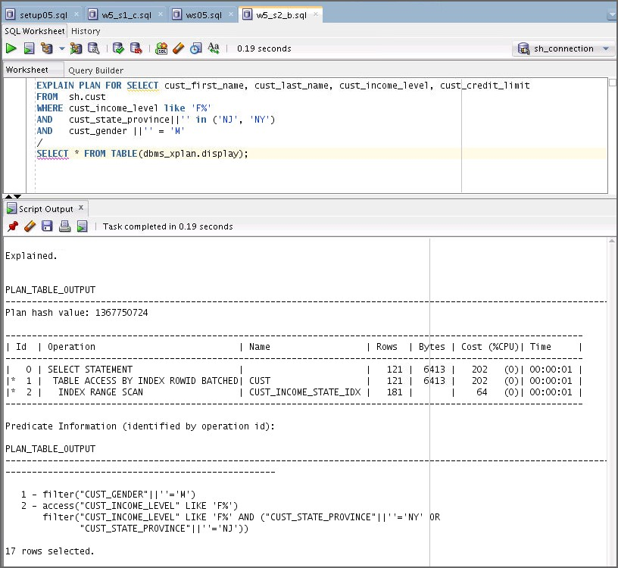

##### Answer:

1. The CUST_INCOME_STATE_IDX index is used.
2. The cost is 202.

**Note:** The cost is 202 in this case. It might differ also.

* 1. Did the optimizer consider the CUST_STATE_GENDER_IDX index? If not, try to explain why the index was not considered.

**Note:** The CUST_STATE_GENDER_IDX index was not considered due to the transformed columns.

1. Test the second query.
   1. Rewrite the SQL statement (Query 2) to consider the CUST_STATE_GENDER_IDX

index as an option as well.

SELECT cust_first_name, cust_last_name, cust_income_level, cust_credit_limit

FROM sh.cust

WHERE cust_income_level like 'F%'

AND cust_state_province in ('NJ', 'NY') AND cust_gender = 'M'

AND rownum < 31

/

* 1. Execute the following sample code and gather the execution plan of the SQL statement using the EXPLAIN PLAN command. You can use the w5_s3_b.sql file.

EXPLAIN PLAN FOR SELECT cust_first_name, cust_last_name, cust_income_level, cust_credit_limit

FROM sh.cust

WHERE cust_income_level like 'F%'

AND cust_state_province in ('NJ', 'NY') AND cust_gender = 'M'

AND rownum < 31

/

SELECT * FROM TABLE (dbms_xplan.display);

* + 1. Which index was used?
    2. What is the total cost?

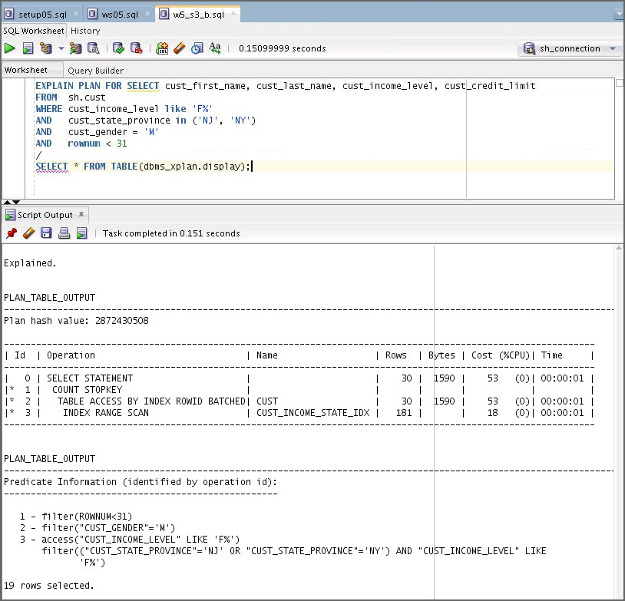

##### Answer:

1. The CUST_INCOME_STATE_IDX index is used.
2. The cost is 53.

**Note:** The cost is 53 in this case. It might differ also.

* 1. Did the optimizer consider the CUST_STATE_GENDER_IDX index? If no, try to explain why the index was not considered in Task 3.

**Note:** In Task 3, the CUST_STATE_GENDER_IDX index was considered, but was not an optimal access path.

1. Test the third query.
   1. Rewrite the SQL statement that returns the same output using an IN-LINE VIEW. Use the following sample code, or you can use the w5_s4_a.sql file.

* The usage of both OR and ROWNUM sometimes causes performance problems. So, you rewrite the SQL statement that includes an IN-LINE VIEW.

SELECT cust_first_name, cust_last_name, cust_income_level, cust_credit_limit

FROM (SELECT cust_first_name, cust_last_name, cust_income_level, cust_credit_limit

FROM sh.cust

WHERE cust_income_level like 'F%' AND cust_state_province = 'NJ' AND cust_gender= 'M'

union all

SELECT cust_first_name, cust_last_name, cust_income_level, cust_credit_limit

FROM sh.cust

WHERE cust_income_level like 'F%' AND cust_state_province = 'NY' AND cust_gender= 'M')

WHERE rownum < 31

/

**Note:** The inline view is a construct in Oracle SQL where you can place a query in the SQL

FROM clause, as if the query was a table name.

* 1. Execute the following sample code and gather the execution plan of the SQL statement by using the EXPLAIN PLAN command. You can use the w5_s4_b.sql file.

EXPLAIN PLAN FOR SELECT cust_first_name, cust_last_name, cust_income_level, cust_credit_limit

FROM (SELECT cust_first_name, cust_last_name, cust_income_level, cust_credit_limit

FROM sh.cust

WHERE cust_income_level like 'F%' AND cust_state_province = 'NJ' AND cust_gender= 'M'

union all

SELECT cust_first_name, cust_last_name, cust_income_level, cust_credit_limit

FROM sh.cust

WHERE cust_income_level like 'F%' AND cust_state_province = 'NY' AND cust_gender= 'M')

WHERE rownum < 31

/

SELECT * FROM TABLE (dbms_xplan.display);

* + 1. Which index was used?
    2. 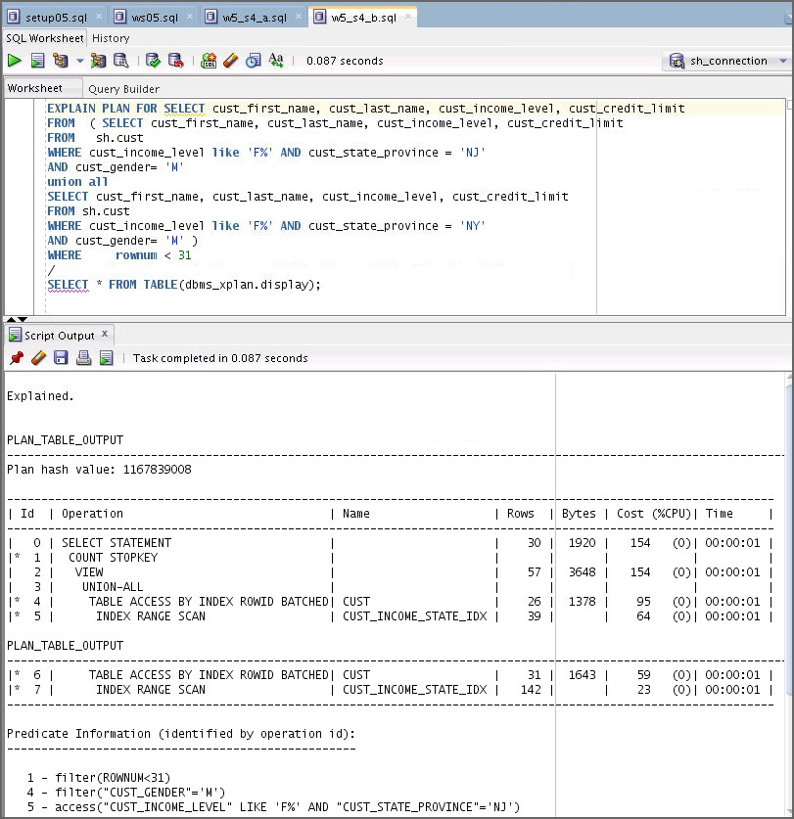What is the total cost?

##### Answer:

1. The CUST_INCOME_STATE_IDX index is used.
2. The cost is 154.

**Note:** The cost is 154 in this case. It might differ also.

* 1. Compare the total costs of three SQL statements.
     1. Cost (Query 1)
     2. Cost (Query 2)
     3. Cost (Query 3)

1. Review the composite index.
   1. You have tested three SQL statements that return the same output. All three SQL statements used the same index, which is CUST_INCOME_STATE_IDX. You still feel that the performance could be improved. Now, you are investigating the CUST_INCOME_STATE_IDX index for further improvement. Retrieve the order of columns in the composite index. You can use the w5_s5_a.sql file.

**Hint:** Use the USER_IND_COLUMNS view.

* + 1. Column Name in Position 1: ( )
    2. Column Name in Position 2: ( )

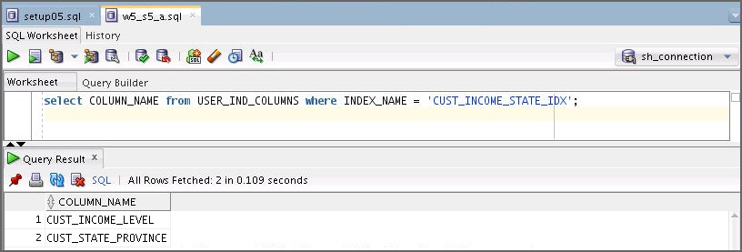

select COLUMN_NAME from USER_IND_COLUMNS where INDEX_NAME = 'CUST_INCOME_STATE_IDX';

##### Answer:

1. Column name in position 1 is cust_income_level.
2. Column name in position 2 is cust_state_province.
   1. Check how these columns are used in the WHERE clause (Query 2).
      1. WHERE ( ) LIKE ‘…’ 2) AND ( ) IN (…..)

##### Answer:

1. WHERE cust_income_level LIKE 'F%'
2. AND cust_state_province IN ('NJ', 'NY')
   1. Execute the following sample code and create a new composite index, CUST_STATE_INCOME_IDX, after considering the order of columns in the CUST_INCOME_STATE_IDX index for better performance. Make sure that you update statistics on the newly created index. You can use the w5_s5_c.sql file.

**Hint:** Think about the order of the Index column.

**Rule of thumb:** If all columns in a composite index are equally used, then consider the following:

* Point condition
* Distribution
* Access paths

DROP INDEX sh.cust_state_income_idx

/

CREATE INDEX sh.cust_state_income_idx

ON sh.cust (cust_state_province, cust_income_level); NOLOGGING

COMPUTE STATISTICS

/

Exec DBMS_STATS_GATHER_TABLE_STATS ('SH','CUST', METHOD_OPT => 'FOR ALL INDEXED COLUMNS', CASCADE =>TRUE)

/

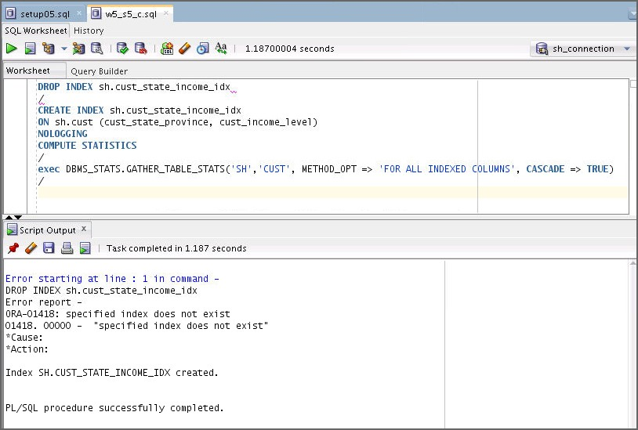

* 1. Execute the SQL statement (Query 2) and review the execution plan by using the sample code, or you can use the w5_s5_d.sql file.

EXPLAIN PLAN FOR SELECT cust_first_name, cust_last_name, cust_income_level, cust_credit_limit

FROM sh.cust

WHERE cust_income_level like 'F%'

AND cust_state_province in ('NJ', 'NY') AND cust_gender = 'M'

AND rownum < 31

/

SELECT * FROM TABLE (dbms_xplan.display);

* + 1. Which index was used?
    2. What is the total cost?

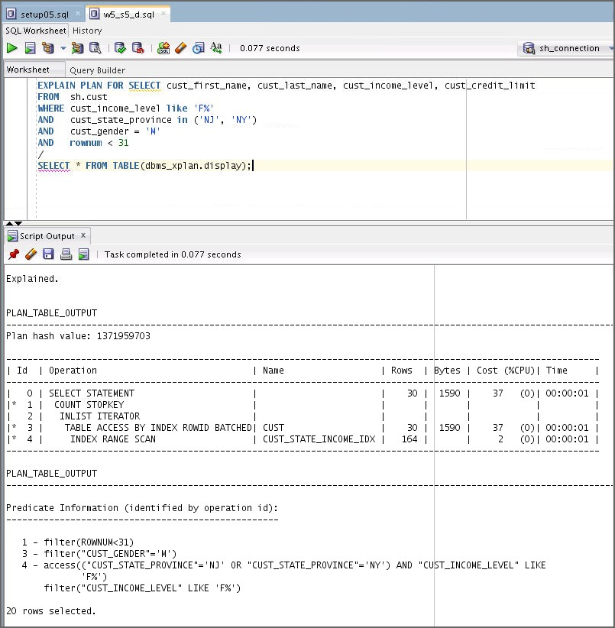

##### Answer:

1. The CUST_STATE_INCOME_IDX index is used.
2. The cost is 37.

**Note:** The cost is 37 in this case. It might differ also.

* 1. Did you observe a better cost?

**Answer:** Yes, the cost is better.

* 1. Clean up the environment. Use the cleanup05.sql file.

DROP INDEX sh.cust_state_idx

/

DROP INDEX sh.cust_state_gender_idx

/

DROP INDEX sh.cust_income_state_idx

/

DROP INDEX sh.cust_state_income_idx

/

1. Which statements are true regarding guidelines for ordering keys in composite indexes?
   1. Create the index so that the keys used in WHERE clauses make up a leading portion.
   2. If some keys appear in WHERE clauses more frequently, then create the index so that the more frequently selected keys make up a leading portion in order to allow the statements that use only these keys to use the index.
   3. If all keys appear in WHERE clauses equally often but the data is physically ordered on one of the keys, then place this key first in the composite index.

**Answer:** a, b, and c

# Workshop 6

## Workshop 6: Overview

### Workshop Overview

In this workshop, you will perform the following tasks:

* Review the execution plan and several sections in an event 10053 trace file.
* Interpret the information to understand the optimizer’s decision.
* Learn how to use the information in the 10053 file to tune the SQL statement.

## Workshop-6: Using Information in the 10053 File to Tune a SQL Statement

### Overview

In this workshop, you review the following execution plan and several sections in an event 10053 trace file. There are also several questions on cost model, selectivity, and cardinality. You interpret the information to understand the optimizer’s decision. Finally, you learn how to verify the cost of a nested loop manually. Note that this workshop is only for demonstration purposes.

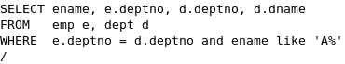

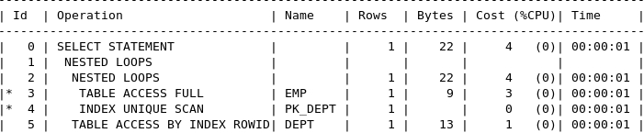

### Tasks

1. From where/how is the cost of the simple nested loops 4 derived?

- First of all, review the information needed to understand the CBO cost model:

* 1. Cost = I/O cost + CPU cost
  2. sreadtim = ioseektim + db_block_size / iotfrspeed
  3. mreadtim = ioseektim + db_file_multiblock_read_count * db_block_size / iotfrspeed
  4. CPU Costing Factor = cpuspeed * 1000 * sreadtim
  5. CPU Cost Scale Factor = 1 / CPU Costing Factor
  6. CPU Cost = Resp_cpu * CPU Cost Scale Factor
  7. NL Cost = Outer Table Cost + (Outer Table Card * Inner Table Cost)
  8. HJ/SMJ Cost = Outer Table Cost + Inner Table Cost + Join Cost2

1. Review the SYSTEM STATISTICS section in an event 10053 trace file and calculate the following information:
   1. sreadtim (db_block_size: 8K): ( )
   2. CPU cost scale factor: ( )

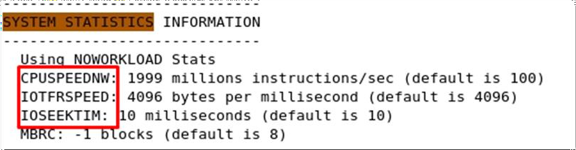

sreadtim = ioseektim + db_block_size / iotfrspeed

= 10ms + 8096/4096 = 12 ms

CPU Costing Factor = cpuspeed * 1000 * sreadtim

= 1999 * 1000 * 12 = 23988000

CPU Cost Scale Factor = 1 / CPU Costing Factor

= 1/(1999 * 1000 * 12) = 0.000000417

(nearly zero)

1. Review the following section for the outer table. Where is the outer table cost 3 from?
   1. Outer Table Cost ( 3 ) = IO Cost ( ) + CPU Cost ( )

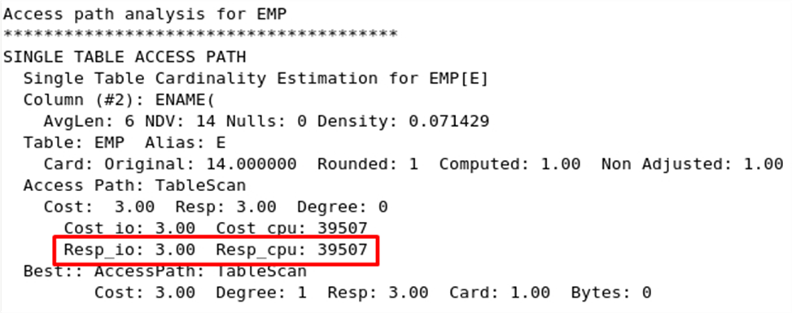

Outer Table Cost = IO Cost + CPU Cost

= **Resp_io** + (**Resp_cpu** * CPU Cost Scale Factor)

= 3 + (39507 * 0.000000417)

= 3 + 0.0162 (nearly zero)

1. Review the following section that includes the inner table information.
   1. Outer Table Card: ( )
   2. Inner Table Cost ( 1 ) = IO Cost ( ) + CPU Cost ( )

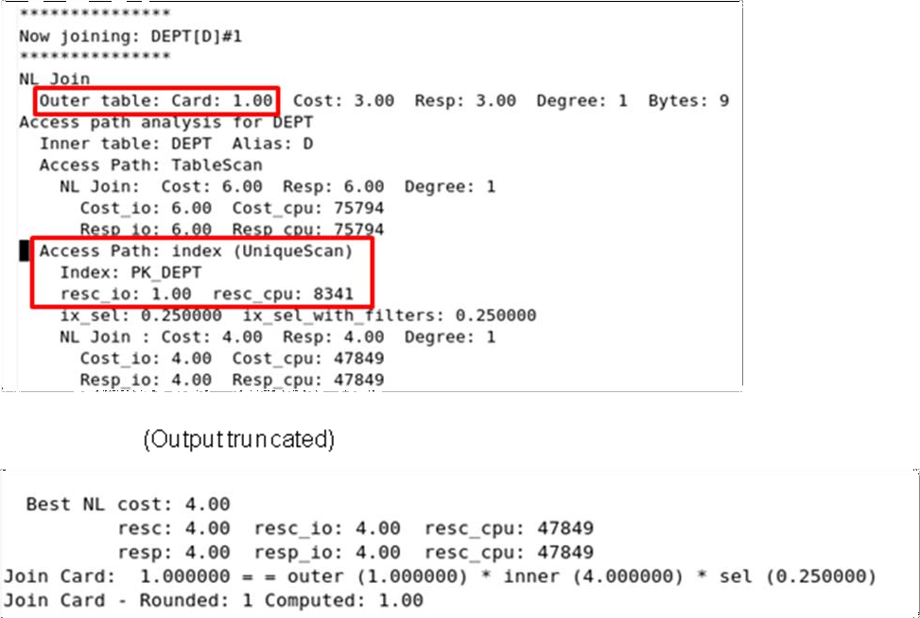

Inner Table Cost = IO Cost + CPU Cost

= resc_io + (resc_cpu * CPU Cost Scale Factor)

= 1 + (8341 * 0.000000417)

= 1 + 0.0162 (nearly zero)

1. Where is the cost of the nested loops from?

- NL Cost = Outer Table Cost + (Outer Table Card * Inner Table Cost)

- 4 = 3 + (1 * 1)

1. Which statements regarding nested loop joins are TRUE?
   1. The optimizer uses nested loop joins when joining a small number of rows, with a good driving condition between the two tables.
   2. The cost of nested loops is easy to verify manually by using an event 10053.
   3. A major component of nested loops cost is CPU cost.
   4. A major component of nested loops cost is I/O cost.

**Answer:** a, b, d

# Workshop 7

## Workshop 7: Overview

### Workshop Overview

In this workshop, you will perform the following tasks:

* Review the execution plan and several sections in an event 10053 trace file.
* Interpret the information to understand the optimizer’s decision.
* Learn how to use the information in the 10053 file to tune a SQL statement.

## Workshop 7: Understanding the Optimizer’s Decision

### Overview

In this workshop, you review the following execution plan and several sections in an event 10053 trace file. You interpret the information to understand the optimizer’s decision. Note that this workshop is only for demonstration purposes.

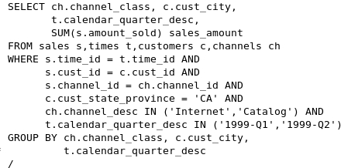

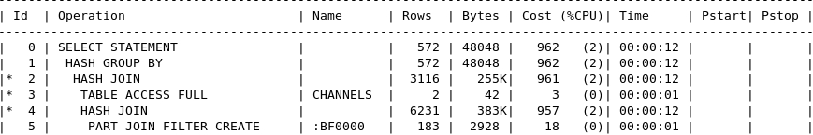

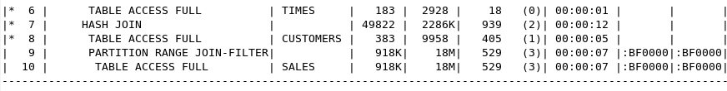

### Tasks

1. Review the preceding execution plan.
   1. What is the plan cost? ( )
   2. Where does the 00:00:12 time come from? ( )

##### Answer:

1. Plan cost is 962.
2. 12 sec = Plan Cost * sreadtim = 962 * 12ms
3. What is the meaning of a cost of 962 and 00:00:12 time.

**Note:** The meaning of the cost 962 is that the Oracle Optimizer computed that the preceding query should take as long as 962 single block reads. The cost of 962 equals an elapsed time of 12 sec.

1. Review the following section in an event 10053. What should be checked here?

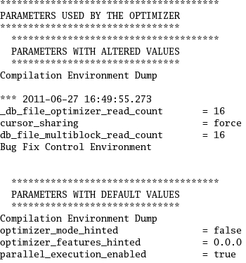

##### Notes

* You have learned in the lesson titled “Optimizer Fundamentals” that there are several parameters that could control the behavior of the optimizer.
* The example in 10053 shows parameters used by the optimizer.
* While reviewing this section, you can examine if any altered parameter values influenced the optimizer’s decision.
* You can also compare 10053 traces between two versions or two different plans to see why the plan cost is different.

1. Review the following section in an event 10053. What should be checked here?

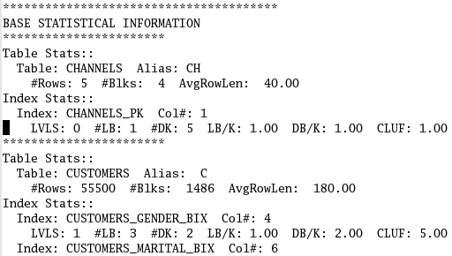

**Note:** It shows statistics gathered for each table and index referred by the query.

Look for any tables that were not analyzed. You see “NOT ANALYZED” in the table stats section if there is no analysis. Indexes that are not analyzed can be identified by default.

1. Review the following section in an event 10053. What should be checked here?

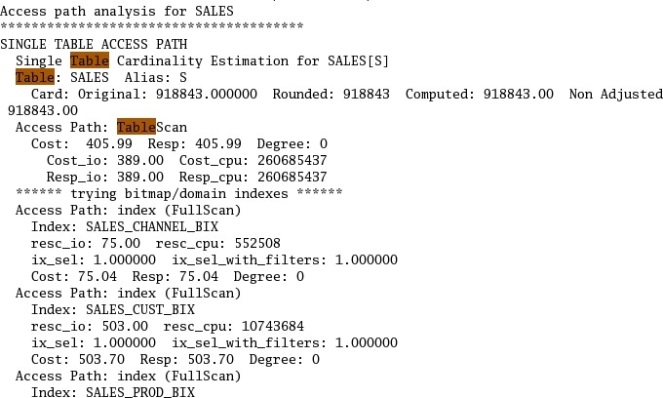

**Note:** Single table access path: You can determine the path that correlates to the execution plan. At the end of this section, you can see the best single table access cost.

1. Review the following section in an event 10053. What should be checked here?

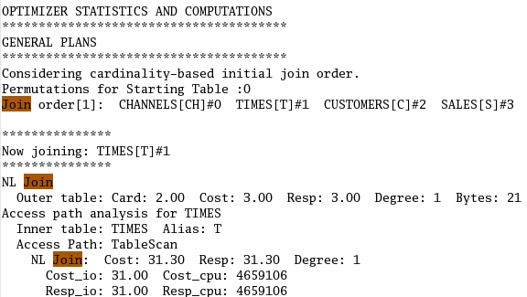

**Note:** Join orders and join methods

1. Suppose that a user is complaining of slow response time of a query. According to the user’s observation, it took 20 minutes to complete. You reviewed the execution plan and cost by using the explain plan and plan_table. The plan cost is 4000.
   1. What is the computed elapsed time based on the cost of 4000?
   2. Was the Oracle Optimizer estimated accurately?
      1. Yes
      2. No
   3. What could be the possible reasons for an inaccurate cost?

##### Answer:

1. Computed elapsed time = Plan Cost * sreadtim (12 ms)

= 4000*12(ms)

= 48000 ms

1. No
2. The reasons for inaccurate cost are:
   1. Large IN list
   2. Large OR statement
   3. Different estimated cardinality
   4. Incorrect selectivity estimate
3. Which statements are TRUE regarding hash joins?
   1. System statistics can influence the optimizer’s decision because hash joins require the intense use of memory and CPU.
   2. Hash joins are performed for equijoins, non-equijoins, and are most useful when joining large amounts of data.
   3. Hash joins can take advantage of the index on the join key column.

**Answer:** a

# Workshop 8

## Workshop 8: Overview

### Workshop Overview

In this workshop, you will perform the following tasks:

* Review parse time reduction strategy.
* Test without cursor sharing.
* Use CURSOR_SHARING.
* Use user-defined bind variables.
* Load SQL statements into a SQL plan baseline.

##### Scripts used in the Workshop

* ws08.sql
* w8_s2_c.sql
* w8_s2_d.sql
* w8_s2_e.sql
* w8_s2_f.sql
* w8_s2_g.sql
* w8_s3_a.sql
* w8_s3_c.sql
* w8_s3_c1.sql
* w8_s3_d.sql
* w8_s4_b.sql
* w8_s4_c.sql
* w8_s5_a.sql
* w8_s5_a1.sql
* w8_s5_b.sql

## Workshop 8: Tuning Strategy

### Overview

You have identified a slow-running SQL statement. It was run 555 times in a certain time period. You noticed that a different literal was used in each execution. This caused the system to parse the same statement 555 times with the high parse time, which is not efficient. What tuning strategy could be used?

call count cpu elapsed disk query current rows

|  |  |  |  |  |  |  |  |  |  |  |
| --- | --- | --- | --- | --- | --- | --- | --- | --- | --- | --- |
| Parse | 555 | 100.09 | 300.83 |  | 0 |  | 0 | 0 |  | 0 |
| Execute | 555 | 0.42 | 0.78 |  | 0 |  | 0 | 0 |  | 0 |
| Fetch | 555 | 14.04 | 85.03 |  | 513 |  | 1448514 | 0 |  | 11724 |
| total  **Tasks** | 1665 | 114.55 | 386.65 |  | 513 |  | 1448514 |  | 0 | 11724 |

1. Review parse time reduction strategy.
   1. Review the preceding output of TKPROF and provide your answers for the following questions.
      1. What is the elapsed time spent parsing? ( ).
      2. What is the elapsed time spent executing? ( )
      3. What is the elapsed time spent fetching? ( )
      4. Would normal query tuning techniques that alter the execution plan help?
      5. Would reducing parse time help? (**Note:** Assume that there is no client network bottleneck issue.)

##### Answer:

1) 300.83

2) 0.78

3) 85.03

1. No
2. Parse time reduction strategy can be used when you have determined that the query spends most of its time in the parse phase.
   1. How would you reduce the parse time? You could consider the following two options:

**Possible Option 1:** Minimize hard parses.

* + 1. Cursor sharing using bind variables
    2. Adaptive cursor sharing

**Possible Option 2:** Reduce the parse elapsed time.

1. If CPU time dominates the parse time, check the following common observations, and others, and apply solutions to resolve the issue.
   1. Dynamic sampling is being used for the query and impacting the parse time
   2. Query has many IN-list parameters
   3. Query has many OR operators
   4. Partitioned table with many partitions (for example, more than 1000)
2. If wait time dominates the parse time, check the following common observations, and others, and apply solutions to resolve the issue.

Waits for large query text to be sent from the client

1. In this workshop, you choose option 1 to reduce the number of hard parses, eventually to reduce the total parse time.
2. Test without cursor sharing.
   1. Connect to the sh schema in SQL Developer.
   2. Review and execute the SQL statements in ws08.sql. You consider the use of bind variables to reduce the parse time.

**Note:** The scripts used in this workshop are available in the workshops folder located in

/home/oracle/labs/workshops.

SELECT cust_city, sum (amount_sold) FROM sales s, customers c

WHERE s.cust_id=c.cust_id and country_id = 52790 GROUP BY cust_city

ORDER BY 2;

SELECT cust_city, sum (amount_sold) FROM sales s, customers c

WHERE s.cust_id=c.cust_id and country_id = 52787 GROUP BY cust_city

ORDER BY 2;

* + 1. Which column is a good candidate for a bind variable? ( )

**Answer:** country_id

* 1. Determine the distribution of all distinct values found in the candidate column in step b. You can use the w8_s2_c.sql file.

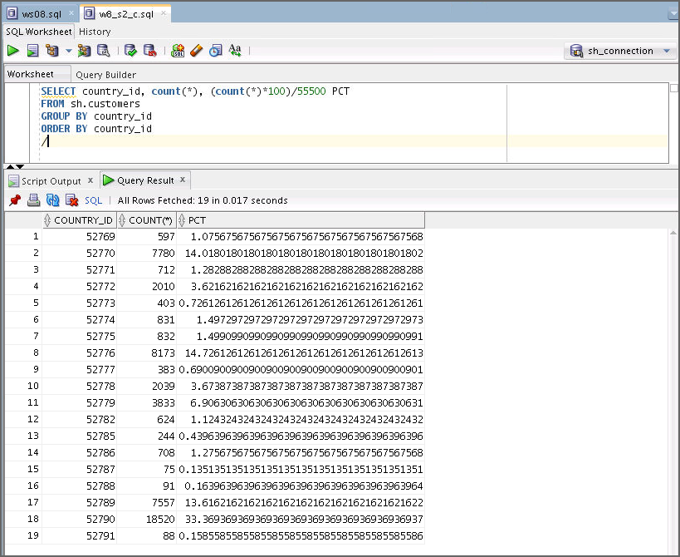

* 1. If needed, create a histogram on the column and check it by using the

USER_TAB_COLUMNS view. You can use the w8_s2_d.sql file.

* + 1. What is the histogram type? ( )
    2. How many buckets exist in the histogram? ( )

exec DBMS_STATS.GATHER_TABLE_STATS(OWNNAME=>'SH', TABNAME=>'CUSTOMERS', METHOD_OPT => 'FOR COLUMNS SIZE 25

country_id', CASCADE => TRUE)

SELECT column_name, histogram, num_buckets

FROM user_tab_columns

WHERE table_name = 'CUSTOMERS'

/

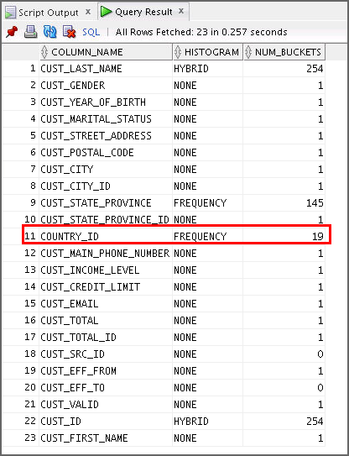

##### Answer:

1. A frequency histogram is used.
2. Number of buckets for COUNTRY_ID: 19. It means there are only 19 distinct values in the column.
   1. Create an index on the column identified in step d by using the following sample code, or use the w8_s2_e.sql file.

DROP INDEX sh.cust_country_id_idx

/

CREATE INDEX sh.cust_country_id_idx ON sh.customers (country_id)

/

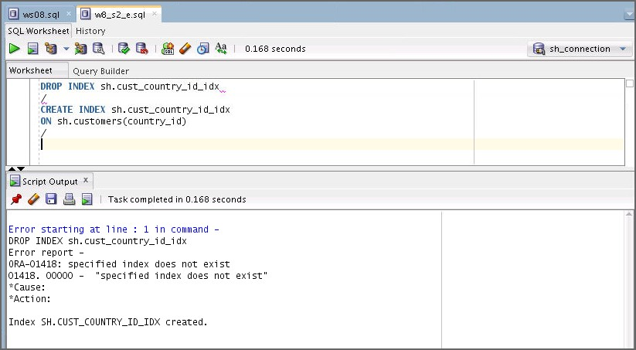

* 1. Determine the execution plan of the following SQL statement. You can use the

w8_s2_f.sql file.

SELECT cust_city, sum (amount_sold) FROM sales s, customers c

WHERE s.cust_id=c.cust_id and country_id = 52790 GROUP BY cust_city

ORDER BY 2

/

SELECT * FROM table (dbms_xplan.display_cursor);

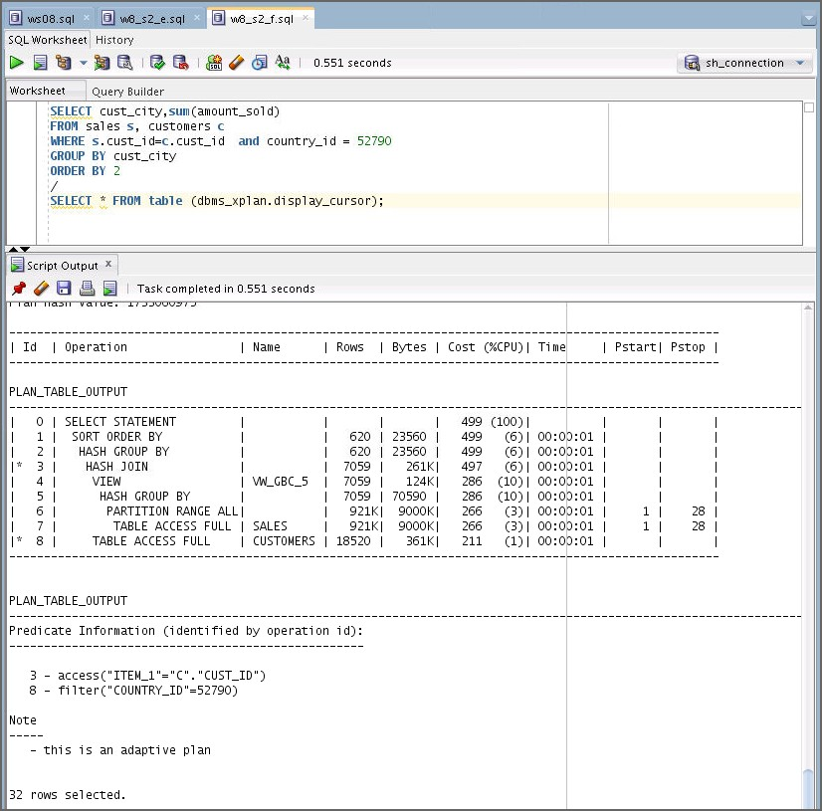

**Note:** 33.3% of the duplicated data is present in the COUNTRY_ID column where the value of country_id = 52790.

* 1. Determine the execution plan of the following SQL statement. You can use the

w8_s2_g.sql file.

SELECT cust_city, sum (amount_sold) FROM sales s, customers c

WHERE s.cust_id=c.cust_id and country_id = 52787 GROUP BY cust_city

ORDER BY 2

/

SELECT * FROM table (dbms_xplan.display_cursor);

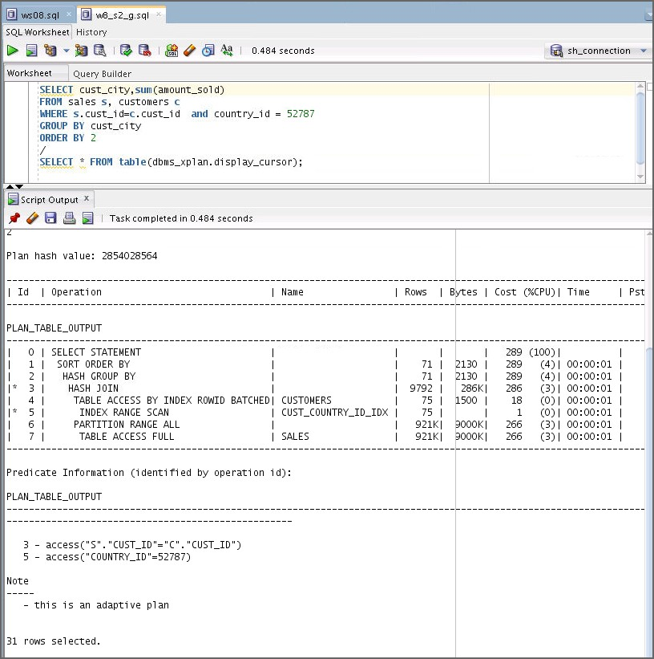

**Note:** 0.135% of the duplicated data is present in the COUNTRY_ID column where the value of country_id = 52787. In this plan, CUST_COUNTRY_ID_IDX is used.

* 1. Try to explain why the execution plans are different in step f and g.
     1. Why are the plans different? Does the optimizer consider two similar SQL statements in step f and g as the same SQL statements?
     2. How many hard parses occurred?
  2. Reduce the number of hard parses in Task 3.

1. Use CURSOR_SHARING.

Assume that the identified SQL statements in ws08.sql are all hard-coded. That means that you cannot use any user-defined bind variables because the SQL statements cannot be modified. In this task, you use system-level bind variable instead.

**Note:** In this workshop, you will choose option 1 to reduce the number of hard parses, eventually to reduce the total parse time.

Remember that the optimizer assigns a value to a bind variable only in the first invocation to generate a good execution plan. The same execution plan is used for the subsequent SQL statements as if the plan is the optimal plan in all cases. In general, this behavior is good in most cases. But it would not work if a bind variable column has a skewed data distribution and even with histograms. A histogram is used only for the peeked value in the first invocation due to bind variable peeking. You know that a bind variable does not work well with a histogram.

You have learned about adaptive cursor sharing in the lesson titled “Introduction to Optimizer Statistics Concepts”. You will examine if adaptive cursor sharing can help the optimizer share a cursor safely and in an intelligent way instead of sharing a cursor blindly.

* 1. Use the following sample trigger to create a LOGON trigger. **You have to set the cursor_sharing parameter to a proper value for system bind variables as soon as the sh user logs on**.

Connect as user sys and execute the sample code, or you can use the w8_s3_a.sql

file. Connection details are as follows: Connection Name: sys_connection Username: sys

Password: fenago

Role: SYSDBA

Host Name: localhost

Service name: orclpdb

create or replace trigger set_cursor_sharing after logon

on database declare begin

if user = 'SH' then execute immediate 'alter session set cursor_sharing=<value>';

end if; exception

when others then

null;

end;

/

.

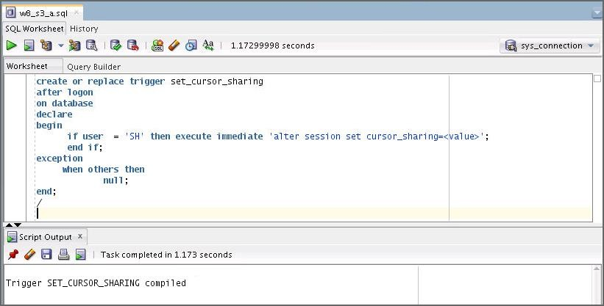

* 1. Connect to the sh schema in SQL Developer.
  2. Execute the following SQL statements to verify whether the system bind variable was used. You can use the w8_s3_c.sql and w8_s3_c1.sql files.

SELECT /* TASK04 */ cust_city, sum (amount_sold) FROM sales s, customers c

WHERE s.cust_id=c.cust_id and country_id = 52790 GROUP BY cust_city

ORDER BY 2

/

SELECT * FROM table (dbms_xplan.display_cursor)

/

SELECT /* TASK04 */ cust_city, sum (amount_sold) FROM sales s, customers c

WHERE s.cust_id=c.cust_id and country_id = 52787 GROUP BY cust_city

ORDER BY 2

/

SELECT * FROM table (dbms_xplan.display_cursor)

/

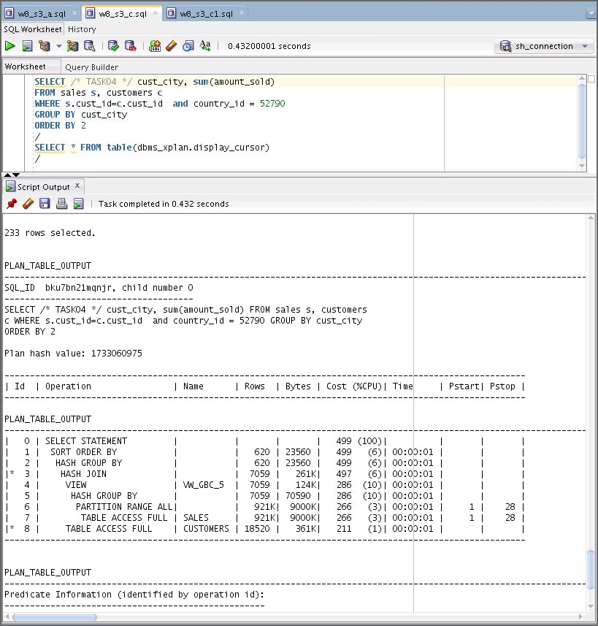

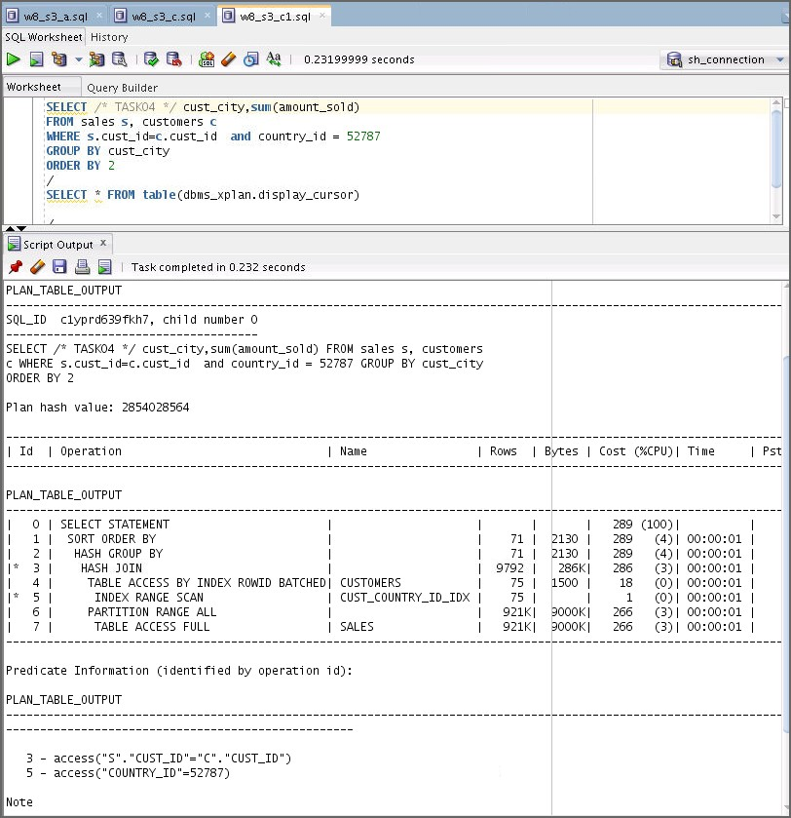

* 1. Drop the set_cursor_sharing trigger by connecting as user sys. Use the

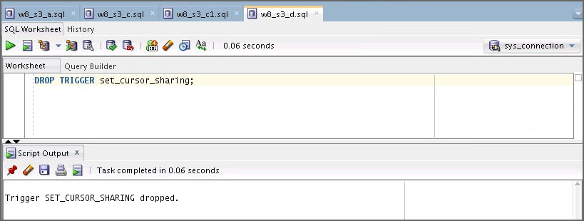w8_s3_d.sql file.

1. Use a user-defined bind variable.

Assume that the identified SQL statements in ws08.sql can be modified. Use a user- defined bind variable.

* 1. Connect to the sh schema in SQL Developer.
  2. Execute the following SQL statement and verify if a user-defined bind variable was used. You can use the w8_s4_b.sql file.

variable country_id number exec :country_id:= 52790

SELECT /* ACS */ cust_city, sum (amount_sold) FROM sales s, customers c

WHERE s.cust_id=c.cust_id and country_id =:country_id GROUP BY cust_city

ORDER BY 2

/

SELECT * FROM table (dbms_xplan.display_cursor)

/

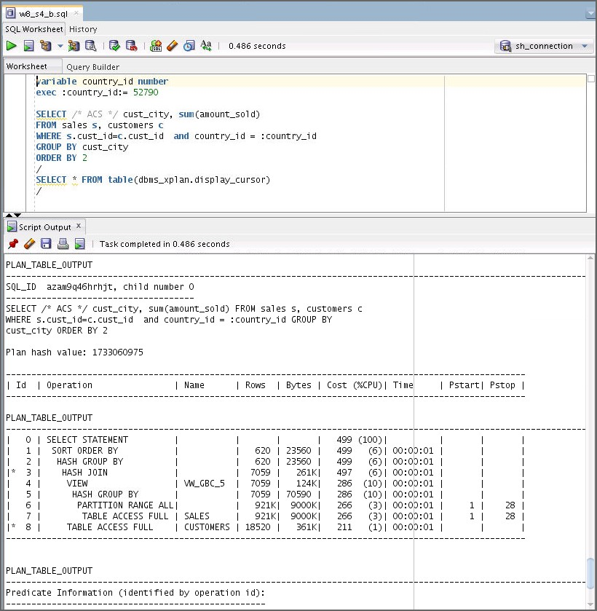

* 1. Execute the following SQL statement and verify if a user-defined bind variable was used. You can use the w8_s4_c.sql file.

variable country_id number exec :country_id:= 52787

SELECT /* ACS */ cust_city, sum (amount_sold) FROM sales s, customers c

WHERE s.cust_id=c.cust_id and country_id =:country_id

GROUP BY cust_city

ORDER BY 2

/

SELECT * FROM table (dbms_xplan.display_cursor)

/

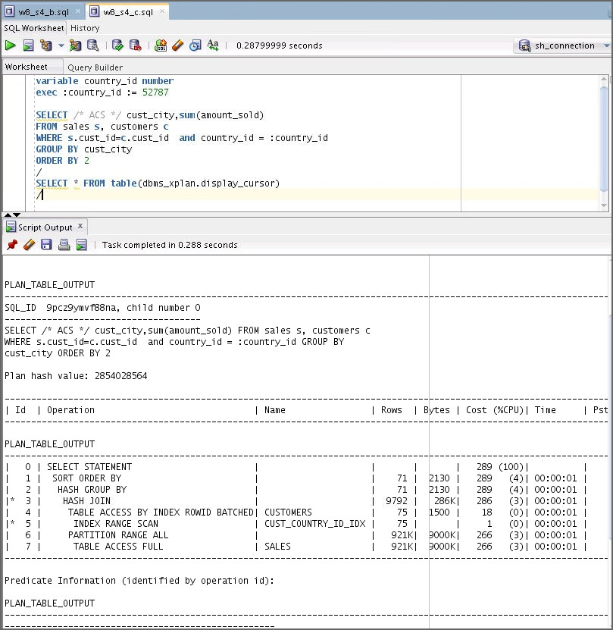

* 1. Even though the country_id user bind variable was defined, the optimizer created two plans. This is different optimizer behavior from Oracle 10g. Try to explain what made it possible.
     1. Do you know the Bind Variable Peeking feature?
     2. Do you know the Adaptive Cursor Sharing feature?

1. Using SQL Plan Baseline
   1. Load the following two plans found in Step b and c into SQL Plan Baseline to maintain these plans over time. Use the following same code. You can use the w8_s5_a.sql and w8_s5_a1.sql files. **Note:** If you get an “Insufficient Privilege” error, grant the following permission to the sh user.

**Note:** Copy SQL_ID and Plan_hash_value values( for w8_s5_a.sql and w8_s5_a1.sql) from the outputs of step 4(b) and 4(c).

GRANT ADMINISTER SQL MANAGEMENT OBJECT TO SH;

var res number ;

exec :res := dbms_spm.load_plans_from_cursor_cache(sql_id => '<<**Please enter the** SQL_ID **value**>>',plan_hash_value => '<<**Please enter the** PLAN_HASH_VALUE **value**>>')

/

* 1. Execute the SQL statement and verify if two plans were successfully loaded into the SQL plan baseline. You can use the w8_s5_b.sql file.

select sql_text, sql_handle, plan_name, enabled, accepted from dba_sql_plan_baselines

where sql_text like 'SELECT /* ACS %';

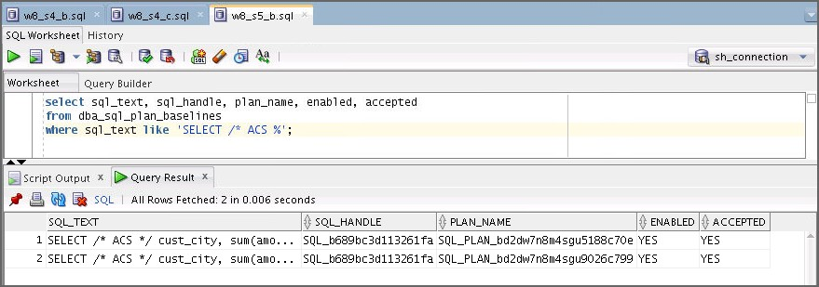

# Workshop 9

## Workshop 9: Overview

### Workshop Overview

In this workshop, you will perform the following task:

Use SQL Plan Baseline to associate a hinted execution plan with a hard-coded SQL statement.

### Scripts Used in the Workshop

* setup09.sql
* ws09.sql
* cleanp09.sql
* w9_s2_a.sql
* w9_s2_b.sql
* w9_s2_c.sql
* w9_s2_d.sql
* w9_s3_a.sql
* w9_s3_b.sql
* w9_s4_a.sql
* w9_s4_b.sql
* w9_s5_a.sql
* w9_s4_c.sql
* w9_s4_c1.sql
* w9_s5_b.sql
* w9_s5_b1.sql
* w9_s5_b2.sql

## Workshop 9: Using SQL Plan Baseline to Manage a Better Execution Plan

### Overview

Oracle has introduced several methods to maintain the stable execution plans of SQL statements such as hints, stored outlines, and SQL profile. In Oracle Database, you can manage the execution plan through a methodology called SQL Plan Baseline.This feature allows the optimizer to make the right decision choosing a verified or tested execution plan in SQL Plan Baseline even if the optimizer generates a new plan during hard parse. In this workshop, you learn how to use this feature to associate a hinted execution plan with a hard- coded SQL statement.

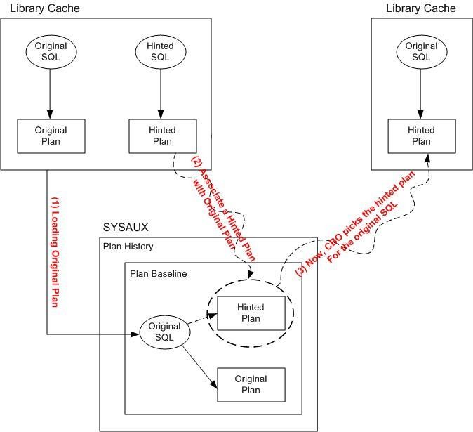

### Tasks

1. Initial setup
   1. Connect to sh schema in SQL Developer.
   2. Execute the setup09.sql script to set up the environment for this workshop.

**Note:** The scripts used in this workshop are available in the workshops folder located in

/home/oracle/labs/workshops.

DROP TABLE sh.cust

/

CREATE TABLE sh.cust AS SELECT * FROM sh.customers

/

DROP INDEX sh.cust_yob_bix

/

CREATE BITMAP INDEX sh.cust_yob_bix ON sh.cust (cust_year_of_birth) NOLOGGING

COMPUTE STATISTICS

/

DROP INDEX sh.cust_gender_bix

/

CREATE BITMAP INDEX sh.cust_gender_bix ON sh.cust (cust_gender)

NOLOGGING

COMPUTE STATISTICS

/

exec DBMS_STATS.GATHER_TABLE_STATS('SH','CUST')

/

alter session set optimizer_use_sql_plan_baselines = true

/

alter session set optimizer_capture_sql_plan_baselines = true;

* 1. Review and execute the SQL statement in ws09.sql.

**Note:** Assume that you have identified this hard-coded SQL statement. This has to be tuned, but there are only a few options available to improve performance.

##### --Original SQL:

SELECT /*+ INDEX_COMBINE (cust cust_gender_bix, cust_yob_bix) */

*

FROM sh.cust

WHERE cust_year_of_birth < 70 AND cust_gender = 'M'

/

1. Review the identified SQL statement.
   1. Execute the SQL statement in ws09.sql. And check sql_id and plan_hash_value using v$sqlarea. Use the following sample code. You can also use the w9_s2_a.sql file.

**Note:** The workshop is used to see SQL plan management. The query in ws09.sql does not return any value on purpose. It is only to see which plan can be used. And the original query will use the hinted execution plan, not the original plan. That is the whole purpose of workshop 9.

In case SQL cannot be modified in the real world and you know a better plan, you can associate the original SQL with the new plan (hinted plan).

select sql_id, plan_hash_value, sql_text from v$sqlarea

where sql_text like 'SELECT /*+ INDEX_COMBINE(cust cust_gender_bix, cust_yob_bix)%';

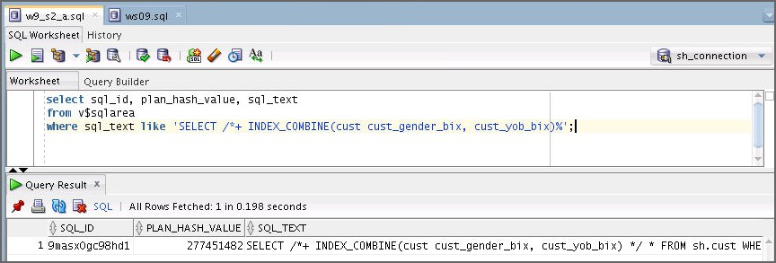

* 1. Execute the following sample code and review the execution plan of the SQL statement. You can use the w9_s2_b.sql file.

SELECT * FROM table (dbms_xplan.display_cursor ('**<<Please Enter the**

**SQL_ID value>>**'));

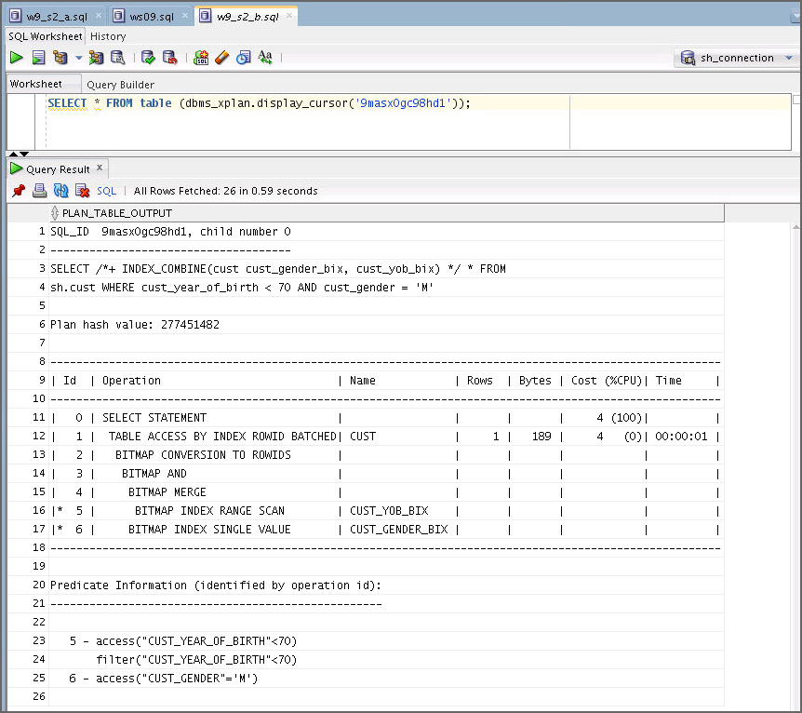

**Note:** The BITMAP MERGE operation is used. Total Cost is 4.

* 1. Load the execution plan of the SQL statement in ws09.sql into the SQL Plan Baseline. You can use the w9_s2_c.sql file.

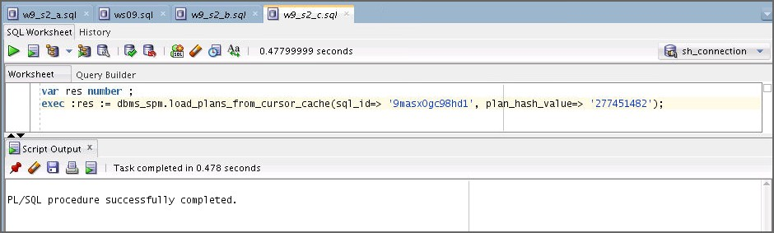

var res number ;

exec :res: = dbms_spm.load_plans_from_cursor_cache (sql_id => '<<**Please enter the original SQL_ID value**>>', plan_hash_value => '<<**Please enter the &original_plan_hash_value**>>');

* 1. Check the loaded plan in SQL Plan Baseline by using the following sample code, or you can use the w9_s2_d.sql file.

select sql_handle, plan_name, sql_text, enabled, accepted from dba_sql_plan_baselines

where sql_text like '%SELECT /*+ INDEX_COMBINE (cust cust_gender_bix, cust_yob_bix)%';

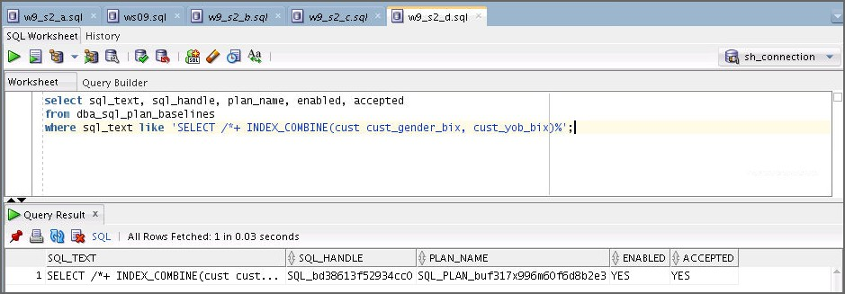

1. Find a better execution plan.
   1. Execute the following hinted SQL statement and check sql_id and

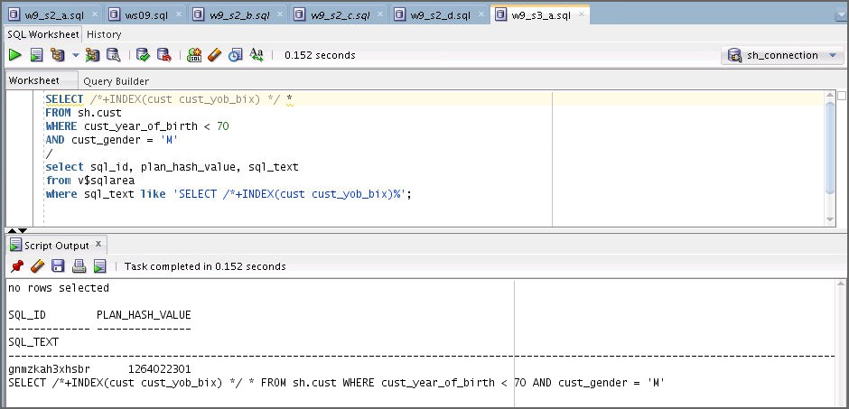plan_hash_value. Use the w9_s3_a.sql file.

SELECT /*+INDEX(cust cust_yob_bix) */ * FROM sh.cust

WHERE cust_year_of_birth < 70 AND cust_gender = 'M'

/

select sql_id, plan_hash_value, sql_text from v$sqlarea

where sql_text like 'SELECT /*+INDEX(cust cust_yob_bix)%';

* 1. Execute the following sample code and review the execution plan of the SQL statement. You can use the w9_s3_b.sql file.

SELECT * FROM table (dbms_xplan.display_cursor ('<<**Please enter the**

**SQL_ID value**>>'));

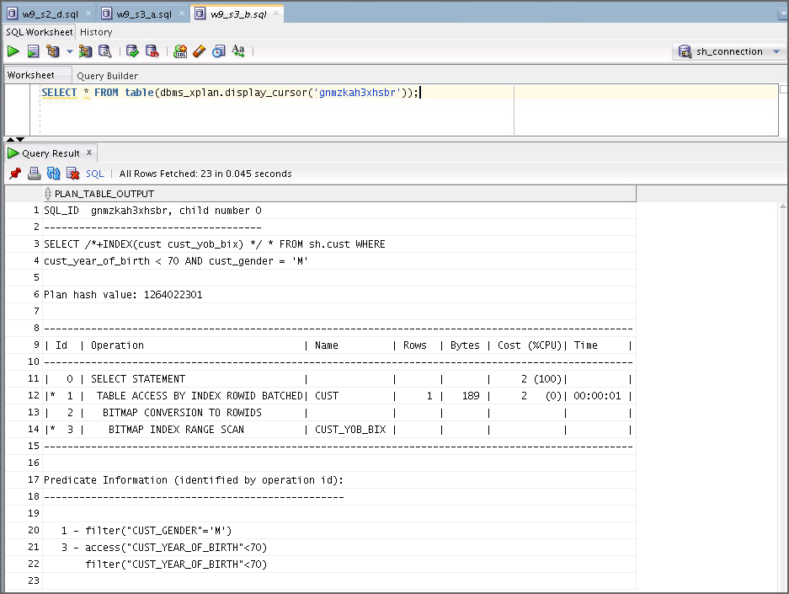

**Note:** The BITMAP MERGE is avoided. Total cost is 2.

1. Load a hinted execution plan into SQL Plan Baseline.
   1. Associate the better execution plan generated in step b of Task 3 with the original SQL statement. Use the w9_s4_a.sql file.

var res number;

exe :res := dbms_spm.load_plans_from_cursor_cache( sql_id => '<<**Please enter the &hinted_SQL_ID value**>>', plan_hash_value

=>'<<**Please enter the &hinted_PLAN_HASH_VALUE**>>', sql_handle => '<<**Please enter the** '**&SQL_HANDLE_for_original**>>');

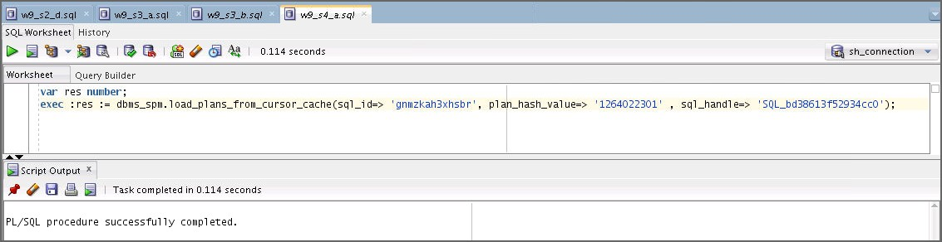

* 1. Execute the following sample code and verify that the better plan is loaded successfully in SQL Plan Baseline for the original SQL statement. You can use the w9_s4_b.sql file.

select sql_text, sql_handle, plan_name, enabled, accepted from dba_sql_plan_baselines

where sql_text like 'SELECT /*+ INDEX_COMBINE(cust%';

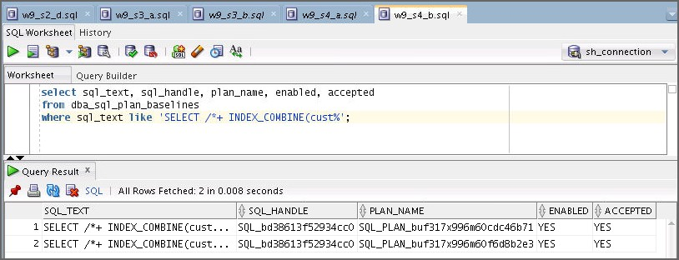

**Note:** The first plan is the hinted plan loaded.

* 1. If the original plan is not needed, drop the original plan (**option1**) from SQL Plan Baseline or fix the better plan to guarantee the plan for the next hard parse (**option2**). Use the w9_s4_c.sql (**option1**) file to drop the original plan file and then execute the w9_s4_c1.sql file to check whether the original plan is dropped or not.

**--Option 1**

var res number;

exec :res :=DBMS_SPM.DROP_SQL_PLAN_BASELINE ('<< **Please enter the &original_SQL_HANDLE value**>>', '<<**Please enter the &original_PLAN_NAME value**>>');

**--Option 2**

var cnt number

exec :cnt := dbms_spm.alter_sql_plan_baseline(sql_handle =>'<<

**Please enter the SQL_HANDLE value**>>', plan_name=> '<<**Please enter the**

**PLAN_NAME value**>>');

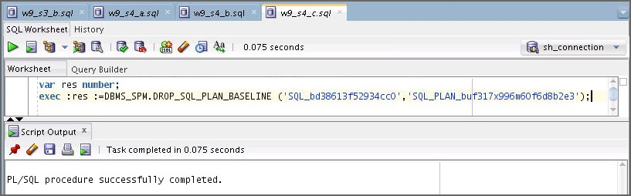

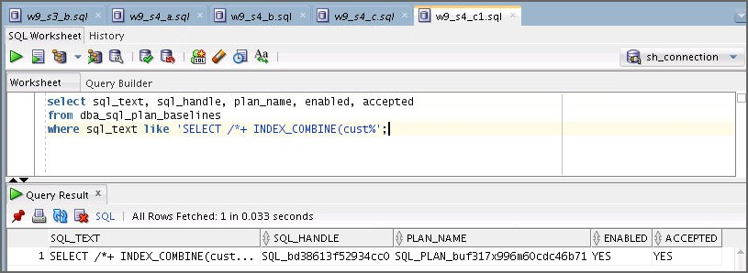

select sql_text, sql_handle, plan_name, enabled, accepted from dba_sql_plan_baselines

where sql_text like 'SELECT /*+ INDEX_COMBINE(cust%';

1. Test the SQL statement with the loaded plan.
   1. Clean up the shared pool for testing in the next step. You can use the w9_s5_a.sql

file. Use the sys user to execute this statement.

ALTER SYSTEM FLUSH SHARED_POOL;

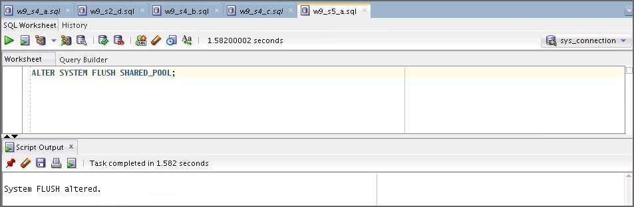

* 1. Execute the SQL statements (**option 1, option 2, and option 3**) and check if the optimizer uses the better execution plan for the original SQL statement. Use the w9_s5_b.sql, w9_s5_b1.sql, and then w9_s5_b2.sql files.

**--Option 1:**

EXPLAIN PLAN FOR

SELECT /*+ INDEX_COMBINE(cust cust_gender_bix, cust_yob_bix) */

*

FROM sh.cust

WHERE cust_year_of_birth < 70 AND cust_gender = 'M'

/

SELECT * FROM table (DBMS_XPLAN.DISPLAY);

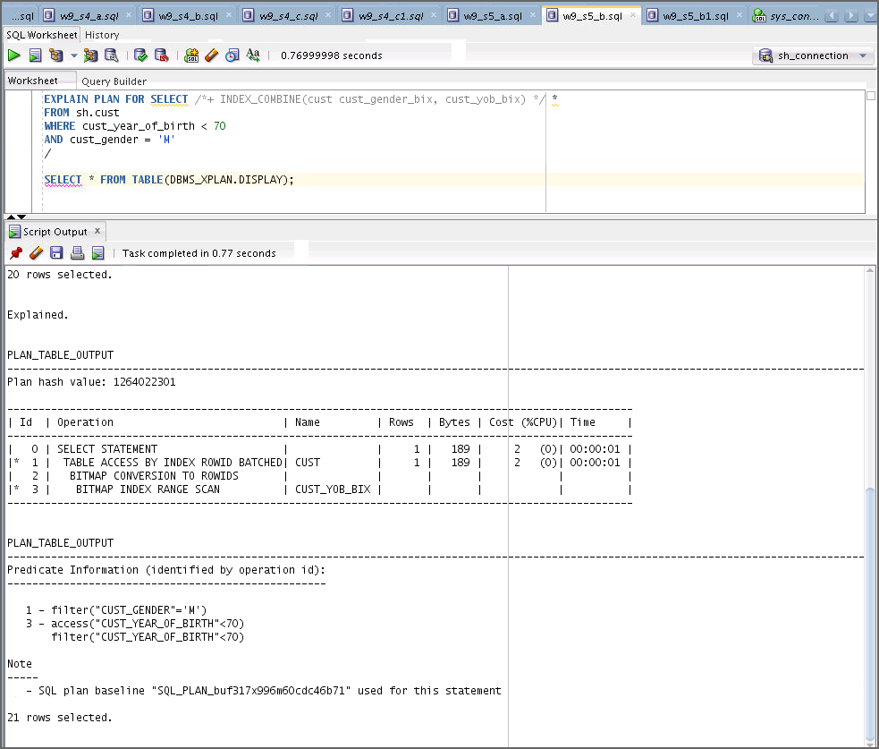

**--Option 2:**

SELECT /*+ INDEX_COMBINE(cust cust_gender_bix, cust_yob_bix) */

*

FROM sh.cust

WHERE cust_year_of_birth < 70 AND cust_gender = 'M'

/

select sql_id, sql_plan_baseline from v$sqlarea where sql_text like 'SELECT /*+ INDEX_COMBINE(cust%';

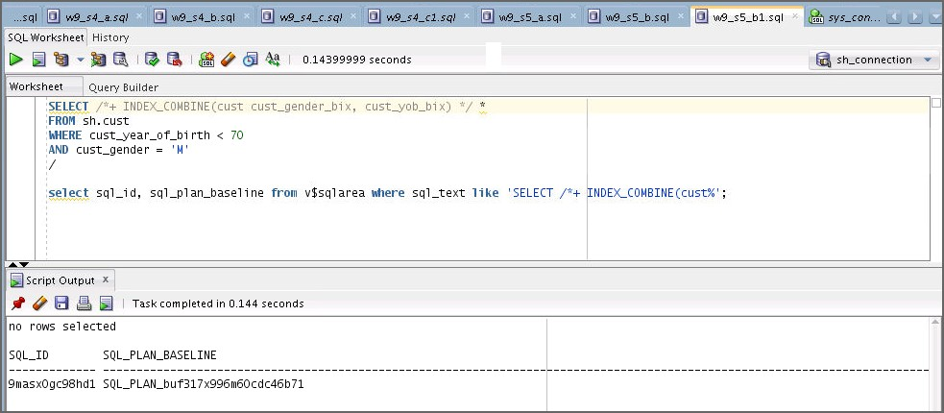

**--Option 3:**

SET LINESIZE 150

SET PAGESIZE 2000

SELECT t.* FROM TABLE (DBMS_XPLAN.DISPLAY_SQL_PLAN_BASELINE ('<<

**Please enter SQL_HANDLE value**>>'))t;

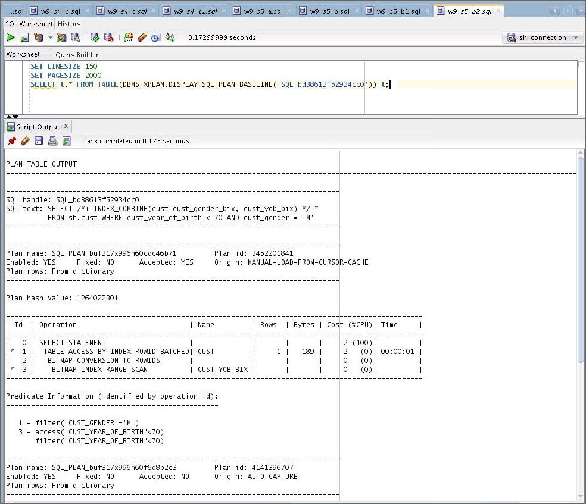

1. Clean up the environment.

Execute the cleanup09.sql script.

select sql_text, sql_handle, plan_name, enabled, accepted from dba_sql_plan_baselines

where sql_text like 'SELECT /*+ INDEX_COMBINE(cust%'

/

var res number;

exec :res :=DBMS_SPM.DROP_SQL_PLAN_BASELINE('<<**Please enter the**

**SQL_HANDLE value**>>');

DROP TABLE sh.cust

/